**Boswellia sacra** (commonly known as **frankincense** is native to the [Arabian Peninsula](https://en.wikipedia.org/wiki/Arabian_Peninsula) ([Oman](https://en.wikipedia.org/wiki/Oman), [Yemen](https://en.wikipedia.org/wiki/Yemen)), and horn of [Africa](https://en.wikipedia.org/wiki/Africa) ([Somalia](https://en.wikipedia.org/wiki/Somalia)). an [aromatic](https://en.wikipedia.org/wiki/Aroma_compound) [resin](https://en.wikipedia.org/wiki/Resin) used in [incense](https://en.wikipedia.org/wiki/Incense) and [perfumes](https://en.wikipedia.org/wiki/Perfume), obtained from trees of the genus [Boswellia](https://en.wikipedia.org/wiki/Boswellia) in the [family](https://en.wikipedia.org/wiki/Family_(biology)) [Burseraceae](https://en.wikipedia.org/wiki/Burseraceae). The word is from [Old French](https://en.wikipedia.org/wiki/Old_French) franc encens ('high-quality incense').

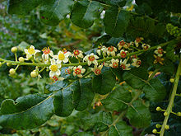

The Story of

Christmas.

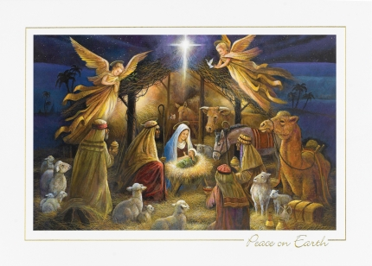

**John 3:16, “For God so loved the world that He gave His only begotten Son, that whoever believes in Him, shall not perish but have everlasting life.”**

Just remember, the most important part of being a Christian is to know and believe that:

God sent His only begotten Son, Jesus, to earth to pay for all of our sins, (past, present and future), by dying on the cross, being buried then resurrected on the third day.

**The Christmas Story**

**Giving of Gifts**

**Prophesy**

Psalms 72:10-11

**Fulfillment**

Matthew 2:11

***The Wise Men bowed down to baby Jesus and honored Him by giving Him gifts of gold, frankincense and myrrh.***

**The Christmas Story**

**Timing of Jesus’ Birth**

**Prophecy**

Daniel 9:25-26

**Fulfillment**

Matthew 2:1-2, 1 Peter 2:24-25

***Jesus is the fulfillment of the 69 weeks as prophesied in the book of Daniel.***

There were about four hundred years where God was silent to mankind between the writing of the Old and New Testaments.

The New Testament is the telling of the fulfillment of the Old Testament. The Christmas Story as we know it today is a mixing of the New Testament books of Matthew and Luke.

**Just to review:**

1) God made the world and all that is in it including us.

2) We have sinned, do sin and will continue sinning making us separate from God.

3) God cannot tolerate any sin in heaven.

4) There is no way for us to be restored to God on our own.

5) The omnipresent, omniscient, omnipotent, all-loving eternal God has provided a Way, Jesus, who was brought into the world not as a stately king but a helpless Babe born in poverty, predicted and told in the Jewish Old Testament.

Merry Christmas

to All and to All

a Blessed Night

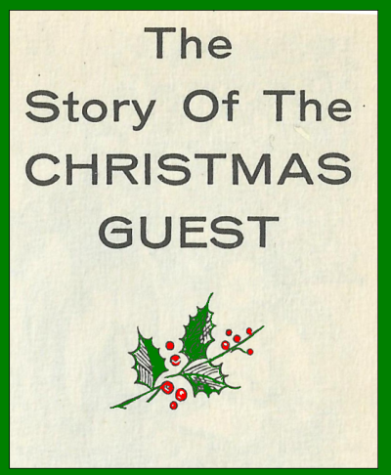

**Frankincense** – an important acknowledgement of the **Priesthood of Jesus, setting Him apart from typical kings**.

Frankincense was used in the temple routines, burned ceremonially by the priests. Precious in both meaning and value to worship Him.



Jesus, the eternal One, Who created the universe and everything in it, paid the ultimate price for us. He did this by stepping down from Heaven, coming into this world as a baby, the most vulnerable of humans. He lived as fully man (the Son of Man) and fully God (the Son of God), to grow up, teach us and die for us like no one else could.

He was the perfect sacrifice.

**The Christmas Story**

**The Star points the way**

**Prophesy**

Numbers 24:17

**Fulfillment**

Matthew 2:1-2

***The Star of Bethlehem led the Magi from where they were to baby Jesus in the manger.***



**But they knew He was sent by God to be our Messiah.**

**Why do we give gifts?**

This tradition probably came from what the Wise Men or Magi gave Jesus to honor Him; gold, frankincense and myrrh.

***Isaiah 60:6b***

***“They shall bring gold and frankincense, and shall bring the good news, the praises of the Lord.”***

The Magi travelled hundreds of miles, led by God’s star, to bow before Jesus, a baby they did not know, born in a manger.

**The Christmas Story**

**Jesus is filled with power, peace and the Spirit at birth**

**Prophecy**

Isaiah 9:6-7, 61:1

**Fulfillment**

Luke 4:18

***Jesus is predicted in Isaiah as the Prince of Peace and fulfilled in Luke as He reads the scroll of Isaiah to the people of Nazareth.***

**The Christmas Story**

**Born in Bethlehem**

**Prophesy**

Micah 5:2

**Fulfillment**

Luke 2:10-11

***Mary, with child in Nazareth, had to go to Bethlehem to be registered with Joseph.***

