**The Christmas Story**

**Confirmation of Lineage**

**Prophesy**

Genesis 12:3, 17:21, 26:4, 28:14, 49:8-12, Isaiah 9:7, 11:1-10

**Fulfillment**

Matthew 1:1-17, Luke 1:68-69

Jesus was promised through the line of Abraham, Isaac, Jacob Jesse and David.

**The Christmas Story**

**Jesus is saved to fulfill His purpose**

**Prophesy**

Jerimiah 31:15

**Fulfillment**

Matthew 2:16-18

**Evil Herod plotted to destroy Jesus. But… God intervened.**

**Be thankful and grateful that you were not born to be Pharaoh, Herod or others with a hard heart for God and His people,**

**The Christmas Story**

**Called to Egypt**

**Prophesy**

Hosea 11:1

**Fulfillment**

Matthew 2:13-15

***Herod, the King, wanted to destroy Jesus. So, the family went to Egypt for a time.***

Christians are all over the world! In many countries and many cultures!

Because of this there are many different traditions surrounding Christmas.

Everyone has different ways of celebrating this important and blessed Christmas season.

**Myrrh** - **(death and mourning)**. Predicting that Jesus would **die** for all mankind.

Myrrh – an anointing oil, used as fragrance and for medicinal purposes and embalming the dead (Balsam of Mecca).

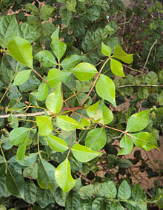

**Commiphora**, the genus of **myrrh**, is the most species-rich genus of flowering plants in the frankincense and myrrh family, Burseraceae, approx.190 species of shrubs and trees, which are distributed throughout the sub-tropical regions of Africa, the western Indian Ocean islands, the Arabian Peninsula, India and Vietnam.



***“And we know that for those who love God, all things work together for good.”***

***Romans 8:28a***

**What Is Christmas?**

Christmas is the day we, as Christians, celebrate the birth or our Lord and Savior Jesus Christ

**What is the meaning of “Christ”?**

Christ means:

Anointed One, Savior, Messiah.

**The Christmas Story**

**Born of a virgin**

**Prophesy**

Isaiah 7:14

**Fulfillment**

Matthew 1:23

***Mary was betrothed to Joseph and had not known any man, yet, she was with child.***

***“Angel of the Lord came to shepherds. Do not be afraid, for behold, I bring you good tidings of great joy which will be to all people. For there is born to you this day in the city of David a Savior, who is Christ the Lord. And this will be a sign to you: you will find a Babe wrapped in swaddling clothes, lying in a manger. Glory to God in the highest, and on earth peace, goodwill toward men.” Luke 2:8-14***

His perfect life, the miracles he performed and His resurrection prove that **HE IS GOD!**

No one else could have done all that He did.

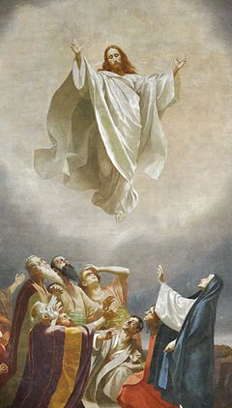

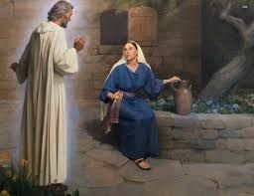

***The Annunciation***

***Luke 1:26-38***

**The Christmas Story**

**Worshiped by shepherds**

**Prophesy Fulfillment**

Psalms 72:9 Luke 2:817

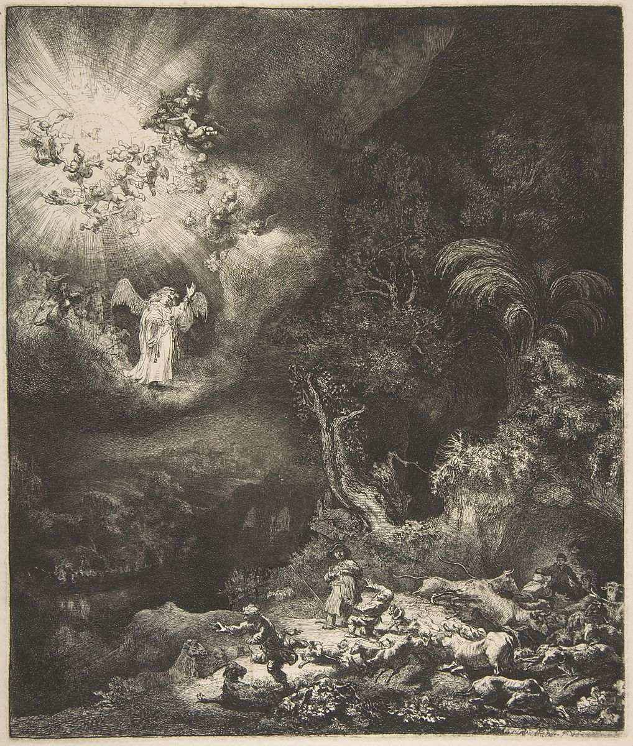

The Angel appearing to the shepherds

**Gold, a** [chemical element](https://en.wikipedia.org/wiki/Chemical_element) with the [symbol](https://en.wikipedia.org/wiki/Symbol_(chemistry)) **Au** ([Latin](https://en.wikipedia.org/wiki/Latin_language): *aurum*) and [atomic number](https://en.wikipedia.org/wiki/Atomic_number) 79, making it one of the higher atomic number elements that occur naturally. In a pure form, it is a [bright](https://en.wikipedia.org/wiki/Brightness), slightly reddish yellow, soft, [malleable](https://en.wikipedia.org/wiki/Malleable) and ductile metal.



**What would be the most awesome gift you could ever receive for Christmas or any other day?**

**That gift has already been given to you. All you need to do is receive it! It is eternal salvation through Jesus the Christ.**

**God is with us!**

**Gold-** valuable, beautiful, and long-lasting. Scholars generally agree that the gift represented **Jesus as a King with an everlasting throne**.

Gold is a treasure befitting royalty, although in this case, royalty was found in the home of a young, poor family.