**Thanksgiving Joy**  
On Thanksgiving Day we thank God   
For our blessings all year through,   
For our family that we dearly love,   
For good friends, old and new.  
For the Son to light and warm our days,  
For stars that twinkle at night,  
For trees of green and skies of blue,  
And billowy clouds of white.  
We're grateful for our eyes that see  
The beauty that abounds,   
For legs to walk and arms to hug,   
And ears to hear all sounds.  
The list of all God’s blessings  
Would fill a great big book;   
Our thankful hearts for our salvation  
 from Him whom we forsook!

By Joanna Fuchs

Happy Thanksgiving 2023

**Who were the Pilgrims?**

TRUSTING GOD DURING TRAGEDY

On November 11, 1620 dangerous storms and strong winter seas forced the Mayflower to anchor in Cape Cod Bay near where Provincetown is now, basically still out in the Atlantic Ocean nowhere near Virginia.

It was here that the Mayflower Compact was drawn up and signed. They agreed to settle and build a self-governing community west of here naming it Plymouth. Many passengers/colonists became sick and many died during the first year of settlement.

**Happy**

**Thanksgiving**

**Thanking God for what He has given us**

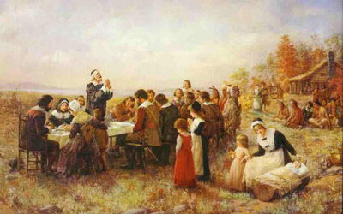

We must remember that God has created everyone and everything for good and His glory and that we should always be thankful for what He has done for us and what He has given to us whether it makes us happy or sad. Because it is not about us… it’s about God and maybe more correctly spoken, it’s all about Jesus.

**Thanksgiving Symbols**

**TURKEY**  
Perhaps the most essential image of Thanksgiving in America is the turkey. Although there’s no direct evidence that turkeys were served at the 1621 Thanksgiving Day supper, they were a major food source for both Natives and the Pilgrims so it is thought that turkeys may have been included. All praise to God for supplying abundant game that year with the friendly Native Americans to help Pilgrims in need who trusted Him for their survival and salvation.

**A Thanksgiving Prayer**

O Lord, our Heavenly Father,

Thank You for all of Your gifts and mercies that you faithfully and constantly bestow upon us, Your undeserving children. We thank You for our families and our friends and ask You to forgive us our sins and bless us all. Thank You for the abundance in our lives and the beauty of Your creation. Thank You for Your love and the gift of Your Son. Amen.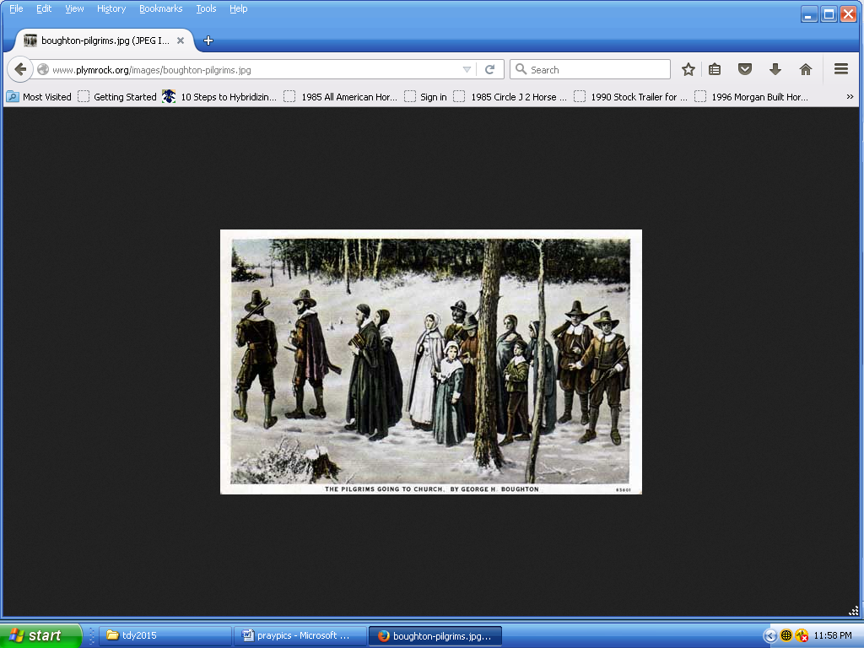

**Who were the Pilgrims?**

**THANKING GOD FOR WHAT HE HAS GIVEN US**

Upon growing a plentiful harvest in the fall of 1621, the Pilgrims gathered with Squanto, Samoset, Massasoit, and ninety other Wampanoag men in a celebration of food and feasting. The Wampanoag brought much of the food. This celebration became the holiday we know as Thanksgiving.

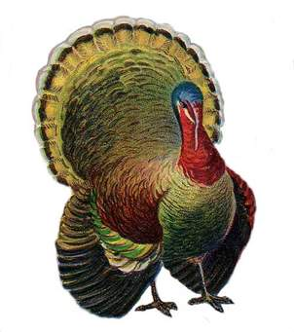

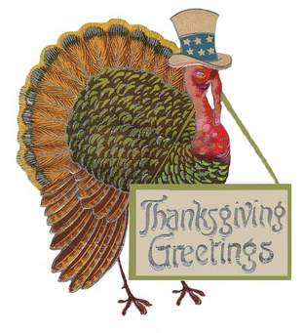

Thanksgiving 1621

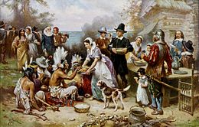

**Who were the Pilgrims?**

**HARDSHIPS LEADING PEOPLE TO GOD**

King Henry VIII of England was the head of the Church of England in 1534.

Certain people in England did not agree with the Church of England.

Those people were called Separatists because they separated into a new church. Some of the Separatists were not treated well due to their beliefs.

### 10 REASONS TO THANK GOD

1. God is good, faithful and loving. **I Chronicles 16:34**

2. God is just. **Psalms 7:17**

3. God helps us when we’re in need. **Psalms 28:7**

4. God is our source of joy. **Ps 43:4**

5. God carries our burdens for us.

**Psalms 68:19**

6. God fulfills His promises to us.

**Psalms 138:1-2**

7. God is always near to us. **Psalms 75:1**

8. God answers our prayers & saves us. **Psalms 118:21**

9. God's Word is good. All His laws are just and good. **Psalms 119:62**

10. God forgives and comforts us. **Isaiah 12:1**

**Who were the Pilgrims?**

LEARNING TO TRUST GOD

The colonists began their voyage with the ships: Mayflower and Speedwell.

The Speedwell had dangerous leaks and was left behind.

The 102 fortunate passengers that were allowed to travel, boarded the Mayflower with 26 crew members.

The 35 Separatists called themselves Saints and other settlers Strangers.

The voyage lasted over two months with one sailor and one passenger perishing during the voyage.

A baby boy was born during the voyage and one when first anchored.

The investors would give the colonists supplies and transportation to the American colonies by agreeing to an exchange or sending back to Europe fish, timber and fur for seven years, paying off their debt.

**Thanksgiving Symbols**

**WHEAT**  
Wheat is an excellent and special symbol of the autumn harvest as the amber waves of God’s grace and mercies are all across America.

**CORN**  
Corn was likely part of the first Thanksgiving celebration held by the Pilgrims and it appears as a dish in many Thanksgiving meals today. God doesn't stop with only yellow! There are also variously colored cobs of corn available for the fall season.

The colors of Thanksgiving reflect the food and season of this annual holiday focused on what God has done for us, originating with the Native Americans and Pilgrims expressing appreciation for bountiful harvests. The holiday is celebrated on the fourth Thursday of November with a feast of foods harvested in the fall.  
**Brown**

**Brown is the dominant color of Thanksgiving because the main course at a Thanksgiving meal is turkey. It is debated that the Pilgrims and Native Americans ate deer or even eel instead of turkey. Besides representing turkey, brown also reflects the color of leaves in deep autumn before they fall.**

**Thanksgiving Symbols**

**PUMPKINS AND GOURDS**  
A reflection of Thanksgiving history as a harvest celebration is the presence of fall fruits such as gourds. Pumpkins are native to North America, and as such are a good symbol of God’s grace for American Thanksgiving tables.

**AUTUMN LEAVES**  
The very embodiment of the fall season, autumn leaves and their

vibrant rich colors are a beautiful element displaying some of God’s creation used in many decorations for Thanksgiving.