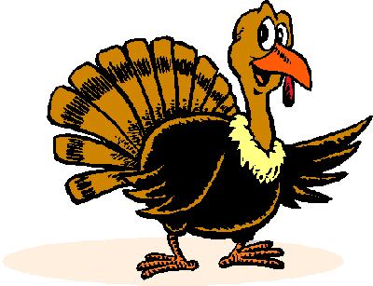

**†**

God’s ways are not our ways and His thoughts are not our thoughts.

During good times and bad times, from trials and tragedies to victory and rejoicing, God is always with us working all things for good and His glory.

**Possible Foods of the**

**1621 Thanksgiving**

VEGETABLES: small quantity of peas, squashes (including pumpkins), beans.

NUTS: walnuts, chestnuts, acorns, hickory nuts, ground nuts.

DRINKS: beer (the primary drinking beverage for everyone), possibly grape wine, hard liquor similar to whiskey or brandy, and springhead water.

OTHER: maple syrup, honey, butter, Holland cheese, and eggs.

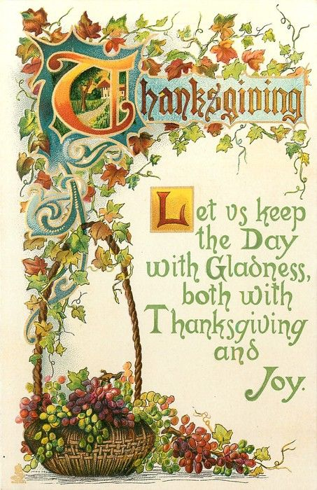

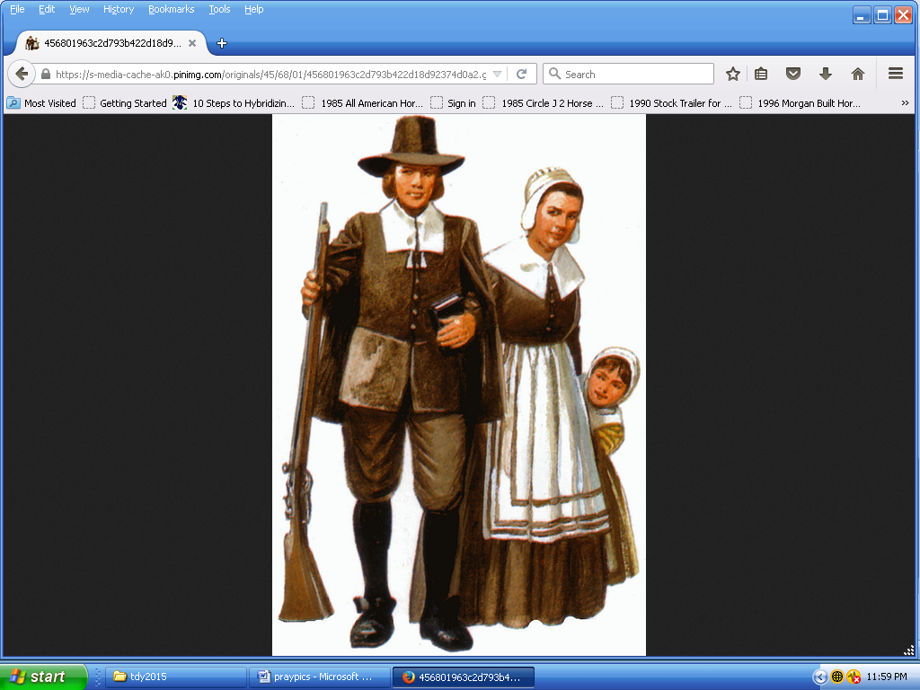

One of the clothing styles used by the Pilgrims/Puritans/Separatists of the early 1600s.

**Who were the Pilgrims?**

**GOD PROVIDES FOR SURVIVAL**

Besides ransacking the Indian food stores, colonists also raided houses of the few Indians who had survived the plagues. More assistance came from Samoset and Tisquantum, known as Squanto, an Indian sent by Wampanoag Chief Massasoit, as an ambassador. Squanto had been kidnapped in 1614 by an English slave raider and sold in Malaga, Spain. Having learned English, he escaped slavery and returned home in 1619.

Teaching the colonists how to farm corn, where to catch fish, and how to make necessary items, he was instrumental in the survival of the settlement. Squanto and another guide in 1621, Hobbamock, helped the colonists set up trading posts for furs to pay off the debt of establishing the colony.

**Possible Foods of the**

**1621 Thanksgiving**

FISH: cod, bass, herring, shad, bluefish, eel.

SEAFOOD: clams, lobsters, mussels, & a small sum of oysters

BIRDS: turkey, goose, duck, partridge.

MEAT: venison (deer)

GRAIN: small quantity of wheat flour (from England), Indian corn and corn meal, barley

FRUITS: raspberries, blueberries, plums, strawberries, grapes, cherries, gooseberries. (dried, as none would be in season).

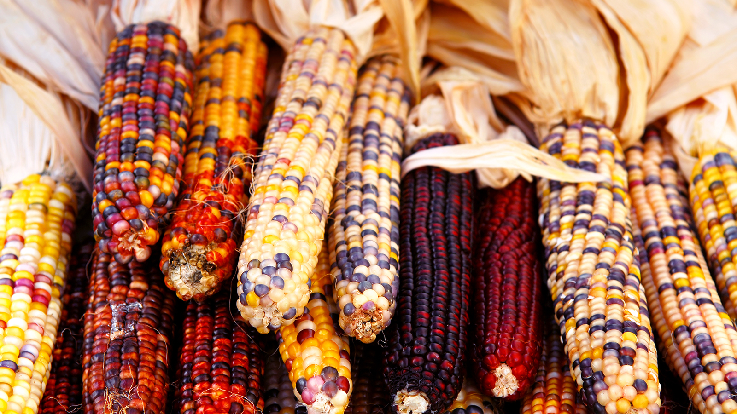

**Yellow**

Yellow is the color of corn, one of the most popular symbols for Thanksgiving because the first Thanksgiving feast celebrated the Pilgrims’ first corn harvest. The Native Americans taught the Pilgrims how to grow corn to survive the brutal winters. Corn comes in a variety of colors: yellow, orange, red, white, blue, even brown. Thanks to God for all of the sights and colors for this and every season.

Those Separatists moved to the town of Leiden in Holland for many years.

The Separatists chose to leave Holland since there was some difficulty finding work, their way of religion was possibly going extinct and promise for them in the New World discovered 128 years earlier was great.

**Orange**

Pumpkins are a very popular staple at Thanksgiving dinners. Whether as pumpkin soup or pumpkin pie, orange adorns almost every Thanksgiving table. The pumpkin is an important symbol of the harvest festival. Native American Indians used pumpkins as a staple in their diets. The Pilgrims might have invented pumpkin pie.

**Red**

**Very much a Thanksgiving color, red is for cranberries, one of many fruits native to North America. Native Americans ate cranberries, believing they had medicinal value and were used for sweetening meat. Pilgrims added maple sugar to them to create cranberry sauce.**

**Thanksgiving Symbols**

**CORNUCOPIA**  
The cornucopia (**horn of plenty)** - a symbol of harvest, abundance and nourishment, usually a horn-shaped container overflowing with produce, dating to the ancient Greeks that represents the Thanksgiving holiday

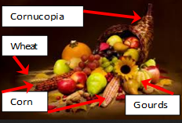

After these explorations, two plagues afflicted coastal New England in 1614 and 1617. Likely transmitted from British and French fishermen to natives on the shore, it killed between 90 and 95% of the local Wampanoag people. The near disappearance of the tribe from the site left their cornfields and other cleared areas for the soon-to-arrive Pilgrims to occupy and meant that the Indians were in no condition to resist the arrival of the colonists.

**Who were the Pilgrims?**

**COMING TO A NEW WORLD AND NEW HARDSHIPS**

The Separatists wanted to start a colony in the north of Virginia Colony at the mouth of the Hudson River.

The group wanted to worship freely in the Americas.

The would-be colonists joined with a group of investors creating a joint stock company.

**Who were the Pilgrims?**

**PRE-COLONIAL ERA**

Prior to the arrival of the Pilgrims, Plymouth was a village of about 2,000 Wampanoag Indians called Pawtuxet. In 1605, Samuel de Champlain sailed to Plymouth Harbor, calling it Port St. Louis. Captain John Smith, a leader of the colony at Jamestown, Virginia, explored parts of Cape Cod Bay; he is credited with naming the region "New Plimouth."