Review article
Ultrasonic and Sonochemical Pathways in Additive Manufacturing: Principles, Process Integration, Research Status, Challenges and Future Perspectives
No: 2501984 Name: Zhang Hanwen(Postgraduates of Mechanical Engineering, 2025)
Course: Principles and Applications of Additive Manufacturing Technology
Highlights
• Ultrasound controls transient states in metal, polymer and bio-AM.
• Acoustic streaming can refine grains without cavitation in laser AM.
• Radiation forces enable programmable particle and fiber architectures.
• Ultrasonic monitoring links soft-material printing to digital twins.
• Standardized acoustic reporting is essential for industrial scale-up.
Graphical abstract
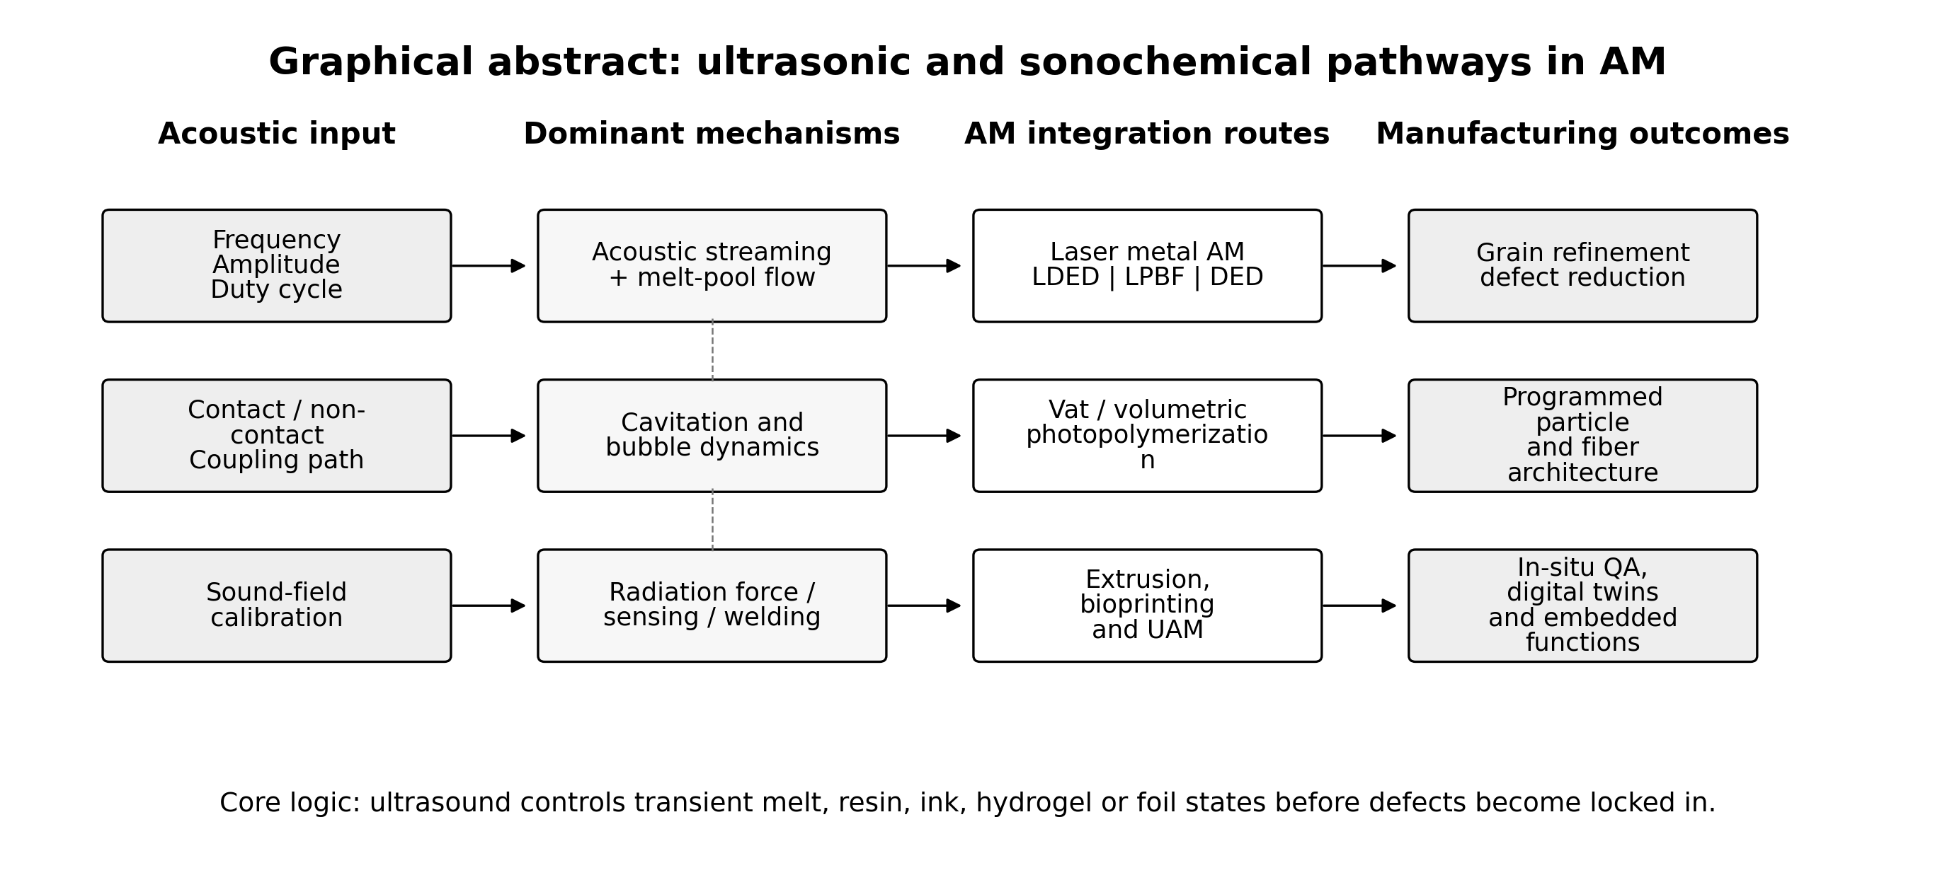
Graphical abstract. Schematic summary of the review scope and mechanism-to-application logic of ultrasound-enabled AM. The figure is an original redraw prepared for this review.
Abstract
Ultrasound-enabled additive manufacturing (AM) integrates acoustic energy with layer-wise material deposition, melting, curing, bonding or monitoring. Unlike conventional parameter optimization, ultrasound acts directly on transient material states, including melt pools, photo-curable resins, particle-loaded inks, soft hydrogels and metal foil interfaces. This review summarizes the principles, equipment configurations, typical AM processes and recent research status of ultrasound-assisted AM, with emphasis on studies reported from 2024 to 2026. The main acoustic mechanisms include acoustic streaming, cavitation and bubble dynamics, acoustic radiation force, ultrasonic interfacial welding, and pulse-echo or shear-wave sensing. Recent work shows that non-contact low-intensity ultrasound can refine grains in laser AM through acoustic streaming, acoustic fields can program fiber and particle architectures in vat photopolymerization, and ultrasound imaging can monitor hydrogel printing with subwavelength resolution. However, the field is still limited by non-transferable acoustic parameters, uncertain local sound fields, possible over-input defects, and the lack of standardized qualification routes. Future progress will depend on calibrated acoustic reporting, multi-physics modelling, closed-loop control, process-specific safety windows and integration with digital twins. Ultrasound is therefore not a universal replacement for thermal or material optimization, but a complementary field-based tool for improving microstructure, architecture and in-situ quality assurance in advanced AM.
Keywords
Additive manufacturing; Ultrasound; Sonochemistry; Acoustic streaming; Cavitation; Acoustic radiation force; In-situ monitoring
Abbreviations
AM, additive manufacturing; DED, directed energy deposition; DIW, direct ink writing; FFF, fused filament fabrication; LDED, laser-directed energy deposition; LPBF, laser powder bed fusion; NDE, nondestructive evaluation; PBF-LB/M, laser-based powder bed fusion of metals; QA, quality assurance; SLA, stereolithography; UAM, ultrasonic additive manufacturing.
1. Introduction
Additive manufacturing (AM) creates three-dimensional parts by selectively depositing, curing, bonding or consolidating material according to a digital model. Its primary advantage is not simply geometric freedom, but the ability to couple geometry, material distribution and functional architecture in a single manufacturing workflow. However, this freedom is obtained through highly localized and transient processing conditions. In metallic AM, a small melt pool solidifies under steep thermal gradients and high cooling rates. In polymer and composite AM, flow, curing, particle migration and interlayer diffusion occur within a narrow time window. In bioprinting, the printed structure must retain shape while preserving cell viability and biochemical functionality.
From a first-principles perspective, the central challenge of AM is the contradiction between localized rapid fabrication and global material reliability. The process must create shape quickly, while also controlling grain morphology, porosity, residual stress, interfacial bonding, filler architecture and hidden defects. Conventional strategies mainly adjust heat-source power, scanning path, feed rate, hatch spacing, layer thickness, resin chemistry or post-processing. These strategies are necessary, but they do not always provide a direct way to manipulate the material state before defects and microstructures become locked in.
Ultrasound offers a complementary route because acoustic waves can inject momentum and pressure into melts, resins, inks, hydrogels and solid interfaces. In sonochemistry, acoustic cavitation and related bubble dynamics are often emphasized. In AM, however, the relevant acoustic mechanisms are broader: acoustic streaming, acoustic radiation force, interfacial friction, shear-wave propagation and ultrasonic imaging can all contribute. Therefore, ultrasound-enabled AM should be understood as a family of hybrid manufacturing methods rather than a single process.
This review focuses on ultrasonic and sonochemical pathways in AM. It first summarizes AM principles, equipment and typical processes, then explains the acoustic mechanisms that are most relevant to AM. The research status is reviewed across metal AM, vat and volumetric photopolymerization, material extrusion, bioprinting, ultrasonic additive manufacturing and in-situ monitoring. Finally, the key limitations and future application prospects are critically discussed. The review is written in the style of an Elsevier review manuscript for Ultrasonics Sonochemistry, while still satisfying the course requirement that the paper introduce AM principles, equipment and representative processes.
2. Search strategy and review scope
This paper is a narrative review rather than a statistical meta-analysis. The available literature on ultrasound-enabled AM is heterogeneous in materials, acoustic coupling modes, process parameters and performance indicators. A strict meta-analysis would therefore mix non-comparable metrics such as grain size, relative density, tensile strength, elastic modulus, fiber orientation rate, imaging resolution and cell viability. Instead, this review uses a mechanism-based synthesis: each study is interpreted according to the transient material state that ultrasound acts upon and the AM process in which the effect occurs.
Priority was given to English-language journal papers published from 2024 to 2026 in high-impact or technically relevant journals, including Nature Communications, Science, Advanced Materials, Additive Manufacturing, Communications Engineering, Communications Materials, Materials Science and Engineering: A, Journal of Manufacturing Processes, Ultrasonics and related manufacturing journals. Earlier works were used only when needed to define AM categories, ultrasonic additive manufacturing, acoustic cavitation or process-monitoring concepts.
Many published figures are protected by publisher copyright. For this reason, the figures in this manuscript are original schematics, mechanism maps or redrawn summary charts prepared from the information reported in the cited literature. This approach preserves the scientific meaning while reducing copyright and academic integrity risks for a course submission.
3. Additive manufacturing fundamentals: principles, equipment and typical processes
3.1. Basic principle of AM
The basic workflow of AM includes digital model construction, slicing, toolpath generation, material delivery, layer-wise consolidation, post-processing and inspection. Depending on the process, consolidation may occur through melting, sintering, photopolymerization, extrusion, jetting, binder deposition or solid-state welding. The essential principle is that the final geometry is obtained by adding material only where needed, while process parameters determine the thermal, mechanical and chemical history of each local volume element.
The ISO/ASTM process families commonly include vat photopolymerization, material extrusion, powder bed fusion, directed energy deposition, binder jetting, material jetting and sheet lamination. Ultrasound can be integrated with several of these families. It may be an auxiliary field used to improve melt-pool flow, align particles, enhance interlayer bonding or monitor the printed part. In ultrasonic additive manufacturing, ultrasound is not auxiliary but the primary bonding energy for metal foil lamination.
3.2. Equipment elements for ultrasound-enabled AM
Table 1. Typical AM processes and ultrasound integration modes.
AM process family | Typical equipment | Ultrasound integration | Main purpose
Laser directed energy deposition (LDED) | Laser head, powder or wire feeder, shielding gas, motion stage | Contact or non-contact transducer near the melt pool | Grain refinement, melt-pool flow modulation, defect reduction
Laser powder bed fusion (LPBF/PBF-LB/M) | Laser scanner, powder bed, recoater, build plate | Vibrating build plate, acoustic actuator or dual-exposure strategy | Reduce anisotropy, alter solidification and improve density
Vat photopolymerization and volumetric printing | Resin vat, DLP/SLA projector, rotating vat or build platform | Standing acoustic waves, PZT array or ultrasonic monitoring probe | Particle/fiber alignment and curing-state monitoring
Material extrusion / FFF / DIW | Heated nozzle or syringe, motion stage, filament or ink feed | Ultrasonic nozzle, vibrating platform or local sonotrode | Improve flow, reduce clogging and enhance interlayer bonding
Bioprinting and soft-material printing | Bioink nozzle, support bath, crosslinking module | Ultrasonic imaging, shear-wave elastography or focused ultrasound | Nondestructive monitoring, elasticity mapping and in vivo printing
Ultrasonic additive manufacturing (UAM) | Rolling sonotrode, metal foils, normal-force system and CNC machining | Ultrasound is the primary bonding energy | Solid-state lamination, embedded sensors and multi-material structures
Typical ultrasound-enabled AM equipment contains both a conventional AM subsystem and an acoustic subsystem. The AM subsystem may include a laser source, scanning optics, powder feeder, recoater, resin vat, DLP projector, extruder, syringe, rolling sonotrode or robotic motion stage. The acoustic subsystem may include a piezoelectric transducer, horn, sonotrode, acoustic lens, phased array, pulse-echo probe, coupling medium, impedance-matching layer and power amplifier. In practical equipment design, the acoustic field must be synchronized with toolpath, deposition time, curing time or monitoring frequency.
The most important equipment-level question is not the nominal ultrasonic power, but the local acoustic state at the material. Acoustic amplitude, pressure, frequency, duty cycle, beam angle, coupling path, attenuation, reflection and resonance all determine whether the process is dominated by streaming, cavitation, radiation force, interfacial welding or sensing. Therefore, equipment descriptions should report calibrated acoustic quantities rather than only transducer power.
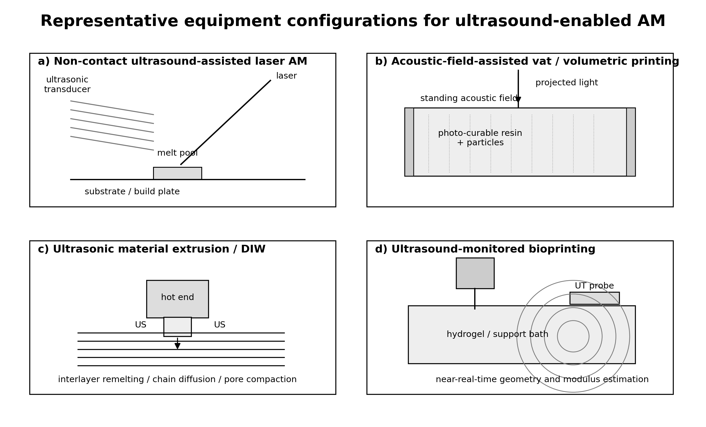
Fig. 1. Representative equipment configurations for ultrasound-enabled AM. The figure is an original schematic redrawn from recent studies on laser AM, vat photopolymerization, extrusion and bioprinting.
4. Ultrasonic and sonochemical mechanisms relevant to AM
4.1. Acoustic streaming and melt-pool flow
Acoustic streaming is a steady flow generated by acoustic attenuation and momentum transfer. In laser-based metal AM, acoustic streaming can modify melt-pool convection before solidification. This mechanism is important because AM melt pools are small and short-lived. Even a modest acoustic flow may influence solute redistribution, dendrite fragmentation, pore motion and the columnar-to-equiaxed transition. Recent non-contact ultrasound-assisted laser AM demonstrates that grain refinement can occur below the cavitation threshold, suggesting that acoustic streaming and Marangoni flow can jointly create high-frequency melt-pool shaking.
The advantage of a streaming-dominated regime is stability. Cavitation can be powerful but difficult to control in reactive, high-temperature and rapidly moving melt pools. Low-intensity non-contact ultrasound may therefore offer a safer route for large-area grain refinement, provided that the sound field is calibrated and the acoustic source can track the melt pool.
4.2. Cavitation and bubble dynamics
Cavitation refers to bubble nucleation, oscillation and collapse under an acoustic pressure field. In sonochemistry, cavitation is responsible for extreme local pressure and temperature events. In metal AM, cavitation may fragment dendrites, assist heterogeneous nucleation and promote pore migration. However, cavitation is not automatically beneficial. Uncontrolled cavitation can introduce new voids, destabilize the melt pool or create rough surfaces. For biomedical or cell-laden materials, excessive cavitation may also damage cells and bioactive molecules.
The key issue is therefore dose control. Cavitation should be treated as a controllable process window rather than a binary switch. Useful reporting should include acoustic pressure, frequency, duty cycle, coupling geometry, melt-pool temperature and evidence of whether cavitation actually occurred.
4.3. Acoustic radiation force and filler architecture
Acoustic radiation force arises when particles, fibers, droplets or cells experience a net force in an acoustic field due to acoustic-property mismatch with the surrounding medium. This mechanism is central to vat photopolymerization and volumetric printing of composites. Before the resin is cured, acoustic fields can align or pattern suspended fillers. After curing, the induced architecture becomes fixed inside the printed part.
This mechanism is attractive because many composite properties depend more strongly on spatial arrangement and orientation than on filler volume fraction alone. Acoustic fields can potentially produce programmable reinforcement paths, anisotropic conductivity, gradient stiffness or locally patterned biological structures without requiring the fillers to be magnetic or electrically conductive.
4.4. Ultrasonic interfacial welding and chain mobility
In material extrusion, ultrasonic vibration can improve the thermal and mechanical state of the extruded filament or deposited layer. Potential effects include lower apparent viscosity, reduced nozzle clogging, local remelting, enhanced polymer-chain diffusion and pore compaction. In UAM, the mechanism is different: metal foils are bonded by normal force and high-frequency scrubbing motion. Oxide layers are disrupted, asperities plastically deform and metallic bonding occurs below the melting point. This makes UAM particularly useful for temperature-sensitive multi-material laminates and embedded sensors.
4.5. Ultrasonic sensing and digital twins
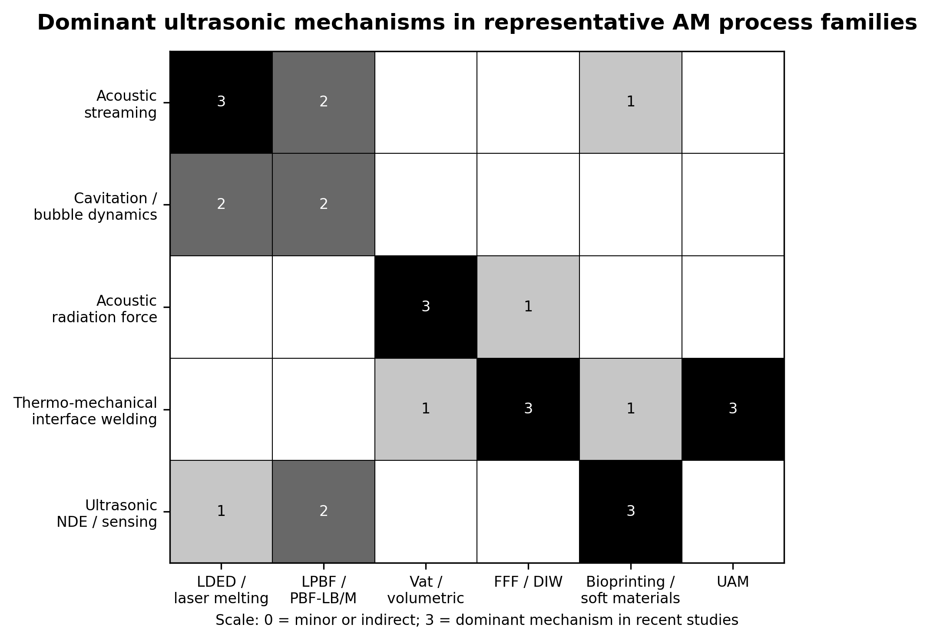
Fig. 2. Dominant ultrasonic mechanisms across representative AM process families. The values indicate qualitative dominance levels summarized from the literature reviewed in this paper.
Ultrasound can also serve as a measurement technology. Pulse-echo, resonance and shear-wave methods can probe buried interfaces and soft materials that are difficult to evaluate optically. This is particularly relevant for hydrogel printing, polymer AM and multilayer structures, where internal bonding, modulus and layer geometry may change during or immediately after deposition. When ultrasonic data are linked with process parameters and acceptance criteria, they can support digital twins and closed-loop quality assurance.
5. Research status across AM process families
5.1. Laser-based metal AM: LDED, LPBF and laser melting
Laser-based metal AM is one of the most active areas for ultrasound integration. Ultrasonic vibration-assisted LDED of high-strength AlMgScZr alloy has shown that ultrasound can alter the thermal and flow field of the melt pool, reduce defects and improve the strength-ductility balance [4]. High-speed synchrotron X-ray imaging has further revealed how ultrasonic melt processing modifies melt-pool dynamics and pore migration, providing direct experimental evidence for physical mechanisms that had previously been inferred mainly from ex-situ microstructures [2].
A major recent advance is the non-contact low-intensity ultrasound-assisted laser AM method reported by Han et al. [1]. The study challenges the assumption that cavitation is required for ultrasonic grain refinement. It shows that acoustic streaming below the melt cavitation threshold can still induce fine equiaxed grains, largely because streaming and Marangoni forces generate high-frequency melt flow that can fatigue and fracture dendrites. This result is important for industrial AM because non-contact ultrasound can maintain a more consistent sound input during layer-by-layer deposition than conventional contact-transmission modes.
LPBF is more difficult to integrate with ultrasound because the powder bed is sensitive to mechanical disturbance. Recent acoustically assisted LPBF research has demonstrated feasible equipment integration for AlSi10Mg and has examined powder behavior and part properties [6]. Dual-exposure ultrasonic assistance in PBF-LB/M has also been explored to improve isotropy and mechanical performance [5]. However, LPBF remains a high-risk integration target because the same vibration that improves consolidation may disturb powder spreading, surface roughness or dimensional accuracy.
5.2. Vat photopolymerization and volumetric composite printing
Vat photopolymerization is a natural platform for acoustic-field-assisted architecture control. In a liquid resin, particles and fibers can be moved by acoustic radiation forces before the structure is fixed by optical curing. SonoPrint demonstrated acoustically assisted volumetric 3D printing of composites, showing that standing acoustic fields can pattern particles during rapid volumetric curing [8]. Ultrasound-assisted stereolithography of glass-fiber-reinforced polymers further demonstrated hierarchical fiber alignment and property enhancement, including a reported orientation rate up to 93.44% within the target angular range [9].
The significance of these studies lies in the shift from printing geometry to printing internal architecture. Conventional AM can produce complex external shapes, but composite performance often requires directional reinforcement at the microscale. Acoustic field design provides a path to integrate local material architecture with macroscopic geometry. The main challenges are resin viscosity, filler sedimentation, acoustic attenuation, curing kinetics and the need to synchronize field exposure with light exposure.
5.3. Acoustic levitation and contactless in-situ printing
Acoustic levitation represents a more radical equipment concept. Instead of supporting material with a build platform, a phased acoustic field can trap, transport and assemble small volumes of material in air. Recent work on omnidirectional and multi-material in-situ 3D printing using acoustic levitation shows that contactless material handling can reduce substrate constraints and cross-contamination [11]. This concept is attractive for printing on complex surfaces or in restricted spaces. Its present limitations include payload size, field stability, resolution, curing synchronization and equipment complexity.
5.4. Material extrusion, DIW and particle-loaded polymers
Material extrusion and DIW are economically important because of their low cost and broad material compatibility. Their main weaknesses are incomplete interlayer bonding, anisotropy, nozzle clogging and limited filler loading. Ultrasonic-assisted printing of PLA/akermanite nanocomposite scaffolds shows that ultrasound can reduce clogging at high ceramic loading and improve mechanical properties [12]. For polymer and composite extrusion, ultrasound may influence both flow and interfacial diffusion. However, the mechanism is strongly material-dependent because polymer viscosity, glass-transition temperature, filler concentration and nozzle geometry all affect acoustic coupling.
5.5. Bioprinting, hydrogels and in vivo sound printing
Bioprinting is a promising but demanding application area. Ultrasound is valuable because it can both monitor and trigger processes in soft and water-rich materials. Real-time in-situ ultrasound monitoring of soft hydrogel 3D printing has shown that pulse-echo analysis can reveal layer formation, interlayer bonding, transient elastic response, surface roughness, nozzle-product contact and post-crosslinking behavior with subwavelength depth resolution [13]. Suspended bioprinting with in-situ elasticity monitoring uses shear-wave phase velocity to assess scaffold elasticity during fabrication [14].
The most ambitious recent direction is imaging-guided deep-tissue in vivo sound printing [15]. In this approach, focused ultrasound releases crosslinking agents from ultrasound-responsive carriers to induce local gelation inside tissue, while ultrasound imaging guides targeting and monitoring. This expands AM from external fabrication toward minimally invasive in-situ construction. The risk profile is also much higher: acoustic intensity, temperature rise, cavitation dose, immune response, biomaterial degradation and long-term safety must be controlled.
5.6. Ultrasonic additive manufacturing and embedded functions
Table 2. Representative recent studies and confidence assessment.
Ref. | Process/material | Ultrasound role | Main finding | Confidence
[1] | Laser AM, Inconel 718 and 316L | Non-contact low-intensity ultrasound | Grain refinement through acoustic streaming below cavitation threshold | High
[2] | Al6061 melt processing relevant to laser AM | 20.2 kHz ultrasonic source with X-ray imaging | Direct observation of melt-pool dynamics and pore migration | High
[4] | AlMgScZr by UV-LDED | Ultrasonic vibration during deposition | Reduced defects and improved strength-ductility balance | High
[6] | LPBF AlSi10Mg | Acoustically assisted LPBF platform | System integration and part-property evaluation | Medium
[8] | Volumetric composite printing | Standing acoustic fields | Particle patterning combined with rapid volumetric curing | High
[9] | Glass-fiber-reinforced polymer SLA | Acoustic radiation force | Fiber orientation and tensile-property enhancement | High
[13] | Hydrogel bioprinting | Pulse-echo ultrasonic monitoring | Subwavelength monitoring of geometry and mechanics | High
[15] | In vivo sound printing | Focused ultrasound and imaging | Deep-tissue in-situ biomaterial fabrication | High
[21,22] | UAM metal laminates | Solid-state ultrasonic bonding | Interface modelling and embedded sensor integration | Medium-high
UAM is a solid-state sheet-lamination process in which metal foils are bonded using ultrasonic vibration and normal pressure. Because the process occurs below the melting point, it is suitable for multi-material laminates and embedded sensors. Recent work on embedded fiber Bragg grating sensors and interface-strength modelling shows that UAM remains important not only as a manufacturing process but also as an integration route for structural health monitoring [21,22]. Compared with laser AM, UAM avoids solidification defects, but it has its own limitations in geometry complexity, interfacial qualification and process-specific material compatibility.
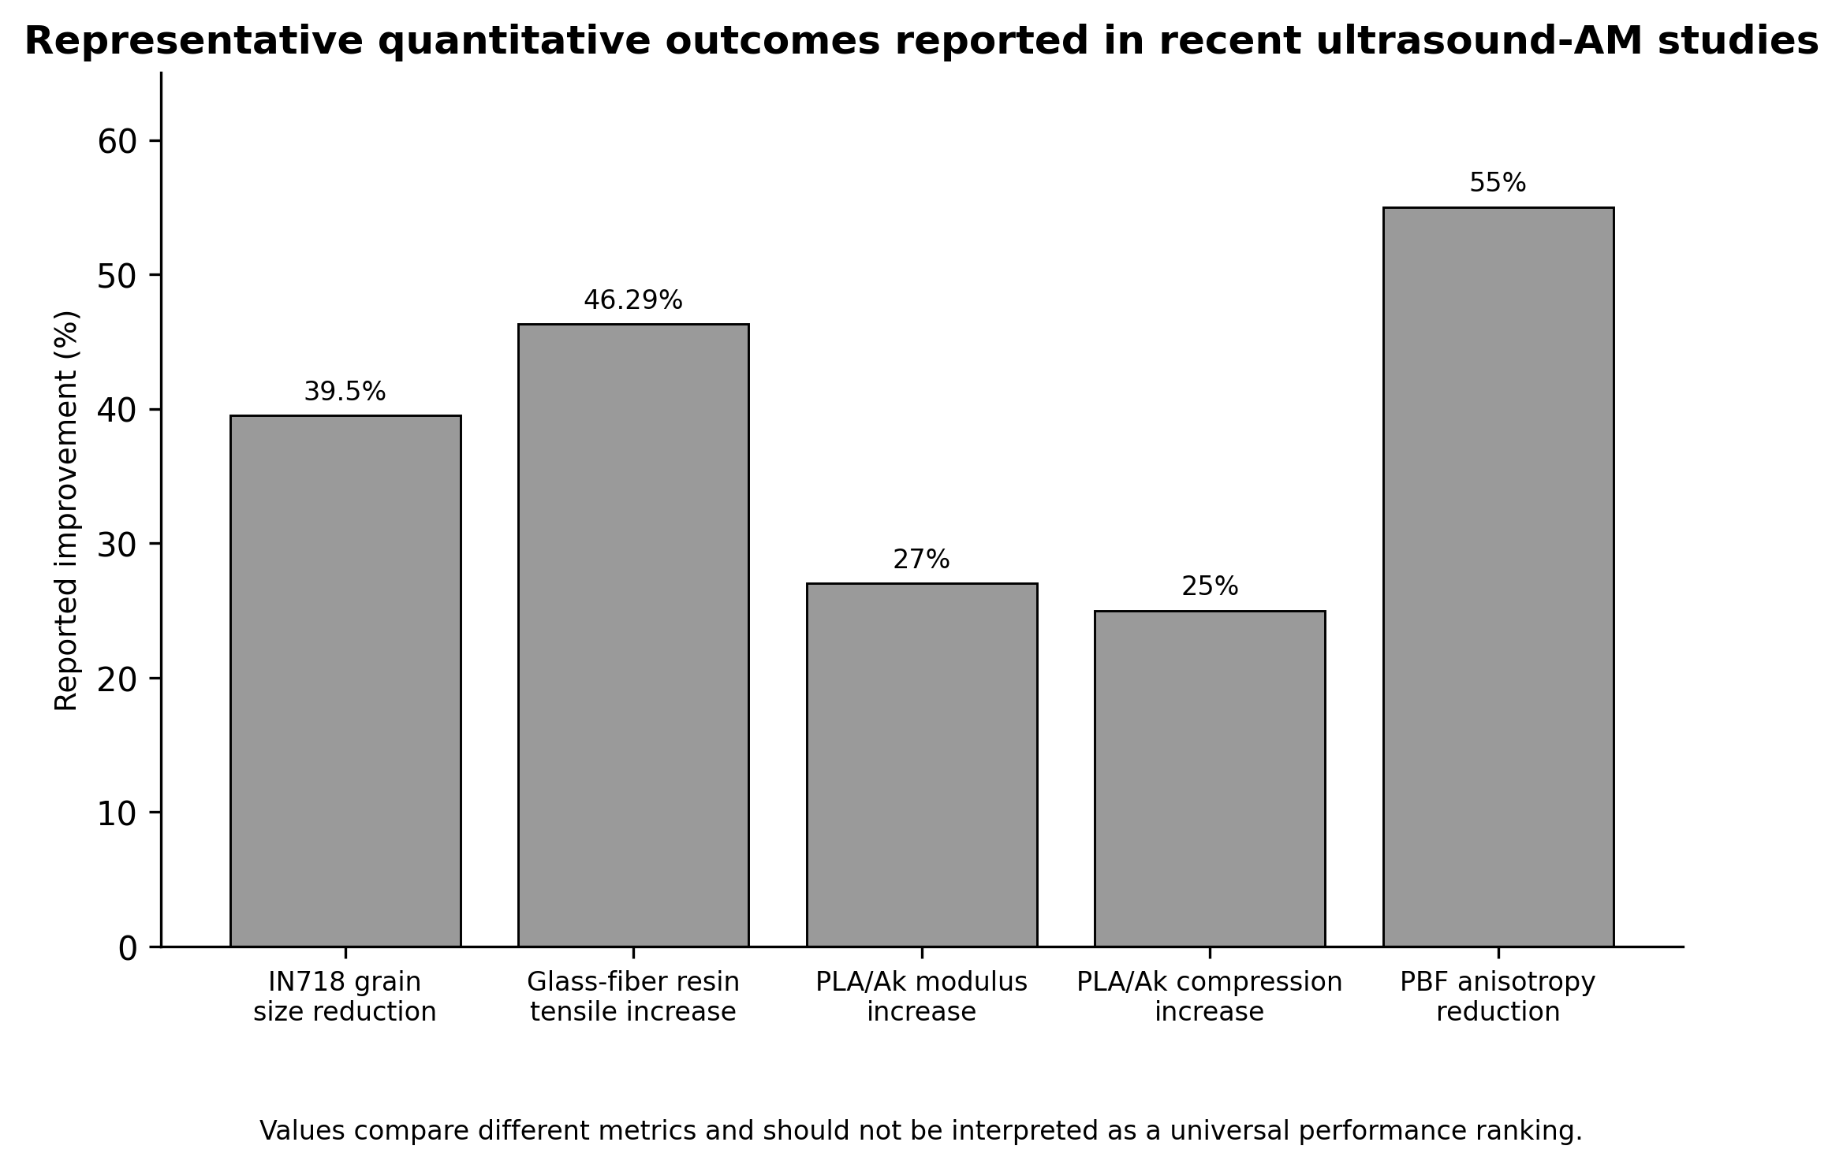
Fig. 3. Representative quantitative outcomes reported in recent ultrasound-AM studies. Because the metrics differ across studies, the values should be interpreted as process-specific evidence rather than a universal ranking.
6. Advantages, limitations and risks
6.1. Advantages
The main advantage of ultrasound-enabled AM is that it acts on transient material states. In metal AM, ultrasound can influence the melt pool before solidification fixes the microstructure. In vat photopolymerization, acoustic fields can organize suspended fillers before optical curing. In extrusion, vibration can modify flow and interlayer contact during deposition. In soft-material printing, ultrasound can monitor or activate crosslinking without direct optical access. These advantages make ultrasound a field-based complement to heat-source control, material formulation and post-processing.
Another advantage is multi-functionality. The same physical platform may potentially be used for processing, architecture control and nondestructive monitoring. For example, a transducer can deliver acoustic energy for filler patterning, while a probe can monitor layer geometry or modulus. In future equipment, ultrasound may become part of closed-loop AM rather than a standalone add-on.
6.2. Limitations and risks
The most serious limitation is poor transferability of acoustic parameters. Reporting only frequency and electrical power is insufficient because local sound pressure and displacement depend on coupling geometry, temperature, attenuation, impedance mismatch and boundary conditions. Two systems with the same nominal power may produce very different acoustic fields at the material. This makes reproducibility difficult and slows industrial qualification.
A second limitation is the risk of over-input. Excessive acoustic energy may create pores, disturb a powder bed, roughen a surface, damage cells or destabilize a curing front. Therefore, ultrasound should not be presented as universally beneficial. It is beneficial only when the local acoustic field is matched to the material state and process objective.
A third limitation is modelling complexity. Ultrasound-enabled AM couples thermal transport, acoustic propagation, fluid flow, bubble dynamics, phase transformation, solidification, curing kinetics and mechanical deformation. Many current models simplify these fields separately. Predictive process design will require coupled simulations validated by in-situ measurements.
Table 3. Key problems, root causes and mitigation strategies.
Problem | Root cause | Potential solution | Expected impact
Non-transferable acoustic parameters | Nominal frequency and power do not define the local sound field | Report calibrated sound pressure, displacement amplitude, coupling geometry and uncertainty | Improved reproducibility
Over-input defects | Excessive cavitation, roughness or cell damage | Develop process-specific acoustic safety windows and feedback control | Better quality-stability trade-off
Weak multi-physics models | Thermal, acoustic, fluid and phase fields are often separated | Couple CFD, solidification, acoustic propagation and materials kinetics | Predictive process design
Limited in-situ qualification | Ultrasonic data are not always linked to acceptance criteria | Build digital twins with uncertainty quantification and probability of detection | Industrial certification
Copyright risk in review figures | Direct reproduction of publisher figures may require permission | Use original redraws or obtain permission for third-party images | Lower academic and legal risk
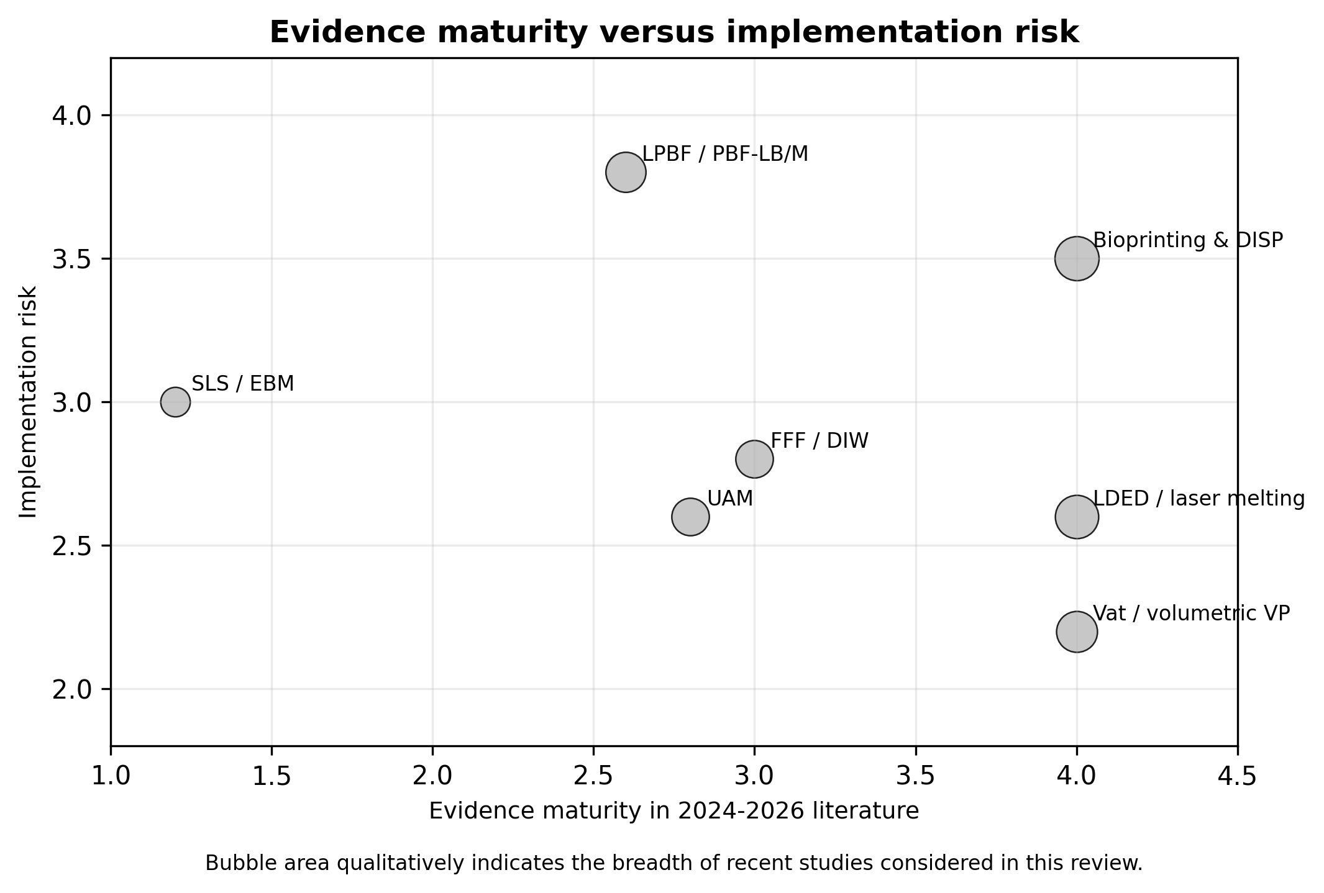
Fig. 4. Qualitative assessment of evidence maturity and implementation risk for representative ultrasound-enabled AM process families.
7. Future perspectives and application prospects
7.1. Calibrated acoustic reporting and standardization
Future studies should move beyond nominal equipment parameters. At minimum, reports should include frequency, waveform, duty cycle, transducer type, coupling path, measured displacement amplitude or sound pressure, estimated attenuation, material temperature and evidence for the dominant mechanism. For metal AM, whether the process is below or above the cavitation threshold should be explicitly discussed. For biological AM, acoustic exposure should be linked to cell viability and thermal safety.
7.2. Multi-physics modelling and closed-loop control
A promising direction is the integration of acoustic modelling with melt-pool simulation, curing kinetics and process monitoring. Digital twins can use ultrasonic signals, thermal images, machine parameters and material models to infer hidden states such as porosity, interlayer bonding or modulus. However, the digital twin must include uncertainty. A monitoring signal is useful for qualification only when it can be tied to a probability of detection or a clear acceptance threshold.
7.3. Process-specific industrial applications
In aerospace and energy components, ultrasound-assisted metal AM may improve grain control, reduce anisotropy and enhance fatigue reliability. In composite AM, acoustic fields can create fiber or particle architectures that are difficult to obtain by nozzle path planning alone. In biomedical AM, ultrasound may enable non-invasive monitoring, localized crosslinking and deep-tissue fabrication. In electronics and sensing, UAM can embed sensors and create multi-material laminates without high-temperature damage.
7.4. Realistic development path
The near-term application path is likely to differ by process family. Ultrasonic monitoring of soft and polymer AM has a relatively clear qualification value because it provides information that optical methods cannot easily obtain. Vat photopolymerization with acoustic filler alignment is also promising for functional composites. Metal AM with non-contact ultrasound is scientifically strong but requires robust industrial equipment integration. Acoustic levitation and in vivo sound printing are highly innovative, but their broad manufacturing adoption will require substantial work on scale, reliability and safety.
8. Conclusions
Ultrasound-enabled AM is an emerging family of hybrid processes that uses acoustic energy to control or monitor transient material states during fabrication. Recent studies demonstrate credible progress in laser-based metal AM, acoustic-field-assisted photopolymerization, material extrusion, bioprinting, UAM and ultrasonic monitoring. The most important conceptual shift is that ultrasound should not be reduced to cavitation alone. Acoustic streaming, radiation force, interfacial welding and sensing may be equally or more important depending on the material state and process objective.
The field also faces clear barriers. Acoustic parameters are often difficult to reproduce, local sound fields are not sufficiently reported, and excessive energy input can create new defects. Industrial adoption will require calibrated acoustic measurements, process-specific safe windows, standardized reporting, validated multi-physics models and closed-loop control. With these conditions met, ultrasound can become a practical tool for improving microstructure, filler architecture, interfacial bonding and in-situ quality assurance in next-generation AM.
Declaration of competing interest
The author declares that there are no known competing financial interests or personal relationships that could have appeared to influence the work reported in this review.
CRediT authorship contribution statement
Zhang Hanwen: Conceptualization, Investigation, Writing - original draft, Visualization, Writing - review and editing.
Data availability
No new experimental data were generated in this review. The review is based on published literature cited in the reference list.
Acknowledgements
The author thanks the instructor and course materials of Principles and Applications of Additive Manufacturing Technology for providing the topic framework.
References
[1] J. Han, S. Wang, W. Ge, H. Chen, Y. Sun, Y. Ai, W. Yuan, S. Ruan, W. Niu, H. Yang, S. Yin, W. Yan, X. Lin, Non-contact ultrasound to assist laser additive manufacturing, Nat. Commun. 16 (2025) 7613. https://doi.org/10.1038/s41467-025-62803-w.
[2] L. Mutswatiwa, L. Katch, N.J. Kizer, J.A. Todd, T. Sun, S.J. Clark, S. Fezzaa, J.S. Lum, D.M. Stobbe, G. Jones, K.C. Meinert, A.P. Argüelles, C.M. Kube, High-speed synchrotron X-ray imaging of melt pool dynamics during ultrasonic melt processing of Al6061, Commun. Mater. 5 (2024) 143. https://doi.org/10.1038/s43246-024-00614-2.
[3] S.L. Lomaev, D.R. Fattalova, G.A. Gordeev, M.A. Timirgazin, M.D. Krivilyov, Quantitative efficiency of optoacoustic ultrasonic treatment in SLM, DED, and LBW applications, Sci. Rep. 15 (2025) 1887. https://doi.org/10.1038/s41598-025-85487-0.
[4] C. Ma, W. Ren, H. Xu, L. Xu, Y. Han, L. Zhao, K. Hao, Ultrasonic vibration-assisted laser-directed energy deposition of high-strength AlMgScZr alloy: Microstructural transformation and strength enhancement, Mater. Sci. Eng. A 923 (2025) 147676. https://doi.org/10.1016/j.msea.2024.147676.
[5] S. Platt, J. Wegner, A. Elspaß, H. Schönrath, S. Kleszczynski, Enhancing mechanical properties and isotropy in ultrasonic assisted powder bed fusion of metals using a laser beam (PBF-LB/M) via Dual Exposure, J. Adv. Join. Process. 11 (2025) 100307. https://doi.org/10.1016/j.jajp.2025.100307.
[6] O. Maurer, D. Bähre, Acoustically assisted additive manufacturing by laser powder-bed fusion of AlSi10Mg, J. Manuf. Process. 156 (2025) 509-524. https://doi.org/10.1016/j.jmapro.2025.10.098.
[7] G. Wang, J. Li, H. Zhao, S. Chen, Effects of ultrasonic vibration combined with heat treatments on microstructure and high-temperature mechanical properties of Inconel 939 fabricated by laser-directed energy deposition, J. Mater. Res. Technol. 39 (2025) 6458-6468. https://doi.org/10.1016/j.jmrt.2025.11.049.
[8] P. Agrawal, S. Zhuang, S. Dreher, S. Mitter, D. Ahmed, SonoPrint: Acoustically assisted volumetric 3D printing for composites, Adv. Mater. 36 (2024) 2408374. https://doi.org/10.1002/adma.202408374.
[9] L. Guo, T. Yu, J. Yao, Y. Ma, M. Chen, Ultrasound-assisted 3D printing of glass fiber-reinforced polymers: Hierarchical fiber alignment and property enhancement, Addit. Manuf. 110 (2025) 104940. https://doi.org/10.1016/j.addma.2025.104940.
[10] D. Le, R. Hou, B. Raeymaekers, Ultrasound-assisted vat photopolymerization of polymer composites with programmable filler architecture using a rotating build plate and multi-step curing strategy, Compos. Part A Appl. Sci. Manuf. 204 (2026) 109621. https://doi.org/10.1016/j.compositesa.2026.109621.
[11] H. Chen, S. Bansal, D.M. Plasencia, L. Di-Silvio, J. Huang, S. Subramanian, R. Hirayama, Omnidirectional and multi-material in situ 3D printing using acoustic levitation, Adv. Mater. Technol. 10 (2025) 2401792. https://doi.org/10.1002/admt.202401792.
[12] M. Khodaei, H. Razavi, H. Nosrati, Effects of ultrasonic vibration on 3D printing of polylactic acid/akermanite nanocomposite scaffolds, Heliyon 10 (2024) e39240. https://doi.org/10.1016/j.heliyon.2024.e39240.
[13] T. Yang, Y. Jin, L.M. Smith, N.B. Dahotre, A. Neogi, Real-time in-situ ultrasound monitoring of soft hydrogel 3D printing with subwavelength resolution, Commun. Eng. 3 (2024) 162. https://doi.org/10.1038/s44172-024-00318-w.
[14] G. Kim, D. Oh, D. Kim, G. Lee, S.H. Park, C. Yoon, S.Y. Nam, Suspended bioprinting with in-situ elasticity monitoring using the assessment of shear wave phase velocity, Addit. Manuf. 99 (2025) 104667. https://doi.org/10.1016/j.addma.2025.104667.
[15] E. Davoodi, J. Li, X. Ma, A.H. Najafabadi, J. Yoo, G. Lu, E.S. Sani, S. Lee, H. Montazerian, G. Kim, J. Williams, J.W. Yang, Y. Zeng, L.S. Li, Z. Jin, B. Sadri, S.S. Nia, L.V. Wang, T.K. Hsiai, P.S. Weiss, Q. Zhou, A. Khademhosseini, D. Wu, M.G. Shapiro, W. Gao, Imaging-guided deep tissue in vivo sound printing, Science 388 (2025) 616-623. https://doi.org/10.1126/science.adt0293.
[16] Z. Wu, J. Wang, D. Huang, Y. Cheng, Y. Zhao, Ultrahigh cell density 3D bioprinting by acoustic fluids-mediated stereolithography, Adv. Mater. 38 (2026) e11418. https://doi.org/10.1002/adma.202511418.
[17] S. Jamshididana, A. Bischoff, A. Olarra, B. Holmgren, D.J. Roach, Real-time digital twin of vat-based 3D printing using in-situ ultrasonic monitoring, Virtual Phys. Prototyp. 20 (2025) e2592734. https://doi.org/10.1080/17452759.2025.2592734.
[18] T.F. de Oliveira, A.C.M. Cavalheiro, F. Buiochi, M.S.G. Tsuzuki, J.P. Leão-Neto, G.C. Silva, G.T. Silva, J.H. Lopes, Ultrasonic characterization of 3D-printed polymer objects, Ultrasonics 149 (2025) 107572. https://doi.org/10.1016/j.ultras.2025.107572.
[19] A. Chakrobarty, T. Sultan, C. Cetinkaya, Machine learning-driven ultrasonic monitoring for quality assurance in additive manufacturing employing 2D phononic coupons, J. Manuf. Process. 141 (2025) 416-430. https://doi.org/10.1016/j.jmapro.2025.02.083.
[20] A.O. Keim, P.P. Pandit, L.D. Sotelo, M.S. McClain, Nondestructive evaluation of material properties in polymer additive manufacturing processes: Moving towards process-agnostic qualification, Virtual Phys. Prototyp. 20 (2025) e2569544. https://doi.org/10.1080/17452759.2025.2569544.
[21] M. Ali, L.M. Headings, M.J. Dapino, Analytical model for estimation of interface weld strength in ultrasonic additive manufacturing of similar and dissimilar tempered aluminum alloy 6061, Sci. Technol. Weld. Join. 30 (2025) 97-104. https://doi.org/10.1080/13621718.2024.2432819.
[22] C. Xu, Y. Cheng, Y. Zhou, X. He, H. Li, Z. Niu, Z. Wang, Copper-coated FBG sensor embedded in Cu/Al laminated metal composites via ultrasonic additive manufacturing, Opt. Laser Technol. 194 (2026) 114450. https://doi.org/10.1016/j.optlastec.2025.114450.
[23] B. Wang, J. Du, H. Zhang, Y. Cao, C. Wen, V. Iacovacci, Z. Lyu, T. Li, Q. Wang, External-field-assisted additive manufacturing for micro/nano device fabrication, Int. J. Extrem. Manuf. 8 (2026) 012005. https://doi.org/10.1088/2631-7990/ae098e.
[24] Z. Qu, Z. Zhang, R. Liu, L. Xu, Y. Zhang, X. Li, Z. Zhao, Q. Duan, S. Wang, L. Li, Y. Ma, X. Shao, R. Yang, J. Eckert, R.O. Ritchie, Z. Zhang, High fatigue resistance in a titanium alloy via near-void-free 3D printing, Nature 626 (2024) 999-1004. https://doi.org/10.1038/s41586-024-07048-1.

