

CAPSTONE PROJECT REPORT
Report 3 – Software Requirement Specification

– Ho Chi Minh City, September 2026 –

Table of Contents
I. Record of Changes 3
II. Software Requirement Specification 4
1. Product Overview 4
2. User Requirements 4
2.1 Actors 4
2.2 Use Cases 4
3. Functional Requirements 6
3.1 System Functional Overview 6
3.2 Account and Profile 10
3.3 Job Description Management 11
3.4 Interview Management 13
3.5 Performance Reporting 18
3.6 Subscription & Billing 20
3.7 Admin Account & User Management 22
3.8 Interview & Technical Configuration 25
3.9 System Analytics 29
3.10 Subscription & Revenue Management 30
4. Non-Functional Requirements 31
4.1 External Interfaces 31
4.2 Quality Attributes 32
5. Requirement Appendix 32
5.1 Business Rules 32
5.2 Common Requirements 33
5.3 Application Messages List 34

I. Record of Changes
Date | A*  M, D | In charge | Change Description
18/09/2026 (planning assumption) | A | Project Team | Completed SRS baseline using the submitted Capstone Project Register, Specification, Implementation Plan, and current PostgreSQL schema.
*A - Added M - Modified D - Deleted

II. Software Requirement Specification

1. Product Overview
The proposed product is a web-based technical interview simulation platform for students and software developers preparing for internships or employment opportunities. A Candidate provides, uploads, or pastes a Job Description (JD); the system extracts relevant technical requirements for the Candidate to review and edit. The selected JD is then used as context for a personalized technical interview. The interview uses voice interaction with a 3D virtual interviewer whose speaking and lip-sync are synchronized. After the session, the system provides an AI-generated performance report. The platform also includes an Admin role for governance, configuration, analytics, and subscription/revenue management defined in the submitted Capstone Project Register.
The high-level context consists of Candidate and Admin users interacting with the web platform. The platform may exchange information with AI, speech, and payment services because these capability categories are included in the submitted registration. The detailed context diagram, interfaces, data flows, and provider decisions are out of scope for this baseline.

2. User Requirements

2.1 Actors
The registered system actors for this initial SRS baseline are Candidate and Admin.
# | Actor | Description
1 | Candidate | A registered user who prepares for a target technical role by managing a profile and JD, configuring and joining a virtual interview, reviewing history and performance reports, and managing subscription, credits, billing, and payments.
2 | Admin | A privileged user who manages Candidate accounts, interview sessions, technical domains, interview configuration, avatar/voice availability, analytics, subscriptions, transactions, and revenue information.

2.2 Use Cases
High-level use cases are derived solely from the submitted Capstone Project Register. Detailed flows, preconditions, validation, and exceptions are out of scope for this baseline.

2.2.1 Diagram(s)
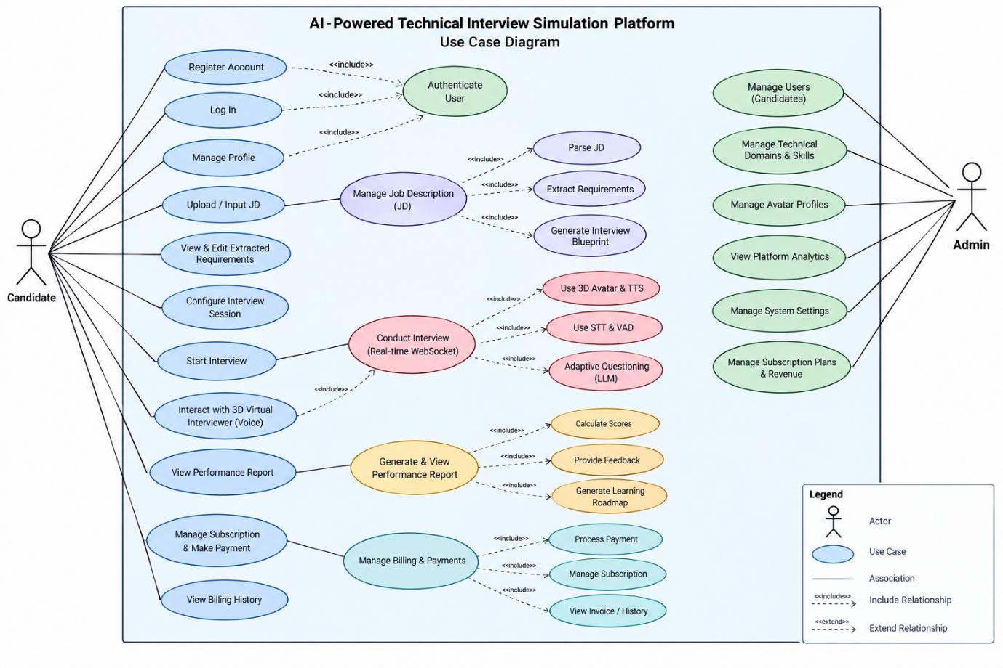

2.2.2 Descriptions
The following use-case list is intentionally high-level for the Week-3 baseline.
ID | Use Case | Actors | Use Case Description
UC-C01 | Register and Authenticate Account | Candidate | Register, log in, and log out of the platform.
UC-C02 | Manage Profile | Candidate | View and update personal profile information and account credentials.
UC-C03 | Manage Job Description | Candidate | Upload, paste, or input a Job Description for interview preparation.
UC-C04 | Review Extracted Requirements | Candidate | Review and edit technical skills, technologies, and domain knowledge extracted from a Job Description.
UC-C05 | Configure Interview | Candidate | Select an analyzed Job Description and configure interview difficulty, duration, and number of questions.
UC-C06 | Participate in AI Virtual Interview | Candidate | Join a one-to-one JD-driven technical interview with voice interaction, adaptive questions, and a 3D virtual interviewer.
UC-C07 | View Interview History | Candidate | View prior interview sessions, dates, status, target JD, and overall score.
UC-C08 | View Performance Report | Candidate | Review overall and technical-domain scores, question-level feedback, strengths, weaknesses, and recommendations.
UC-C09 | Manage Subscription and Credits | Candidate | View the current subscription plan and remaining interview credits.
UC-C10 | Manage Billing and Payment | Candidate | Upgrade a plan or purchase additional interview credits through a payment gateway and view billing/transaction history.
UC-A01 | Manage Candidate Accounts | Admin | View Candidate accounts and lock or unlock accounts when necessary.
UC-A02 | Manage Interview Sessions | Admin | View, filter, and inspect interview sessions and their status.
UC-A03 | Manage Technical Domains | Admin | Manage technical domains and technologies used as interview context.
UC-A04 | Configure Interviews and AI Behaviour | Admin | Configure interview difficulty, duration, evaluation criteria, behaviour guidelines, and evaluation settings.
UC-A05 | Manage Avatar and Voice Profiles | Admin | Manage available 3D virtual interviewer avatars and supported voice profiles.
UC-A06 | View System Analytics | Admin | View interview statistics, performance information, and commonly identified technical weaknesses.
UC-A07 | Manage Subscription and Revenue | Admin | Manage pricing plans or credit packages, transactions, payment status, and revenue reports.

3. Functional Requirements

3.1 System Functional Overview
The system is organized around Candidate and Admin functional areas. Candidate functionality covers account/profile management, JD analysis and review, interview configuration, AI virtual interviewing, history and performance reporting, and subscription/credit/billing/payment management. Admin functionality covers Candidate accounts, interview sessions, technical domains, interview and AI configuration, avatar/voice profiles, system analytics, and subscription/revenue management.

Screens Flow
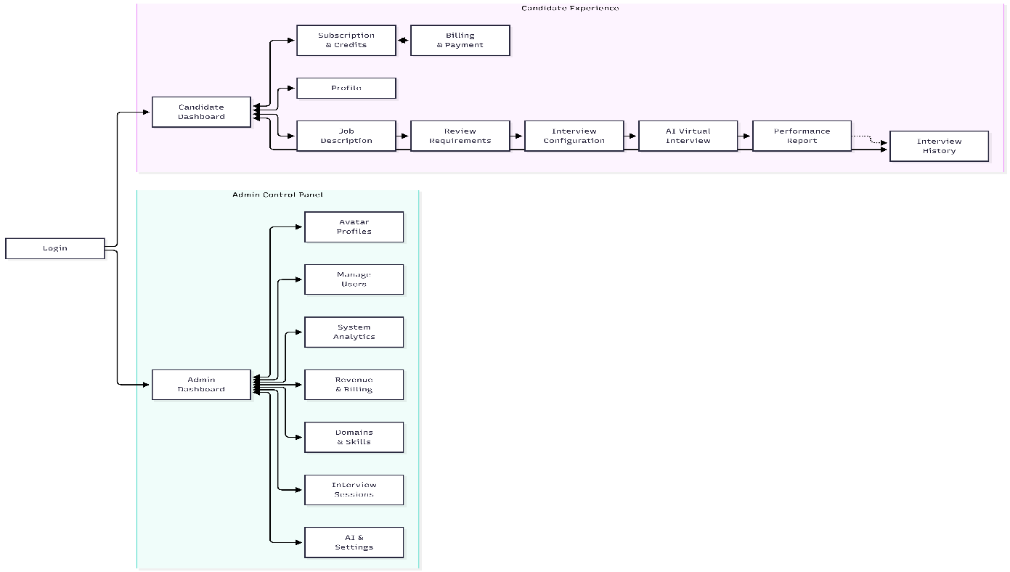

3.1.2 Screen Descriptions
# | Feature | Screen | Description
1 | Authentication | Login | Allows users to authenticate and access the platform according to their role.
2 | Account & Profile | Candidate Dashboard | Main Candidate screen providing navigation to Candidate functions.
3 | Profile Management | Profile | Allows the Candidate to view and manage personal account/profile information.
4 | Job Description Management | Job Description | Allows the Candidate to upload, paste, or input a Job Description.
5 | Job Description Management | Review Extracted Requirements | Allows the Candidate to review and edit technical skills, technologies, and domain knowledge extracted from the Job Description.
6 | Interview Management | Interview Configuration | Allows the Candidate to select a Job Description and configure interview difficulty, duration, and number of questions.
7 | Interview Management | AI Virtual Interview | Provides the Candidate's technical interview with voice interaction and a 3D virtual interviewer.
8 | Interview Management | Interview History | Allows the Candidate to view previous interview sessions, including session information, status, date, and overall score.
9 | Performance Reporting | Performance Report | Displays the Candidate's interview evaluation, including scores, feedback, strengths, weaknesses, and recommendations.
10 | Subscription & Billing | Subscription & Credits | Allows the Candidate to view their subscription plan and remaining interview credits.
11 | Subscription & Billing | Billing & Payment | Allows the Candidate to manage subscription or credit purchases and view billing/payment transaction information.
12 | Admin Management | Admin Dashboard | Main Admin screen providing navigation to administrative functions.
13 | User Management | Manage Users | Allows the Admin to view Candidate accounts and lock or unlock accounts.
14 | Technical Domain Management | Domains & Skills | Allows the Admin to manage technical domains and skills/technologies used as interview context.
15 | Avatar & Voice Management | Avatar Profiles | Allows the Admin to manage available 3D virtual interviewer avatar profiles and associated voice/configuration information.
16 | Interview Management | Interview Sessions | Allows the Admin to view, filter, and inspect interview sessions and their statuses.
17 | Interview & AI Configuration | Interview & AI Configuration | Allows the Admin to configure interview difficulty, duration, evaluation criteria, behaviour guidelines, and AI evaluation settings.
18 | System Analytics | System Analytics | Allows the Admin to view interview statistics, performance information, and commonly identified technical weaknesses.
19 | Subscription & Revenue | Subscription & Revenue | Allows the Admin to manage subscription/credit packages, transactions, payment status, and revenue information.

3.1.3 Screen Authorization
The authorization matrix below records high-level functional access. Detailed screen and action authorization is out of scope for this baseline.
Functional Area | Candidate | Admin
Account and Profile | Own account/profile | Manage Candidate accounts
Job Description Management | Own Job Descriptions | —
Interview Management | Configure and join own interviews | View/manage interview sessions
Performance Reporting | View own history/results and performance reports | —
Interview & AI Configuration | — | Configure interview behaviour and evaluation settings
Technical Domain & Skill Management | — | Manage technical domains and skills
Avatar & Voice Management | — | Manage avatar and voice profiles
System Analytics | — | View system analytics
Subscription & Billing | View/manage own subscription, credits, billing, and transactions | —
Subscription & Revenue Management | — | Manage plans, transactions, payment status, and revenue reports

3.1.4 Non-Screen Functions
The following non-screen functions are stated only at capability level. Interfaces, providers, processing rules, and data structures are not specified in the supplied requirements.
# | Feature | System Function | Description
1 | Job Description Management | AI Requirement Extraction | Extract technical skills, technologies, and domain knowledge from Job Description content for Candidate review.
2 | Interview Management | Adaptive Questioning | Generate personalized and contextual follow-up questions based on JD requirements and prior answers.
3 | Interview Management | Speech Recognition and Speech Synthesis | Support voice communication between Candidate and virtual interviewer.
4 | Interview Management | Synchronized Speaking and Lip-Sync | Synchronize the virtual interviewer’s speaking animation with synthesized speech.
5 | Performance Reporting | AI Evaluation | Assess technical accuracy, depth of understanding, problem-solving ability, answer relevance, and communication clarity against JD requirements and generate performance feedback.
6 | Billing and Payment | Payment Processing | Support payment-gateway processing for subscriptions or additional interview credits and billing/transaction history.

3.1.5 Entity Relationship Diagram
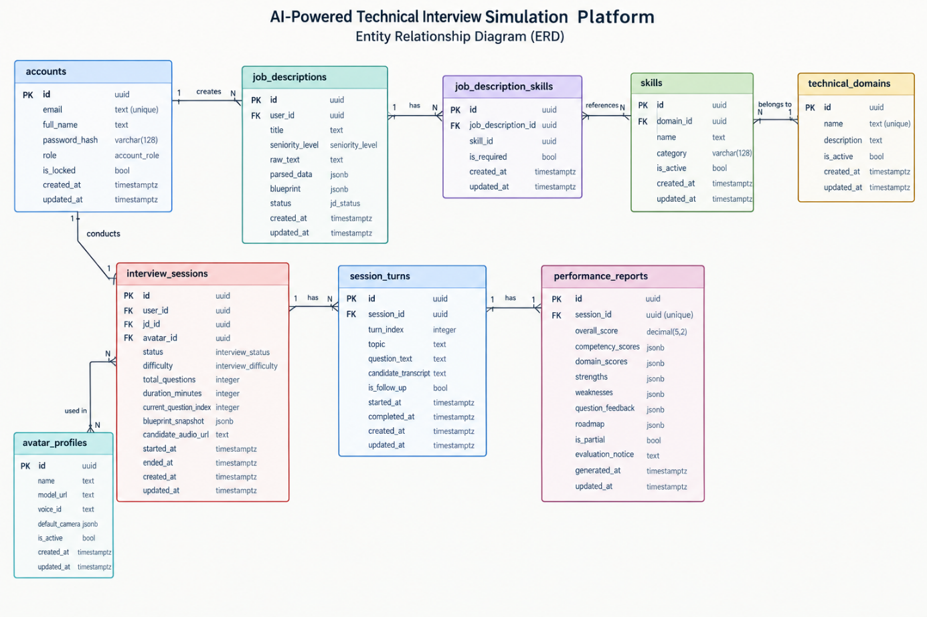

# | Entity | Description
1 | accounts | Stores Candidate/Admin accounts, credentials, role, lock status, and timestamps.
2 | technical_domains | Stores technical domains and active status.
3 | skills | Stores skills/technologies associated with a technical domain.
4 | job_descriptions | Stores Candidate JDs, seniority level, raw text, parsed data, blueprint, status, and timestamps.
5 | job_description_skills | Associates Job Descriptions with skills and records whether each skill is required.
6 | avatar_profiles | Stores 3D interviewer avatar profiles, model URL, voice ID, default camera configuration, and active status.
7 | interview_sessions | Stores Candidate sessions, selected JD/avatar, status, difficulty, question progress, blueprint snapshot, audio URL, and timestamps.
8 | session_turns | Stores interview turns, questions, Candidate transcripts, follow-up status, turn order, and timestamps.
9 | performance_reports | Stores one report per interview session, including overall/domain scores, competency scores, strengths, weaknesses, question feedback, roadmap, partial status, and evaluation notice.

3.2 Account and Profile

3.2.1 Login
Function Trigger: The function is triggered when a user opens the Login screen and submits their account credentials.
Function Description: The Login screen allows Candidate and Admin users to authenticate and access functions according to their role. The system validates the provided credentials and determines the user's authorization level. Protected functions require authentication, and role-based authorization distinguishes Candidate and Admin users.
Screen Layout:
The screen contains:
• Email input
• Password input
• Login button
• Validation/error message area
Function Details:
Normal case:
1. User enters email and password.
2. User submits the Login form.
3. System validates the credentials.
4. System authenticates the account.
5. System identifies the user's role.
6. User is redirected to the appropriate Dashboard.
Abnormal cases:
• Invalid credentials → display an authentication error.
• Locked account → prevent access.
• Unauthenticated user attempts to access a protected function → require authentication.

3.2.2 Profile
Function Trigger: The Candidate navigates from the Candidate Dashboard to the Profile screen.
Function Description: The Profile screen allows the Candidate to view and update personal profile information and account credentials.
Screen Layout:
The screen contains:
• Account information
• Profile information
• Editable fields
• Save/Update button
• Validation/error messages
Function Details:
Normal case:
1. Candidate opens Profile.
2. System retrieves the Candidate's account information.
3. Candidate edits permitted information.
4. Candidate submits the changes.
5. System validates and saves the updated information.
Abnormal cases:
• Invalid input → display validation message.
• Save operation fails → display an appropriate error message.
• Unauthorized access → deny access.

3.3 Job Description Management

3.3.1 Job Description
Function Trigger: The Candidate selects Job Description from the Candidate Dashboard.
Function Description: The function allows the Candidate to upload, paste, or input a Job Description used for interview preparation. The system processes the submitted content and extracts technical skills, technologies, and domain knowledge for later review.
Screen Layout:
The screen contains:
• JD text input/paste area
• File upload area
• Upload/Analyze button
• Processing/progress indicator
• Error message area
Function Details:
Normal case:
1. Candidate uploads or enters JD content.
2. System receives and processes the content.
3. AI Requirement Extraction extracts relevant requirements.
4. System stores the JD and extracted information.
5. Candidate proceeds to requirement review.
Abnormal cases:
• Invalid/corrupted JD input → display an appropriate error.
• JD analysis failure → display an error and allow retry.
• AI processing is still running → display a loading/progress indication.

3.3.2 Review Extracted Requirements
Function Trigger: The function is triggered after JD analysis has produced extracted requirements.
Function Description: The Candidate reviews and edits technical skills, technologies, domain knowledge, seniority, and related extracted requirements before starting an interview. The Candidate can add or remove extracted skills.
Screen Layout:
The screen contains:
• Extracted technical domains
• Extracted skills
• Skill add/remove controls
• Seniority information
• Blueprint preview
• Confirm/Proceed button
Function Details:
Normal case:
1. System displays extracted requirements.
2. Candidate reviews the information.
3. Candidate adds or removes requirements if necessary.
4. Candidate confirms the requirements.
5. System saves the customized JD information.
Abnormal cases:
• AI extraction fails → display retry option.
• Required information is missing → prevent confirmation until valid information is provided.
• Save operation fails → display an error.

3.3.3 AI Requirement Extraction
Function Trigger: Triggered when the Candidate submits a new Job Description for analysis.
Function Description: The system extracts technical skills, technologies, domain categories, and seniority-related information from the supplied Job Description so that the Candidate can review the extracted requirements.
Screen Layout:
No independent screen. The function operates as part of the Job Description and Review Extracted Requirements screens.
Function Details:
Normal case:
1. System receives JD content.
2. System processes the content.
3. AI extracts relevant requirements.
4. System produces structured extracted information.
5. Extracted information is presented to the Candidate for review.
Abnormal cases:
• Invalid/insufficient input → analysis fails with an appropriate validation message.
• AI response cannot be processed → retry or report analysis failure.
• Processing takes time → show progress/loading state.

3.4 Interview Management

3.4.1 Interview Configuration
Function Trigger: The Candidate selects an analyzed Job Description and navigates to Interview Configuration.
Function Description: The Candidate configures the interview before starting it. Configuration includes interview difficulty, duration, number of questions, and the selected Job Description. The resulting interview is based on the requirements of the selected JD.
Screen Layout:
The screen contains:
• Selected Job Description
• Difficulty selection
• Duration setting
• Number of questions
• Avatar selection
• Start Interview button
Function Details:
Normal case:
1. Candidate selects an analyzed JD.
2. Candidate selects interview difficulty.
3. Candidate specifies interview duration and question count.
4. Candidate confirms configuration.
5. System creates the interview session.
6. Candidate proceeds to the AI Virtual Interview.
Abnormal cases:
• No valid JD selected → prevent interview start.
• Invalid configuration → display validation message.
• Session creation fails → display an error.

3.4.2 AI Virtual Interview
Function Trigger: Triggered when the Candidate starts a configured interview session.
Function Description: The Candidate participates in a one-to-one technical interview with the AI virtual interviewer. The system provides voice communication, synthesized interviewer speech, a 3D virtual interviewer, and adaptive questions based on the selected JD and previous answers.
Screen Layout:
The screen contains:
• 3D virtual interviewer
• Interview status
• Question counter
• Timer
• Candidate microphone controls
• Live transcript
• Finish Speaking control
• End Interview control
Function Details:
Normal case:
1. Candidate enters the interview room.
2. System initializes the interview session.
3. Virtual interviewer presents the question.
4. Candidate answers using voice.
5. System processes the Candidate's speech.
6. Candidate's response is transcribed.
7. AI evaluates the response for interview progression.
8. System generates either a follow-up question or the next planned question.
9. Process continues until the interview is completed or terminated.
Abnormal cases:
• Microphone permission denied → display microphone guidance.
• Temporary network interruption → attempt reconnection.
• WebGL/avatar failure → use the defined degraded 2D audio mode.
• Candidate ends the interview early → terminate the session and generate partial evaluation.
• Unrecoverable error → terminate the session appropriately.

3.4.3 Adaptive Questioning
Function Trigger: Triggered after the Candidate finishes answering a question during an active interview.
Function Description: The system evaluates the Candidate's response and determines whether to generate a contextual follow-up question or advance to the next planned interview topic.
Screen Layout:
No independent screen. The function operates within the AI Virtual Interview screen.
Function Details:
Normal case:
1. Candidate finishes speaking.
2. System transcribes the response.
3. AI evaluates the response.
4. If the answer requires further exploration, the system generates a follow-up.
5. Otherwise, the system advances to the next blueprint topic.
6. The next question is delivered through the virtual interviewer.
Abnormal cases:
• AI service timeout → use the configured fallback question.
• Candidate remains silent → display a silence warning.
• No remaining blueprint topics → complete the interview.

3.4.4 Speech Recognition and Speech Synthesis
Function Trigger: Triggered during voice interaction in an active interview session.
Function Description: Speech Recognition converts Candidate audio into transcript text. Speech Synthesis converts interviewer question text into audio for the Candidate.
Screen Layout:
No independent screen. The function operates within the AI Virtual Interview screen.
Function Details:
Normal case:
1. Candidate speaks into the microphone.
2. System captures the audio.
3. Speech Recognition processes the audio.
4. Candidate transcript is produced.
5. System generates interviewer response/question.
6. Speech Synthesis produces interviewer audio.
7. Audio is played in the interview room.
Abnormal cases:
• Microphone unavailable → display microphone error.
• Speech service temporarily fails → display appropriate error.
• External service rate limit/failure → use available fallback behavior.

3.4.5 Synchronized Speaking and Lip-Sync
Function Trigger: Triggered when synthesized interviewer speech is played.
Function Description: The function synchronizes the virtual interviewer's speaking animation with synthesized speech using speech/viseme timing information.
Screen Layout:
No independent screen. The function operates within the AI Virtual Interview screen.
Function Details:
Normal case:
1. System receives synthesized interviewer audio.
2. System receives corresponding viseme information.
3. Audio playback starts.
4. Avatar mouth animation follows the provided viseme timing.
5. Animation returns to a neutral state when speech ends.
Abnormal cases:
• Missing viseme information → use the available fallback mouth animation.
• Avatar/WebGL failure → switch to degraded presentation mode.

3.4.6 Interview History
Function Trigger: The Candidate selects Interview History from the Candidate Dashboard.
Function Description: The function allows Candidates to view previous interview sessions, including the target JD, interview date, status, and overall score, and revisit completed performance reports.
Screen Layout:
The screen contains:
• Interview session list
• Target JD
• Interview date
• Status
• Overall score
• View Report action
Function Details:
Normal case:
1. Candidate opens Interview History.
2. System retrieves the Candidate's sessions.
3. System displays the sessions.
4. Candidate selects a session.
5. System opens the corresponding result/report when available.
Abnormal cases:
• No previous sessions → display an empty-state message.
• Report is not yet available → display the current evaluation/session status.
• Unauthorized session access → deny access.

3.5 Performance Reporting

3.5.1 Performance Report
Function Trigger: The Candidate opens a completed interview result from Interview History, or is redirected to the report after interview completion.
Function Description: The Performance Report presents the Candidate's interview evaluation, including overall performance, technical-domain scores, competency assessments, question-level feedback, strengths, weaknesses, and personalized recommendations.
Screen Layout:
The screen contains:
• Overall score
• Technical-domain scores
• Competency score information
• Strengths
• Weaknesses
• Question-level feedback
• Improvement roadmap
Function Details:
Normal case:
1. Interview is completed.
2. System evaluates the session.
3. Evaluation results are stored.
4. Candidate opens the Performance Report.
5. System displays the generated evaluation.
Abnormal cases:
• Evaluation still processing → display processing state.
• Report unavailable → display appropriate status/error.
• Early-terminated session → display partial evaluation notice.

3.5.2 AI Evaluation
Function Trigger: Triggered after an interview session is completed or terminated early.
Function Description: The system evaluates the Candidate's interview transcript against the Job Description requirements and produces competency/domain scores and performance feedback.
Screen Layout:
No independent screen. The function operates behind the Performance Report.
Function Details:
Normal case:
1. System collects the interview transcript and JD/blueprint requirements.
2. AI evaluates the interview.
3. System calculates the overall and domain results.
4. System generates strengths, weaknesses, question feedback, and recommendations.
5. System saves the performance report.
6. Candidate can view the result.
Abnormal cases:
• AI evaluation fails → report generation fails and appropriate status/error is displayed.
• Interview was terminated early → generate a partial evaluation with an appropriate notice.
• Report is requested while evaluation is still running → return/display evaluation-in-progress state.

3.6 Subscription & Billing

3.6.1 Subscription & Credits
Function Trigger: The Candidate selects Subscription & Credits from the Candidate Dashboard.
Function Description: The function allows the Candidate to view their current subscription plan and remaining interview credits, and to upgrade a plan or purchase additional interview credits.
Screen Layout:
The screen contains:
• Current subscription plan
• Remaining interview credits
• Available subscription/credit options
• Upgrade/Purchase actions
Function Details:
Normal case:
1. Candidate opens Subscription & Credits.
2. System retrieves the Candidate's current subscription and credit information.
3. System displays the current status.
4. Candidate selects an available upgrade or credit purchase if needed.
5. System proceeds to Billing & Payment.
Abnormal cases:
• Subscription/credit information unavailable → display appropriate error.
• Purchase cannot be completed → display payment-related error.
• External payment service temporarily fails → display an appropriate error message.

3.6.2 Billing & Payment
Function Trigger: Triggered when the Candidate chooses to upgrade a subscription or purchase additional interview credits.
Function Description: The function processes subscription or interview-credit purchases through a payment gateway and provides access to personal billing and transaction history.
Screen Layout:
The screen contains:
• Selected plan/package
• Payment information
• Payment status
• Transaction history
• Payment action
Function Details:
Normal case:
1. Candidate selects a subscription or credit package.
2. System prepares the payment transaction.
3. Candidate completes payment through the payment gateway.
4. System receives the payment result.
5. System updates the relevant billing/credit status.
6. Transaction information becomes available in billing history.
Abnormal cases:
• Payment rejected → display failed-payment status.
• Payment gateway unavailable → display an appropriate error.
• Transaction fails → do not treat the purchase as successfully completed.
• Temporary payment-service failure → display an appropriate error message.

3.7 Admin Account & User Management

3.7.1 Admin Dashboard
Function Trigger: An authenticated Admin navigates to the Admin Dashboard.
Function Description: The Admin Dashboard provides access to administrative functions and displays system-level information such as interview/session metrics, Candidate management, session monitoring, configuration, and system analytics.
Screen Layout:
The screen contains:
• System metrics
• Active/recent session information
• Navigation to administrative functions
Function Details:
Normal case:
1. Admin logs in.
2. System verifies Admin authorization.
3. Admin Dashboard loads.
4. Admin selects the required management function.
Abnormal cases:
• Candidate attempts to access Admin Dashboard → deny access.
• Unauthorized request → return authorization error.

3.7.2 Manage Users
Function Trigger: Admin selects Manage Users from the Admin Dashboard.
Function Description: The function allows the Admin to view Candidate accounts and manage their account lock status.
Screen Layout:
The screen contains:
• Candidate list
• Candidate account information
• Search/filter controls
• Lock/Unlock action
• Confirmation message
Function Details:
Normal case:
1. Admin opens Manage Users.
2. System retrieves Candidate accounts.
3. Admin selects an account.
4. Admin locks or unlocks the account.
5. System updates the account status.
Abnormal cases:
• Non-Admin attempts access → deny access.
• Account update fails → display error.
• Locked account has an active interview session → terminate the active session according to the defined session-management behavior.

3.8 Interview & Technical Configuration

3.8.1 Manage Interview Sessions
Function Trigger: Admin selects Manage Interview Sessions from the Admin Dashboard.
Function Description: The function allows the Admin to view, inspect, and monitor interview sessions, including their status and session information, and provides access to session transcripts and audio playback links.
Screen Layout:
The screen contains:
• Session list
• Candidate
• JD/session information
• Session status
• Session details
• Transcript/session inspection area
Function Details:
Normal case:
1. Admin opens Manage Interview Sessions.
2. System retrieves available sessions.
3. Admin filters or selects a session.
4. System displays session information.
Abnormal cases:
• No matching session → display empty state.
• Session information unavailable → display an error.
• Candidate attempts access → deny access.

3.8.2 Manage Technical Domains & Skills
Function Trigger: Admin selects Technical Domains & Skills from the Admin Dashboard.
Function Description: The function allows the Admin to manage technical domains and associated skills used by the platform for Job Description analysis and interview context.
Screen Layout:
The screen contains:
• Technical domain list
• Skill list
• Add/Edit/Delete controls
• Active/inactive status
Function Details:
Normal case:
1. Admin opens the management screen.
2. System displays technical domains and skills.
3. Admin creates or updates a domain/skill.
4. System validates and saves the change.
Abnormal cases:
• Duplicate domain/skill → reject the operation.
• Invalid data → display validation error.
• Non-Admin access → deny access.

3.8.3 Manage Avatar Profiles
Function Trigger: Admin selects Avatar Profiles from the Admin Dashboard.
Function Description: The function allows the Admin to manage available 3D virtual interviewer avatars and supported interviewer voice profiles.
Screen Layout:
The screen contains:
• Avatar profile list
• Avatar name
• Model information
• Voice information
• Active/inactive status
• Add/Edit controls
Function Details:
Normal case:
1. Admin opens Avatar Profiles.
2. System retrieves available profiles.
3. Admin creates or modifies a profile.
4. System validates and saves the profile.
Abnormal cases:
• Invalid avatar information → reject/save error.
• Avatar cannot be loaded → display an error/status.
• Non-Admin access → deny access.

3.8.4 Interview & AI Configuration
Function Trigger: Admin selects Interview & AI Configuration from the Admin Dashboard.
Function Description: The function allows the Admin to configure interview difficulty levels, duration constraints, evaluation criteria, interview behavior guidelines, and AI interview/evaluation settings.
Screen Layout:
The screen contains:
• Interview difficulty settings
• Duration settings
• Evaluation criteria
• Interview behavior settings
• AI configuration settings
• Save/Update controls
Function Details:
Normal case:
1. Admin opens the configuration screen.
2. System displays current settings.
3. Admin modifies supported settings.
4. System validates the configuration.
5. System saves the updated configuration.
Abnormal cases:
• Invalid configuration → display validation error.
• Save failure → display error.
• Candidate attempts access → deny access.

3.9 System Analytics

3.9.1 System Analytics
Function Trigger: Admin selects System Analytics from the Admin Dashboard.
Function Description: The function provides aggregate platform information, including total, completed, failed, and interrupted interview sessions, interview volume, average Candidate performance, and commonly identified technical weaknesses.
Screen Layout:
The screen contains:
• Total interview sessions
• Completed sessions
• Failed sessions
• Interrupted sessions
• Average Candidate performance
• Technical weakness information
Function Details:
Normal case:
1. Admin opens System Analytics.
2. System retrieves aggregate interview information.
3. System calculates/displays the supported metrics.
4. Admin reviews the results.
Abnormal cases:
• Analytics data unavailable → display an appropriate error.
• No completed interview data → display an appropriate empty state.

3.10 Subscription & Revenue Management

3.10.1 Subscription & Revenue
Function Trigger: Admin selects Subscription & Revenue from the Admin Dashboard.
Function Description: The function allows the Admin to manage pricing plans, subscription tiers or interview-credit packages, view user transaction/payment statuses, and generate revenue reports.

Screen Layout:
The screen contains:
• Subscription/credit packages
• Pricing information
• Transaction information
• Payment status
• Revenue information
• Revenue reporting controls
Function Details:
Normal case:
1. Admin opens Subscription & Revenue.
2. System retrieves available subscription/package information.
3. Admin manages supported plans or credit packages.
4. Admin reviews transactions and payment statuses.
5. Admin views revenue information.
Abnormal cases:
• Transaction data unavailable → display an error.
• Invalid plan/package configuration → display validation error.
• Revenue data unavailable → display appropriate error.
• Candidate attempts access → deny access.

4. Non-Functional Requirements

4.1 External Interfaces
Web interface: Candidate and Admin interact through the web application. AI interface: the platform exchanges JD, interview, and evaluation information with Large Language Model services for requirement extraction, interview generation, adaptive questioning, and answer evaluation. Speech interfaces: Speech-to-Text supports Candidate transcription and Text-to-Speech supports synthesized interviewer speech. 3D interface: the web client renders the virtual interviewer with synchronized speaking/lip-sync behaviour. Payment interface: the platform exchanges payment and transaction information with a payment gateway for subscriptions and additional interview credits. Provider names, API endpoints, and detailed request/response contracts are not specified.

4.2 Quality Attributes
The following quality attributes preserve the non-functional requirements stated in the submitted Capstone Project Register without strengthening their targets.

4.2.1 Usability
The system should provide a simple and consistent web interface suitable for first-time users; clear validation and error messages; clear interview progress, session status, scores, and performance feedback; guidance for microphone and voice-based interview functionality; and responsive support on commonly used desktop and mobile browsers.

4.2.2 Reliability
Interview session data should be saved correctly when an interview is completed. The system should correctly record completed, failed, and interrupted session statuses; associate results with the correct Candidate, Job Description, and interview session; maintain consistency of credits and payment records when a purchase is completed; and display an appropriate error message for temporary failures from external AI, speech, or payment services. Availability, MTBF, MTTR, defect-rate targets, and recovery procedures are to be defined by the Project Team.

4.2.3 Performance
Common operations such as login, profile viewing, interview-history retrieval, and report viewing should respond within about 3 seconds under normal usage. JD analysis and AI evaluation should provide loading or progress indication while processing. The system should support at least 20 concurrent users during normal testing. The interview interface should maintain acceptable responsiveness during voice communication and virtual-interviewer animation.

4.2.4 Security
Protected functions require authentication. The system should enforce role-based access control between Admin and Candidate; store passwords using secure password hashing; use HTTPS for client-server communication; protect against common vulnerabilities such as SQL Injection, XSS, and unauthorized access; and ensure that Candidates access only their own profile, sessions, results, and transaction records.

5. Requirement Appendix
This appendix records only requirements that can be established from the submitted registration. Other business, common, and message requirements are deferred.

5.1 Business Rules
Preliminary rules are drawn directly from the registered scope; detailed rules are:
ID | Rule Definition
BR-01 | Protected functions require authentication, and role-based access control distinguishes Admin and Candidate roles.
BR-02 | A Candidate may access only their own profile, interview sessions, results, and transaction records.
BR-03 | A Candidate may review and edit requirements extracted from a Job Description before starting an interview.
BR-04 | A personalized interview is based on the requirements of the Candidate-selected Job Description.
BR-05 | Interview sessions record statuses including completed, failed, interrupted, and terminated early.
BR-06 | Interview credits and payment records should remain consistent when a purchase is completed.
BR-07 | An interview session retains the blueprint used for that session through blueprint_snapshot.
BR-08 | A performance report is associated with one interview session and contains overall/domain scores and detailed feedback.
BR-09 | A Candidate may configure interview difficulty, duration, and number of questions before starting an interview.
The system shall provide the Candidate and Admin capabilities defined in Sections 2 and 3. Common functional areas include authentication, JD management, interview configuration, real-time AI interviewing, performance reporting, subscription/credits/billing/payment, administration, analytics, and revenue management. Detailed provider-specific contracts are outside the supplied requirements.

5.2 Common Requirements
The following common requirements apply across multiple functional areas. They consolidate cross-cutting requirements stated in Sections 3 and 4, the preliminary business rules in Section 5.1, and the application message contexts in Section 5.3. They remain at baseline requirement level; provider-specific APIs, endpoints, and detailed request/response contracts are outside the supplied scope.
ID | Requirement | Rule Definition
CR-01 | Authentication and role access | Protected functions require authentication, and role-based access control distinguishes Candidate and Admin users.
CR-02 | Resource ownership | A Candidate may access only their own profile, interview sessions, performance results, and transaction records.
CR-03 | Input validation | Candidate and Admin inputs shall be validated before an operation is accepted; invalid input or failed operations shall produce a clear validation or operation error message.
CR-04 | Processing and status feedback | Long-running or stateful operations such as JD analysis, AI evaluation, payment processing, and interview sessions shall expose an appropriate processing or status state to the user.
CR-05 | External-service failure handling | Temporary failures from AI, speech, payment, or network services shall result in the corresponding error, retry, reconnection, or fallback behavior defined by the functional requirements.
CR-06 | Interview session state | Interview sessions shall record supported states including completed, failed, interrupted, and terminated early, and the resulting state shall remain available to the relevant Candidate or Admin according to authorization.
CR-07 | Requirement and result traceability | Interview configuration and results shall remain associated with the correct Candidate, selected Job Description, interview session, and session blueprint; performance reports shall be linked to the corresponding interview session.
CR-08 | Result availability | After interview completion or early termination, the system shall display the resulting session state and make the available performance result accessible; when evaluation is still processing, the system shall indicate that status.
CR-09 | Subscription, payment, and credit consistency | When a purchase is completed, the related credit and payment records shall remain consistent. A failed transaction shall not be treated as a completed purchase.
CR-10 | User-facing guidance and errors | The system shall provide clear validation, authorization, service-failure, interview-connection, payment, and microphone/voice-related guidance appropriate to the affected function.

5.3 Application Messages List
# | Message code | Message Type | Context | Content
MSG-01 | Authentication | Protected function | Unauthenticated access | Display an appropriate authentication-required message.
MSG-02 | Validation | Candidate/Admin input | Invalid input or failed operation | Display a clear validation or operation error message.
MSG-03 | JD Analysis | AI requirement extraction | JD analysis is processing | Display a loading or progress indication.
MSG-04 | AI Service | JD analysis / interview / evaluation | Temporary AI-service failure | Display an appropriate external-service error message.
MSG-05 | Speech Service | Voice interaction | Temporary STT/TTS failure | Display an appropriate speech-service error message.
MSG-06 | Interview Connection | Real-time interview | Temporary network interruption | Display the reconnecting state and resume according to the interview reconnection flow.
MSG-07 | Interview Result | Interview completion / early termination | Session ends | Display the resulting session state and available performance result.
MSG-08 | Payment | Billing and payment | Payment-gateway processing failure | Display an appropriate payment error message.
MSG-09 | Authorization | Candidate/Admin resource access | Unauthorized resource access | Prevent access and display an appropriate authorization error message.

