Lab 3. K-map, Multi-Level, Multi-Output Logic

Results

2017-11405 방승원

6.2

4.2 가의 논리식은 다음과 같다.

이 논리식을 breadboard에 구성한 회로는 그림1과 같다. 각 스위치를 조작하여 확인한 truth table은 표1과 같다.

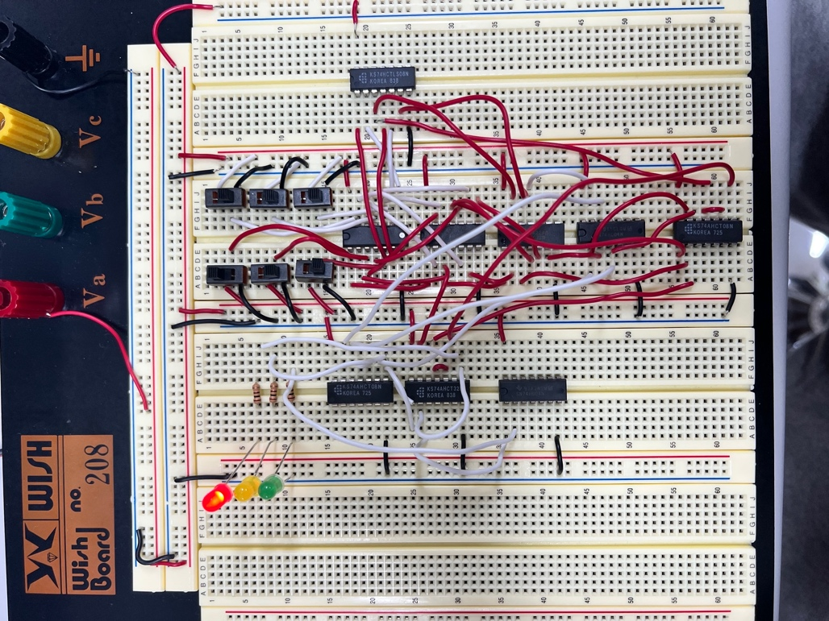

Figure 1. 3-bit Comparator 회로

Table 1. Truth Table for 3-bit Comparator

|  |  |  |  |  |  |  |  |  |
| --- | --- | --- | --- | --- | --- | --- | --- | --- |
| A2 | A1 | A0 | B2 | B1 | B0 | F2 | F1 | F0 |
| 0 | 0 | 0 | 0 | 0 | 0 | 0 | 1 | 0 |
| 0 | 0 | 0 | 0 | 0 | 1 | 1 | 0 | 0 |
| 0 | 0 | 0 | 0 | 1 | 0 | 1 | 0 | 0 |
| 0 | 0 | 0 | 0 | 1 | 1 | 1 | 0 | 0 |
| 0 | 0 | 0 | 1 | 0 | 0 | 1 | 0 | 0 |
| 0 | 0 | 0 | 1 | 0 | 1 | 1 | 0 | 0 |
| 0 | 0 | 0 | 1 | 1 | 0 | 1 | 0 | 0 |
| 0 | 0 | 0 | 1 | 1 | 1 | 1 | 0 | 0 |
| 0 | 0 | 1 | 0 | 0 | 0 | 0 | 0 | 1 |
| 0 | 0 | 1 | 0 | 0 | 1 | 1 | 0 | 0 |
| 0 | 0 | 1 | 0 | 1 | 0 | 1 | 0 | 0 |
| 0 | 0 | 1 | 0 | 1 | 1 | 1 | 0 | 0 |
| 0 | 0 | 1 | 1 | 0 | 0 | 1 | 0 | 0 |
| 0 | 0 | 1 | 1 | 0 | 1 | 1 | 0 | 0 |
| 0 | 0 | 1 | 1 | 1 | 0 | 1 | 0 | 0 |
| 0 | 0 | 1 | 1 | 1 | 1 | 1 | 0 | 0 |
| 0 | 1 | 0 | 0 | 0 | 0 | 0 | 0 | 1 |
| 0 | 1 | 0 | 0 | 0 | 1 | 0 | 0 | 1 |
| 0 | 1 | 0 | 0 | 1 | 0 | 0 | 1 | 0 |
| 0 | 1 | 0 | 0 | 1 | 1 | 1 | 0 | 0 |
| 0 | 1 | 0 | 1 | 0 | 0 | 1 | 0 | 0 |
| 0 | 1 | 0 | 1 | 0 | 1 | 1 | 0 | 0 |
| 0 | 1 | 0 | 1 | 1 | 0 | 1 | 0 | 0 |
| 0 | 1 | 0 | 1 | 1 | 1 | 1 | 0 | 0 |
| 0 | 1 | 1 | 0 | 0 | 0 | 0 | 0 | 1 |
| 0 | 1 | 1 | 0 | 0 | 1 | 0 | 0 | 1 |
| 0 | 1 | 1 | 0 | 1 | 0 | 0 | 0 | 1 |
| 0 | 1 | 1 | 0 | 1 | 1 | 0 | 1 | 0 |
| 0 | 1 | 1 | 1 | 0 | 0 | 1 | 0 | 0 |
| 0 | 1 | 1 | 1 | 0 | 1 | 1 | 0 | 0 |
| 0 | 1 | 1 | 1 | 1 | 0 | 1 | 0 | 0 |
| 0 | 1 | 1 | 1 | 1 | 1 | 1 | 0 | 0 |
| 1 | 0 | 0 | 0 | 0 | 0 | 0 | 0 | 1 |
| 1 | 0 | 0 | 0 | 0 | 1 | 0 | 0 | 1 |
| 1 | 0 | 0 | 0 | 1 | 0 | 0 | 0 | 1 |
| 1 | 0 | 0 | 0 | 1 | 1 | 0 | 0 | 1 |
| 1 | 0 | 0 | 1 | 0 | 0 | 0 | 1 | 0 |
| 1 | 0 | 0 | 1 | 0 | 1 | 1 | 0 | 0 |
| 1 | 0 | 0 | 1 | 1 | 0 | 1 | 0 | 0 |
| 1 | 0 | 0 | 1 | 1 | 1 | 1 | 0 | 0 |
| 1 | 0 | 1 | 0 | 0 | 0 | 0 | 0 | 1 |
| 1 | 0 | 1 | 0 | 0 | 1 | 0 | 0 | 1 |
| 1 | 0 | 1 | 0 | 1 | 0 | 0 | 0 | 1 |
| 1 | 0 | 1 | 0 | 1 | 1 | 0 | 0 | 1 |
| 1 | 0 | 1 | 1 | 0 | 0 | 0 | 0 | 1 |
| 1 | 0 | 1 | 1 | 0 | 1 | 0 | 1 | 0 |
| 1 | 0 | 1 | 1 | 1 | 0 | 1 | 0 | 0 |
| 1 | 0 | 1 | 1 | 1 | 1 | 1 | 0 | 0 |
| 1 | 1 | 0 | 0 | 0 | 0 | 0 | 0 | 1 |
| 1 | 1 | 0 | 0 | 0 | 1 | 0 | 0 | 1 |
| 1 | 1 | 0 | 0 | 1 | 0 | 0 | 0 | 1 |
| 1 | 1 | 0 | 0 | 1 | 1 | 0 | 0 | 1 |
| 1 | 1 | 0 | 1 | 0 | 0 | 0 | 0 | 1 |
| 1 | 1 | 0 | 1 | 0 | 1 | 0 | 0 | 1 |
| 1 | 1 | 0 | 1 | 1 | 0 | 0 | 1 | 0 |
| 1 | 1 | 0 | 1 | 1 | 1 | 1 | 0 | 0 |
| 1 | 1 | 1 | 0 | 0 | 0 | 0 | 0 | 1 |
| 1 | 1 | 1 | 0 | 0 | 1 | 0 | 0 | 1 |
| 1 | 1 | 1 | 0 | 1 | 0 | 0 | 0 | 1 |
| 1 | 1 | 1 | 0 | 1 | 1 | 0 | 0 | 1 |
| 1 | 1 | 1 | 1 | 0 | 0 | 0 | 0 | 1 |
| 1 | 1 | 1 | 1 | 0 | 1 | 0 | 0 | 1 |
| 1 | 1 | 1 | 1 | 1 | 0 | 0 | 0 | 1 |
| 1 | 1 | 1 | 1 | 1 | 1 | 0 | 1 | 0 |

6.3

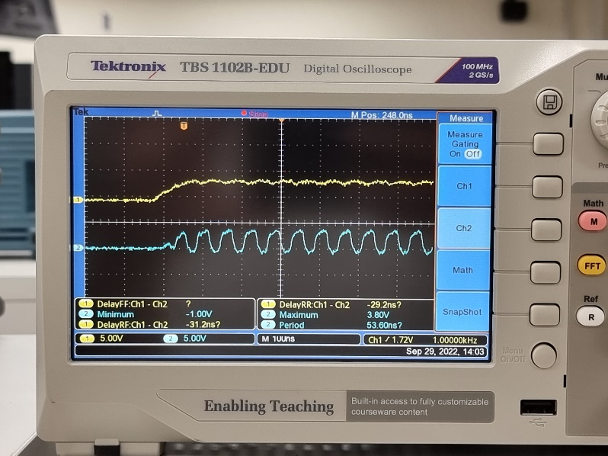

Figure 2. Waveforms of Signal A (CH1) and B (CH2)

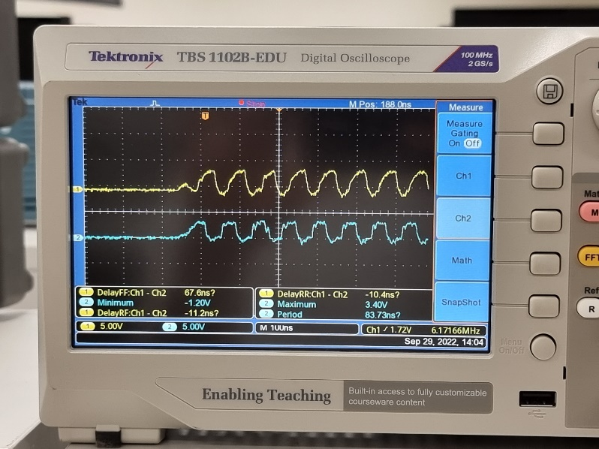

Figure 3. Waveforms of Signal B (CH1) and C (CH2)

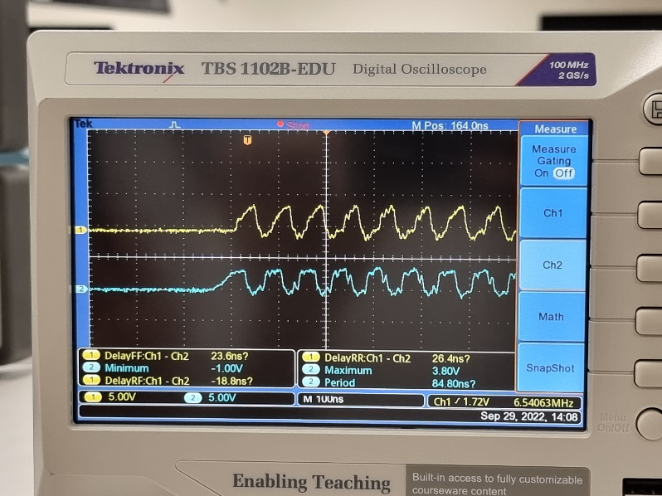

Figure 4. Waveforms of Signal C (CH1) and D (CH2)

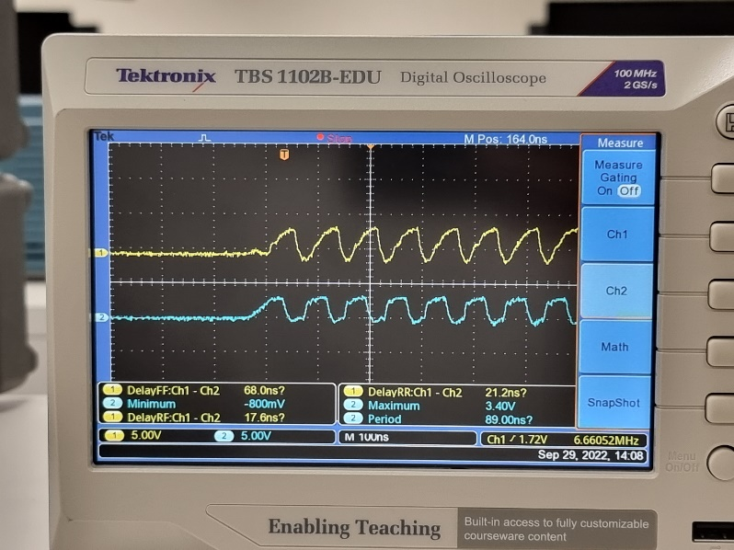

Figure 5. Waveforms of Signal D (CH1) and B (CH2)

|  |  |  |  |  |  |
| --- | --- | --- | --- | --- | --- |
| CH1 | CH2 | CH1 – CH2 Delay (ns) | CH2 Max V (V) | CH2 Min V (V) | CH2 Period (ns) |
| A | B | -29.2 | 3.80 | -1.00 | 53.60 |
| B | C | -10.4 | 3.40 | -1.20 | 83.73 |
| C | D | 26.4 | 3.80 | -1.00 | 84.80 |
| D | B | 21.2 | 3.40 | -0.800 | 89.00 |