Lab 4. Steering Logic

Results

2017-11405 방승원

6.1 가

|  |  |  |  |  |  |  |
| --- | --- | --- | --- | --- | --- | --- |
| Select | | Input | | | | Output |
| S1 | S0 | I3 | I2 | I1 | I0 | F0 |
| 0 | 0 | 0 | 1 | 0 | 1 | 1 |
| 1 | 0 | 0 | 1 | 0 | 1 | 1 |

6.1 나

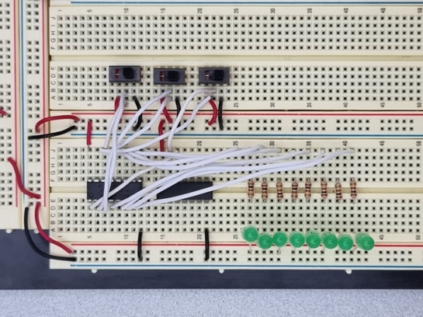

|  |  |  |  |  |  |  |  |  |  |  |
| --- | --- | --- | --- | --- | --- | --- | --- | --- | --- | --- |
| Input | | | Output | | | | | | | |
| I2 | I1 | I0 | F0 | F1 | F2 | F3 | F4 | F5 | F6 | F7 |
| 0 | 0 | 0 | 1 | 0 | 0 | 0 | 0 | 0 | 0 | 0 |
| 1 | 1 | 1 | 0 | 0 | 0 | 0 | 0 | 0 | 0 | 1 |