MONTHLY CLEANING ACTIVITY REPORT - OCTOBER 2026

Date: 08.10.2026

BLOCK B
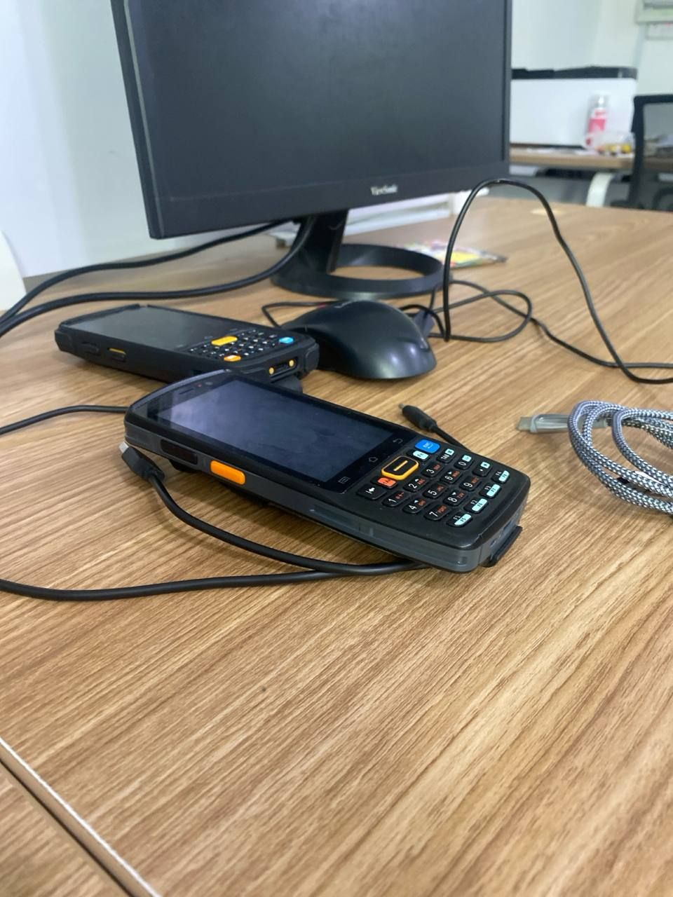
[-] Task completed

BLOCK C
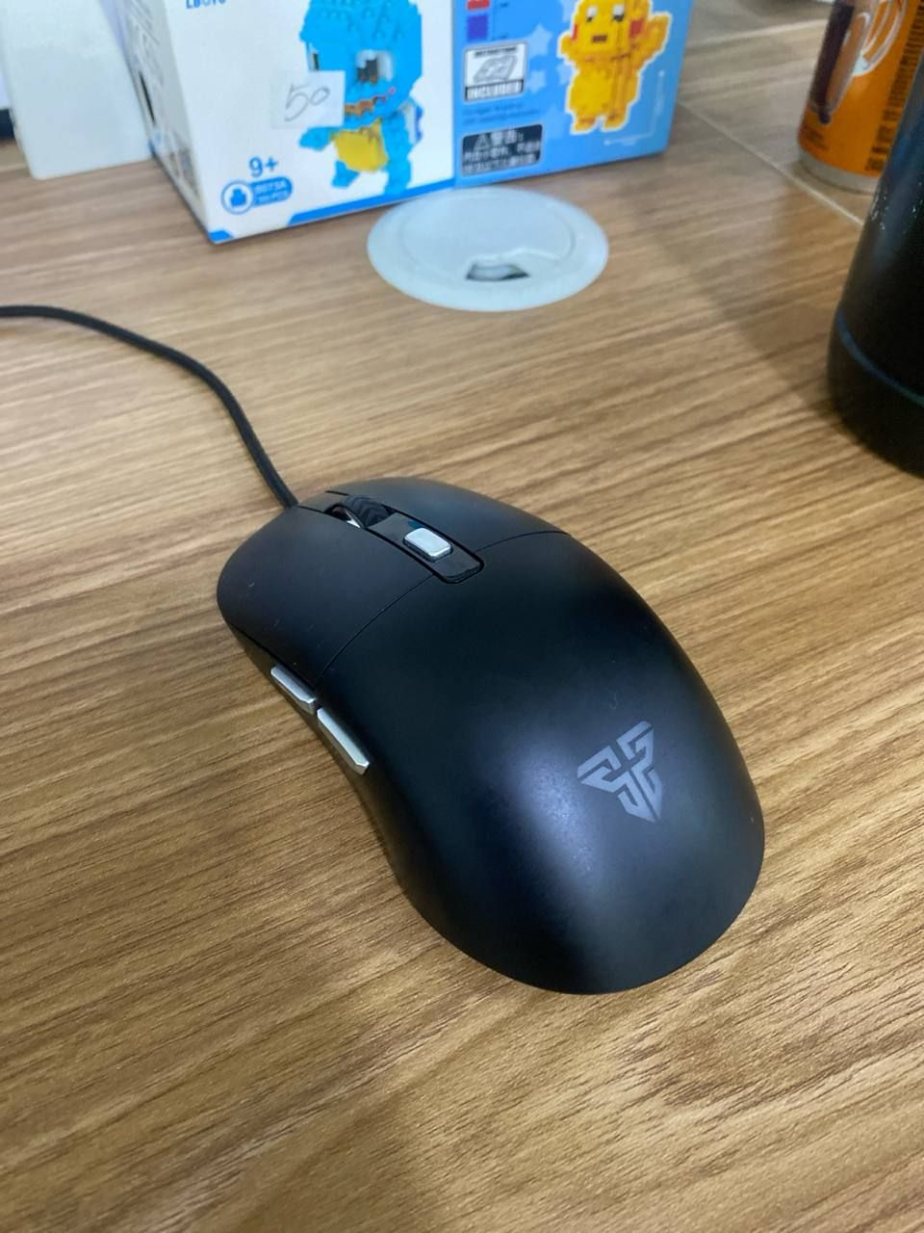
[-] Task completed

BLOCK D
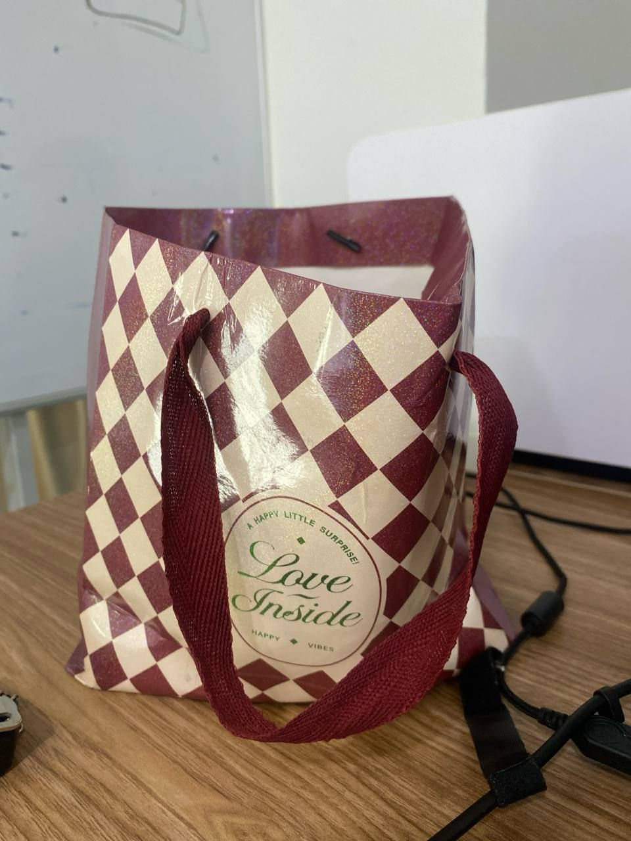
[-] Task completed

Date: 12.10.2026

BLOCK A
🔴 BEFORE | 🟢 AFTER
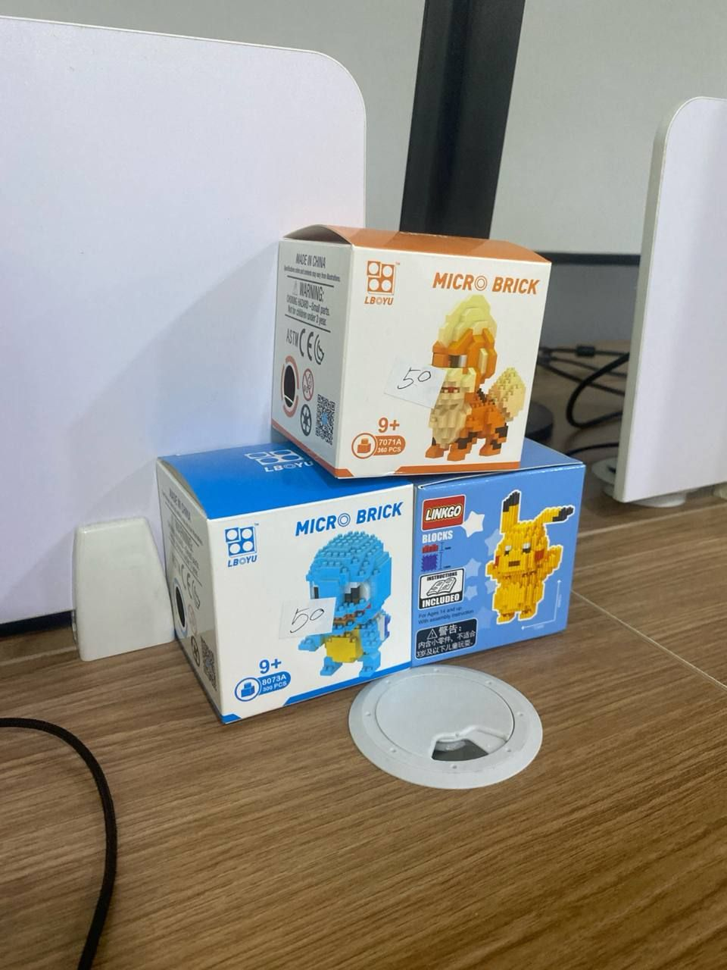 | 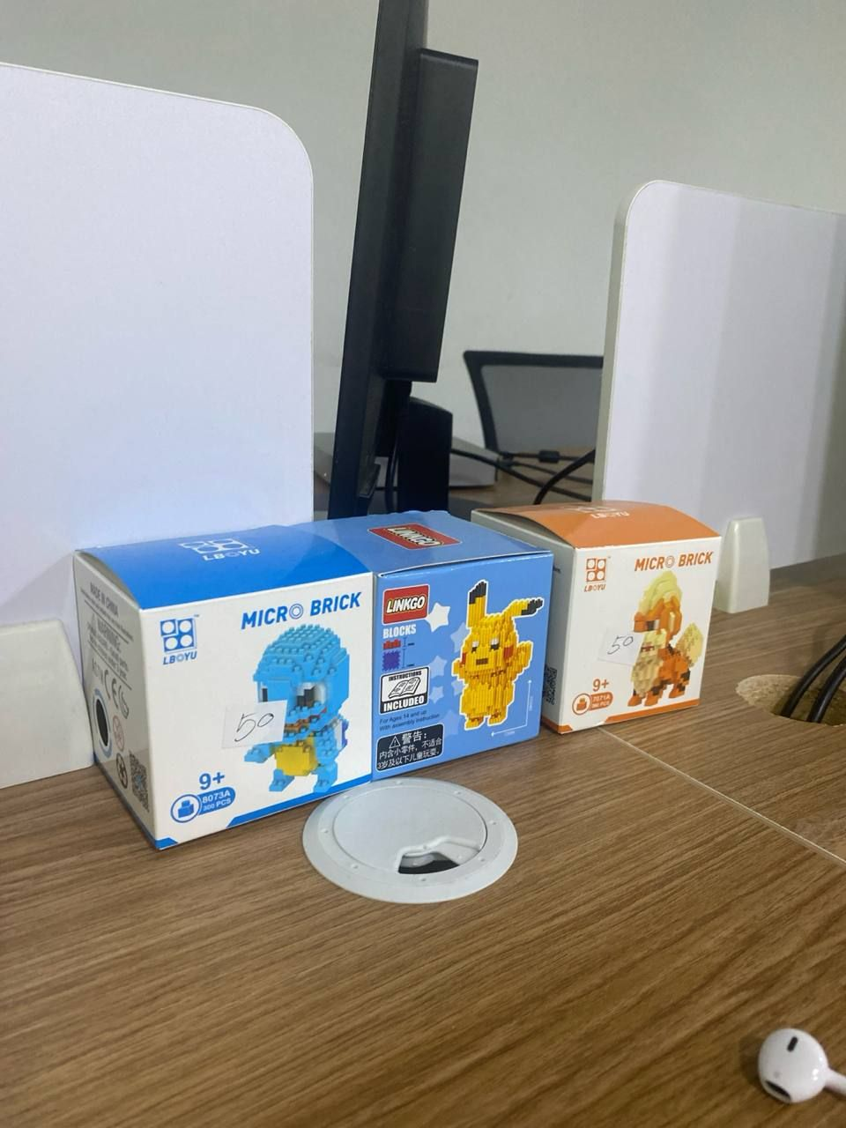
[-] Task completed (COMPLETED)
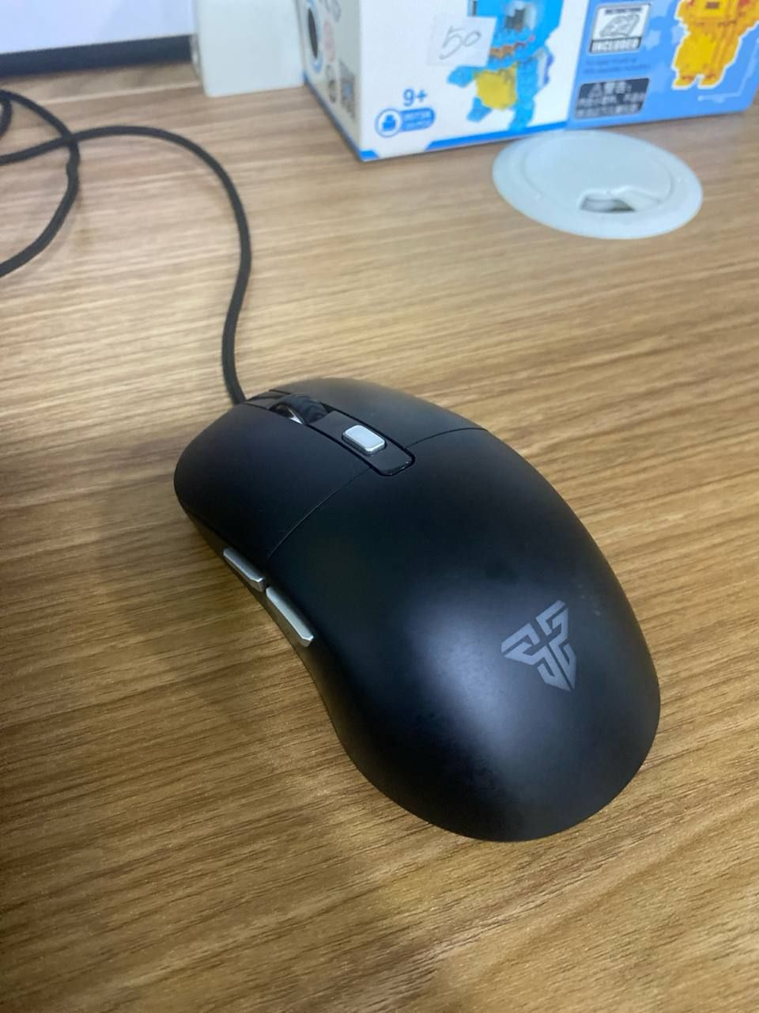
[-] before

UNASSIGNED
🔴 BEFORE | 🟢 AFTER
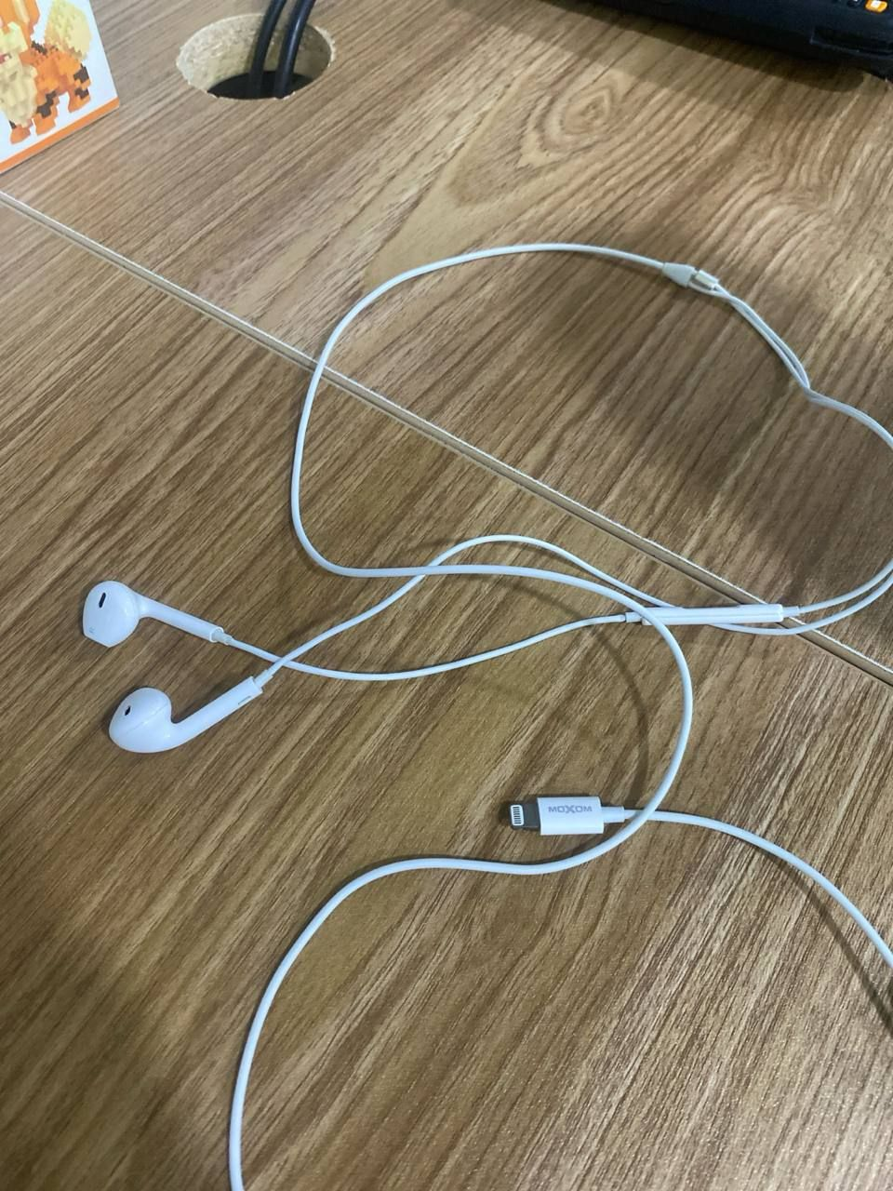 | [Pending After Photo]
[-] Task completed (PENDING)

BLOCK B
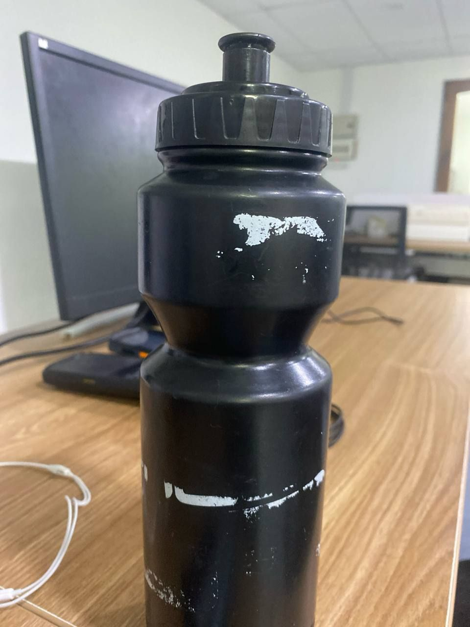
[-] Task completed (Unmatched #after)

