1. Open Visual Studio
2. Select ASP.NET Core Web Application

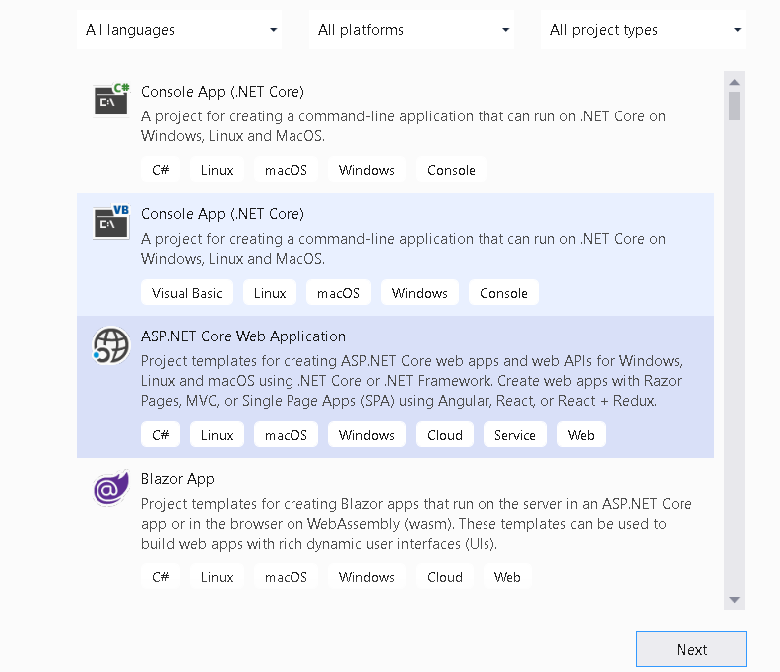

1. Name it

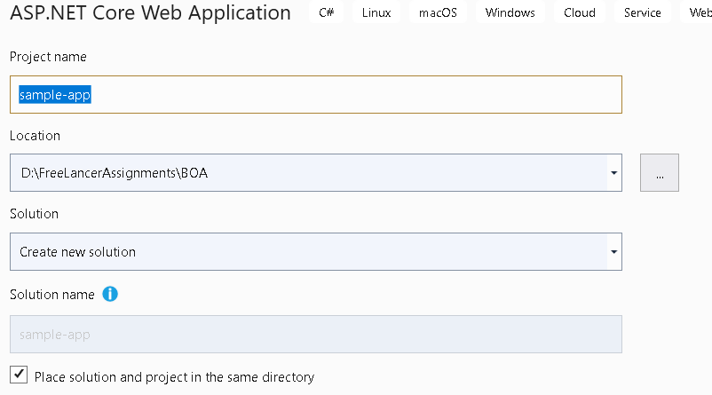

1. Select Empty Application option and remove Configure HTTPS for now

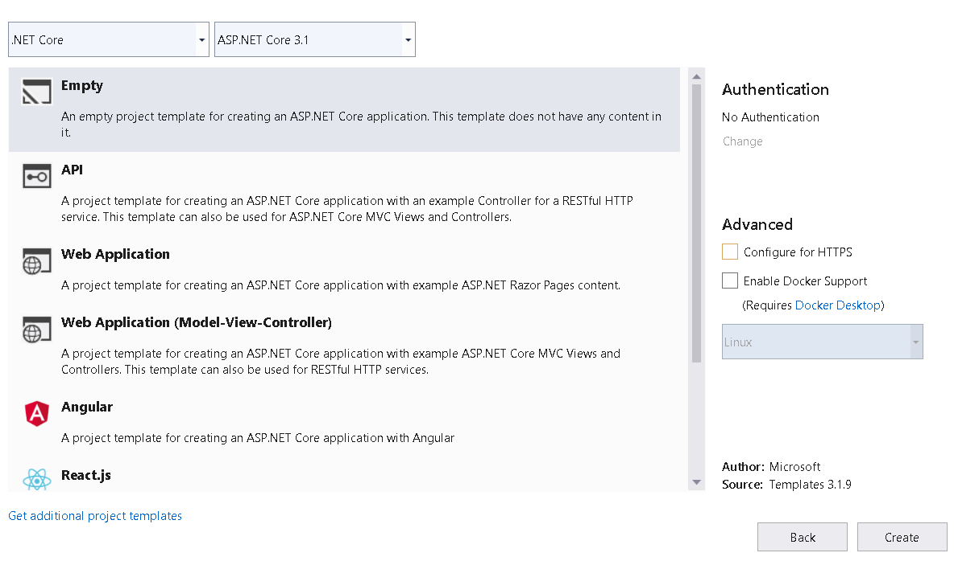

1. Check the Project Structure

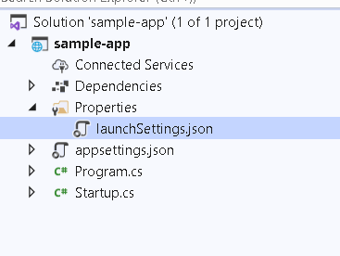

Demo 1 Middleware

1. Add Couple of Use Method to check the middleware usage

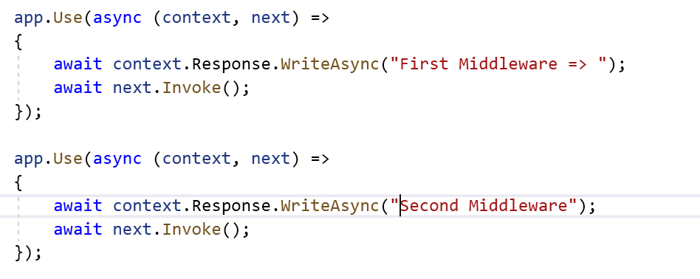

**Check the Output**

1. Add Run method

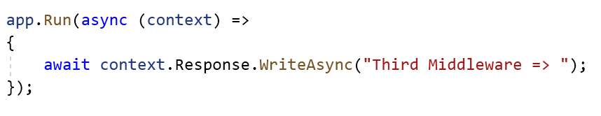

**Check the Output**

1. Put Run method between Use methods and check the Output

Demo 2: Custom Middleware : Attach the Culture Information on current request using Custom middleware

* Middleware class received RequestDelegate as constructor parameter . which is used to forward request to the net component
* Invoke method is automatically called when a request is received.
* Request is received insided HttpContext object.
* Class based middleware components are added using UseMiddleware method which accepts the middleware as type argument.

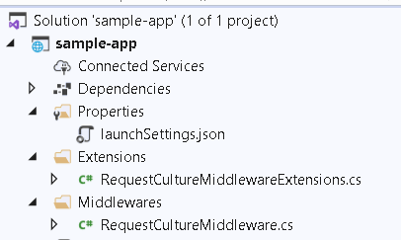

1. Add Middleware folder and add the class that contain the logic of Setting Culture

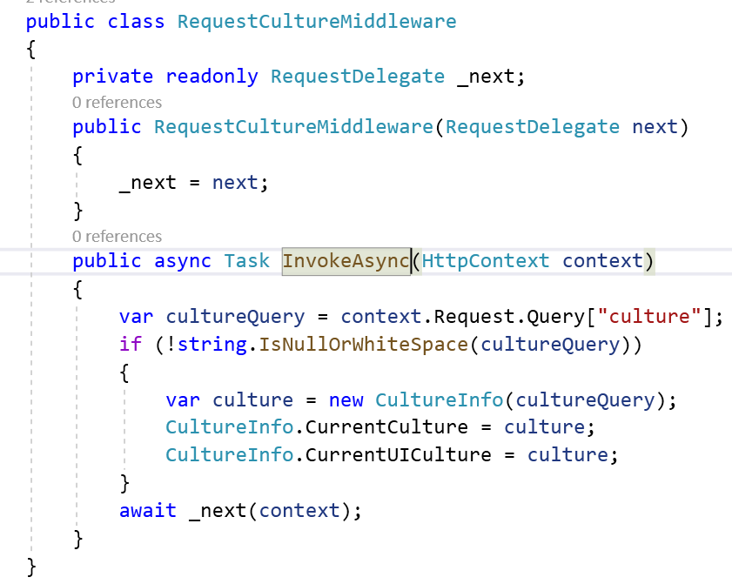

1. Create Extensions folder and add the extension method to make this logic available to IApplicationBuilder Object

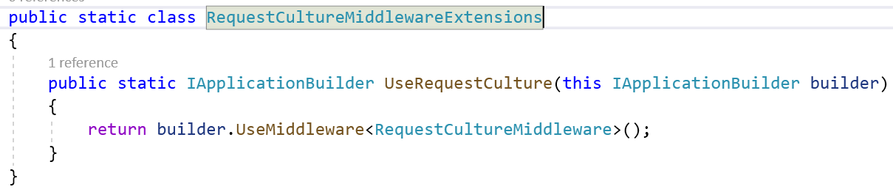

1. Use this in middleware in request pipeline

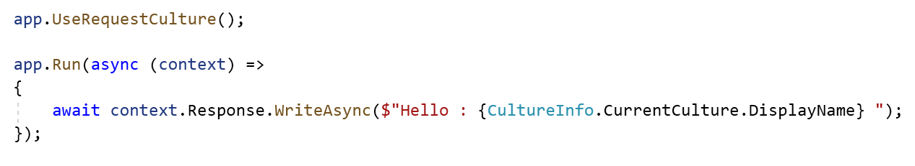

1. Check the Output

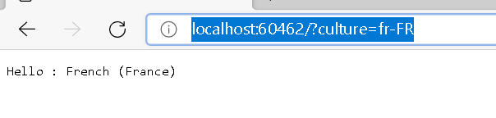

Demo 3: Serving Static Content

1. Create wwwroot folder and add some static files into it

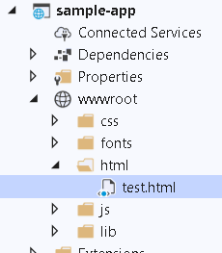

1. Call Static Middleware

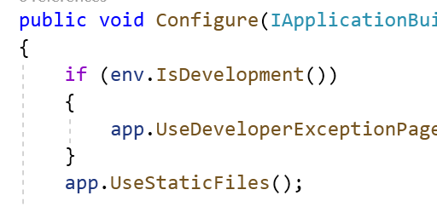

1. Call static file



1. Add Folder Static Files

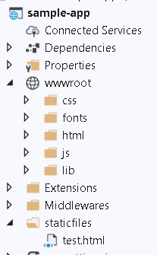

1. Add UseStatic Files

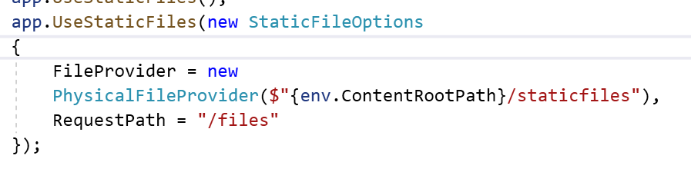

1. Get the HTML

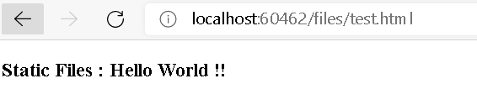

Demo : Enable MVC For .Net Core Application

1. Add a Home Controller and its associated view

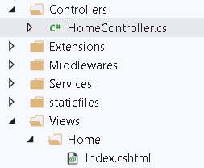

1. Enable Routing for MVC for default Route

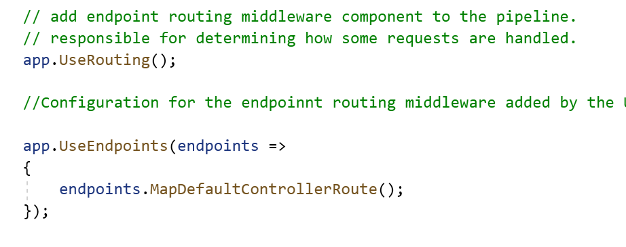

1. Add the Required services

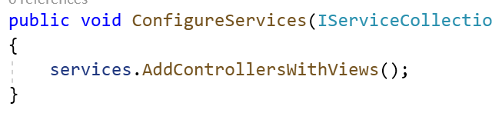

1. Check the Output

Demonstration : Service Lifetime

1. Create IRandomService Interface

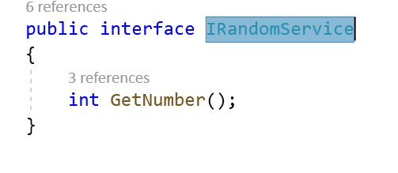

1. Add RandomService Logic

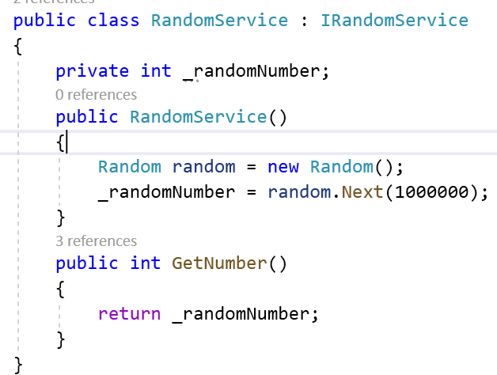

1. Add Another Service which is dependent on this service for the data

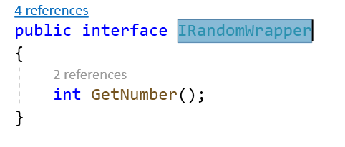

1. Add Randomwrapper service

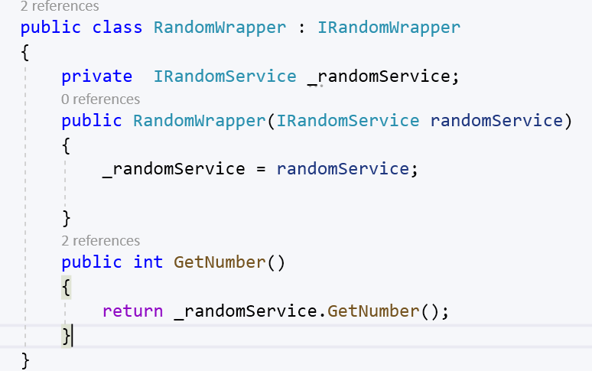

1. Inject thru ctor in HomeController

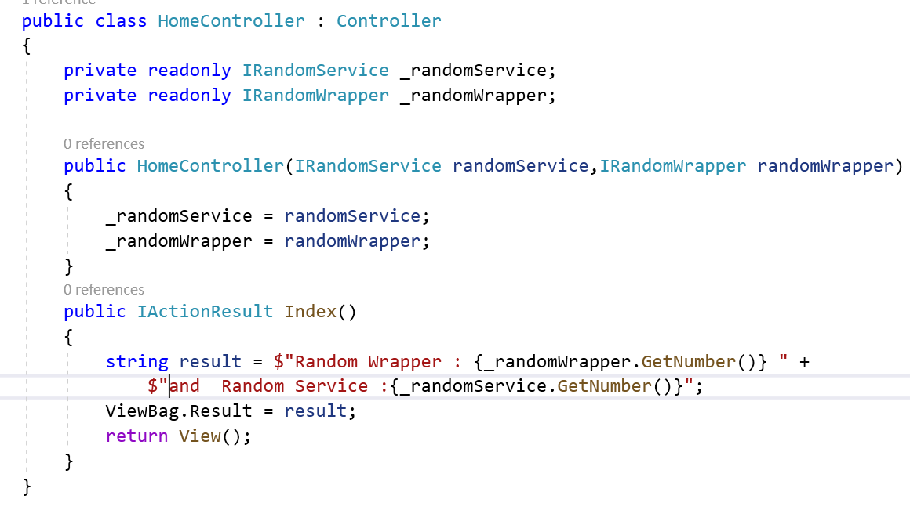

1. Make Available those objects through ConfigureServices

