Mircrosoft Hackathon app

Screenshots of International Women’s Hackathon 2014 conducted between April 25–27, 2014 Worldwide on university campuses and live at the USA Science & Engineering Festival, Washington DC

Screen1

A candidate (user) records her interests.

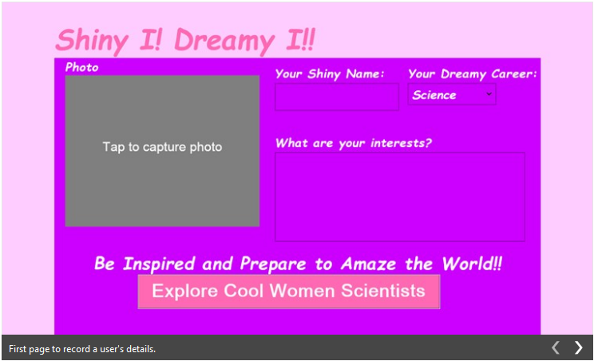

Screen2

Shows list of popular women working in STEM

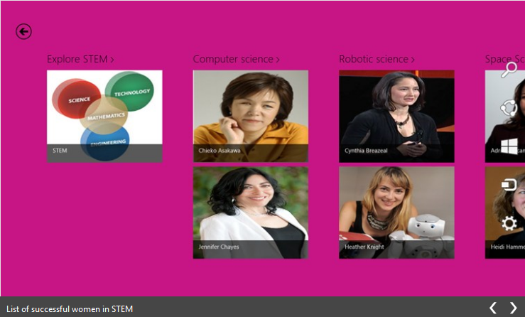

Screen3

When tapped on Jennifer Chayes photograph a detailed description about her contributions in Computer Science field show up as follows:

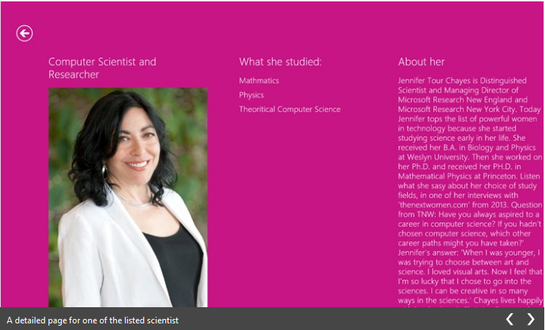

Screen4

Candidate (user) can take a picture of her and find her among the famous women who are working in STEM and become encouraged.

