**MR3522 Lab 3: Analysis of Landsat 8 Data**

Purpose: Convert raw Landsat data to useful, interesting variables and imagery, and interpret the plotted data.

*Starting up*

1. Log in to your JupyterLab. In the file viewer, go to “MR3522/Lab3” and double click landsat.ipynb to open the Jupyter notebook.
2. Show line numbers in each cell by clicking “View” -> “Show Line Numbers” in the menu bar.

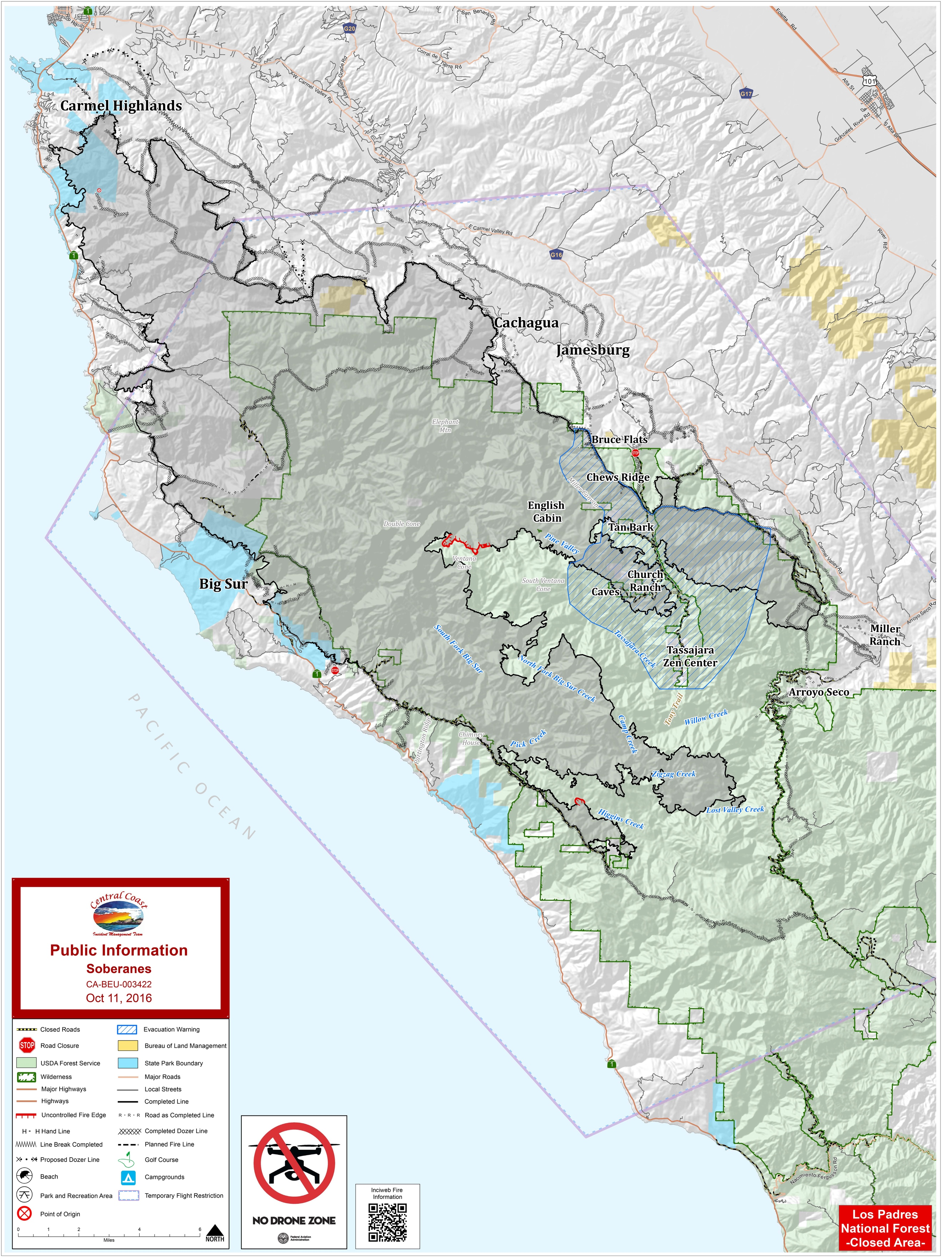The Soberanes fire burnt over a large part of the Los Padres National Forest and Ventana Wilderness in Monterey County during the summer of 2016. The fire burn over 130,000 acres, and its total cost was around $260,000,000. In this lab, we will plot and analyze imagery from before and just after the fire along Path 43, Row 35. We will look at two scenes with less than 10% cloud cover so that we can see changes to the land surface that occurred over the course of the summer. The scene in April was captured during a particularly warm day; be cautious about comparing land surface temperatures between the two scenes.

Figure : Map of fire's total extent by October 2016. Credit: CALFIRE

The python code is broken into several cells. You will only change a few things, although you are welcome (and encouraged) to experiment with your plots. The Landsat data contains 16-bit integers that are converted to a radiance using the coefficients seen in the cell starting at Line 2 of the 2nd cell. K1 and K2 are values used to convert radiance to brightness temperature for the IR channels.

Lines 1 and 2 of the 3rd cell point to the two directories where data live. Make sure only one is uncommented at a time. A line can be commented out by putting a # sign at the beginning of the line. You will alternate which line is commented out based on the data you want to plot. To start, you will plot data from April 2016, a few months before the fire started. Later, you will comment out Line 1 and uncomment Line 2 to plot data from October 2016, after the fire was extinguished. Lines 3 and 4 of the 3rd cell are the channels that are used to compute NDVI.

The 9th cell (Combine Channels 2–4…) plots RGB “true color” raster imagery by default. You can adjust the 800 in Lines 8 and 10 of this cell to alter the contrast of your imagery. Select a set of numbers that you think yields a realistic output image. All images will be output in your Lab3 subdirectory.

You will have to adjust Lines 43 and 47 in the “Function for making plots” cell in order to change which channel for which you plot the radiance (Line 43) as well as the range of the color bar (value of vmax in Line 47). If the land looks white on the radiance image, raise vmax. If land all looks black, lower vmax. You may benefit by making little notes about what vmax you used for each channel so that you can repeat this quickly as you return to plotting the same channels for different days. Re-run this cell immediately after you make changes to it and before re-running the final cell to plot anything new. The final cell will produce a drop-down menu with three options: Radiance for whatever channel you selected in Line 43, NDVI, and land surface temperature.

All figures created will automatically save to your File Viewer when created. The code is set up so that plots of radiance in the same channel, NDVI, or land surface temperature will overwrite each other, but also that a plot for October will not overwrite a plot for April. So as you experiment with changing vmax, you don’t have to worry about continually deleting old figures and keeping track of the good versions. Separate radiance images will be saved for each channel plotted, so you also don’t have to worry about one channel overwriting the image saved for another channel.

**In this lab, three numbers will appear when you scroll over a figure. x and y are coordinates, and z is the value of the quantity plotted at those coordinates.**

*Making Plots*

1. Fill in X and Y with the appropriate Landsat-8 channels to compute NDVI in the third cell if it isn’t already filled in. In the code, X and Y are used in Line 1 of the cell labeled, “Compute NDVI and land surface temperature…”
2. Run all the code. A .TIF file will appear in your Lab3 folder, which is the true color image generated. In the dropdown menu beneath the last cell, select “Radiance” from the dropdown menu.
   1. **Using the number slider, select a channel that will highlight sandy beaches in the radiance field. (If you move the channel slider while viewing the other two fields, the figure will reload but nothing will change.) What channel did you select? Why did you choose this channel?**

**Consult the plot of surface reflectance for various surfaces as seen in class lecture notes. Search for a wavelength detected by Landsat-8 for which sand is much more reflective than other surfaces. There are a few possibilities, but Channel 4 is optimal because sand is much more reflective of 650 nm radiation than other surfaces that might be detected in this scene.**

1. **Include a plot of the radiance for the channel you chose above in your write-up, and circle or otherwise indicate an example of a sandy beach.**
2. **Next, choose a channel that provides information about the temperature of Earth’s surface. Justify your choice of channel. In your explanation, state all of the Landsat channels/bands that could not be used for this purpose. Also choose Land Surface Temperature from the drop-down menu to create a plot of it. You don’t need to save these plots. They will auto-save in your File Viewer on the left-hand side of JupyterLab.**

**Use a thermal infrared band. Channel 10, centered near 11 microns, is probably better because the atmosphere is slightly more transparent to 11-micron radiation than 12-micron (Channel 12) radiation. Channels 1–9 cannot be used because they detect solar radiation reflected off of Earth.**

1. Plot radiance in the cirrus band. The plot should be saved. We’ll come back to this shortly.
2. If all went well, you should have at least three radiance plots, a RGB plot, a NDVI plot, and a LST plot in your Lab3 folder. All should be labeled as representing April 2016 (201604) in the file name.
3. Go to the cell labeled “ Combine Channels 2–4 to make RGB Raster Image”. At Line 8, change “RGB” to “Veggie”. In Lines 1–3, change the numbers 1, 2, and 3, respectively, to 2, 3, and 4. (The numbers 1, 2, and 3 correspond to Landsat bands 2, 3, and 4 because python uses zero-indexing.) Re-run just this cell. It will produce another plot in figures named “Veggie_201604.tif”.
4. Change Lines 1–3 in the “Combine Channels 2–4…” cell back to what they were, with numbers 1, 2, and 3 as the indices (the numbers in the brackets).
5. **For the April scene, pick out one obviously urban area, like a street or building top in Seaside or Salinas or another town.** 
   1. **What is the approximate range of NDVI you see in urban areas? Record the coordinates of the data point you select on the plot (x and y points in text immediately below figure) and the value of NDVI.**
   2. **Do the same for forested regions in the hills southeast of Monterey.**
   3. **Then do the same for an agricultural plot that is actively growing and for one that is fallow.**

**Your exact answers will vary based on what areas you choose. Generally, NDVI for urban areas is 0–0.2, for forested regions is 0.6–0.8, and for agricultural plots are above 0.5 for active regions and perhaps 0.1–0.2 for fallow fields.**

1. In the third cell (the one with “fdir” defined in it), comment out Line 1 (add a # to the beginning of it) and uncomment Line 2 (remove the # from the beginning of it). Re-run the code to produce new plots. Then repeat the same exercise as in Step 7, except change “RGB” to “Veggie” in Line 10 instead of 8. At the end, you should have at least one new radiance plot, RGB plot, and Veggie plot made.
2. **Plot radiance in the cirrus band for October as well and compare this plot with the one you generated for April. Are there any locations for which the land surface temperature might obviously be biased low because of contamination by high cloud? If not, what might be the reason for any difference observed between the two plots? (Hint: Consider the absolute magnitude of the radiance and its spatial pattern.)**

**Likely, no. Only very small radiances (<1 W m-2) are seen in the cirrus band: Some apparently artificial values, which are oriented along the satellite path, and some small radiances that appear to follow the terrain are seen in April. These likely represent actual reflectance of incoming shortwave radiation off the highest terrain, which is possible because the higher elevation means that the radiation has less optically thick atmosphere to travel through. That radiances are non-zero in April probably indicates that the atmosphere during the April scene was drier than that during the October scene.**

1. **Repeat Question 9 for October.**

**Same as Question 9. Your exact answers will vary based on what areas you choose. Generally, NDVI for urban areas is 0–0.2, for forested regions is 0.6–0.8, and for agricultural plots are above 0.5 for active regions and perhaps 0.1–0.3 for fallow fields.**

1. **To a first order, what is generally true about the relationship between NDVI and land surface temperature? What colors over land in the true color image do you encounter where NDVI is low? What effect does vegetation have on land surface temperature?**

**Land surface temperature is higher where NDVI is low. In the true color image, bright., reflective colors (light brown, white, gray) are often encountered where NDVI is low. Vegetation appears to correlate with lower land surface temperature.**

1. **In the plots with file name “Veggie” in them, what does the red represent? Why do these parts of each image appear mainly red and not blue or green? What does the burn scar look like in the “Veggie” images?**

**Red represents vegetation. They appear red because the near-infrared channel is being mapped to red. Red and green reflectance is mapped to green and blue, respectively. The burn scar appears brown in this type of false color image.**

1. **Was agriculture more active in April 2016 or October 2016 in the Salinas Valley? Explain how you know.**

**October 2016. NDVI is generally higher in the Salinas Valley over agricultural plots. Brighter reds are also seen in this region in the false color “Veggie” image.**

1. **After the fire, which side of ridges in Los Padres National Forest were generally warmest during the daytime? What satellite channel(s) help you determine this?**

**Generally, the southern or southwestern side of ridges were warmest. Use a thermal infrared channel to help determine this.**