ปฏิบัติการที่ 10 Static Route
6710210-317 | นายวีรชาติ แก้วขำ

Task 1 - Single Router
- Router model: 2911
- Switch model: Switch-PT
- PC model: PC-PT
- Connect
- เครื่อง A, B, C และ D ต้องติดต่อกันได้
- กำหนด IP, GW ลงในรูปภาพ

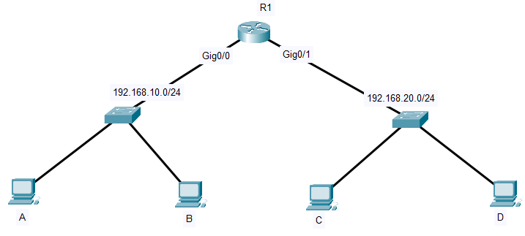
IP: 192.168.10.3
GW: 192.168.10.1
IP: 192.168.20.3
GW: 192.168.20.1
IP: 192.168.20.2
GW: 192.168.20.1
IP: 192.168.20.1
IP: 192.168.10.1
IP: 192.168.10.2
GW: 192.168.10.1

ข้อกำหนด Router
Router | IP address | Subnet Mask
R1
Gig0/0 | 192.168.10.1 | 255.255.255.0
Gig0/1 | 192.168.20.1 | 255.255.255.0

ข้อกำหนด PC
PC | IP address | Subnet Mask | Default Gateway
A | 192.168.10.2 | 255.255.255.0 | 192.168.10.1
B | 192.168.10.3 | 255.255.255.0 | 192.168.10.1
C | 192.168.20.2 | 255.255.255.0 | 192.168.20.1
D | 192.168.20.3 | 255.255.255.0 | 192.168.20.1

ชุดคำสั่ง R1
- configuration mode
Router> enable
Router# configure terminal
Router(config)# no ip domain-lookup
Router(config)# hostname R1
- interface Gi0/0
R1(config)# interface gigabitEthernet 0/0
R1(config-if)# ip address 192.168.10.1 255.255.255.0
R1(config-if)# no shutdown
R1(config-if)# exit
- interface Gi0/1
R1(config)# interface gigabitEthernet 0/1
R1(config-if)# ip address 192.168.20.1 255.255.255.0
R1(config-if)# no shutdown
R1(config-if)# exit
- show IP
do show ip interface brief
do show ip interface brief
Interface IP-Address OK? Method Status Protocol
GigabitEthernet0/0 192.168.10.1 YES manual up up
GigabitEthernet0/1 192.168.20.1 YES manual up up
GigabitEthernet0/2 unassigned YES unset administratively down down
Vlan1 unassigned YES unset administratively down down

ทดสอบ
- A > B
ping 192.168.10.3
Pinging 192.168.10.3 with 32 bytes of data:

Reply from 192.168.10.3: bytes=32 time<1ms TTL=128
Reply from 192.168.10.3: bytes=32 time<1ms TTL=128
Reply from 192.168.10.3: bytes=32 time<1ms TTL=128
Reply from 192.168.10.3: bytes=32 time<1ms TTL=128

Ping statistics for 192.168.10.3:
Packets: Sent = 4, Received = 4, Lost = 0 (0% loss),
Approximate round trip times in milli-seconds:
Minimum = 0ms, Maximum = 0ms, Average = 0ms

tracert 192.168.10.3
Tracing route to 192.168.10.3 over a maximum of 30 hops:

1 0 ms 0 ms 0 ms 192.168.10.3

Trace complete.

- A > C
ping 192.168.20.2
Pinging 192.168.20.2 with 32 bytes of data:

Reply from 192.168.20.2: bytes=32 time<1ms TTL=127
Reply from 192.168.20.2: bytes=32 time<1ms TTL=127
Reply from 192.168.20.2: bytes=32 time=1ms TTL=127
Reply from 192.168.20.2: bytes=32 time<1ms TTL=127

Ping statistics for 192.168.20.2:
Packets: Sent = 4, Received = 4, Lost = 0 (0% loss),
Approximate round trip times in milli-seconds:
Minimum = 0ms, Maximum = 1ms, Average = 0ms

tracert 192.168.20.2
Tracing route to 192.168.20.2 over a maximum of 30 hops:

1 0 ms 0 ms 0 ms 192.168.10.1
2 0 ms 0 ms 0 ms 192.168.20.2

- A > D
ping 192.168.20.3
Pinging 192.168.20.3 with 32 bytes of data:

Reply from 192.168.20.3: bytes=32 time<1ms TTL=127
Reply from 192.168.20.3: bytes=32 time<1ms TTL=127
Reply from 192.168.20.3: bytes=32 time<1ms TTL=127
Reply from 192.168.20.3: bytes=32 time<1ms TTL=127

Ping statistics for 192.168.20.3:
Packets: Sent = 4, Received = 4, Lost = 0 (0% loss),
Approximate round trip times in milli-seconds:
Minimum = 0ms, Maximum = 0ms, Average = 0ms

tracert 192.168.20.3
Tracing route to 192.168.20.3 over a maximum of 30 hops:

1 0 ms 0 ms 0 ms 192.168.10.1
2 0 ms 0 ms 0 ms 192.168.20.3

Trace complete.

ผลลัพธ์ R1
- show routing table
do show ip route
Codes: L - local, C - connected, S - static, R - RIP, M - mobile, B - BGP
D - EIGRP, EX - EIGRP external, O - OSPF, IA - OSPF inter area
N1 - OSPF NSSA external type 1, N2 - OSPF NSSA external type 2
E1 - OSPF external type 1, E2 - OSPF external type 2, E - EGP
i - IS-IS, L1 - IS-IS level-1, L2 - IS-IS level-2, ia - IS-IS inter area
* - candidate default, U - per-user static route, o - ODR
P - periodic downloaded static route

Gateway of last resort is not set

192.168.10.0/24 is variably subnetted, 2 subnets, 2 masks
C 192.168.10.0/24 is directly connected, GigabitEthernet0/0
L 192.168.10.1/32 is directly connected, GigabitEthernet0/0
192.168.20.0/24 is variably subnetted, 2 subnets, 2 masks
C 192.168.20.0/24 is directly connected, GigabitEthernet0/1
L 192.168.20.1/32 is directly connected, GigabitEthernet0/1

Task 2 - Two Router
- Router model: 2911
- เพิ่ม HWIC-2T (Cisco 2-Port Serial High-Speed WAN Interface Card)
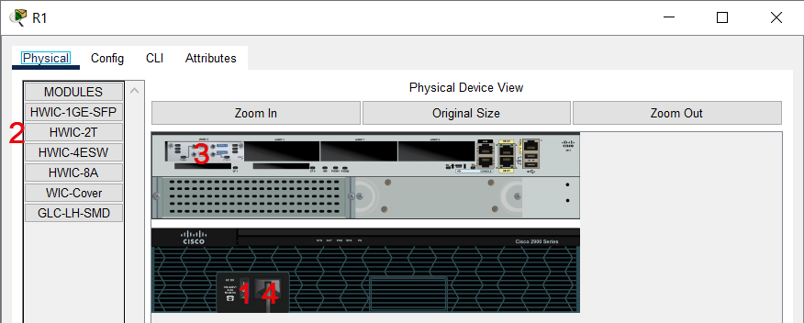

- Switch model: Switch-PT
- PC model: PC-PT
- Static route
- เครื่อง A, B และ C ต้องติดต่อกันได้
- กำหนด IP, GW ลงในรูปภาพ
IP: 192.168.1.1
IP: 192.168.1.2
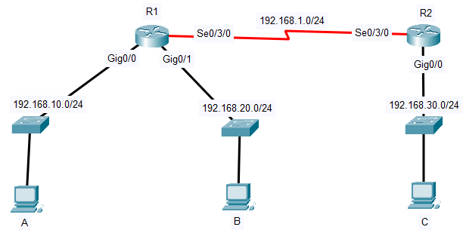
IP: 192.168.10.2
GW: 192.168.10.1
IP: 192.168.30.1
IP: 192.168.10.1
IP: 192.168.20.1
IP: 192.168.20.2
GW: 192.168.20.1
IP: 192.168.30.2
GW: 192.168.30.1

ข้อกำหนด Router
Router | IP address | Subnet Mask
R1
Se0/3/0 | 192.168.1.1 | 255.255.255.0
Gig0/0 | 192.168.10.1 | 255.255.255.0
Gig0/1 | 192.168.20.1 | 255.255.255.0
R2
Se0/3/0 | 192.168.1.2 | 255.255.255.0
Gig0/0 | 192.168.30.1 | 255.255.255.0

ตาราง Routing
Router | Network | Subnet Mask | Next Hop
R1
1 | 192.168.30.0 | 255.255.255.0 | 192.168.1.2
R2
1 | 192.168.10.0 | 255.255.255.0 | 192.168.1.1
2 | 192.168.20.0 | 255.255.255.0 | 192.168.1.1

ข้อกำหนด PC
PC | IP address | Subnet Mask | Default Gateway
A | 192.168.10.2 | 255.255.255.0 | 192.168.10.1
B | 192.168.20.2 | 255.255.255.0 | 192.168.20.1
C | 192.168.30.2 | 255.255.255.0 | 192.168.30.1

ชุดคำสั่ง R1
- configuration mode
Router> enable
Router# configure terminal
Router(config)# no ip domain-lookup
Router(config)# hostname R1
- interface Se0/3/0
R1(config)# interface serial 0/3/0
R1(config-if)# ip address 192.168.1.1 255.255.255.0
R1(config-if)# clock rate 64000
R1(config-if)# no shutdown
R1(config-if)# exit
- interface Gi0/0
R1(config)# interface gigabitEthernet 0/0
R1(config-if)# ip address 192.168.10.1 255.255.255.0
R1(config-if)# no shutdown
R1(config-if)# exit
- interface Gi0/1
R1(config)# interface gigabitEthernet 0/1
R1(config-if)# ip address 192.168.20.1 255.255.255.0
R1(config-if)# no shutdown
R1(config-if)# exit
- static route
R1(config)# ip route 192.168.30.0 255.255.255.0 192.168.1.2
- show IP
do show ip interface brief
Interface IP-Address OK? Method Status Protocol
GigabitEthernet0/0 192.168.10.1 YES manual up up
GigabitEthernet0/1 192.168.20.1 YES manual up up
GigabitEthernet0/2 unassigned YES unset administratively down down
Serial0/3/0 192.168.1.1 YES manual up up
Serial0/3/1 unassigned YES unset administratively down down
Vlan1 unassigned YES unset administratively down down

ชุดคำสั่ง R2
- configuration mode
Router> enable
Router# configure terminal
Router(config)# no ip domain-lookup
Router(config)# hostname R2
- interface Se0/3/0
R2(config)# interface serial 0/3/0
R2(config-if)# ip address 192.168.1.2 255.255.255.0
R2(config-if)# no shutdown
R2(config-if)# exit
- interface Gi0/0
R2(config)# interface gigabitEthernet 0/0
R2(config-if)# ip address 192.168.30.1 255.255.255.0
R2(config-if)# no shutdown
R2(config-if)# exit
- static route
R2(config)# ip route 192.168.10.0 255.255.255.0 192.168.1.1
R2(config)# ip route 192.168.20.0 255.255.255.0 192.168.1.1
- show IP
do show ip interface brief
Interface IP-Address OK? Method Status Protocol
GigabitEthernet0/0 192.168.30.1 YES manual up up
GigabitEthernet0/1 unassigned YES unset administratively down down
GigabitEthernet0/2 unassigned YES unset administratively down down
Serial0/3/0 192.168.1.2 YES manual up up
Serial0/3/1 unassigned YES unset administratively down down
Vlan1 unassigned YES unset administratively down down

ทดสอบ
- A > B
ping 192.168.20.2
Pinging 192.168.20.2 with 32 bytes of data:

Reply from 192.168.20.2: bytes=32 time<1ms TTL=127
Reply from 192.168.20.2: bytes=32 time=7ms TTL=127
Reply from 192.168.20.2: bytes=32 time<1ms TTL=127
Reply from 192.168.20.2: bytes=32 time<1ms TTL=127

Ping statistics for 192.168.20.2:
Packets: Sent = 4, Received = 4, Lost = 0 (0% loss),
Approximate round trip times in milli-seconds:
Minimum = 0ms, Maximum = 7ms, Average = 1ms

tracert 192.168.20.2
Tracing route to 192.168.20.2 over a maximum of 30 hops:

1 0 ms 0 ms 0 ms 192.168.10.1
2 0 ms 0 ms 2 ms 192.168.20.2

Trace complete.

- A > C
ping 192.168.30.2
Pinging 192.168.30.2 with 32 bytes of data:

Reply from 192.168.30.2: bytes=32 time=13ms TTL=126
Reply from 192.168.30.2: bytes=32 time=14ms TTL=126
Reply from 192.168.30.2: bytes=32 time=14ms TTL=126
Reply from 192.168.30.2: bytes=32 time=14ms TTL=126

Ping statistics for 192.168.30.2:
Packets: Sent = 4, Received = 4, Lost = 0 (0% loss),
Approximate round trip times in milli-seconds:
Minimum = 13ms, Maximum = 14ms, Average = 13ms

tracert 192.168.30.2
Tracing route to 192.168.30.2 over a maximum of 30 hops:

1 0 ms 0 ms 0 ms 192.168.10.1
2 2 ms 2 ms 3 ms 192.168.1.2
3 2 ms 4 ms 0 ms 192.168.30.2

Trace complete.

ผลลัพธ์ R1
- show routing table
do show ip route
192.168.1.0/24 is variably subnetted, 2 subnets, 2 masks
C 192.168.1.0/24 is directly connected, Serial0/3/0
L 192.168.1.1/32 is directly connected, Serial0/3/0
192.168.10.0/24 is variably subnetted, 2 subnets, 2 masks
C 192.168.10.0/24 is directly connected, GigabitEthernet0/0
L 192.168.10.1/32 is directly connected, GigabitEthernet0/0
192.168.20.0/24 is variably subnetted, 2 subnets, 2 masks
C 192.168.20.0/24 is directly connected, GigabitEthernet0/1
L 192.168.20.1/32 is directly connected, GigabitEthernet0/1
S 192.168.30.0/24 [1/0] via 192.168.1.2

ผลลัพธ์ R2
- show routing table
do show ip route
192.168.1.0/24 is variably subnetted, 2 subnets, 2 masks
C 192.168.1.0/24 is directly connected, Serial0/3/0
L 192.168.1.2/32 is directly connected, Serial0/3/0
S 192.168.10.0/24 [1/0] via 192.168.1.1
S 192.168.20.0/24 [1/0] via 192.168.1.1
192.168.30.0/24 is variably subnetted, 2 subnets, 2 masks
C 192.168.30.0/24 is directly connected, GigabitEthernet0/0
L 192.168.30.1/32 is directly connected, GigabitEthernet0/0

Task 3 - Three Router
- Router model: 2911 (เพิ่ม HWIC-2T (Cisco 2-Port Serial High-Speed WAN Interface Card)
- Switch model: Switch-PT
- PC model: PC-PT
- Static route
- เครื่อง A และ B ต้องติดต่อกันได้
- กำหนด IP, GW ลงในรูปภาพ
IP: 192.168.1.1
IP: 192.168.1.2
IP: 192.168.2.2
IP: 192.168.2.1
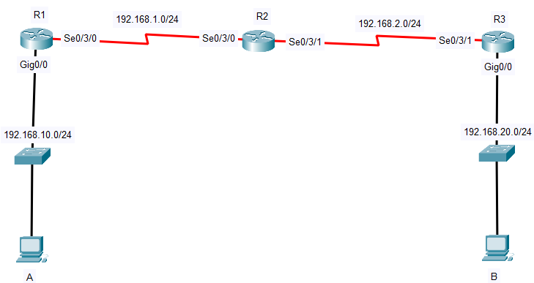
IP: 192.168.20.2
GW: 192.168.20.1
IP: 192.168.10.2
GW: 192.168.10.1
IP: 192.168.20.1
IP: 192.168.10.1

ข้อกำหนด Router
Router | IP address | Subnet Mask
R1
Se0/3/0 | 192.168.1.1 | 255.255.255.0
Gig0/0 | 192.168.10.1 | 255.255.255.0
R2
Se0/3/0 | 192.168.1.2 | 255.255.255.0
Se0/3/1 | 192.168.2.1 | 255.255.255.0
R3
Se0/3/1 | 192.168.2.2 | 255.255.255.0
Gig0/0 | 192.168.20.1 | 255.255.255.0

ตาราง Routing
Router | Network | Subnet Mask | Next Hop
R1
1 | 192.168.20.0 | 255.255.255.0 | 192.168.1.2
R2
1 | 192.168.10.0 | 255.255.255.0 | 192.168.1.1
2 | 192.168.20.0 | 255.255.255.0 | 192.168.2.2
R3
1 | 192.168.10.0 | 255.255.255.0 | 192.168.2.1

ข้อกำหนด PC
PC | IP address | Subnet Mask | Default Gateway
A | 192.168.10.2 | 255.255.255.0 | 192.168.10.1
B | 192.168.20.2 | 255.255.255.0 | 192.168.20.1

ชุดคำสั่ง R1
- configuration mode
Router> enable
Router# configure terminal
Router(config)# no ip domain-lookup
Router(config)# hostname R1
- interface Se0/3/0
R1(config)# interface serial 0/3/0
R1(config-if)# ip address 192.168.1.1 255.255.255.0
R1(config-if)# clock rate 64000
R1(config-if)# no shutdown
R1(config-if)# exit
- interface Gi0/0
R1(config)# interface gigabitEthernet 0/0
R1(config-if)# ip address 192.168.10.1 255.255.255.0
R1(config-if)# no shutdown
R1(config-if)# exit
- static route
R1(config)# ip route 192.168.20.0 255.255.255.0 192.168.1.2
- show IP
do show ip interface brief
Interface IP-Address OK? Method Status Protocol
GigabitEthernet0/0 192.168.10.1 YES manual up up
GigabitEthernet0/1 unassigned YES unset administratively down down
GigabitEthernet0/2 unassigned YES unset administratively down down
Serial0/3/0 192.168.1.1 YES manual up up
Serial0/3/1 unassigned YES unset administratively down down
Vlan1 unassigned YES unset administratively down down

ชุดคำสั่ง R2
- configuration mode
Router> enable
Router# configure terminal
Router(config)# no ip domain-lookup
Router(config)# hostname R2
- interface Se0/3/0
R2(config)# interface serial 0/3/0
R2(config-if)# ip address 192.168.1.2 255.255.255.0
R2(config-if)# no shutdown
R2(config-if)# exit
- interface Se0/3/1
R2(config)# interface serial 0/3/1
R2(config-if)# ip address 192.168.2.1 255.255.255.0
R2(config-if)# clock rate 64000
R2(config-if)# no shutdown
R2(config-if)# exit
- static route
R2(config)# ip route 192.168.10.0 255.255.255.0 192.168.1.1
R2(config)# ip route 192.168.20.0 255.255.255.0 192.168.2.2
- show IP
do show ip interface brief
Interface IP-Address OK? Method Status Protocol
GigabitEthernet0/0 unassigned YES unset administratively down down
GigabitEthernet0/1 unassigned YES unset administratively down down
GigabitEthernet0/2 unassigned YES unset administratively down down
Serial0/3/0 192.168.1.2 YES manual up up
Serial0/3/1 192.168.2.1 YES manual up up
Vlan1 unassigned YES unset administratively down down

ชุดคำสั่ง R3
- configuration mode
Router> enable
Router# configure terminal
Router(config)# no ip domain-lookup
Router(config)# hostname R3
- interface Se0/3/1
R3(config)# interface serial 0/3/1
R3(config-if)# ip address 192.168.2.2 255.255.255.0
R3(config-if)# no shutdown
R3(config-if)# exit
- interface Gig0/0
R3(config)# interface gigabitEthernet 0/0
R3(config-if)# ip address 192.168.20.1 255.255.255.0
R3(config-if)# no shutdown
R3(config-if)# exit
- static route
R3(config)# ip route 192.168.10.0 255.255.255.0 192.168.2.1
- show IP
do show ip interface brief
Interface IP-Address OK? Method Status Protocol
GigabitEthernet0/0 192.168.20.1 YES manual up up
GigabitEthernet0/1 unassigned YES unset administratively down down
GigabitEthernet0/2 unassigned YES unset administratively down down
Serial0/3/0 unassigned YES unset administratively down down
Serial0/3/1 192.168.2.2 YES manual up up
Vlan1 unassigned YES unset administratively down down

ทดสอบ
- A > B
ping 192.168.20.2
Yes
Pinging 192.168.20.2 with 32 bytes of data:

Reply from 192.168.20.2: bytes=32 time=21ms TTL=125
Reply from 192.168.20.2: bytes=32 time=20ms TTL=125
Reply from 192.168.20.2: bytes=32 time=20ms TTL=125
Reply from 192.168.20.2: bytes=32 time=19ms TTL=125

Ping statistics for 192.168.20.2:
Packets: Sent = 4, Received = 4, Lost = 0 (0% loss),
Approximate round trip times in milli-seconds:
Minimum = 19ms, Maximum = 21ms, Average = 20ms

tracert 192.168.20.2
Tracing route to 192.168.20.2 over a maximum of 30 hops:

1 0 ms 0 ms 0 ms 192.168.10.1
2 2 ms 3 ms 2 ms 192.168.1.2
3 4 ms 5 ms 4 ms 192.168.2.2
4 6 ms 5 ms 7 ms 192.168.20.2

Trace complete.

ผลลัพธ์ R1
- show routing table
do show ip route
192.168.1.0/24 is variably subnetted, 2 subnets, 2 masks
C 192.168.1.0/24 is directly connected, Serial0/3/0
L 192.168.1.1/32 is directly connected, Serial0/3/0
192.168.10.0/24 is variably subnetted, 2 subnets, 2 masks
C 192.168.10.0/24 is directly connected, GigabitEthernet0/0
L 192.168.10.1/32 is directly connected, GigabitEthernet0/0
S 192.168.20.0/24 [1/0] via 192.168.1.2

ผลลัพธ์ R2
- show routing table
do show ip route
192.168.1.0/24 is variably subnetted, 2 subnets, 2 masks
C 192.168.1.0/24 is directly connected, Serial0/3/0
L 192.168.1.2/32 is directly connected, Serial0/3/0
192.168.2.0/24 is variably subnetted, 2 subnets, 2 masks
C 192.168.2.0/24 is directly connected, Serial0/3/1
L 192.168.2.1/32 is directly connected, Serial0/3/1
S 192.168.10.0/24 [1/0] via 192.168.1.1
S 192.168.20.0/24 [1/0] via 192.168.2.2

ผลลัพธ์ R3
- show routing table
do show ip route
192.168.2.0/24 is variably subnetted, 2 subnets, 2 masks
C 192.168.2.0/24 is directly connected, Serial0/3/1
L 192.168.2.2/32 is directly connected, Serial0/3/1
S 192.168.10.0/24 [1/0] via 192.168.2.1
192.168.20.0/24 is variably subnetted, 2 subnets, 2 masks
C 192.168.20.0/24 is directly connected, GigabitEthernet0/0
L 192.168.20.1/32 is directly connected, GigabitEthernet0/0

