**Project Documentation: Hosting a Static Website on AWS S3**

**Overview**

In this project, I hosted a static website using Amazon Web Services (AWS) Simple Storage Service

(S3). The task involved setting up an S3 bucket, configuring static website hosting, and uploading

website assets. The project provided insight into the configuration process and common challenges.

**What is Amazon S3?**

Amazon S3 (Simple Storage Service) is a scalable object storage service that allows users to store

and retrieve any amount of data from anywhere on the web. It is a highly reliable service for static

website hosting, data backup, and content delivery.

**Step 1: Setting Up an S3 Bucket**

I created an S3 bucket in the Asia Pacific (Mumbai) region (ap-south-1). The crucial point is that

bucket names must be globally unique across all AWS users, ensuring that no two buckets have the

same name.

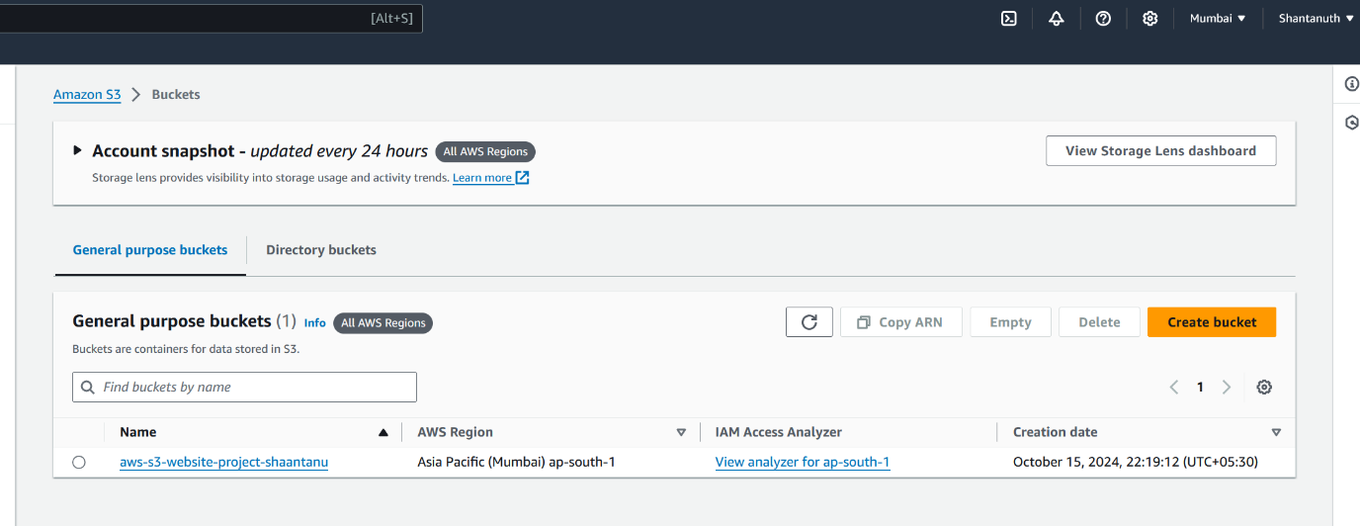

**Step 2: Uploading Website Files**

I uploaded two files: index.html (the main webpage) and a .zip file containing images and assets.

Both files are required for the website. The HTML file provides the structure, while the .zip file

contains the media files to enhance the visual presentation.

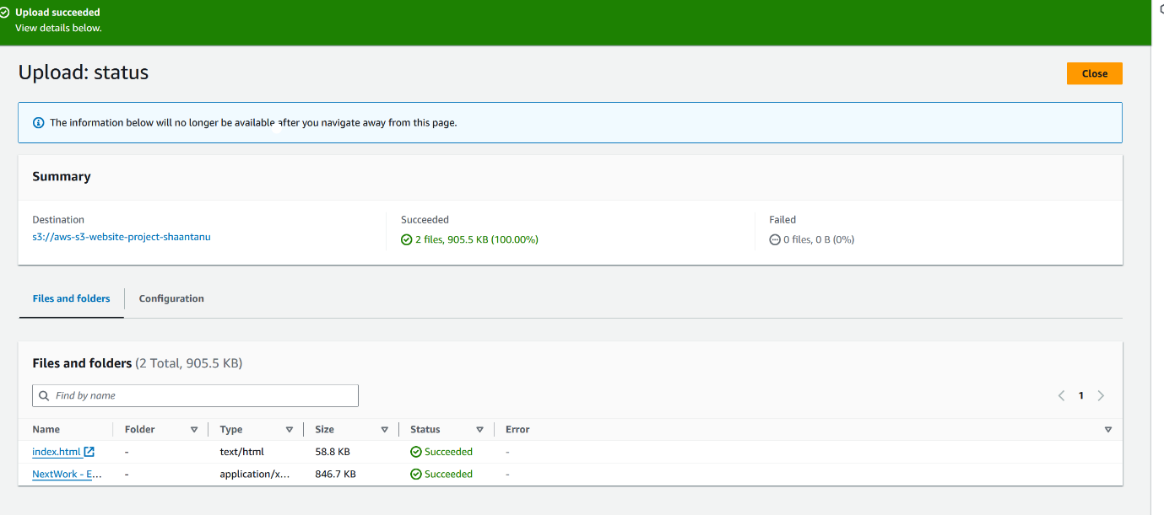

**Step 3: Enabling Static Website Hosting**

I navigated to the S3 bucket settings and enabled static website hosting. The index.html file was

selected as the entry point. Public access permissions were adjusted to make the site accessible to

the internet.

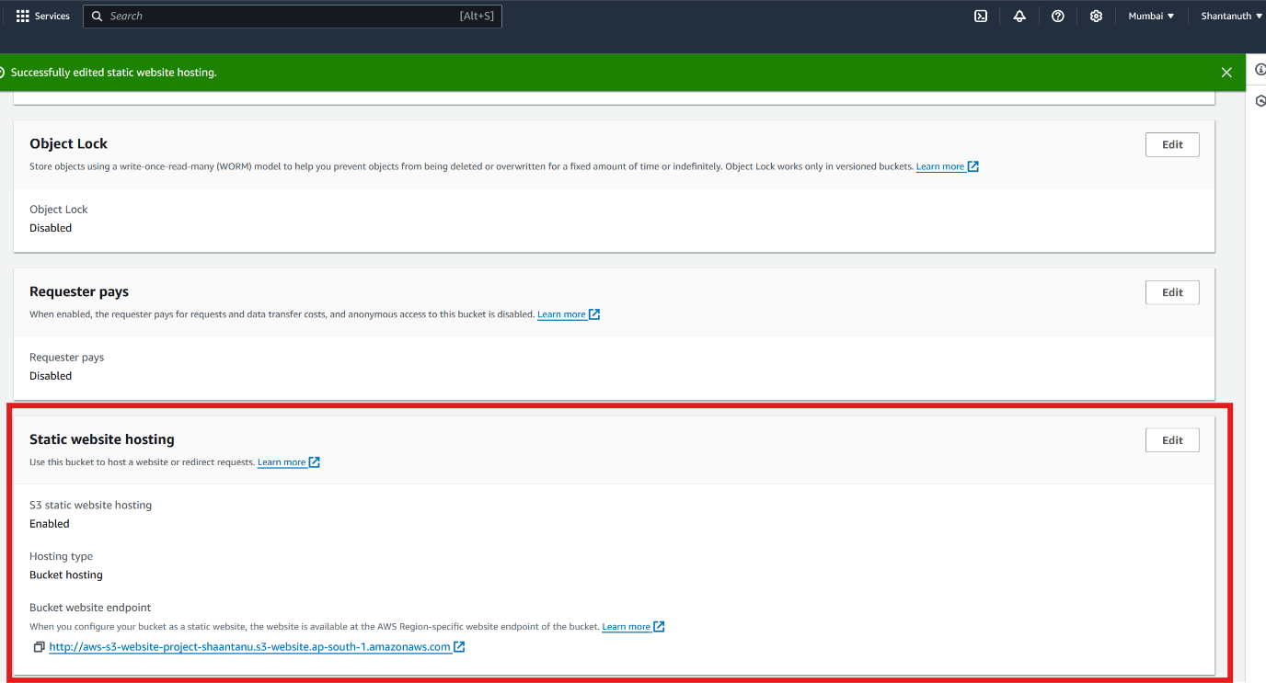

**Step 4: Bucket Website Endpoint URL**

Once hosting was enabled, AWS generated a unique bucket website URL. This endpoint URL is the

link where the website can be accessed publicly.

( highlighted in above snapshot)

**Step 5: Error Encountered**

When visiting the URL, I initially encountered a 403 Forbidden error. This occurred because the

default S3 settings restrict public access. I updated the permissions to resolve the issue.

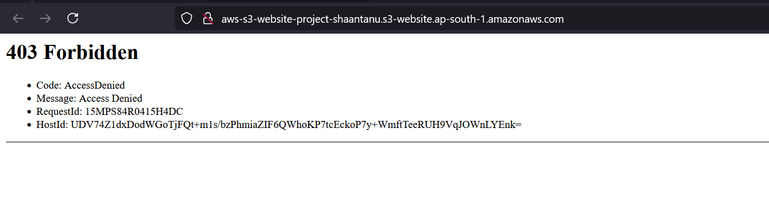

**Step 6: Resolving the Error**

To fix the 403 error, I enabled public access for the index.html file and the media files contained in

the .zip file. Once the correct permissions were applied, the website was accessible.

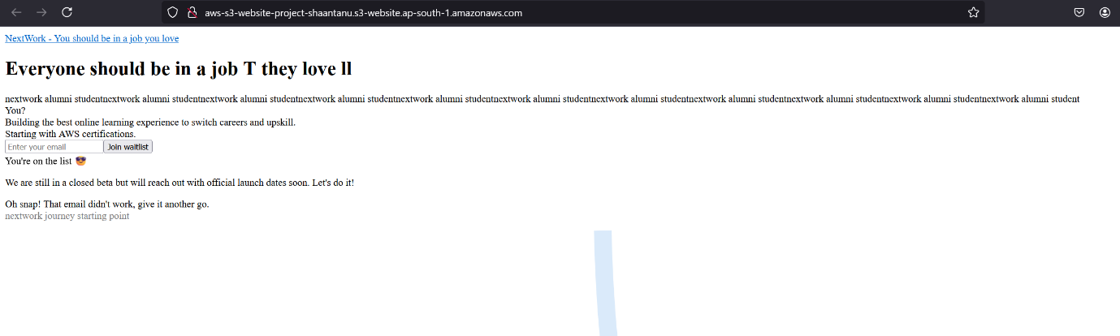

**Conclusion**

The entire project took about 30 minutes. The most surprising part was how straightforward it was to configure permissions for public access. AWS provides a simple yet powerful interface for hosting

static websites.