CS350: Independent Testing of SafeHome

Testing: Team 1
Tested by: Team2

20220686 | Minjun Choi
20200315 | Daegyu Sung
20230704 | Songho Cho
20230091 | Minkyeong Kim

Table of Content

I. Installation errors 3
A. Insufficient requirements 3
II. DB update errors 3
A. Web password changes not saved properly 3
B. Changes in safehome mode on web not reflected to control panel 3
C. Control panel ‘reset’ doesn’t work properly 4
III. Design errors 4
A. Configure page is not scrollable 4
B. Guest login impossible when guest password is empty 5
C. Guest password changing impossible when guest password is empty 5
D. No sensor management page 5
E. Panic button can be pressed when system is off 6
F. Entering phone number when entering security page should be required every time 6
IV. Abnormal behavior/UI 6
A. Errors on turning the system off 6
B. Abnormal behavior on panic button (Clicking single time) 7
C. Abnormal behavior on panic button (Clicking multiple times) 7
D. Errors in adding safety zone with long name 8
E. Errors in quitting to add security zone 8
F. Surveillance page is downed 9
G. Surveillance page shows wrong image 9

- Installation errors
  - Insufficient requirements
Title | Author | Date
Insufficient requirements | Daegyu Sung | 25.12.08
Description
Main.py requires extra installation to run
Test sequence
1. python version 3.14
2. python3 -m venv .venv
3. source .venv/bin/activate
4. pip install -r requirements.txt
5. python main.py
Expected result
Main.py opens without error
Actual result
ModuleNotFoundError: No module named 'PIL’
Comment (including traceability)
Refer to Manual(ReadMe) – Environment Setup (line 56)
- DB update errors
  - Web password changes not saved properly
Title | Author | Date
Web password changes not saved properly | Daegyu Sung | 25.12.08
Description
Web password changes should be saved
Test sequence
1. enter System Setting page by clicking ‘Configure System Setting’ in web
2. enter current password and new password (’1234qwer’)
3. restart app (`python main.py`)
4. try to login with new password (’1234qwer’)
Expected result
Login success with new password
Actual result
Login fail with new password, and success with old password
Comment (including traceability)
I tried ‘qwerasdf’ also (full char passwords), but it still doesn’t work.
Refers to UC ‘Configure system setting’
  - Changes in safehome mode on web not reflected to control panel
Title | Author | Date
Changes in safehome mode on web not reflected to control panel | MinKyoung Kim | 25.12.08
Description
Safehome mode settings should be shown on control panel screen
Test sequence
1. enter Security page → Set Safehome mode on web
2. change Safehome mode on web (ex. home/away)
Expected result
Current (changed) mode appears on control panel
Actual result
Changed mode does not appear on control panel
Comment (including traceability)
Even considering real-time update isn’t supported, when refresh is done on control panel by other functions (ex. by changing password), mode doesn’t reflect current state
Refer to UC ‘Arm/disarm system through web brower’; ‘The system applies new status to the entire system’ (from SDS)
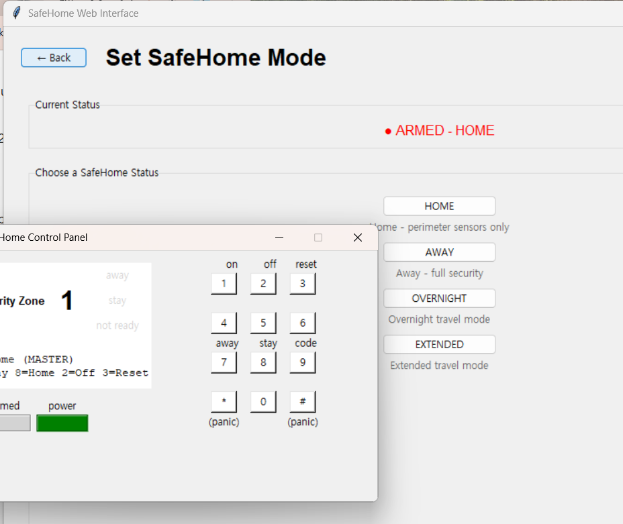
  - Control panel ‘reset’ doesn’t work properly
Title | Author | Date
Control panel ‘reset’ doesn’t work properly | MinKyoung Kim | 25.12.08
Description
Reset button should reset all user settings, including passwords
Test sequence
1. turn on the control panel
2. press 9 and enter new password (ex. 7890)
3. reset the system - password (master) should be reset to default value (1234)
4. try to log in with 1234
Expected result
1234 login success
Actual result
Logging in with 1234 fails. 7890 successes.
Comment (including traceability)
None
- Design errors
  - Configure page is not scrollable
Title | Author | Date
Configure page (System settings) is not scrollable | Daegyu Sung | 25.12.08
Description
A page that might not show all buttons at once should be scrollable
Test sequence
1. enter System Setting page by clicking ‘Configure System Setting’ in web
2. this page is not scrollable so I can’t see `save all change` button at first.
Expected result
Showing all buttons at once, or the page being able to scrollable
Actual result
Buttons hided to user
Comment (including traceability)
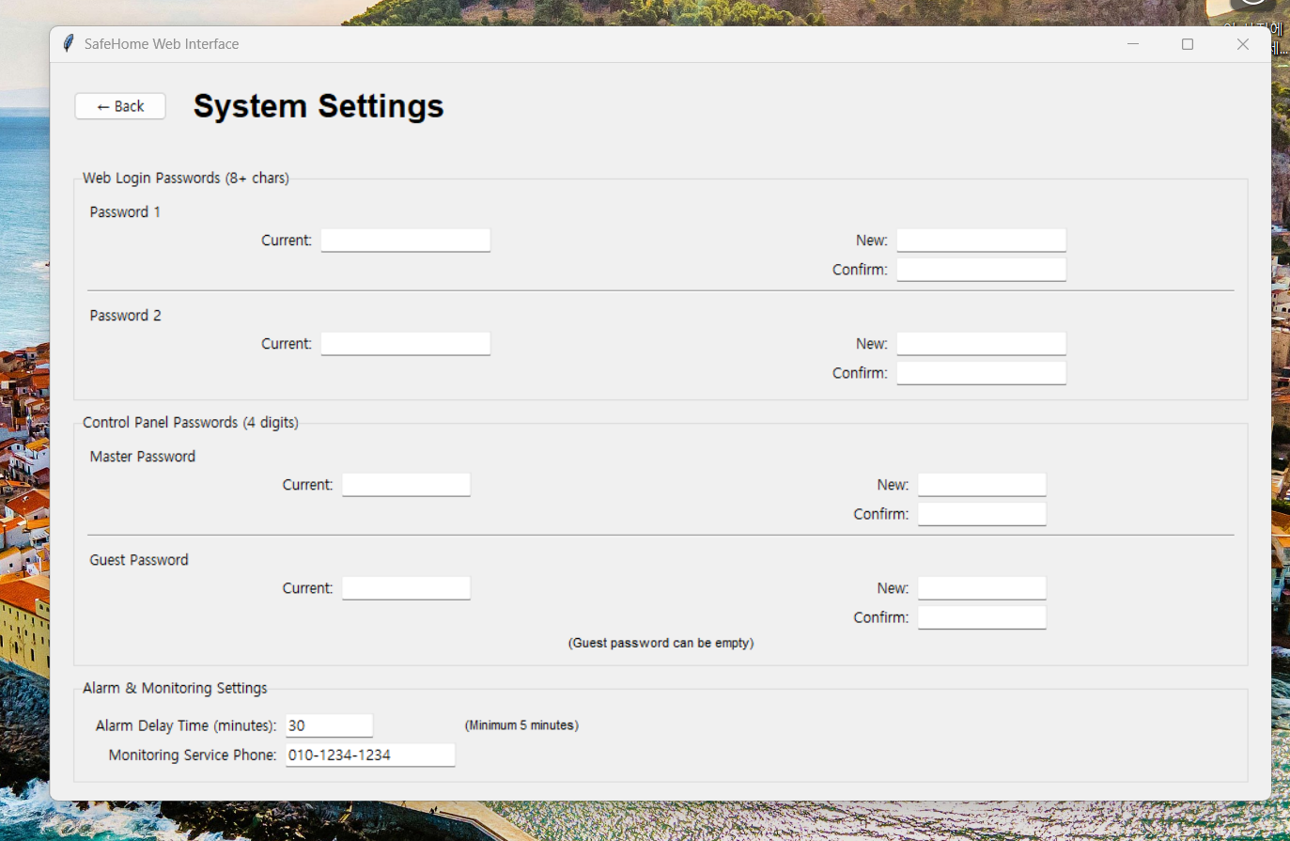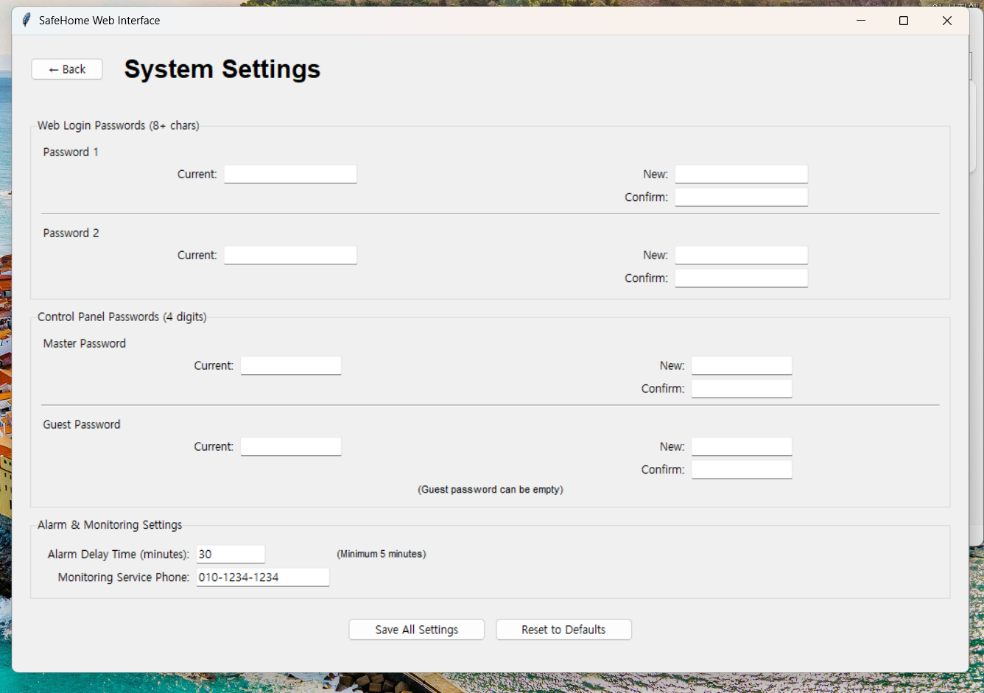
What appears / what it should be
  - Guest login impossible when guest password is empty
Title | Author | Date
Guest login impossible when guest password is empty | MinKyoung Kim | 25.12.08
Description
Guest login should be possible by some way in every situations
Test sequence
1. Set guest password as empty from web-configuration
2. Turning the control panel on requires ‘Enter password’ as default
3. Then, there is no way to log in as guest as no password exists.
Expected result
Guest login available with empty password
Actual result
No way to login as guest
Comment (including traceability)
There should be a button for guest login to fix this error. You cannot enter nothing to login
If some method exists, it should be on manual.
Refers to UC ‘Configure system setting’; Guest password can have no value. UC ‘log onto the system through control panel’ should still work.
  - Guest password changing impossible when guest password is empty
Title | Author | Date
Guest password changing impossible when guest password is empty | MinKyoung Kim | 25.12.08
Description
Guest password change should be possible by some way in every situations
Test sequence
1. Set guest password as empty from web-configuration
2. Try to change guest password from web-configuration
3. Leaving ‘guest password - current’ empty, as it is set now, shows error message ‘Current guest password is required’
Expected result
Guest password change when the password is empty should not require current password
Actual result
Requires current password; no way to set the password again, except for resetting the entire system
Comment (including traceability)
Refers to UC ‘Configure system setting’

(sequence 1)
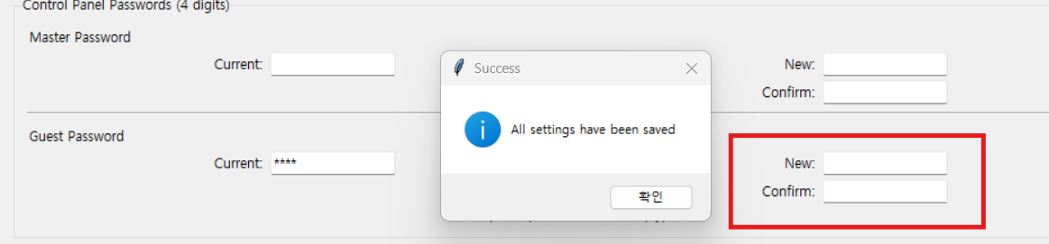
(sequence 2)
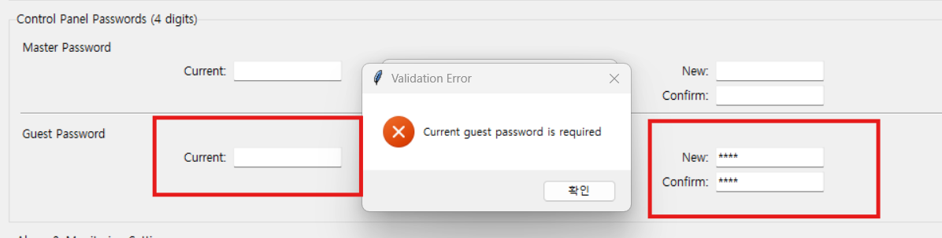
  - No sensor management page
Title | Author | Date
No sensor management page (arm/disarm and intrude/release single sensor) | Daegyu Sung | 25.12.08
Description
Sensor management pages is needed for intrusion simulation
Test sequence
None
Expected result
Sensor management page enables intrusion simulations
Actual result
No method for intrusion simulations
Comment (including traceability)
None
  - Panic button can be pressed when system is off
Title | Author | Date
Panic button can be pressed when system is off | MinJun Choi | 25.12.08
Description
Panic button requires system being ready (on)
Test sequence
1. Press panic button on control panel, before pressing the ‘on’ button.
Expected result
Panic should not occur since the system is off
Actual result
Panic occurs
Comment (including traceability)
Refers to UC ‘Call monitoring service through control panel’ – preconditions include ‘System is running’
Team 1’s SITS mentions (Unit tests 1.A.1.k) panic should work every time, but it seems to be an unlikely modification. There are no other comments that the control panel has a battery, or internal supplies that enable the panic button and password verification when the system is off - it is unlikely the panic button works when the system is off.
  - Entering phone number when entering security page should be required every time
Title | Author | Date
Entering phone number when entering security page should be required every time | MinKyoung Kim | 25.12.08
Description
To enter the security page, phone number should be entered every time.
Test sequence
1. Go to security page
2. Enter phone number
3. Leave security page
4. Go back to security page
Expected result
Phone number should be re-entered for entering page
Actual result
Access available without typing phone number. (Already verified)
Comment (including traceability)
Various UCs, including ‘Arm/disarm safety zone selectively’ mentions scenarios of ‘The homeowner selects “Security” from major function buttons.’, then ‘The homeowner enters address or phone number to reconfirm identity.’ Thus reconfirmation should be done every time entering ‘Security’ page.
- Abnormal behavior/UI
  - Errors on turning the system off
Title | Author | Date
Errors on turning the system off | Daegyu Sung | 25.12.08
Description
System should be turned of by pressing 1
Test sequence
1. Run `python main.py`
2. press 1 for turn on control panel
3. press 1 again
Expected result
The control panel should be turned off
Actual result
Panel is not offed
Comment (including traceability)
Manual (Readme) indicates: Power Off: Press 1 again. The LED turns off. (line 105)
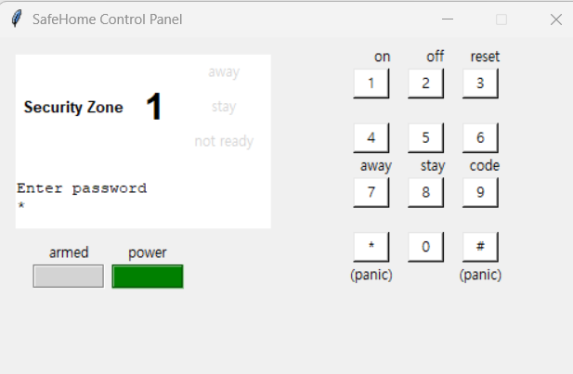
Clicking 1 again is inputted as part of password
  - Abnormal behavior on panic button (Clicking single time)
Title | Author | Date
Abnormal behavior on panic button (Clicking single time) | MinKyoung Kim | 25.12.08
Description
Panic button pressing should show proper message on panel
Test sequence
1. Press panic button on control panel
2. It should show ‘Panic mode’ message.
3. But, after a very short display of ‘Panic mode’ , it changes to ‘!ALARM! INTRUSION \n UNKNOWN @ UNKNOWN’ message (while no intrusion happened)
Expected result
Display ‘Panic Mode’
Actual result
Display !ALARM! INTRUSION \n UNKNOWN @ UNKNOWN’
Comment (including traceability)
Pressing the panic button again displays ‘Panic mode’ message again. But anyway, the panel doesn’t show a proper message when clicked once.
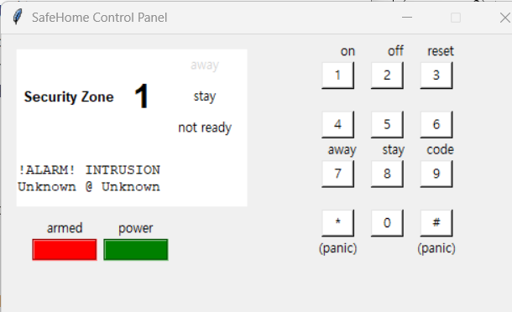
  - Abnormal behavior on panic button (Clicking multiple times)
Title | Author | Date
Abnormal behavior on panic button (Clicking multiple times) | MinKyoung Kim | 25.12.08
Description
Repeatedly clicking the panic button should not cause different behaviors.
Test sequence
1. Press panic button on control panel repeatedly in very short time(likely to happen in real-world panic situations)
Expected result
Enter the master password, and the system is turned off.
Actual result
i. Sometimes, entering the master password once (to disable panic) makes the system turned on, logged in
ii. Other times, entering the master password leads to a turned on, logged out state. Then, if I enter the master password to login, login doesn’t work right away. It shows another ‘Enter password’ screen.
Comment (including traceability)
Problems don’t occur always; trying it several times lead to occasional errors.
  - Errors in adding safety zone with long name
Title | Author | Date
Errors in adding security zone with long name | MinKyoung Kim | 25.12.08
Description
Security zones with long name shouldn’t cause abnormal behavior
Test sequence
1. From web, go to security → safety zone → create safety zone
2. Enter a very long name (over 30 characters)
Expected result
The configuration page normally works.
Actual result
Adding a very long name makes the floor plan’s width small, while it’s window is unscrollable - cannot access to the hidden side of the floor plan
Comment (including traceability)
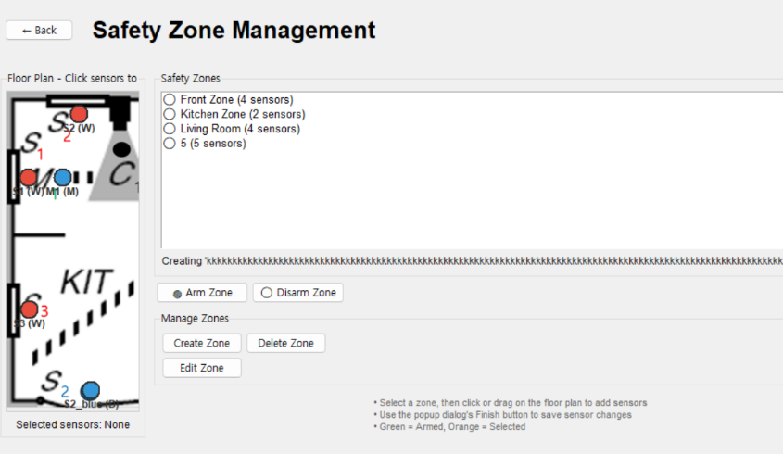

  - Errors in quitting to add security zone
Title | Author | Date
Errors in quitting to add security zone | MinKyoung Kim | 25.12.08
Description
Adding the zone should be aborted if user leaves security page.
Test sequence
1. From web, go to security → safety zone → create safety zone
2. A popup window ‘Create Zone: (name)’ appears
3. Press ‘Back’ button (to Security page),
Expected result
Adding security zone is aborted
Actual result
The popup window doesn’t disappear
Comment (including traceability)
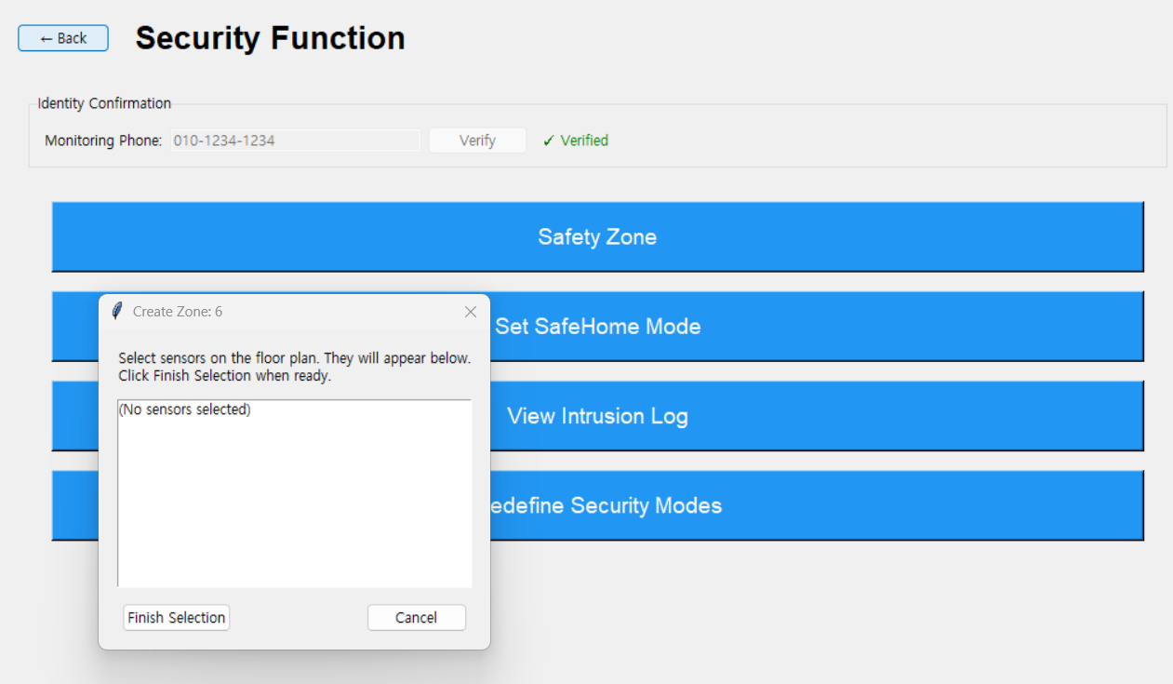
  - Surveillance page is downed
Title | Author | Date
Surveillance page is downed | Daegyu Sung | 25.12.08
Description
Some sequences lead to abnormally rendered pages for surveillance
Test sequence
1. login to web
2. go to surveillance page (press `Surveillance Function`)
3. click camera (C2) and set new password
4. back to surveillance page
5. click camera (C2) and type wrong password
6. web interface show gray page

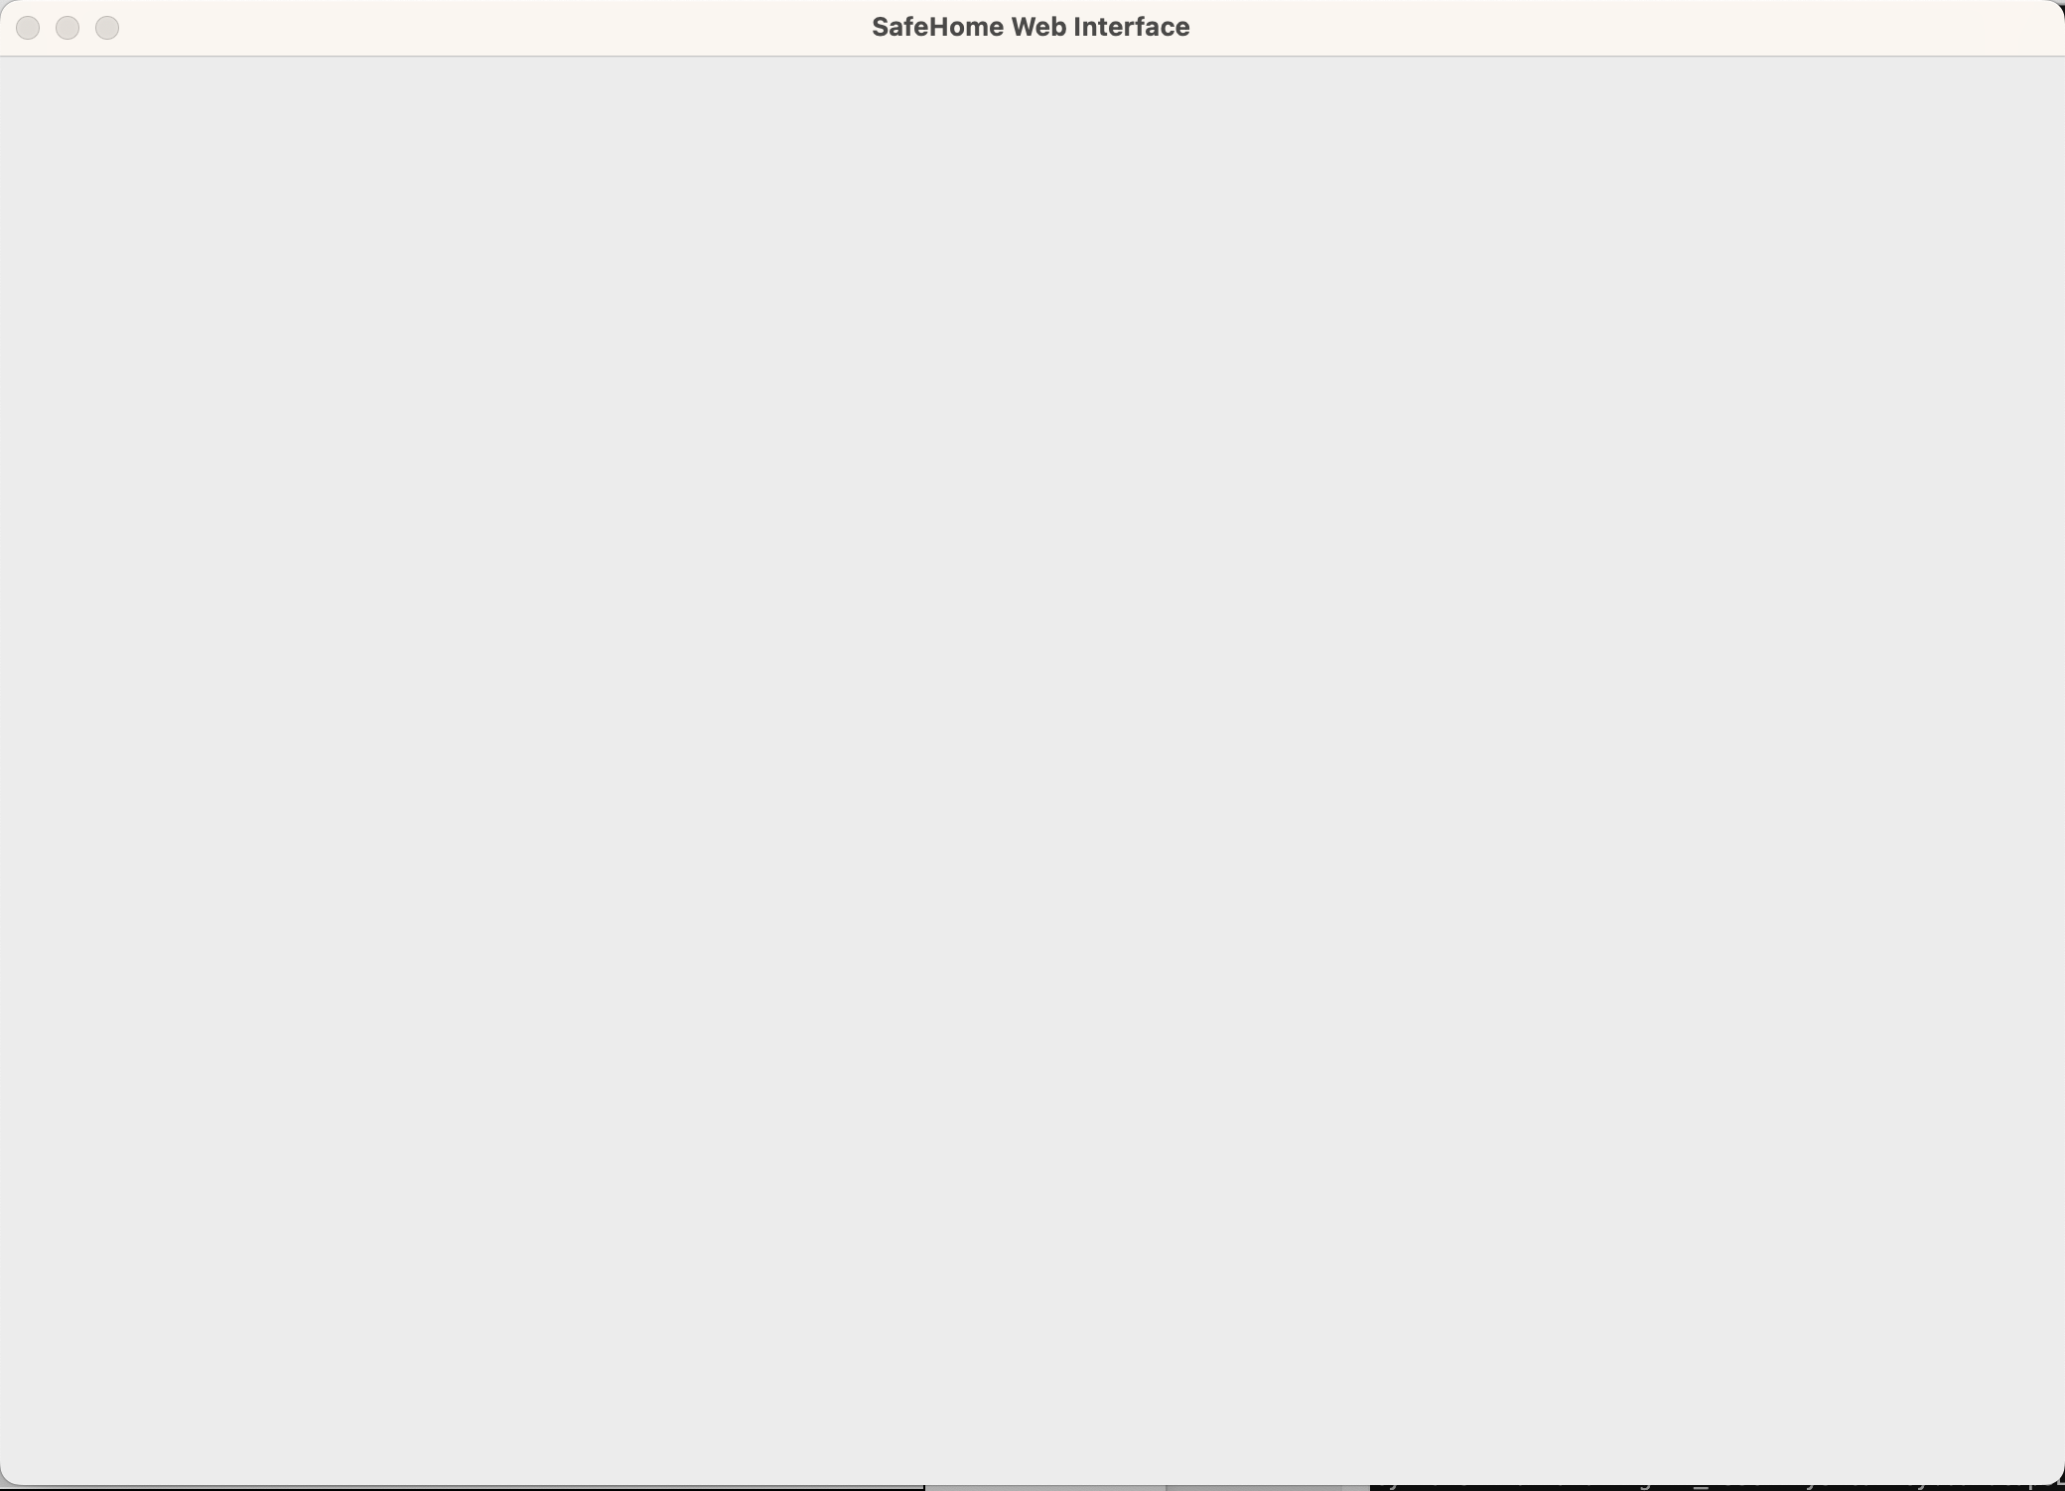
Expected result
Show Single Camera Page without bug
Actual result
Page is not rendered well (all gray page)
Comment (including traceability)
None
  - Surveillance page shows wrong image
Title | Author | Date
Surveillance page shows wrong image | MinKyoung Kim | 25.12.08
Description
When only some cameras are enabled, disabled cameras show wrong image.
Test sequence
1. Set password for camera C1, enable it
2. Leave cameras C2 and C3 disabled
3. go to ‘all cameras’(thumbnail view) page
4. click C2/C3 camera page
Expected result
No image should be displayed, as it is disabled.
Actual result
Shows image of camera C1
Comment (including traceability)
As a similar issue, when a wrong image is shown, the pan/tilt/zoom doesn’t match the explanation.
