CS350: Independent Testing of SafeHome

Testing: Team 3
Tested by: Team2

20220686 | Minjun Choi
20200315 | Daegyu Sung
20230704 | Songho Cho
20230091 | Minkyeong Kim

Table of Content

I. Critical Bug 1
A. example 1
II. Unintended Behavior 2
A. example 2

- Critical Bug

  - example
Title | Author | Date
Wrong Web password restriction | Minjun Choe | 25.12.05
Description
Web password must be 8 characters long and allow letters, but currently it is restricted to 4 digits or has no limit in the configuration page.
Test sequence
1. Log in via Web Browser.
2. Go to 'Configure system setting' page.
3. Attempt to set a web password with letters and 8 characters.
Expected result
Web password should accept 8 characters including letters and numbers. Invalid length or format should trigger a warning.
Actual result
Configuration page accepts any length but does not apply it correctly.
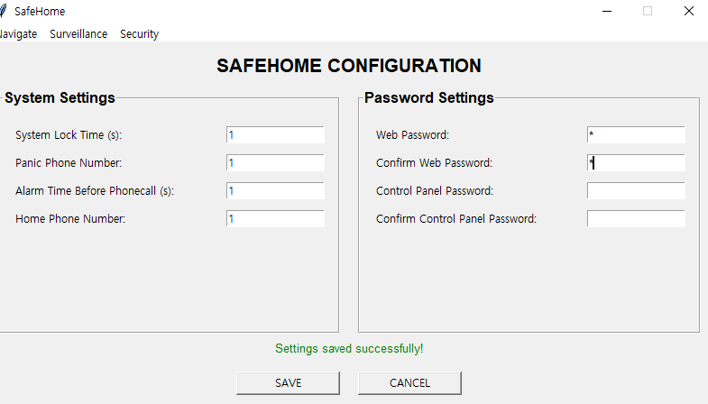
Comment (including tracibility)
SRS V.1.b.3: The homeowner enters two level passwords, each have 8 characters.

Title | Author | Date
Safetymode Unsyschronize problem | Minjun Choe | 25.12.05
Description
The control panel's mode change does not synchronize with the webpage in real time.
Test sequence
1. Change system mode on the Control Panel (e.g., Disarmed -> Away).
2. Check the current security status on the Web Interface.
Expected result
The Web Interface status should immediately reflect the mode change made on the Control Panel.
Actual result
The Web Interface shows the previous status until the page is refreshed.

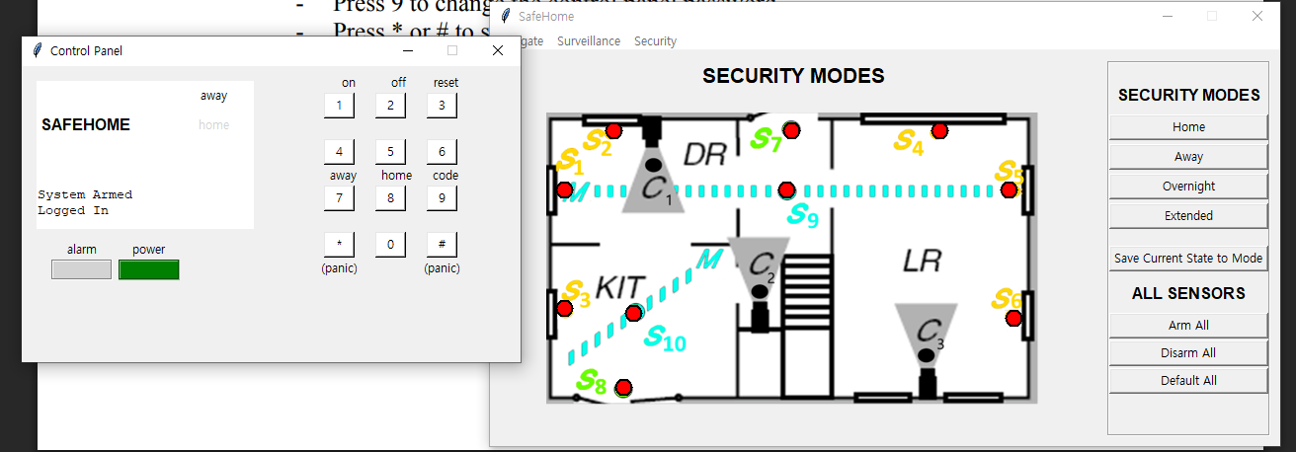
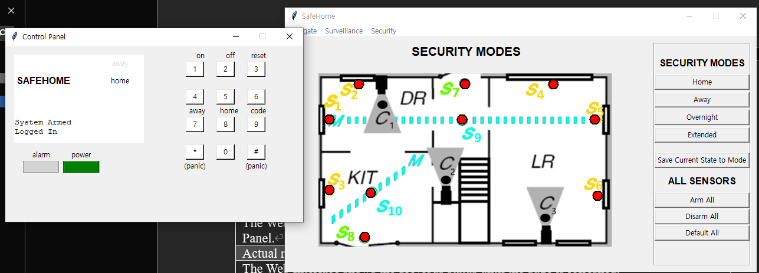
Comment (including tracibility)
SRS V.2.b.6: The system displays current house safety situation... (Real-time synchronization requirement)

Title | Author | Date
Safety zones overlapping problem | Minjun Choe | 25.12.05
Description
Safety zones must not overlap.
Test sequence
1. Connect to Web Interface and go to Safety Zone settings.
2. Select 'Create new safety zone'.
3. Attempt to drag and create a zone that overlaps with an existing one.
Expected result
The system should prevent creating overlapping zones or display an error message.
Actual result
Overlapping zones are created without any warning or error.
Comment (including tracibility)
SRS V.2.f Exception 3a: New safety zone is same with an existing safety zone - system displays error. (Overlap check missing)

Title | Author | Date
Safety zone deleting error | MinKyoung Kim | 25.12.05
Description
Safety zones must be deleted properly
Test sequence
1. Connect to Web Interface and go to Safety Zone settings.
2. Select 'Create new safety zone'.
3. Resize the safety zone by dragging.
3. Attempt to delete the safety zone very quickly, just after finishing the dragging.
Expected result
The dragging should finish properly and delete should be normally done.
Actual result
Exception in Tkinter callback
Traceback (most recent call last):
File "C:\Users\...\.pyenv\pyenv-win\versions\3.14.0rc3\Lib\tkinter\__init__.py", line 2082, in __call__
return self.func(*args)
~~~~~~~~~^^^^^^^
File "C:\Users\...\src\gui\gui_securityzone.py", line 310, in resize_drag
rect = [r for r, n in self.zone_icons.items() if n == zone_name][0]
~~~~~~~~~~~~~~~~~~~~~~~~~~~~~~~~~~~~~~~~~~~~~~~~~~~~~~~~~^^^
IndexError: list index out of range

Called multiple times.
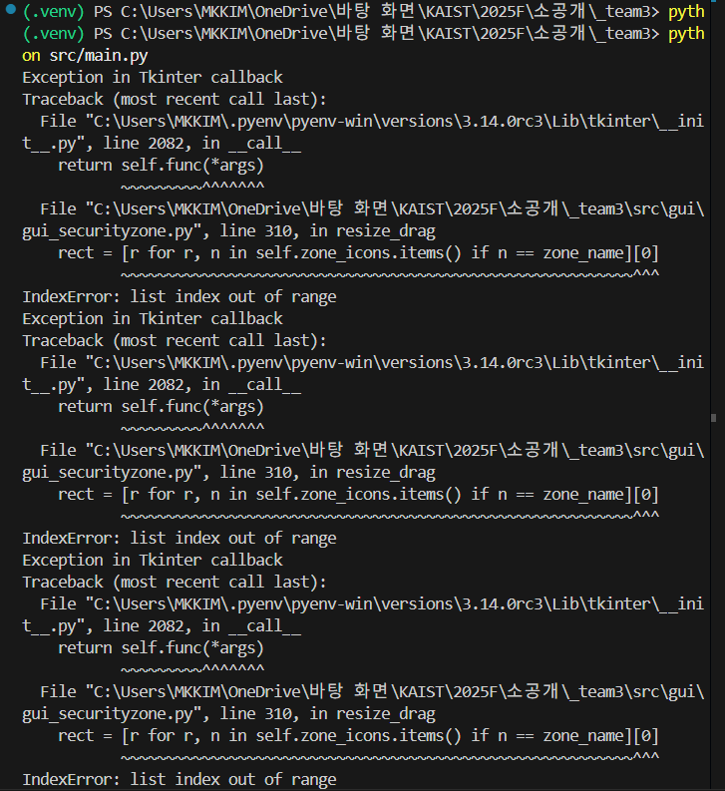
Comment (including tracibility)
None

Title | Author | Date
Unable mode after pressing 'Default all' | Sungho Cho | 25.12.05
Description
GUI unit tests are failing.
Test sequence
1. Run the provided 'gui_unit_tests' script.
2. Check the console output for errors.
Expected result
All GUI unit tests should pass without errors.
Actual result
GUI test errors occur during execution.
Comment (including tracibility)
General System Stability / Quality Assurance issue.

Title | Author | Date
Guest login not supported | MinGyeong Kim | 25.12.05
Description
Guest login functionality is not supported.
Test sequence
1. Attempt to log in using Guest credentials defined in the requirements.
2. Check for Guest specific options in the configuration.
Expected result
The system should allow Guest login with restricted permissions as per the requirements.
Actual result
There is no option or functionality for Guest login.
Comment (including tracibility)
SRS V.1.a: 'Log onto the system through control panel' (Homeowner, Guest) & V.1.c (Guest password configuration).

Title | Author | Date
Unable mode after pressing 'Default all' | Seongho Cho | 25.12.05
Description
The 'Update Safety Zone' function is missing from the Safety Zone UI.
Test sequence
1. Go to 'Safety Zone' configuration page.
2. Look for the 'Update Safety Zone' button or function.
Expected result
There should be a button or mechanism to update an existing safety zone.
Actual result
The 'Update Safety Zone' button is missing from the interface.
Comment (including tracibility)
SRS V.2.h: 'Update an exist safety zone'. The functionality is explicitly defined in the Use Cases but missing in UI.

- Unintended Behavior

  - example
Title | Author | Date
Wrong phone number entering UI | Minjun Choe | 25.12.05
Description
The Web UI displays 're-enter phone number' even though it is the first time entering it.
Test sequence
1. Connect to Web Interface.
2. Select ‘Configuration’ function.
3. Check the phone number input popup for identity confirmation.
Expected result
For the first input, a simple request message should appear, not 're-enter'.
Actual result
The message 'Re-enter phone number' is displayed despite being the first attempt.
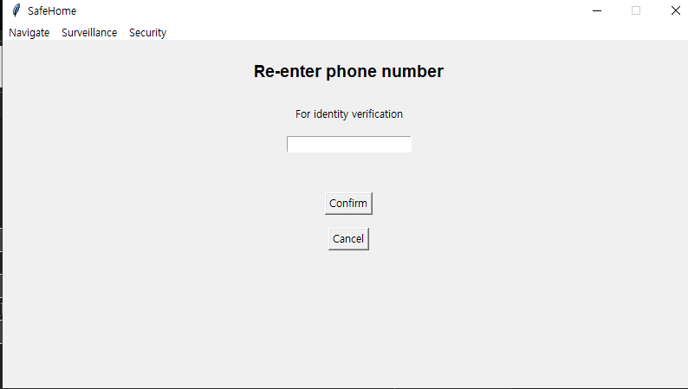
Comment (including tracibility)
SRS V.2.c.3: The homeowner enters address or phone number to reconfirm identity. (UI Text consistency issue)

Title | Author | Date
Unsynchronize of camera lock state | Minjun Choe | 25.12.05
Description
Even if you add a password to the camera to lock it, the status on the right does not immediately change to ON.
Test sequence
1. Connect to Web Interface.
2. Go to 'Surveillance' menu.
3. Select a specific camera and perform 'Set Password'.
4. Check the LOCK status in the Camera Status on the right.
Expected result
The LOCK status of the camera should update from OFF to ON immediately after setting the password.
Actual result
The LOCK status in the Camera Status does not update immediately after setting the password.
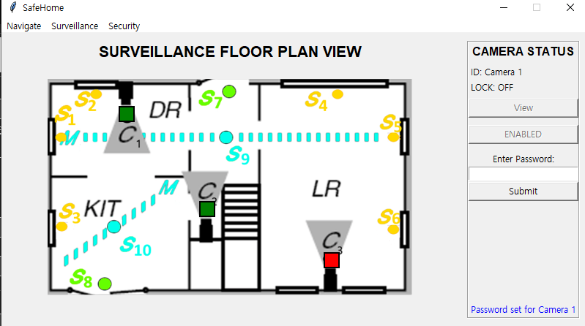
Comment (including tracibility)
SRS V.3.c: Set camera password & SRS II GUI (Camera Status Panel definition).

Title | Author | Date
Unable mode after pressing 'Default all' | Sungho Cho | 25.12.05
Description
Initial phone number is displayed incorrectly.
Test sequence
1. Go to 'Configure system setting' page.
2. Check the default value in the phone number field.
Expected result
The initial phone number should be empty or show a valid default value, not an incorrect one.
Actual result
An incorrect or garbage phone number is displayed.
Comment (including tracibility)
SRS V.1.c Configure system setting: Default values should be handled correctly.

Title | Author | Date
Camera view panning goes out of range | MinKyong Kim | 25.12.05
Description
Camera view panning extends beyond the image boundaries, displaying a black area.
Test sequence
1. Select a camera in Surveillance view.
2. Pan the camera Left or Right to the extreme edge.
Expected result
The panning action should stop exactly at the edge of the camera image.
Actual result
The camera view continues to pan past the image, showing a black background.
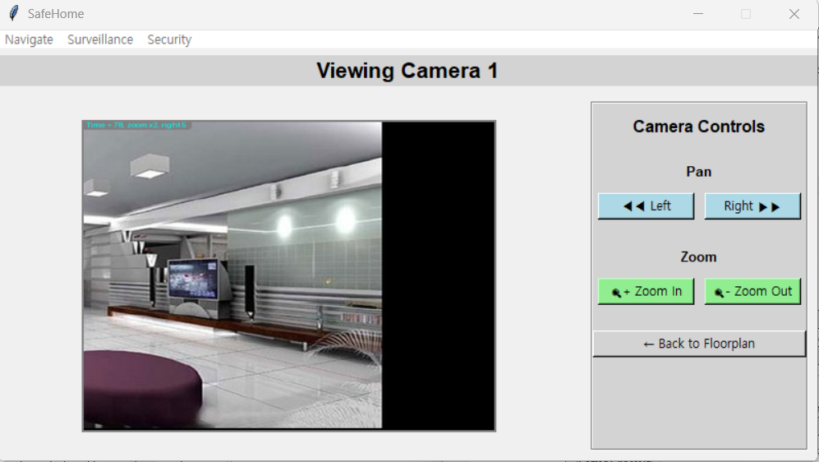
Comment (including tracibility)
SRS V.3.b Pan/Zoom specific camera view: User interface constraint.

Title | Author | Date
Security mode webpage size differences on clicking button | MinKyoung Kim | 25.12.05
Description
In security mode menu, saving changes causes the menu layout/size to shift due to the message box.
Test sequence
1. Go to 'Configure SafeHome modes'.
2. Modify a mode and click 'Save'.
3. Observe the menu window size and layout.
Expected result
The menu layout should remain stable, and the message box should appear within the existing bounds without resizing the window.
Actual result
The menu size changes, and the layout shifts when the success/notification message box appears.

Comment (including tracibility)
SRS Non-functional requirements: 5) User-friendliness (Consistent Interface).
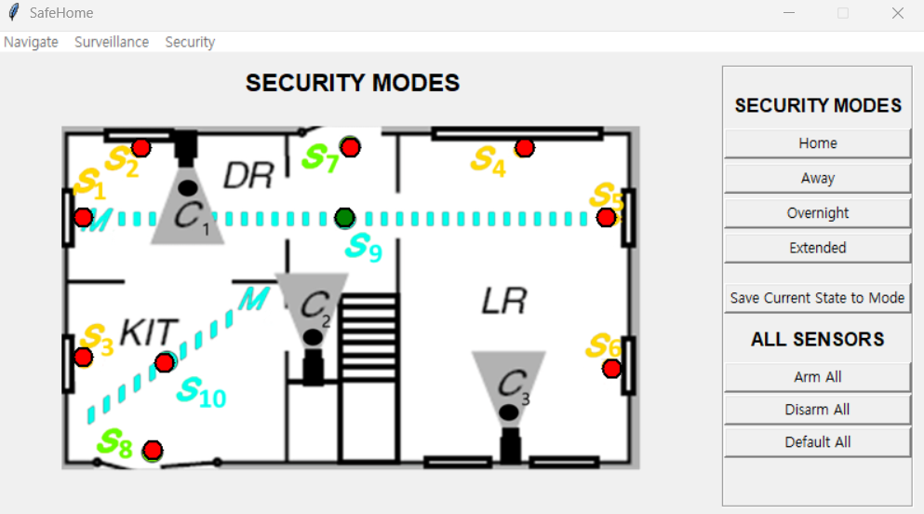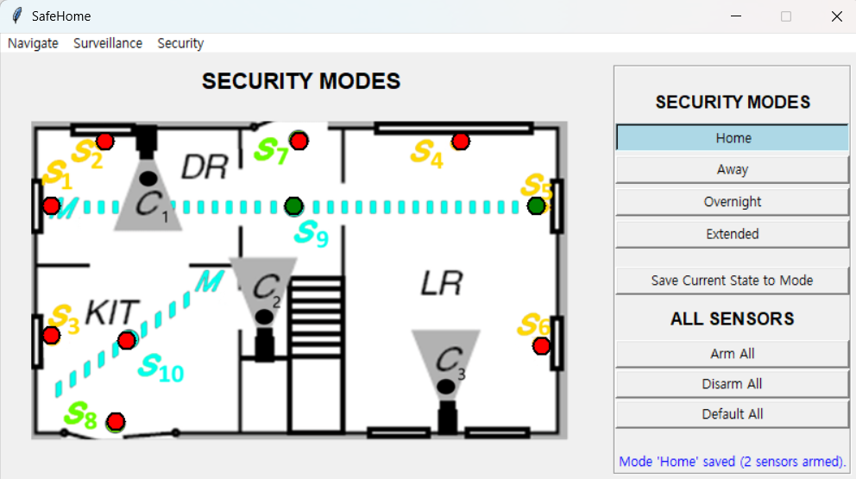
Before selection / After pressing button

Title | Author | Date
Unable to deselect a zone in security zone page | Minkyoung Kim | 25.12.05
Description
After creating a zone, it is impossible to 'deselect' it without performing an action (disarm/delete) or navigating away.
Test sequence
1. Create a new safety zone on the floor plan.
2. Select the created zone.
3. Click on an empty area of the floor plan to deselect.
Expected result
Clicking on a blank area should deselect the currently selected zone.
Actual result
The zone remains selected until a functional button (Disarm/Delete) is pressed or the page is changed.
Comment (including tracibility)
SRS V.2.e Configure safety zone: Usability issue regarding object selection/deselection.

Title | Author | Date
Inappropriate alarm delay time available | MinKyoung Kim | 25.12.05
Description
Alarm delay time setting accepts values under 5 minutes.
Test sequence
1. Go to 'Configure system setting'.
2. Attempt to set 'Delay time' to 4 minutes or less.
3. Click Submit.
Expected result
The system should reject the input and show an error message stating the minimum time is 5 minutes.
Actual result
The system accepts values less than 5 minutes.
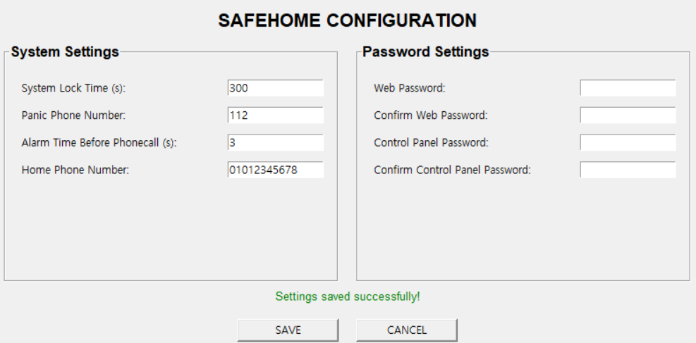
Comment (including tracibility)
SRS V.1.c Exception 6b: 'delay time is less than 5 minutes - The system shows an error message'.

