目录

重启记得配置/etc/resolv.conf 2

安装增强功能 复制粘贴 2

修改源为阿里云： 2

安装vim 3

网卡配置 3

安装SSH 3

添加新用户neo 密码matrix 4

添加neo到sudoer 4

BIND9 4

Nginx web 域名访问 7

Nginx SSL 443 8

PHP 10

Java tomcat 11

Postfix 13

Mysql 13

防火墙 14

RAID1 15

### 重启记得配置/etc/resolv.conf

最前面添加 nameserver 192.168.56.101

### 安装增强功能 复制粘贴

### 修改源为阿里云：

备份：cp /etc/apt/sources.list /etc/apt/sources.list.bak

修改 /etc/apt/sources.list

# deb cdrom:[Ubuntu 16.04 LTS _Xenial Xerus_ - Release amd64 (20160420.1)]/ xenial main restricted

deb-src http://archive.ubuntu.com/ubuntu xenial main restricted #Added by software-properties

deb http://mirrors.aliyun.com/ubuntu/ xenial main restricted

deb-src http://mirrors.aliyun.com/ubuntu/ xenial main restricted multiverse universe #Added by software-properties

deb http://mirrors.aliyun.com/ubuntu/ xenial-updates main restricted

deb-src http://mirrors.aliyun.com/ubuntu/ xenial-updates main restricted multiverse universe #Added by software-properties

deb http://mirrors.aliyun.com/ubuntu/ xenial universe

deb http://mirrors.aliyun.com/ubuntu/ xenial-updates universe

deb http://mirrors.aliyun.com/ubuntu/ xenial multiverse

deb http://mirrors.aliyun.com/ubuntu/ xenial-updates multiverse

deb http://mirrors.aliyun.com/ubuntu/ xenial-backports main restricted universe multiverse

deb-src http://mirrors.aliyun.com/ubuntu/ xenial-backports main restricted universe multiverse #Added by software-properties

deb http://archive.canonical.com/ubuntu xenial partner

deb-src http://archive.canonical.com/ubuntu xenial partner

deb http://mirrors.aliyun.com/ubuntu/ xenial-security main restricted

deb-src http://mirrors.aliyun.com/ubuntu/ xenial-security main restricted multiverse universe #Added by software-properties

deb http://mirrors.aliyun.com/ubuntu/ xenial-security universe

deb http://mirrors.aliyun.com/ubuntu/ xenial-security multiverse

**sudo apt-get update**

### 安装vim

sudo apt-get install vim

### 网卡配置

记得关闭虚拟机之后再设置网卡

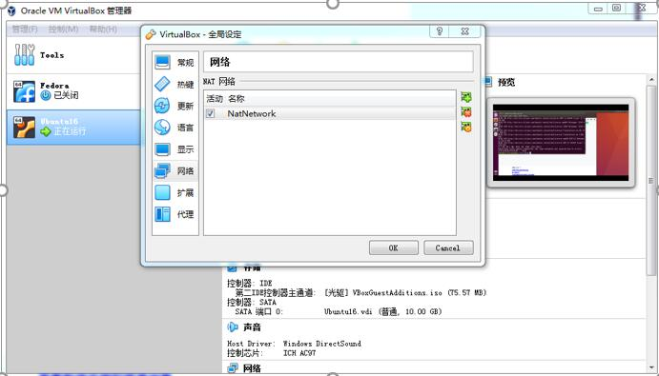

Host-only

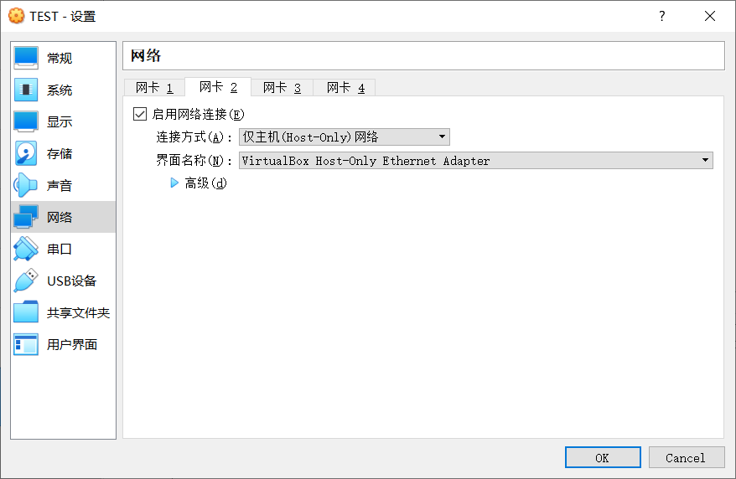

sudo vim /etc/network/interfaces

auto **enp0s8 #注意网卡名 ifconfig查看**

iface enp0s8 inet static

address 192.168.0.101

netmask 255.255.255.0

重启网卡： sudo ifdown enp0s8

sudo ifup enp0s8

ifconfig

或者 /etc/init.d/networking restart

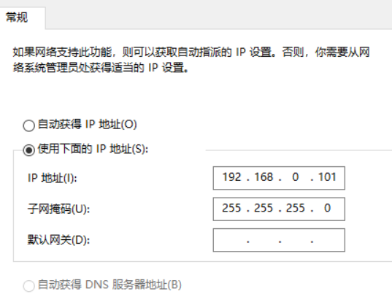

### 安装SSH

sudo apt-get install ssh

开启 sudo service ssh start

考虑用cmd来做

### 添加新用户neo 密码matrix

sudo passwd root

sudo su

adduser neo

输入密码后一直回车

### 添加neo到sudoer

Root下：visudo

# User privilege specification

root ALL=(ALL:ALL) ALL

添加：

**neo ALL=(ALL:ALL) ALL**

ctrl+x 退出 选择yes 回车保存

用neo登陆

**测试能不能用sudo命令 如sudo su**

### BIND9

sudo apt install bind9

cd /etc/bind

在主配置/etc/bind/named.conf.local文件中添加正向和反向zone声明

sudo vim /etc/bind/named.conf.local

**zone "oasis.com"{**

**type master;**

**file "/etc/bind/db.oasis.com";**

**};**

**zone "56.168.192.in-addr.arpa"{**

**type master;**

**file "/etc/bind/db.192.oasis.com";**

**};**

**配置正向文件**

sudo vim db.oasis.com

**$TTL 604800**

**$ORIGIN oasis.com.**

**@ IN SOA oasis.com. root.oasis.com. (**

**2006080401 ; Serial**

**604800 ; Refresh**

**86400 ; Retry**

**2419200 ; Expire**

**604800 ) ; Negative Cache TTL**

**@ IN NS ns**

**@ IN A 192.168.0.101**

**mail IN A 192.168.0.101**

**web IN A 192.168.0.101**

**ns IN A 192.168.0.101**

**race IN A 192.168.0.101**

**shining IN A 192.168.0.101**

**game IN A 192.168.0.101**

编辑反向文件

sudo vim db.192.oasis.com

**$TTL 604800**

**@ IN SOA oasis.com. root.oasis.com. (**

**2006080401 ; Serial**

**604800 ; Refresh**

**86400 ; Retry**

**2419200 ; Expire**

**604800 ) ; Negative Cache TTL**

**;**

**@ IN NS oasis.com.**

**101 IN PTR mail.oasis.com.**

**101 IN PTR web.oasis.com.**

**101 IN PTR ns.oasis.com.**

**101 IN PTR race.oasis.com.**

**101 IN PTR shining.oasis.com.**

**101 IN PTR game.oasis.com.**

确保客户端中/etc/resolv.conf文件中有域名服务器地址，**最前面添加：**

**nameserver 192.168.0.101**

sudo vim /etc/network/interfaces

第二块网卡添加（重启时会在resolv中添加nameserver）：

dns-nameservers 192.168.0.101

重启bind9 sudo /etc/init.d/bind9 restart

sudo systemctl restart bind9.service

sudo systemctl enable bind9.service

查看状态

sudo systemctl status bind9.service

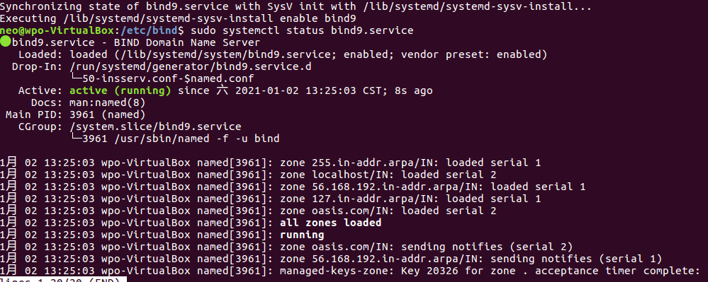

# 正向

ping web.oasis.com

# 反向

host 192.168.0.101

配置网卡的dns：dns为192.168.0.101

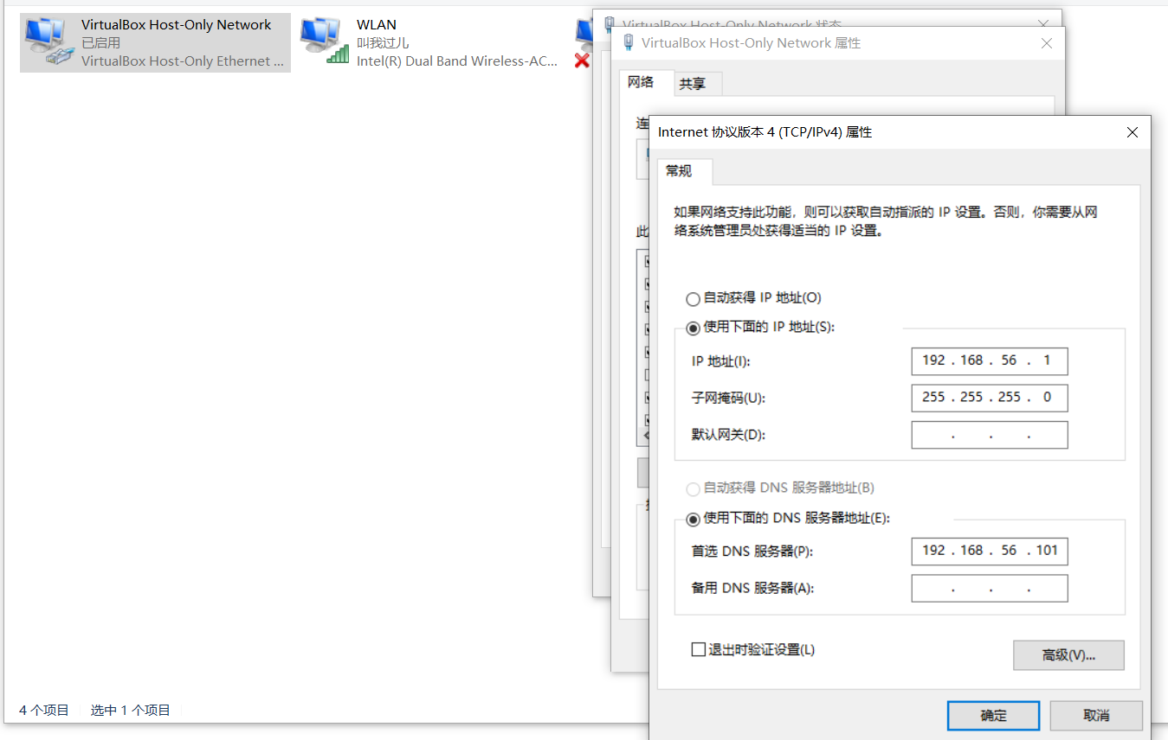

### Nginx web 域名访问

安装nginx：sudo apt-get install nginx

在linux下的浏览器试试输入ip 域名啥的

cd /etc/nginx/sites-available

**复制default，修改root ，servername（域名）和 race的index**

sudo cp default /etc/nginx/sites-available/race

**root /var/www/race;**

**index index.html;**

**server_name race.oasis.com;**

sudo cp default /etc/nginx/sites-available/shining

sudo cp default /etc/nginx/sites-available/game

建立连接

**sudo ln -s /etc/nginx/sites-available/race /etc/nginx/sites-enabled/**

**sudo ln -s /etc/nginx/sites-available/shining /etc/nginx/sites-enabled/**

**sudo ln -s /etc/nginx/sites-available/game /etc/nginx/sites-enabled/**

在/var/www/下创建相应文件夹

cd /var/www

**sudo mkdir race**

**sudo vim /race/index.html**

**<h1> race.oasis.com </h1>**

sudo mkdir shining

sudo mkdir game

sudo chown -R www-data:www-data /var/www/race/

sudo chown -R www-data:www-data /var/www/shining/

sudo chown -R www-data:www-data /var/www/game/

检查语法和重启

**sudo nginx -t**

**sudo systemctl reload nginx**

### Nginx SSL 443

**sudo mkdir /etc/nginx/ssl**

**cd /etc/nginx/ssl**

# 创建服务器私钥，命令会让你输入一个口令(matrix)：

sudo openssl genrsa -des3 -out server.key 1024

# 创建签名请求的证书（CSR）：

sudo openssl req -new -key server.key -out server.csr

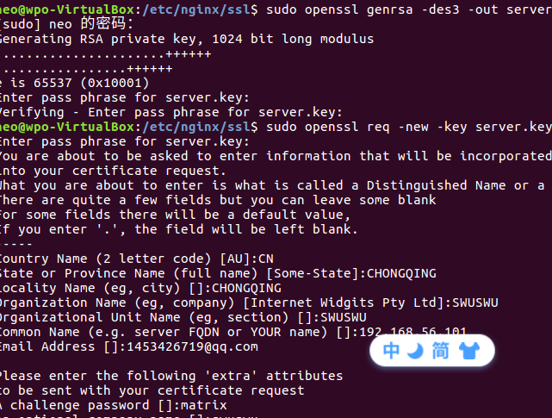

sudo cp server.key server.key.org

sudo openssl rsa -in server.key.org -out server.key

sudo openssl x509 -req -days 365 -in server.csr -signkey server.key -out server.crt

sudo vim /etc/nginx/sites-available/race

**放在server外面，重写的一个server**

server {

listen 443;

server_name race.oasis.com;

ssl on;

ssl_certificate /etc/nginx/ssl/server.crt;

ssl_certificate_key /etc/nginx/ssl/server.key;

ssl_session_timeout 5m;

ssl_protocols TLSv1 TLSv1.1 TLSv1.2;

ssl_ciphers ECDHE-RSA-AES128-GCM-SHA256:HIGH:!aNULL:!MD5:!RC4:!DHE;

ssl_prefer_server_ciphers on;

location / {

root /var/www/race;

index index.php index.html index.htm;

}

}

检查和重启

**sudo nginx -t**

**sudo systemctl reload nginx**

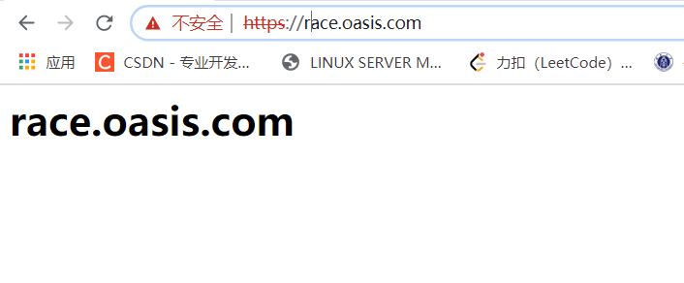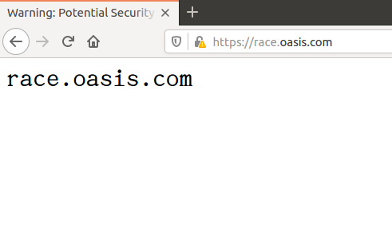

### PHP

sudo apt-get install php-fpm php-mysql 注意版本(7.0否)

sudo vim /etc/php/7.0/fpm/php.ini

修改 cgi.fix_pathinfo=0

sudo systemctl restart php7.0-fpm

sudo vim /etc/nginx/sites-available/shining

修改 index **index.php** index.html index.htm index.nginx-debian.html;

添加：

location ~ \.php$ {

include snippets/fastcgi-php.conf;

fastcgi_pass unix:/run/php/php7.0-fpm.sock;

}

location ~ /\.ht {

deny all;

}

sudo vim /var/www/shining/index.php

<?php

phpinfo(INFO_LICENSE);

?>

**sudo nginx -t**

**sudo systemctl reload nginx**

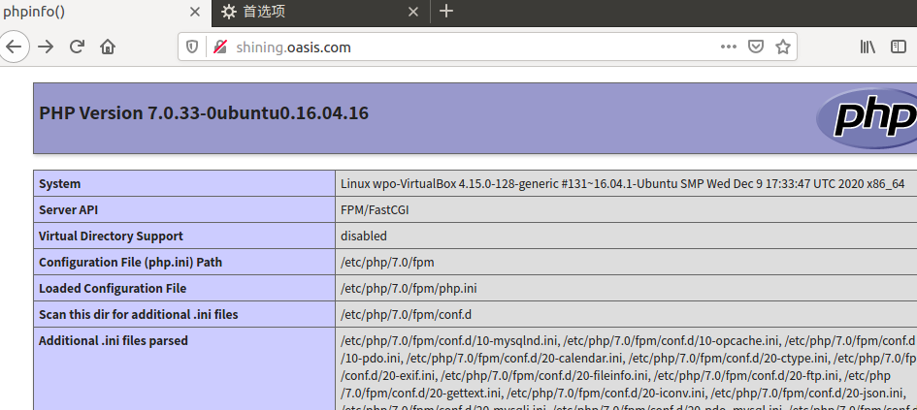

### Java tomcat

**Jdk**：

cd /tmp

wget http://172.18.5.74/download/jdk-8u112-linux-x64.tar.gz

sudo mkdir /usr/lib/java

sudo tar -C /usr/lib/java -xzf jdk-8u112-linux-x64.tar.gz

sudo vim ~/.bashrc

添加

**export JAVA_HOME=/usr/lib/java/jdk1.8.0_112**

**export JRE_HOME=${JAVA_HOME}/jre**

**export CLASSPATH=.:${JAVA_HOME}/lib:${JRE_HOME}/lib**

**export PATH=${JAVA_HOME}/bin:$PATH**

**重启(好像不用)**

Reboot

测试

java -version

* 安装tomcat

cd /tmp

wget https://mirror.bit.edu.cn/apache/tomcat/tomcat-8/v8.5.61/bin/apache-tomcat-8.5.61.tar.gz

mkdir ~/tomcat

cp apache-tomcat-8.5.61.tar.gz ~/tomcat/

cd ~/tomcat/

tar -zxvf apache-tomcat-8.5.61.tar.gz

* 改环境变量

sudo vim /etc/profile

添加：

export TOMCAT_HOME=/home/neo/tomcat/apache-tomcat-8.5.61

export CATALINA_HOME=/home/neo/tomcat/apache-tomcat-8.5.61

* 启动Tomcat

cd ~/tomcat/apache-tomcat-8.5.61/bin

./startup.sh

* tomcat自启 （用户级别）

sudo vim ~/.bashrc

添加

/home/neo/tomcat/apache-tomcat-8.5.61/bin/startup.sh

* 代理

sudo vim /etc/nginx/sites-available/game

location / {

# First attempt to serve request as file, then

# as directory, then fall back to displaying a 404.

**proxy_pass http://192.168.0.101:8080;**

try_files $uri $uri/ =404;

}

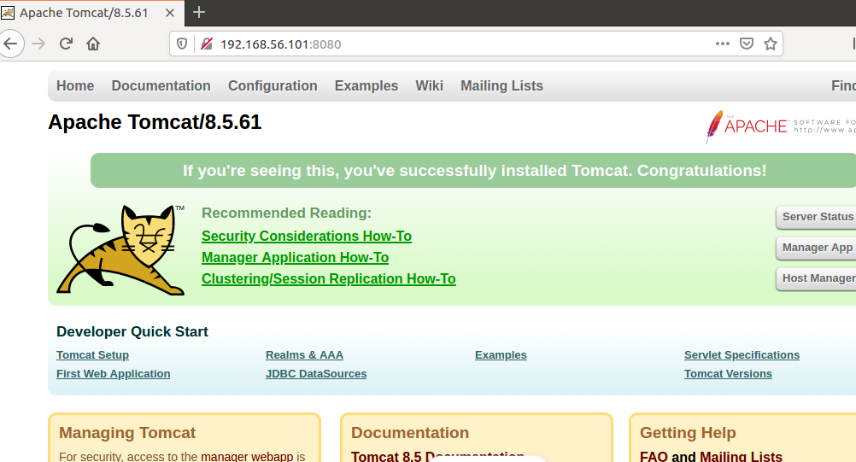

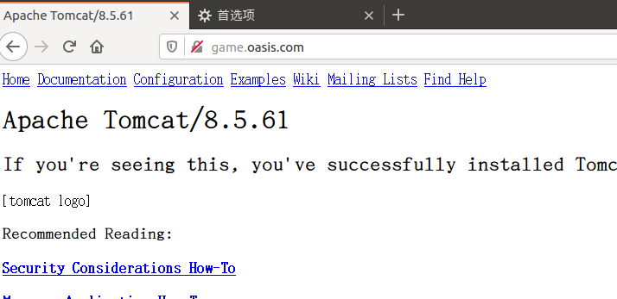

### Postfix

sudo apt update

sudo DEBIAN_PRIORITY=low apt install postfix

internet site

[user1@oasis.com](mailto:user1@oasis.com)

root@ postmaster@

默认

NO

默认

默认0

默认

All

sudo apt install mailutils

echo 'it is only a test' | sendmail "test eamil" neo@oasis.com

cd /var/mail是否有邮件neo

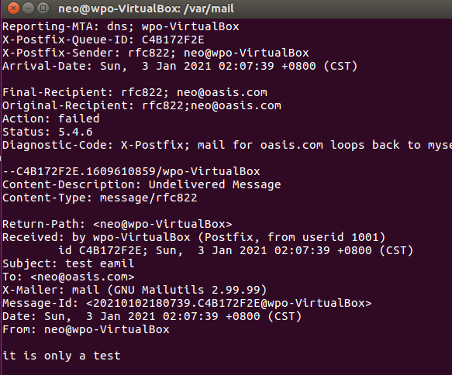

### Mysql

安装 密码设为 oracle

sudo apt install mysql-server

改端口

sudo vim /etc/mysql/mysql.conf.d/mysqld.cnf

port = 3366

sudo systemctl restart mysql

创建数据库

mysql -u root -p

输入密码 oracle , 进入mysql 命令行界面

mysql> CREATE DATABASE zion;

mysql> quit

测试

mysql -u root -P 3366 -h localhost -D zion -poracle

看到如下界面说明成功了

mysql: [Warning] Using a password on the command line interface can be insecure.

Welcome to the MySQL monitor. Commands end with ; or \g.

Your MySQL connection id is 4

Server version: 5.7.32-0ubuntu0.16.04.1 (Ubuntu)

Copyright (c) 2000, 2020, Oracle and/or its affiliates. All rights reserved.

Oracle is a registered trademark of Oracle Corporation and/or its

affiliates. Other names may be trademarks of their respective

owners.

Type 'help;' or '\h' for help. Type '\c' to clear the current input statement.

mysql>

mysql> quit

### 防火墙

启动防火墙

sudo ufw enable

添加规则

sudo ufw allow 22

sudo ufw allow 25

sudo ufw allow 80

sudo ufw allow 443

sudo ufw allow 110

sudo ufw allow 143

查看规则

sudo ufw status numbered

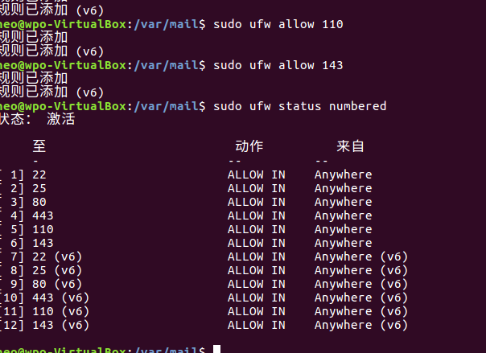

重启：

sudo ufw reload

### RAID1

* 添加2块1GB的虚拟硬盘（需要关机）

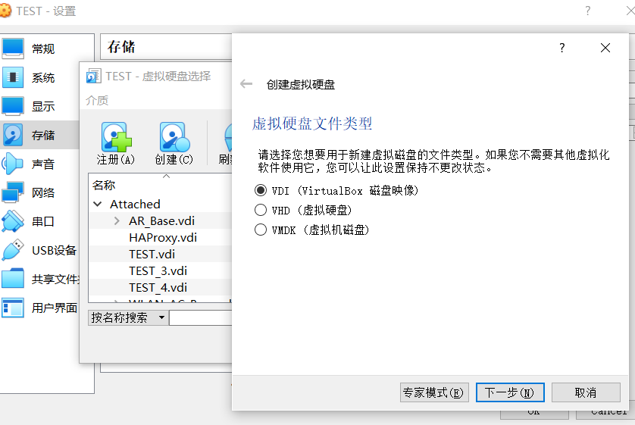

安装mdadm

sudo apt install mdadm

* 查看新增磁盘信息

sudo fdisk -l

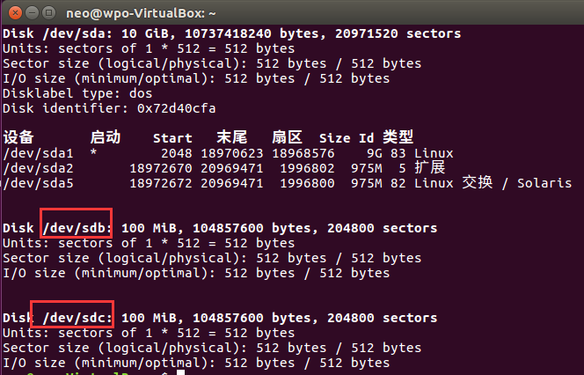

* 分区：

sudo fdisk /dev/sdb

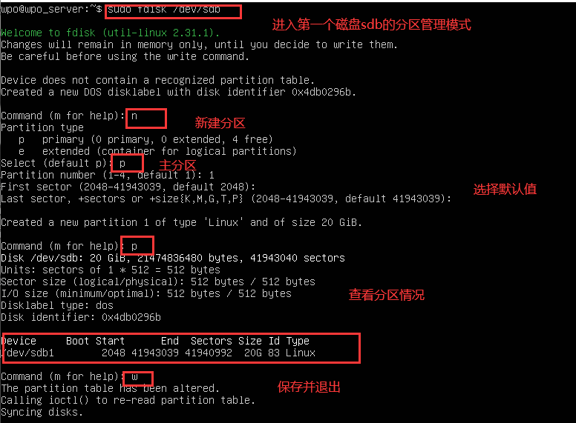

sudo fdisk /dev/sdc

* RAID1:

sudo mdadm --create --verbose /dev/md0 --level=1 --raid-devices=2 /dev/sdb /dev/sdc

* 查看RAID1详细信息

sudo mdadm --detail /dev/md0

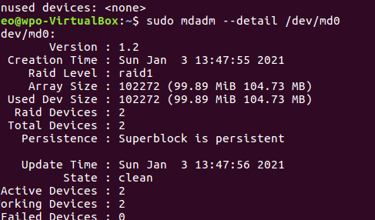

* 格式化和挂载

sudo mkfs -t ext4 /dev/md0

sudo mkdir /mnt/md0

sudo mount /dev/md0 /mnt/md0

用df查看：

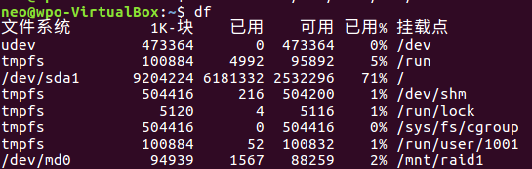

* 开机自动挂载

sudo mdadm --detail --scan | sudo tee -a /etc/mdadm/mdadm.conf

sudo update-initramfs -u

echo '/dev/md0 /mnt/md0 ext4 defaults,nofail,discard 0 0' | sudo tee -a /etc/fstab