**Bibliometric Analysis of Mangrove-Dependent Fisheries**

Sophie Wulfing1*and Rohani Ambo-Rappe1

1Fakultas Ilmu Kelautan dan Perikanan, Universitas Hasanuddin, Makassar, Sulawesi Selatan, Indonesia

* Corresponding authors: Sophie Wulfing [(SophieWulfing@gmail.com)](mailto:(SophieWulfing@gmail.com)

1 **ABSTRACT**

2 Mangroves are increasingly being recognized as essential biomes for mitigating effects of cli-

3 mate change and maintaining biodiversity. Mangroves also play key roles in many coastal

4 fisheries, as they act as nursery zones form many fished species. As food security and coastal

5 community health become increasingly pressing issues, it is essential to understand where

6 research in these areas are occurring and what are the trending topics related to research

7 on fisheries in mangrove environments. We conduct a bibliometric analysis of research that

8 combines the disciplines of fisheries and mangroves, particularly through the lens of biomass

9 and biodiversity. We find that the number of articles in these topics have been steadily

10 increasing since the 1980’s, and there has been increased focus on human impacts and cli-

11 mate change. Further, the majority of research in these areas has been conducted in English

12 speaking countries, or has been published in the English language. Our findings demonstrate

13 that, as the effects of climate change are becoming more severe, protecting these habitats and

14 food sources is also growing in importance. The result that most research is presented in En-

15 glish may also present an accessibility issue, as the majority of mangrove-dependent fisheries

16 being located in countries where English is not the primary language. This study provides

17 insights into why the study of mangrove-dependent fisheries is so important and researchers

18 can potentially address accessibility gaps and facilitate the dissemination of knowledge in

19 this area.

20 Keywords: mangroves, fisheries, biomass, biodiversity, bibliometric analysis

21 **1 INTRODUCTION**

22 Mangroves are inter-tidal forests that are essential components to many tropical ecosystems.

23 Mangroves are an essential component of carbon sequestration world-wide (Alongi, 2012;

24 Cameron et al., 2019) and help mitigate extreme weather effects, as they absorb the impacts

25 of high winds. Their root systems also hold land against abrasion from waves, therefore

26 reducing coastal erosion in these areas (Zhang et al., 2012; Rahdarian & Niksokhan, 2017).

27 Mangroves are key actors in maintaining the biodiversity of the ecosystems they inhabit.

28 Mangroves have been reported to support up 20% of the benthic biodiversity in their habi-

29 tats (Carugati et al., 2018). They provide essential nutrients, temperature controls, and

30 protection from predators for marine life (Blue Forests, 2012). Further, Mangroves have

31 been shown to increase fishery yields in their surrounding areas, therefore increasing fisher

32 income (Aburto-Oropeza et al., 2008). The root systems of mangroves provide shelter and

33 protection for juvenile fish, allowing them to grow and develop safely away from predators

34 and also act as a buffer against strong currents and waves, creating calmer and more stable

35 environments where fish can feed and reproduce (Alongi, 2008). Areas with intact mangrove

36 forests have been shown to support higher fish abundance and diversity compared to areas

37 without mangroves (Nagelkerken et al., 2008). Mangroves provide a rich food web, with leaf

38 litter and detritus serving as a source of nutrients that fuel the basis of the food chain, sup-

39 porting the growth and survival of various fish species (Alongi, 2008). Furthermore, both fish

40 and fisher communities benefit from mangrove’s ability to buffer the effects of storm surges

41 and erosion (Nagelkerken et al., 2008). Mangroves offer a crucial line of defense against the

42 impacts of climate change and other anthropogenic effects on fisheries (Figure 1). Mangrove

43 forests in the Western Tropical Pacific are the most diverse of these habitats globally (A. M.

44 Ellison et al., 1999).

45 Despite all of their contributions to ecosystem health, mangrove environments are being

46 threatened worldwide. Rising sea-levels has been shown to be a major contributor to man-

47 grove loss (Gilman et al., 2008). Further, as extreme events are becoming more intense and

48 more frequent, these could potentially threaten mangroves due to defoliation, soil erosion, or

49 by altering the chemical makeup or temperature of soils (Gilman et al., 2008). Mangroves are

50 also directly threatened by anthropogenic activity. Pollution, coastal development, and aqua-

51 culture development have also contributed to mangrove ecosystem loss (Adeel & Pomeroy,

52 2002).

53 Anthropogenic activity provides a threat to mangroves as 210 million people worldwide live

54 within 10 km mangroves. The largest single-driver of mangrove loss has been urban expansion

55 or the development of aquaculture ponds. However, economic gains from these activities have

56 been shown to be temporary or only benefiting small portions of the community (Hutchison

57 & Spalding, 2014). Therefore, the destruction of mangroves often leads to long term financial

58 loss. Although the exact financial gain from fisheries dependent on mangroves is hard to

59 measure world-wide, estimates of the financial contribution of mangroves to small scale

60 fisheries has been shown to be as high as $12,305 per hectare per year. (Hutchison & Spalding,

61 2014). An estimated 4.1 million of fishers rely on mangrove-dependent fisheries, primarily

62 in Indonesia, Bangladesh, Myanmar, and Brazil (Zu Ermgassen et al., 2021). Some of the

63 countries with highest numbers of mangrove reliant fishers also have the highest dependence

64 on these fisheries for essential sources of nutrition (Zu Ermgassen et al., 2021). Therefore,

65 not only do mangroves provide essential climate change mitigation and protection against

66 extreme weather, but are the base of of the food web for many essential fisheries around the

67 globe and are a key actor in ensuring food security for many tropical communities.

68 In order to understand the current status of research in mangrove-dependent fisheries, we

69 conduct a bibliometric analysis of research relating to mangroves, fisheries, and biomass or

70 biodiversity. Bibliometric analysis is a statistical analysis of trends in research related to a

71 specific topic. It can identify the evolution of a scientific topic, as well as emerging questions

72 and interests in the field. It can also be used to locate gaps in scientific knowledge in order

73 to direct where future research should focus (Donthu et al., 2021). Bibliometric analysis is a

74 useful tool to glean out high-impact research as well, and provide a baseline for which papers

75 are highly cited and influential in a field of study (Ellegaard & Wallin, 2015).

76 In this study, we aim to conduct a bibliometric analysis of research trends that connect

77 mangroves to fisheries, particularly through the lens of biomass and biodiversity. Our goal

78 of this research is to 1) identify which countries and journals have had the highest impact in

79 this field of study 2) identify trends in keywords in order to identify what issues have driven

80 the research of mangrove-dependent fisheries and 3) to assess the amount of cooperation and

81 collaboration that is occurring in this field in order to understand existing trends in where

82 studies have taken place and identify possible future directions for this field of research.

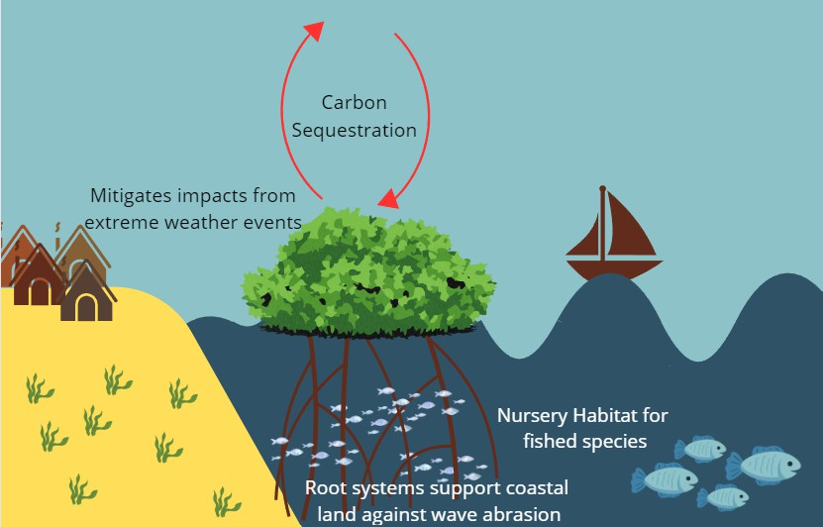

Figure 1: Mangrove benefits to both local environment and coastal communities.

83 **2 METHODS**

84 Documents were collected using the Scopus database. The keywords “Mangroves”, “Fish-

85 eries”, and “Biomass OR Biodiversity” were used to conduct the search, and results were

86 filtered to the following subject areas: Environmental Science, Agriculture and Biological

87 Sciences, Earth and Planetary Sciences, Social Sciences, Economics Econometrics and Fi-

88 nance, Multidisciplinary, Energy, Computer Science, Mathematics, and Decision Sciences. A

89 total of 251 articles were found from a total of 138 different sources, and results were limited

90 to research articles so to focus on current research being conducted in this field. Information

91 on year, journal, authors and author country of origin, citations and number of times the

92 paper was cited was collected on each paper to conduct bibliometric analysis.

93 **2.1 ANALYSIS**

94 The search results were cleaned using OpenRefine website to avoid duplicate keywords with

95 the same meanings. VOSviewer was used to visualize the network of country co-authorship.

96 Further the R package Bibliometrix (Aria & Cuccurullo, 2017) was used to analyze annual

97 scientific production of this topic, which journals and countries have published the most on

98 this topic, and the trending topics covered in papers relating to mangroves, fisheries, and

99 biomass or biodiversity (Figure 2).

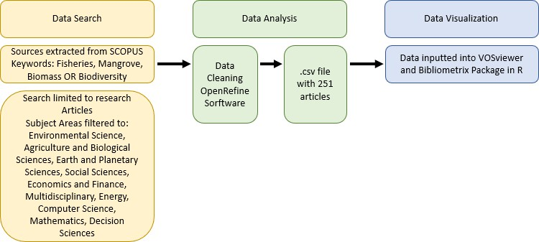

Figure 2: Bibliometric analysis method of data extraction, cleaning, and visualization.

100 **3 RESULTS**

101 Dates of publication ranged from 1989 to 2024, and 36.65% of these articles were written with

102 international co-Authorship. Figure 3 shows the total number of articles published which

103 use the keywords of mangroves, fisheries and biomass or biodiversity, showing an average

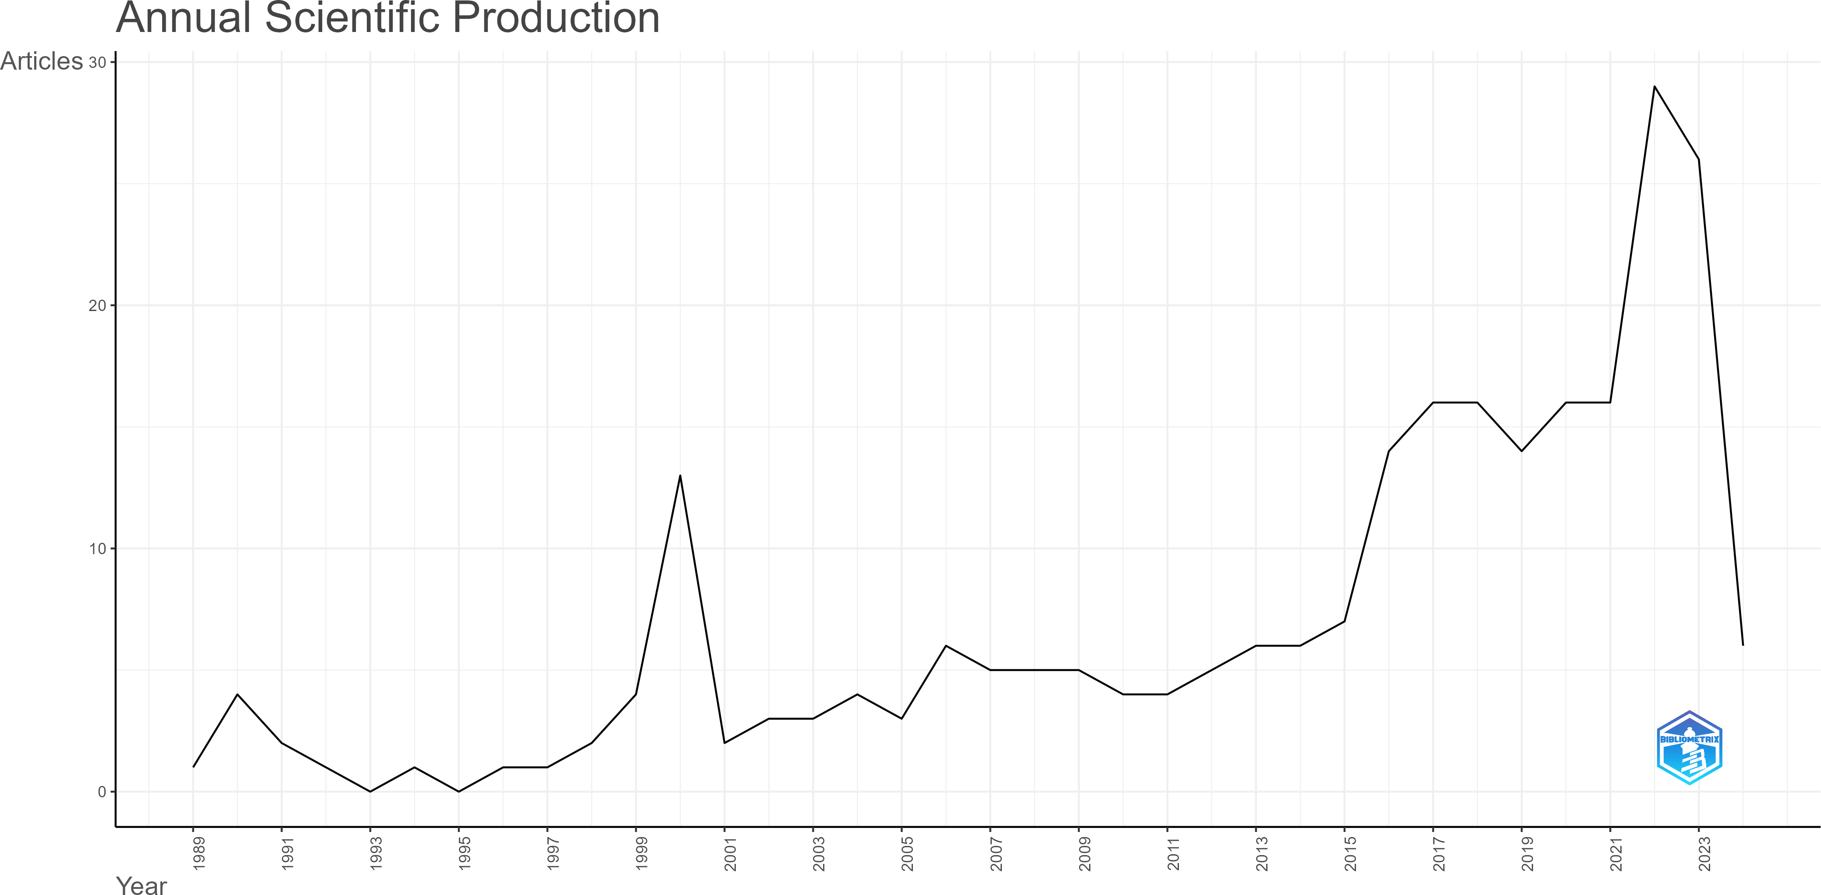

Figure 3: Total number of research articles per year that relate to fisheries, mangroves, biomass and biodiversity.

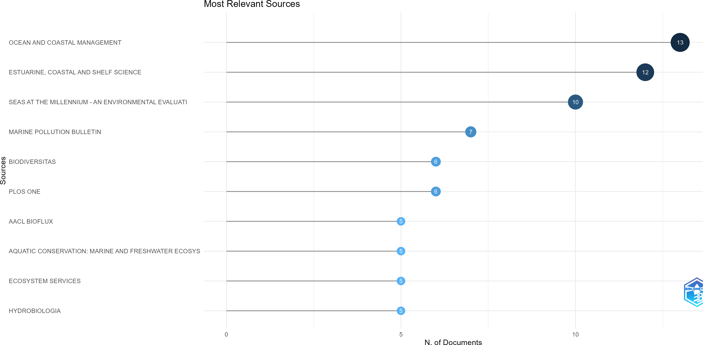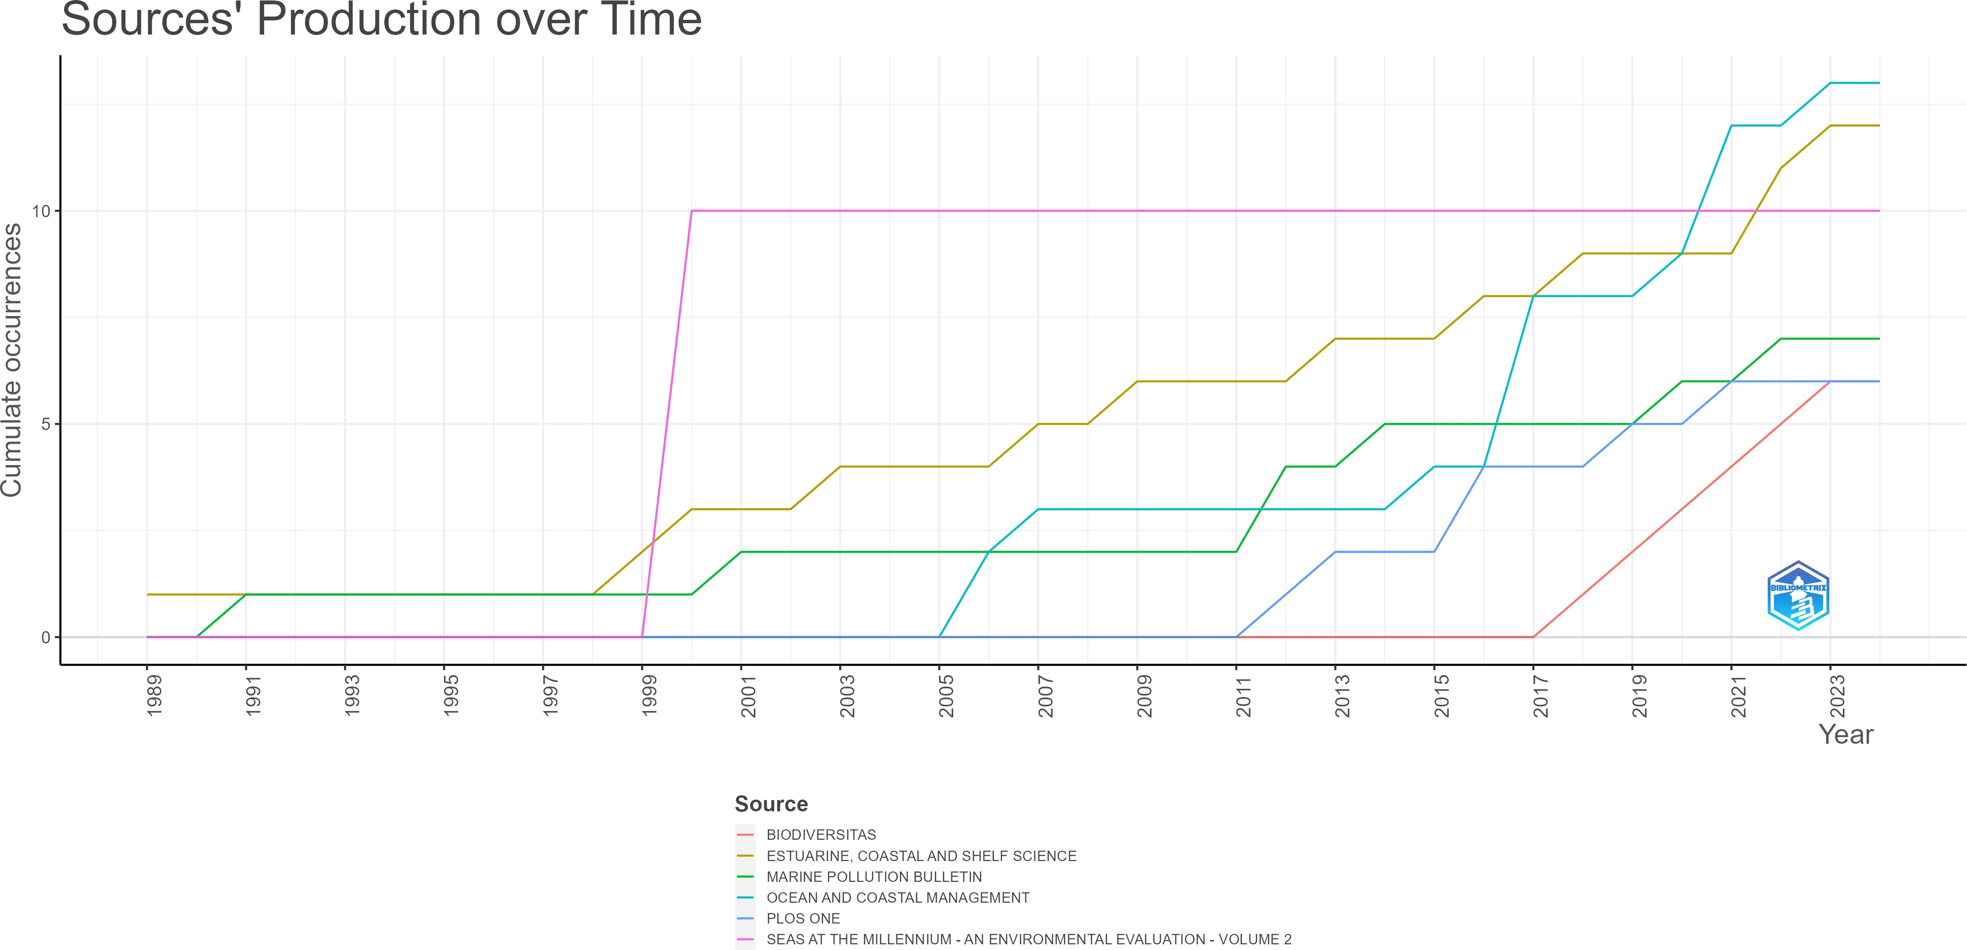

Figure 4: Total number of publications relating to mangroves, fisheries, and biomass and biodiversity from the top 10 journals (left). Publication trends from the top 6 journals over time (right)

104 annual growth rate of 5.25%. The greatest increase in the number of papers written that

105 covers these three topics was in 2015, when the number of articles was 7 to 2016, where the

106 number of articles doubled to 14. The highest number of articles in this analysis was seen

107 in 2022 with 29 articles. This indicates that mangrove and fishery research is increasing in

108 relevance and greater focus on the benefits of mangrove on fisheries worldwide.

109 The journal that has published the most papers in these areas was Ocean and Coastal Man-

110 agement with 13 total publications. However, this journal’s first paper relevant to mangroves,

111 fisheries, and biomass or biodiversity was first published in 2005, whereas Estuarine, Coastal,

112 and Shelf Science, the second most active journal, published its first paper on the subject

113 in 1989. The journal of Ocean and Coastal Management publishes papers that focus on

114 governance and management issues while the Estuarine, Coastal, and Shelf Science journal

115 covers a broader, more general focus on ocean and estuary science. However, Seas at the

116 Millennium, the journal with the third most papers, was a one-time journal published at the

117 turn of the century that provided a comprehensive review of the environmental condition of

118 the seas of the world. The top six journals that have published on mangroves, fisheries, and

119 biomass or biodiversity all require publications to be made in English.

120 In terms of geographic distribution of research on mangroves, fisheries, and biomass or bio-

121 diversity, Australia has the highest number of total authorship as well as the highest number

122 of single-country authorship whereas the country with the most Multi-country authorship

123 is the United States. The United States also has the highest number of cited documents,

124 with 3,681 total citations (Figure 5). Figure 6 shows the difference between the countries

125 with the most publications relating to mangroves, fisheries, and biomass or biodiversity and

126 compared to the amount of mangrove cover each country has (Jia et al., 2023.) The United

127 States is the most cited country in this area (Figure 7), with over three times the number of

128 citations as the United Kingdom, country with the second highest number of citations.

129 Figure 9 shows the amount of authorship collaboration that occurs between each country.

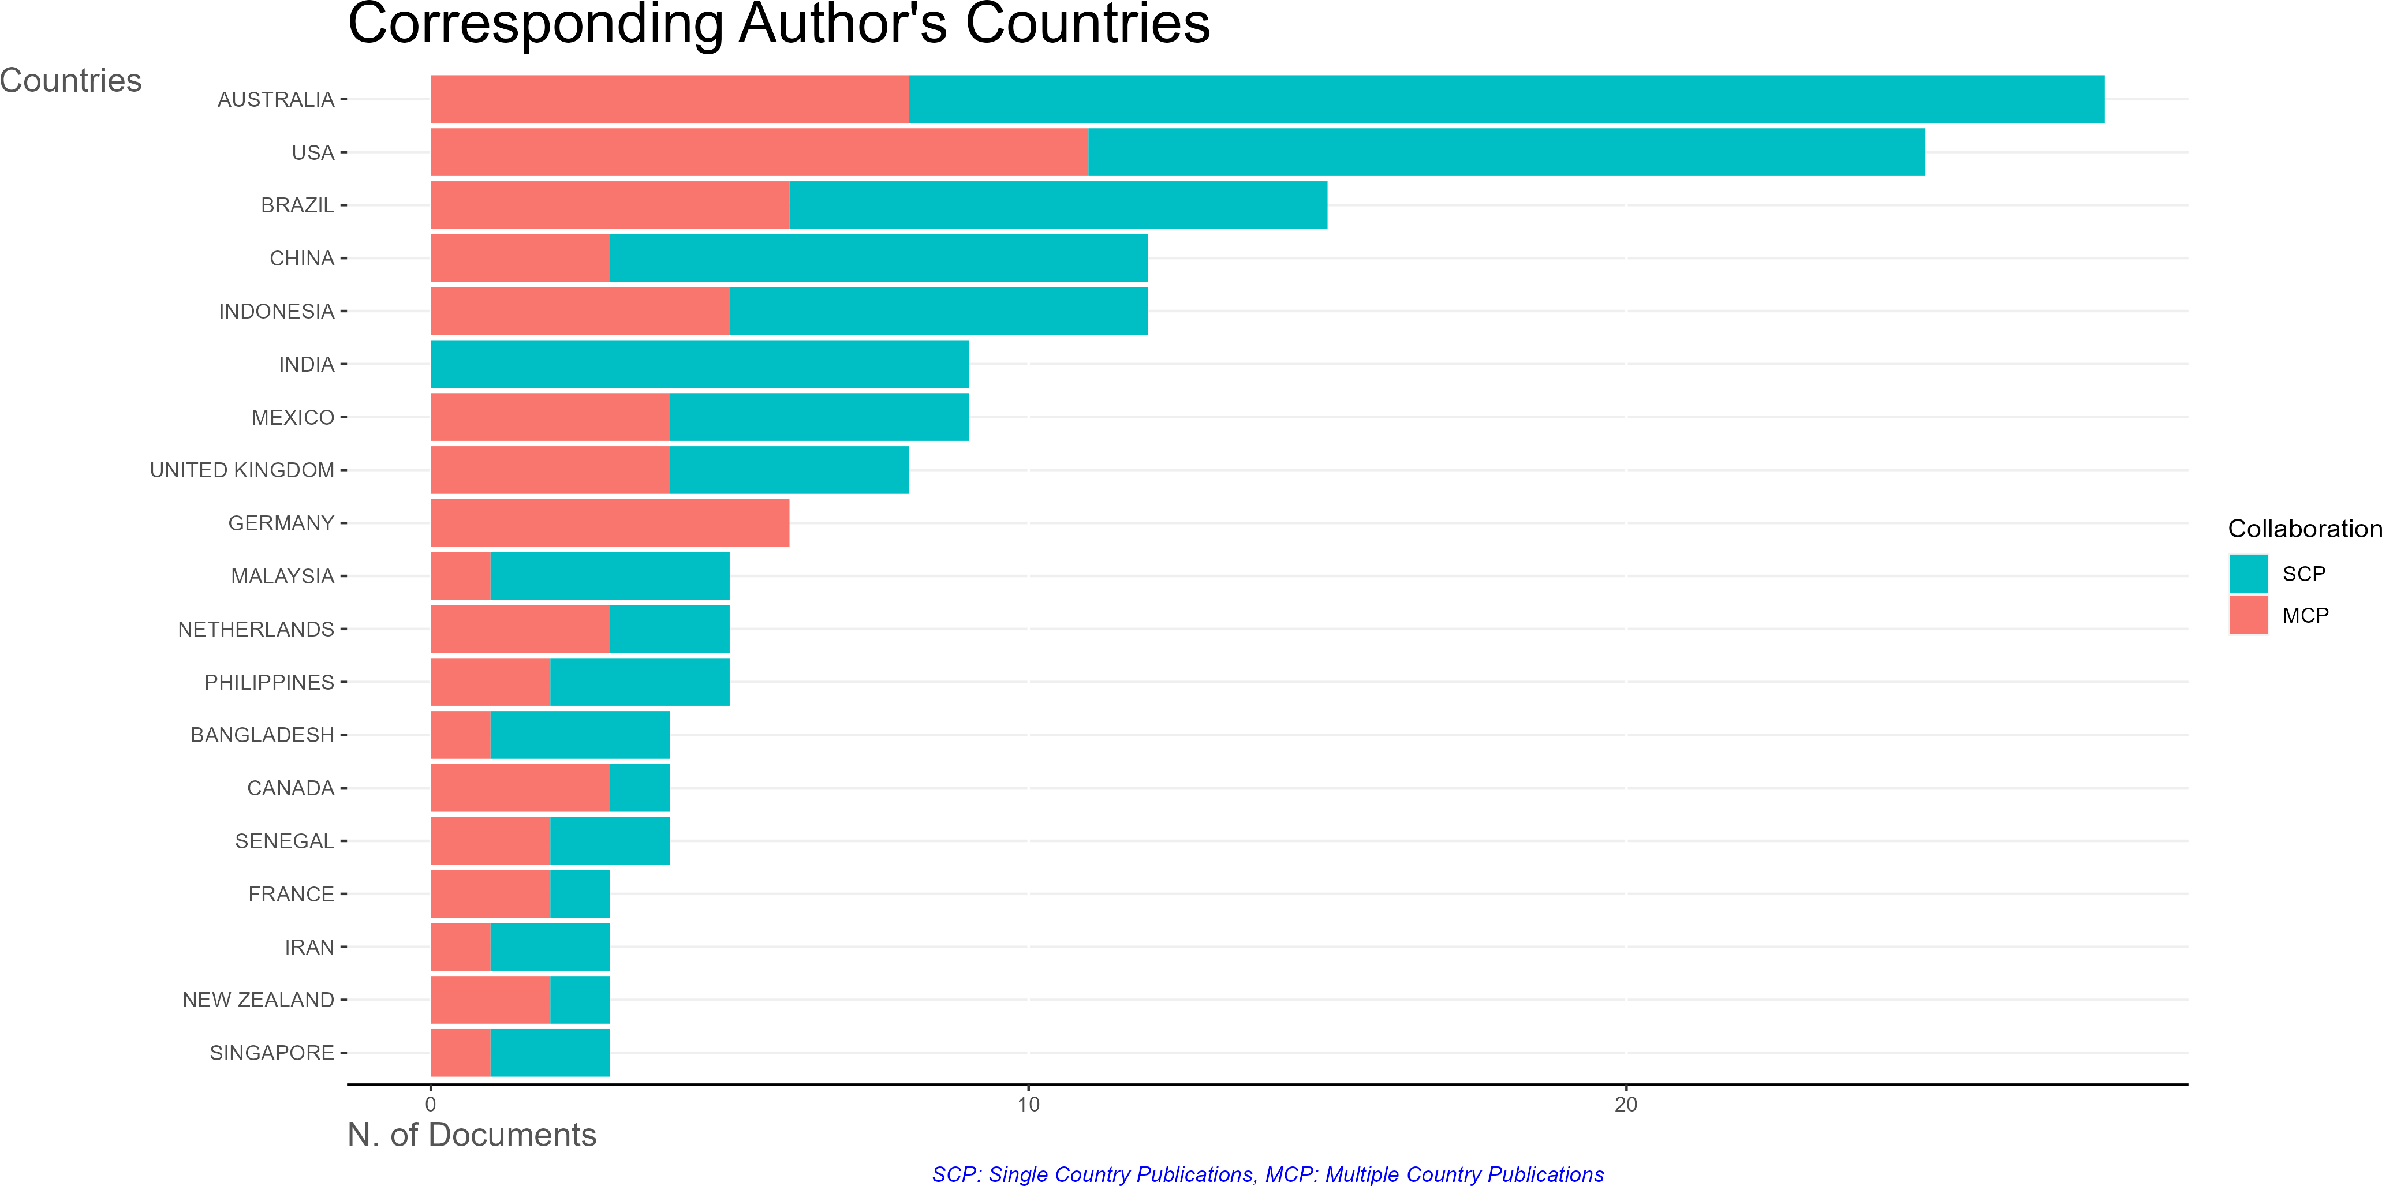

Figure 5: Authors’ country of origin of documents written from both single country publi- cations (SCP) and multiple country publications (MCP).

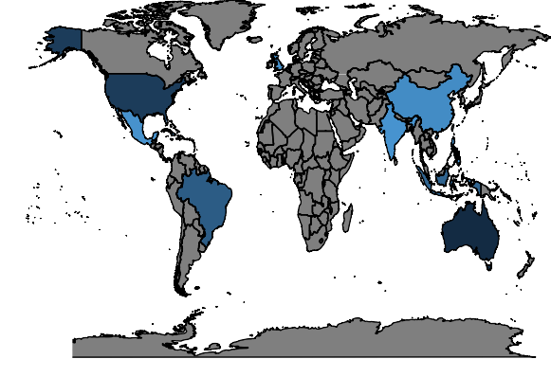

Publications

50

100

150

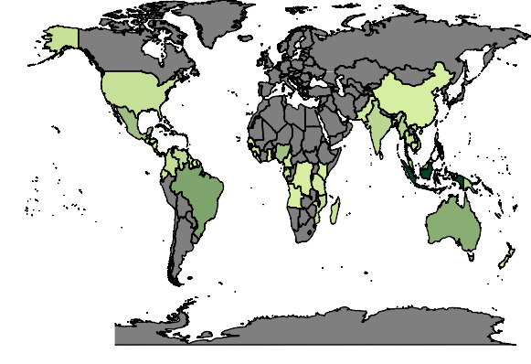

MangroveCover (KM)

20000

10000

Figure 6: Number of publications relating to fisheries, mangroves, and biomass or biodiversity (left). Countries with mangrove environments (right)

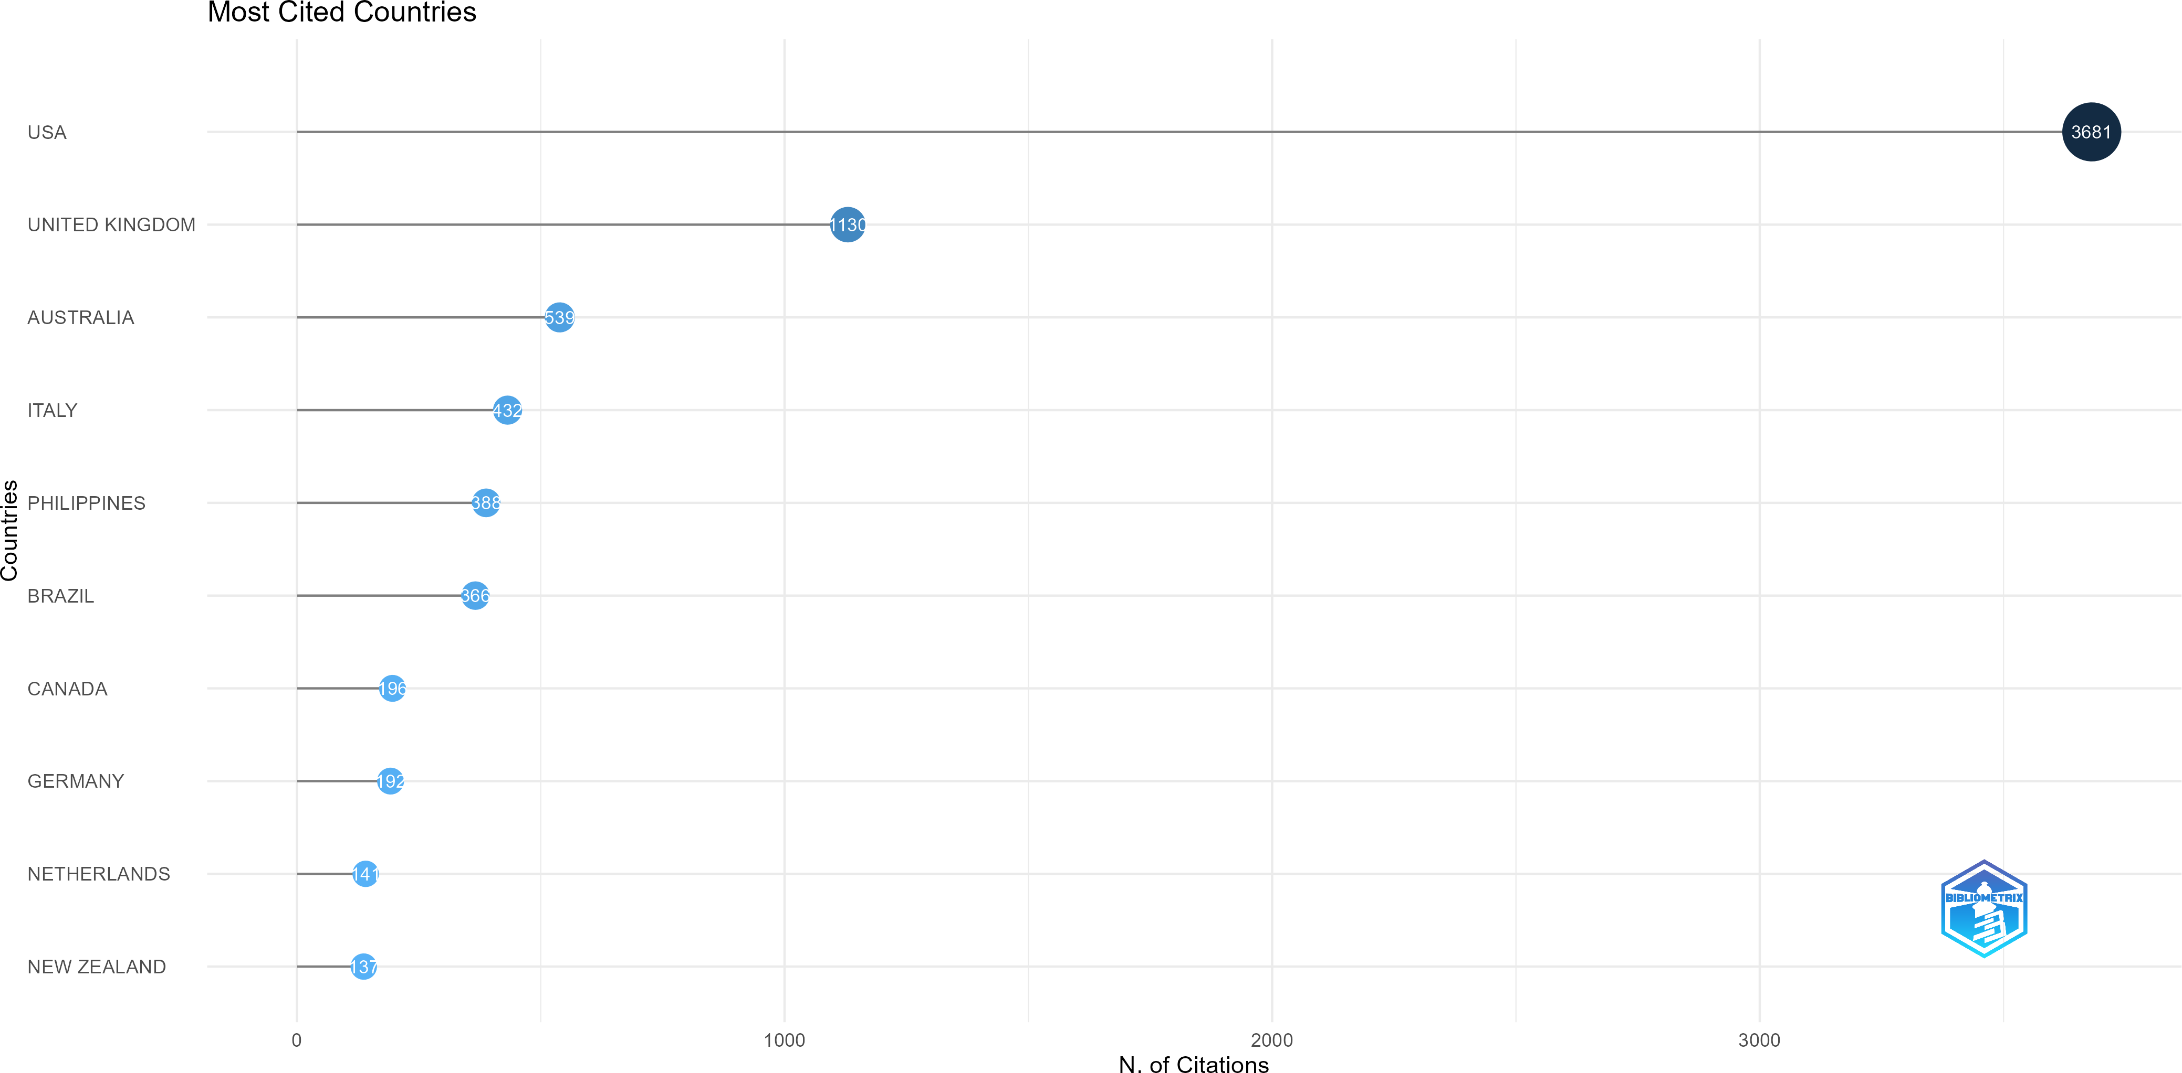

Figure 7: Top ten most cited countries on articles relating to mangroves, fisheries, biomass and biodiversity

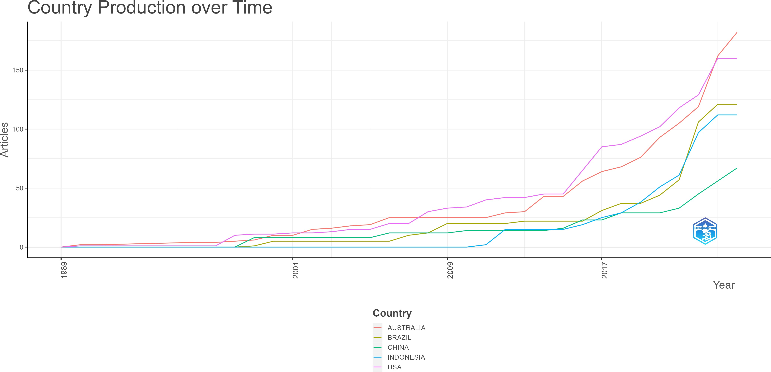

Figure 8: Trends of country production in research relating to mangroves, fisheries, and biomass or biodiversity.

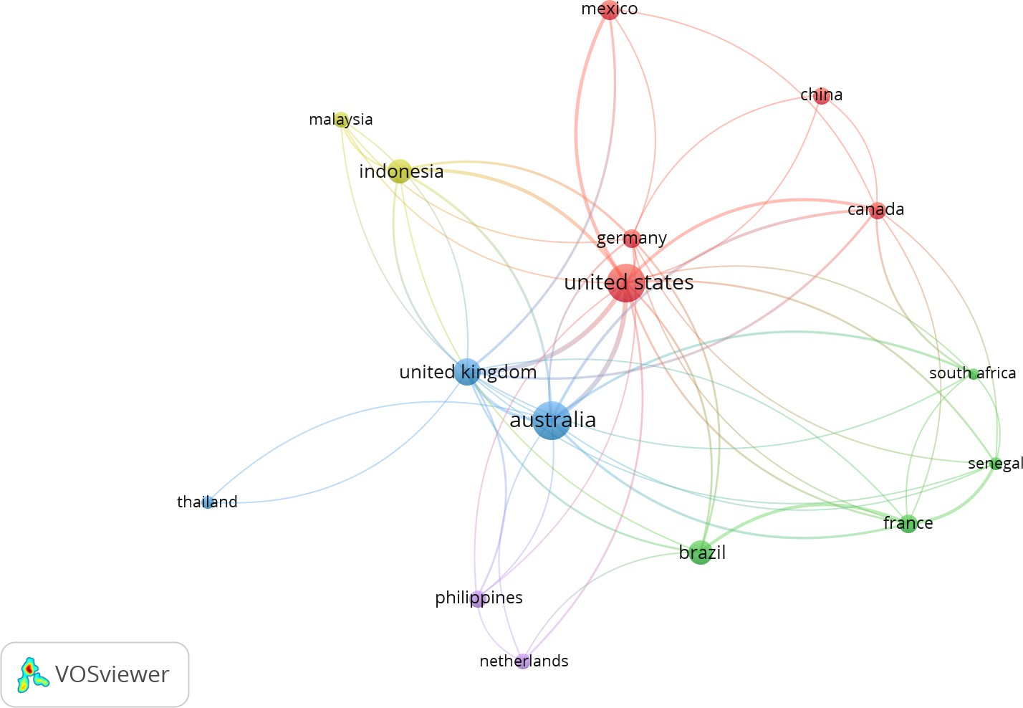

Figure 9: Network of each country’s collaboration with each other, larger nodes mean a higher number of publications while thicker edges represent higher numbers of collaborations.

130

131

132

133

134

135

136

137

138

By far, the greatest amount of authorship collaboration that occurs is between the United States, Australia, and the United Kingdom. Australia has the 3rd largest area of mangroves in the world as of 2020, and the United States has the 19th largest area (Jia et al., 2023). The United Kingdom does not have any mangroves as reported by (Jia et al., 2023)

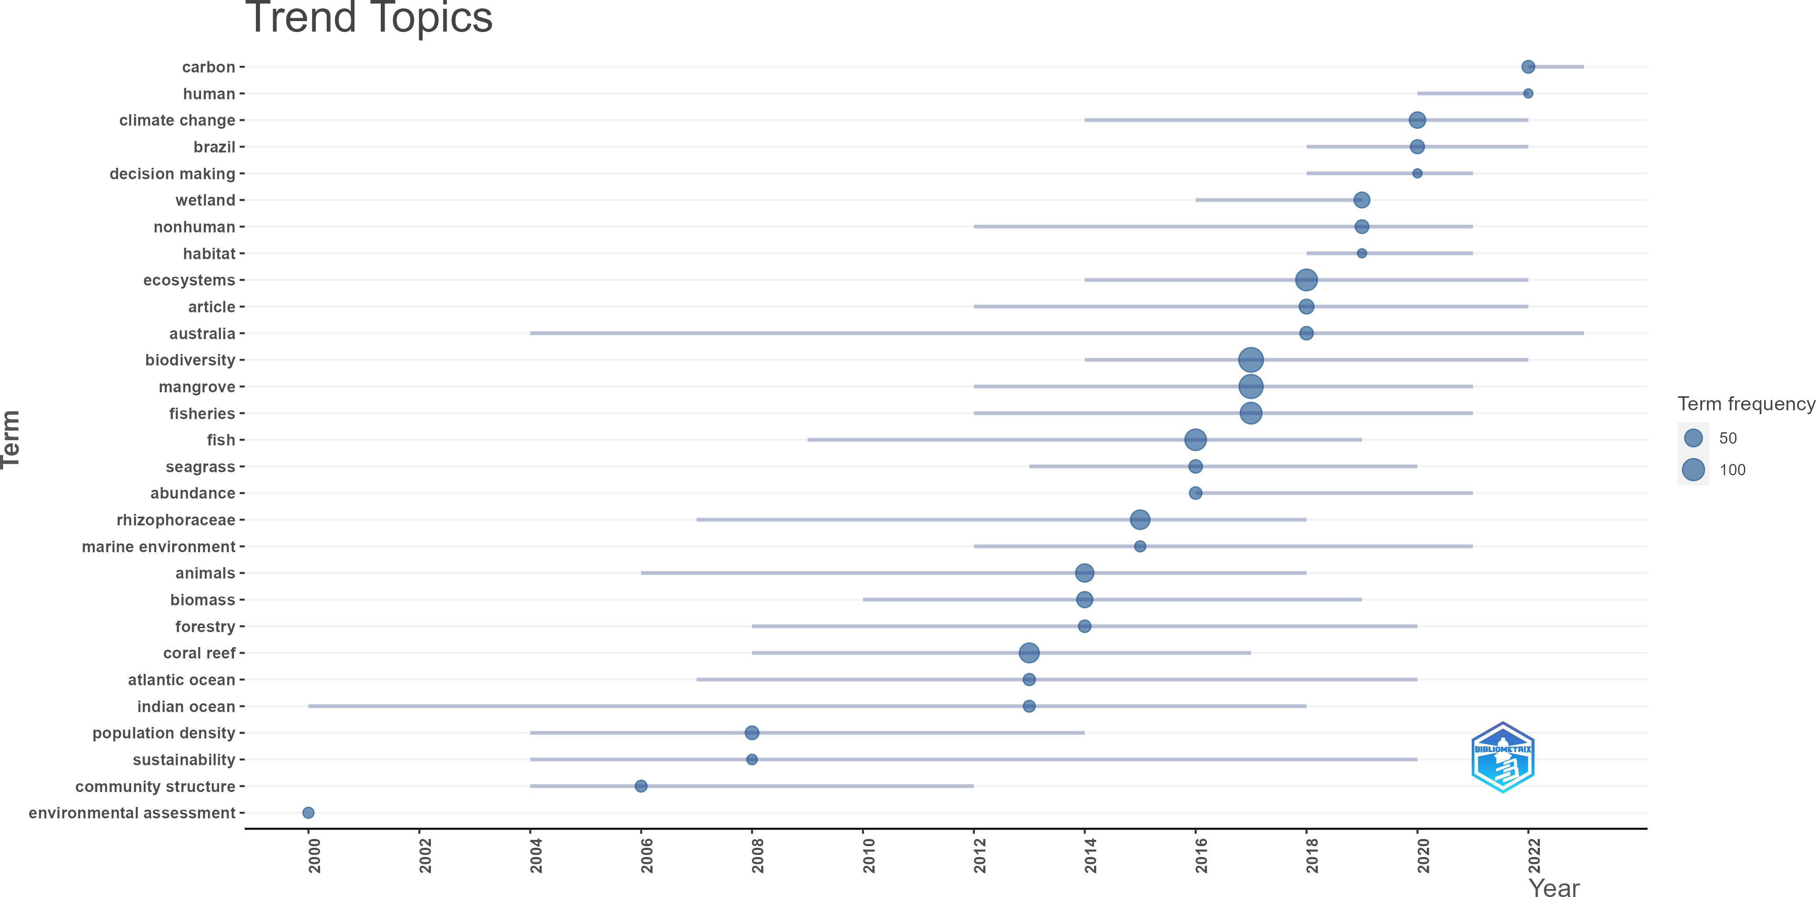

Figure 10: Trending topics covered by papers relating to mangroves, fisheries, and biomass or biodiversity. The keywords on the left represent words used more than ten times total since 2000.

Keyword trends are helpful indicators of what issues are relevant when studying mangroves, fisheries. Figure 10 shows the most relevant keywords (used more than ten times total and over three times a year) and which years they have been the most used. Most recently, the terms carbon, human, and climate change have become the most relevant topics. Keywords Australia and Indian Ocean both have the longest span of relevancy.

139 **4 DISCUSSION**

140 Our evaluation of the number of publications relating to mangroves, fisheries, and biomass

141 or biodiversity the over time shows that this area is growing in importance. As the world’s

142 population grows and anthropogenic effects on our environment creates greater challenges

143 for food security worldwide, our need to understand nutrition sources for coastal commu-

144 nities is also becoming more relevant. Further, reasons for mangrove loss have been shown

145 to be mostly economic (Chowdhury et al., 2017). However, research has shown that these

146 monetary gains from converting mangroves to aquaculture ponds or using mangrove trees

147 for timber and charcoal only has temporary economic benefits, and the lasting financial ben-

148 efits of maintaining mangrove habitats over the long term outweighs these temporary gains

149 (Hutchison & Spalding, 2014; Anneboina & Kavi Kumar, 2017; Chowdhury et al., 2017).

150 Our analysis of trending topics in this field show that human influence on our environment

151 is driving our need for understanding these systems, especially under the growing threats

152 of climate change. Climate change presents greater challenges to food security worldwide

153 (Gregory et al., 2005; Connolly-Boutin & Smit, 2016; Misra, 2014), as well as mangrove

154 environments, as rising sea levels and extreme weather events have been found to contribute

155 to mangrove loss worldwide (Alongi, 2015; J. C. Ellison, 2015; Ward et al., 2016).

156 A major finding of this bibliometric analysis was the disparity between the sources of this

157 research and where mangrove-dependent fishery research is most relevant. Most of the

158 collaborations in the subject area of mangrove-dependent fisheries happens between authors

159 from the United States, United Kingdom, and Australia, which are also the most cited

160 countries (Figure 7). However, this analysis only considers the authors’ countries of origin,

161 not where the research is focused. This might indicate an over-representation in research

162 conducted in the United States and Australia, or that authors from these countries are

163 researching mangrove-dependent fisheries in outside countries, but may not be incorporating

164 local researchers in these projects. The countries calculated to have the highest amount of

165 their fisheries reliant on mangrove systems are Indonesia, India, Bangladesh, Myanmar, and

166 Brazil (Zu Ermgassen et al., 2021). None of these countries are primarily English speaking,

167 which can present an issue with accessibility to the outcomes of this research. Not only does

168 science accessibility matter because of a language barrier between the research and local

169 communities, but this may also limit the local knowledge that can be incorporated into the

170 research. Local knowledge is essential to restoration projects, especially in mangroves, as

171 the incorporation of local knowledge and experiences has been shown to increase compliance,

172 foster relations between communities and research, and give more accurate pictures of the

173 status of restoration in coastal areas (Macintosh, 2012; Nguyen et al., 2016; Nguyen et al.,

174 2017). This is especially relevant in African countries, as this continent is home to 19.3% of

175 the worlds mangroves (Jia et al., 2023), but have lost about 55,000 hectares of mangroves

176 from 1996 to 2016 (Spaulding & Leal, 2021). However, there have been no authors who

177 originate from any country in Africa (Figure 6). This trend could be changing, however,

178 as figure 8 shows that although Australia and the United States are the leaders in research

179 production, Brazil, China, and Indonesia have seen greater increases in the number of papers

180 published since 2018. However, a limitation of this research is that this analysis only includes

181 the author’s country of origin, not where the research is taking place. Figure 10 shows that

182 keywords Indian Ocean has been the longest trending topic along with Australia and recently,

183 Brazil has been the focus of a lot of research, starting in 2017. This could indicate a possibly

184 discrepancy between where research is occurring and the country of origin of the authors.

185 In this paper, we have identified the sources of research on mangroves and fisheries with

186 a focus on biomass and biodiversity. We have found that as climate change and other

187 anthropogenic factors grow more severe, this has increased the amount of research in this

188 area. Further, we found a discrepancy between the authors and language used in these

189 reports and where this research would be the most relevant. A limitation of this research is

190 that we did not focus on where the research was being conducted, only the country of origin

191 of the author. A further study into where this research is taking place could shed further

192 light into which locations could benefit the most from increased focus on conservation.

193 *Funding* - The authors gratefully acknowledges financial support for this publication by the

194 Fulbright U.S. Student Program, which is sponsored by the U.S. Department of State and

195 by the American Indonesian Exchange Foundation. Its contents are solely the responsibility

196 of the author and do not necessarily represent the official views of the Fulbright Program,

197 the Government of the United States, or the American Indonesian Exchange Foundation.

198 *Data Availability* - All supplemental material and code for this project are available at

199 [https://github.com/swulfing/FisheriesBibA.](https://github.com/swulfing/FisheriesBibA)

200 *Competing interests* - None.

201 **REFERENCES**

202 Aburto-Oropeza, O., Ezcurra, E., Danemann, G., Valdez, V., Murray, J., & Sala, E. (2008).

203 Mangroves in the Gulf of California increase fishery yields. *Proceedings of the National*

204 *Academy of Sciences*, *105* (30), 10456–10459. <https://doi.org/10.1073/pnas.0804601105>

205 Adeel, Z., & Pomeroy, R. (2002). Assessment and management of mangrove ecosystems

206 in developing countries. *Trees*, *16* (2-3), 235–238. [https://doi.org/10.1007/s00468-002-](https://doi.org/10.1007/s00468-002-0168-4)

207 [0168-4](https://doi.org/10.1007/s00468-002-0168-4)

208 Alongi, D. M. (2008). Mangrove forests: Resilience, protection from tsunamis, and responses

209 to global climate change. *Estuarine, Coastal and Shelf Science*, *76* (1), 1–13. [https:](https://doi.org/10.1016/j.ecss.2007.08.024)

210 [//doi.org/10.1016/j.ecss.2007.08.024](https://doi.org/10.1016/j.ecss.2007.08.024)

211 Alongi, D. M. (2012). Carbon sequestration in mangrove forests. *Carbon Management*, *3* (3),

212 313–322. <https://doi.org/10.4155/cmt.12.20>

213 Alongi, D. M. (2015). The Impact of Climate Change on Mangrove Forests. *Current Climate*

214 *Change Reports*, *1* (1), 30–39. <https://doi.org/10.1007/s40641-015-0002-x>

215 Anneboina, L. R., & Kavi Kumar, K. S. (2017). Economic analysis of mangrove and marine

216 fishery linkages in India. *Ecosystem Services*, *24*, 114–123. [https://doi.org/10.1016/j.](https://doi.org/10.1016/j.ecoser.2017.02.004)

217 [ecoser.2017.02.004](https://doi.org/10.1016/j.ecoser.2017.02.004)

218 Aria, M., & Cuccurullo, C. (2017). Bibliometrix: An r-tool for comprehensive science map-

219 ping analysis. *Journal of Informetrics*. <https://doi.org/10.1016/j.joi.2017.08.007>

220 Blue Forests. (2012). *Adaptive Collaborative Management Plan for Building Mangrove*

221 *Resilience in Tanakeke Island*.

222 Cameron, C., Hutley, L. B., & Friess, D. A. (2019). Estimating the full greenhouse gas

223 emissions offset potential and profile between rehabilitating and established mangroves.

224 *Science of The Total Environment*, *665*, 419–431. [https://doi.org/10.1016/j.scitotenv.](https://doi.org/10.1016/j.scitotenv.2019.02.104)

225 [2019.02.104](https://doi.org/10.1016/j.scitotenv.2019.02.104)

226 Carugati, L., Gatto, B., Rastelli, E., Lo Martire, M., Coral, C., Greco, S., & Danovaro, R.

227 (2018). Impact of mangrove forests degradation on biodiversity and ecosystem function-

228 ing. *Scientific Reports*, *8* (1), 13298. <https://doi.org/10.1038/s41598-018-31683-0>

229 Chowdhury, R. R., Uchida, E., Chen, L., Osorio, V., & Yoder, L. (2017). Anthropogenic

230 Drivers of Mangrove Loss: Geographic Patterns and Implications for Livelihoods. In V.

231 H. Rivera-Monroy, S. Y. Lee, E. Kristensen, & R. R. Twilley (Eds.), *Mangrove Ecosys-*

232 *tems: A Global Biogeographic Perspective* (pp. 275–300). Springer International Pub-

233 lishing. <https://doi.org/10.1007/978-3-319-62206-4_9>

234 Connolly-Boutin, L., & Smit, B. (2016). Climate change, food security, and livelihoods in

235 sub-Saharan Africa. *Regional Environmental Change*, *16* (2), 385–399. [https://doi.org/](https://doi.org/10.1007/s10113-015-0761-x)

236 [10.1007/s10113-015-0761-x](https://doi.org/10.1007/s10113-015-0761-x)

237 Donthu, N., Kumar, S., Mukherjee, D., Pandey, N., & Lim, W. M. (2021). How to conduct

238 a bibliometric analysis: An overview and guidelines. *Journal of Business Research*, *133*,

239 285–296. <https://doi.org/10.1016/j.jbusres.2021.04.070>

240 Ellegaard, O., & Wallin, J. A. (2015). The bibliometric analysis of scholarly production:

241 How great is the impact? *Scientometrics*, *105* (3), 1809–1831. [https://doi.org/10.1007/](https://doi.org/10.1007/s11192-015-1645-z)

242 [s11192-015-1645-z](https://doi.org/10.1007/s11192-015-1645-z)

243 Ellison, A. M., Farnsworth, E. J., & Merkt, R. E. (1999). Origins of mangrove ecosystems

244 and the mangrove biodiversity anomaly: Mangrove biodiversity anomaly. *Global Ecology*

245 *and Biogeography*, *8* (2), 95–115. <https://doi.org/10.1046/j.1466-822X.1999.00126.x>

246 Ellison, J. C. (2015). Vulnerability assessment of mangroves to climate change and sea-level

247 rise impacts. *Wetlands Ecology and Management*, *23* (2), 115–137. [https://doi.org/10.](https://doi.org/10.1007/s11273-014-9397-8)

248 [1007/s11273-014-9397-8](https://doi.org/10.1007/s11273-014-9397-8)

249 Gilman, E. L., Ellison, J., Duke, N. C., & Field, C. (2008). Threats to mangroves from

250 climate change and adaptation options: A review. *Aquatic Botany*, *89* (2), 237–250.

251 <https://doi.org/10.1016/j.aquabot.2007.12.009>

252 Gregory, P. J., Ingram, J. S. I., & Brklacich, M. (2005). Climate change and food security.

253 *Philosophical Transactions of the Royal Society B: Biological Sciences*, *360* (1463), 2139–

254 2148. <https://doi.org/10.1098/rstb.2005.1745>

255 Hutchison, J., & Spalding, M. (2014). The Role of Mangroves in Fisheries Enhancement.

256 *The Nature Conservancy and Wetlands International.*

257 Jia, M., Wang, Z., Mao, D., Ren, C., Song, K., Zhao, C., Wang, C., Xiao, X., & Wang,

258 Y. (2023). Mapping global distribution of mangrove forests at 10-m resolution. *Science*

259 *Bulletin*, *68* (12), 1306–1316. <https://doi.org/10.1016/j.scib.2023.05.004>

260 Macintosh, M., D. J. (2012). *Sharing Lessons on Mangrove Restoration*. Bangkok, Thailand:

261 Mangroves for the Future; Gland, Switzerland: IUCN.

262 Misra, A. K. (2014). Climate change and challenges of water and food security. *International*

263 *Journal of Sustainable Built Environment*, *3* (1), 153–165. [https://doi.org/10.1016/j.](https://doi.org/10.1016/j.ijsbe.2014.04.006)

264 [ijsbe.2014.04.006](https://doi.org/10.1016/j.ijsbe.2014.04.006)

265 Nagelkerken, I., Blaber, S. J. M., Bouillon, S., Green, P., Haywood, M., Kirton, L. G.,

266 Meynecke, J.-O., Pawlik, J., Penrose, H. M., Sasekumar, A., & Somerfield, P. J. (2008).

267 The habitat function of mangroves for terrestrial and marine fauna: A review. *Aquatic*

268 *Botany*, *89* (2), 155–185. <https://doi.org/10.1016/j.aquabot.2007.12.007>

269 Nguyen, T. P., Luom, T. T., & Parnell, K. E. (2017). Existing strategies for managing

270 mangrove dominated muddy coasts: Knowledge gaps and recommendations. *Ocean &*

271 *Coastal Management*, *138*, 93–100. <https://doi.org/10.1016/j.ocecoaman.2017.01.016>

272 Nguyen, T. P., Van Tam, N., Quoi, L. P., & Parnell, K. E. (2016). Commu-

273 nity perspectives on an internationally funded mangrove restoration project:

274 Kien Giang province, Vietnam. *Ocean & Coastal Management*, *119*, 146–154.

275 <https://doi.org/10.1016/j.ocecoaman.2015.10.008>

276 Rahdarian, A., & Niksokhan, M. H. (2017). Numerical modeling of storm surge attenuation

277 by mangroves in protected area of mangroves of Qheshm Island. *Ocean Engineering*, *145*,

278 304–315. <https://doi.org/10.1016/j.oceaneng.2017.09.026>

279 Spaulding, M. D., & Leal, M. (2021). *The state of the world’s mangroves 2021*. Mangrove

280 Alliance.

281 Ward, R. D., Friess, D. A., Day, R. H., & Mackenzie, R. A. (2016). Impacts of climate

282 change on mangrove ecosystems: A region by region overview. *Ecosystem Health and*

283 *Sustainability*, *2* (4), e01211. <https://doi.org/10.1002/ehs2.1211>

284 Zhang, K., Liu, H., Li, Y., Xu, H., Shen, J., Rhome, J., & Smith, T. J. (2012). The role of

285 mangroves in attenuating storm surges. *Estuarine, Coastal and Shelf Science*, *102–103*,

286 11–23. <https://doi.org/10.1016/j.ecss.2012.02.021>

287 Zu Ermgassen, P. S. E., Mukherjee, N., Worthington, T. A., Acosta, A., Rocha Araujo, A.

288 R. D., Beitl, C. M., Castellanos-Galindo, G. A., Cunha-Lignon, M., Dahdouh-Guebas,

289 F., Diele, K., Parrett, C. L., Dwyer, P. G., Gair, J. R., Johnson, A. F., Kuguru, B.,

290 Savio Lobo, A., Loneragan, N. R., Longley-Wood, K., Mendonça, J. T., . . . Spalding,

291 M. (2021). Reprint of : Fishers who rely on mangroves: Modelling and mapping the

292 global intensity of mangrove-associated fisheries. *Estuarine, Coastal and Shelf Science*,

293 *248*, 107159. <https://doi.org/10.1016/j.ecss.2020.107159>

**Declarations:**

**Ethics approval and consent to participate**

Not applicable

**Consent for publication**

Not applicable

**Availability of data and material**

All datasets generated for analysis and subsequent code are available on GitHub at https://github.com/swulfing/TanakekeProject/tree/master/BibAnalysisProj/InR

**Competing interests**

The authors declare that they have no competing interests

**Funding**

The authors gratefully acknowledges financial support for this publication by the Fulbright U.S. Student Program, which is sponsored by the U.S. Department of State and by the American Indonesian Exchange Foundation. Its contents are solely the responsibility of the author and do not necessarily represent the official views of the Fulbright Program, the Government of the United States, or the American Indonesian Exchange Foundation.

**Authors' contributions**

SW: Conceptualization, Funding acquisition, Methodology, Software, Formal Analysis, Writing - original draft, Writing - Review & Editing

RAB: Conceptualization, Methodology, Software, Validation, Supervision, Writing - original draft, Writing - Review & Editing

All authors reviewed and approved the manuscript

**Acknowledgements**

Not applicable