SAW 29
Von Bertalanffy Growth Params
Previous sea scallop assessments used the growth curves estimated by Serchuk et al. (1979), but reviewers expressed concern about lack of recent information on growth. As a result, a scallop growth study was carried out using shells collected during the 2001-2006 NEFSC scallop surveys. Growth curves based on new data have lower L_inf and higher K:
Region | Source | L_inf | SE | K | SE
MAB | New | 131.6 | 0.4 | 0.495 | 0.004
GB | New | 146.5 | 0.3 | 0.375 | 0.002
MAB | Serchuk et al 1979 | 151.84 |  | 0.2997
GB | Serchuk et al 1979 | 152.46 |  | 0.3374

See Appendix III, pg 273 (279 in PDF) for how growth params were estimated for ‘New’ estimates:
Other growth parameter estimates
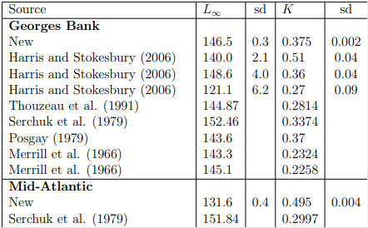

Shell Height (H) - Meat Weight (W) Relationships
Exn: ln(W) = a + b·ln(H)
Area | Source | a | b | Gamma
MAB | Haynes 1996 | -11.0851 | 3.0431
MAB | Serchuk & Rak 1983 | -12.1628 | 3.2539
MAB | NEFSC 2001 | -12.2484 | 3.2641
MAB | Lai and Helser 2004 | -12.3405 | 3.2754
MAB | New | -12.01 | 3.22
MAB | New + Depth Effect | -9.18 | 3.18 | -0.65
GB | Haynes 1996 | -10.8421 | 2.9490
GB | Serchuk & Rak 1983 | -11.7656 | 3.1693
GB | NEFSC 2001 | -11.6038 | 3.1221
GB | Lai and Helser 2004 | -11.4403 | 3.0734
GB | New | -10.70 | 2.94
GB | New + Depth Effect | -8.62 | 2.95 | -0.51
NEFSC (2001) combined the shell height/meat weight relationships from Serchuk and Rak (1983) with relationships from NEFSC (1999; later published as Lai and Helser 2004) to obtain “blended” estimates that were used in the last two assessments. New shell height/meat weight data was collected during annual NEFSC sea scallop surveys during July of 2001-2006
Natural Mort
Follows previous assessments where M = 0.1 y^-1 for shell heights >40mm
Estimate based on Merrill and Posgay 1964, based on clapper to live scallop ratio
The observed ratio C/L was about 0.066 and M was estimated to be about 0.1 y-1. MacDonald and Thompson (1986) found a similar overall natural mortality rate, though they suggested that natural mortality increases at larger shell heights.
Other notes:
- ‘Early attempts to model sea scallop population dynamics (NEFSC 1992, 1995, 1997, 1999) were not useful because biomass estimates were less than the minimum swept area biomass obtained from the NEFSC scallop survey (NEFSC 1999). In lieu of model based estimates, fishing mortality in the most recent three assessments (SARC-29,32 and 39; NEFSC 1999, 2001, 2004) was estimated using a simple rescaled F method which relies heavily on survey and landings data (the rescaled F and other models were tested by simulation as part of this assessment, see Appendix B12).’
- Also used SMAST video survey in this assessment

