Title: Applications of machine learning to develop statistical emulators for complex spatial marine ecosystem models for improved management decision-making

Lead PI: Gavin Fay, Department of Fisheries Oceanography, School for Marine Science and Technology, University of Massachusetts Dartmouth

Project partners: Scott Large, Sarah Gaichas, Joseph Caracappa, Geret DePiper
(all at NOAA Fisheries Northeast Fisheries Science Center, Woods Hole MA)

Project Personnel Roles: PI Fay will provide project management, advise the PhD student, supervise the technical associate, participate in project team meetings, and provide guidance on development of the statistical emulators and calibrations. He will also contribute to and review communication products and reports. NOAA partners Large, Gaichas, Caracappa, and DePiper will facilitate UMassD staff access to data, train students on the Atlantis ecosystem model, and help incorporate student developed analyses into the established workflow for model scenarios, as well as providing guidance on model calibration and scenario design. Graduate students at UMass Dartmouth funded by the project will conduct Atlantis simulations, develop statistical emulators, apply models to training and test data sets, and use calibrated emulators to explore fisheries management performance. A Technical Associate at UMass Dartmouth will work with NOAA NEFSC partners to guide the development of fishing and fisheries management scenarios that the Atlantis model and statistical emulators will be applied to, synthesizing fishery dependent and fishery independent data to parameterize fishing scenarios. The Technical Associate and PhD student will also provide supervision, training and instruction for undergraduate students on fishery ecosystem modeling and R statistical programming software. Undergraduate student technicians funded by the project will apply statistical models, evaluate their performance, and develop code to visualize the outputs of fisheries management scenarios.

ONR areas targeted:
Mathematics, Computer, and Information Science
(also Artificial Intelligence, Digital Warfare and Computation Intelligence)

Project Summary
Whole-of-system (‘end-to-end’) spatial marine ecosystem models can integrate environmental drivers, ecological dynamics, and human uses and be useful tools for marine ecosystem-based management. These complex models require extensive parameterization and calibration and have long run times, making it difficult to fully assess model behavior across a range of plausible uncertainty. We will develop and test the performance of fishing scenario ecosystem emulators that can approximate the dynamics of fishing scenarios in the Northeast Atlantis model to explore a larger range of fishing scenarios, to identify ranges of decision parameter space that can satisfy management goals.

Proposal narrative

Statement of the Problem
Whole-of-system (‘end-to-end’) spatial marine ecosystem models can integrate environmental drivers, ecological dynamics, and the geographically varying consequences of human uses (including fishing, development of offshore renewable energy, marine transportation). These models can form an important part of toolbox for evaluating the holistic consequences of policy alternatives for marine ecosystem-based management (Tallis et al. 2010). However, these models require extensive parameterization and calibration (thousands of parameters) to incomplete data, and have long run times. This makes it difficult to fully assess model behavior across range of plausible uncertainty, particularly for submodels that have limited data to parameterize dynamics, for comparison to available data on expected mode behavior, reducing the ability to fully explore the policy space when evaluating the consequences of alternative management decisions.

Leveraging recent and planned developments to the Northeast US Atlantis Ecosystem Model (Atlantis NEUS; Link et al. 2010, Caraccapa et al. 2022), we propose to develop and test the performance of fishing scenario ecosystem emulators that can approximate the dynamics of fishing scenarios in Atlantis to explore a larger range of fishing scenarios, to identify ranges of decision parameter space that can satisfy management goals. This work will demonstrate the application of machine learning methods and high performance computing for data integration and decision-making uncertainty across large linked climate-ecosystem-economic models to generate expectations of outcomes for coastal communities at a range of spatial and temporal scales. The project will provide training for graduate and undergraduate students in applications of data science, machine and deep learning, and statistics for dynamic marine ecosystem modeling, and the research will demonstrate the utility of pairing machine learning methods with mechanistic models for improved management decision-making.

Objectives
Our specific objectives are to:
1) Develop a training set of Atlantis scenarios by running a sequence of simulations across a set of fishing scenarios and ecosystem scenarios,
2) Apply machine learning / deep learning methods to develop emulators for ecosystem dynamics that can capture spatial fishing effort allocation across a range of fishing fleets for multiple species,
3) Assess the performance of the emulators in their ability to mimic modeled and observed ecosystem dynamics, and
4) Use emulators to explore the performance of a large range of ecosystem-based fisheries management alternatives for coastal communities given expected regional effects of climate change.

Background
Atlantis NEUS is an end-to-end ecosystem model and can simulate regional-level biogeochemical processes, lower trophic level dynamics, fish population dynamics, and regional fishery dynamics. The model simulates the dynamics of individual species, including all federally managed species instead of aggregated groups. Ecosystem dynamics are forced using satellite-based primary production and global physics reanalysis products and the model is calibrated with contemporary survey, assessment, and diet data. Atlantis NEUS operates on 22 large (~1000 km²) polygons covering the continental shelf from Cape Hatteras through the Gulf of Maine. In general, Atlantis models allow for a practical balance between spatial resolution and computational intensiveness, while preserving a high degree of ecological complexity. Applications of the NEUS Atlantis model have addressed strategic questions including the interactions between environmental and management drivers on spatiotemporal patterns in fisheries socio-economics (Fay et al. 2017, Olsen et al. 2018, Fay et al. 2019).

Current work by NOAA NEFSC partners is focused on improving the applicability of the Atlantis NEUS fisheries submodel by defining communities-at-sea (Young et al. 2019, Rogers et al. 2019) and how these might change based on hindcasts parameterized by community-at-sea-level effort via fishing footprints generated from fishery dependent data. This expansion of the Atlantis NEUS fishery submodel provides a more detailed resolution of the implications of changes to fishery yield due to environmental and management change than previous analyses, including at the port level, than has previously been possible. Our previous work suggested that aggregation of ecosystem model output at system, regional, or even sector level scale may mask heterogeneity in consequences of ecosystem drivers (Fay et al. 2019); not all communities may experience the same consequences for policy choices.
Ecosystem-Based Fisheries Management (EBFM) approaches consider tradeoffs among multiple species and multiple fishing fleets and management plans for achieving conservation and socio-economic goals (e.g. Fogarty 2014, Patrick and Link 2015). Understanding the interactions of varying policy choices for fishing effort allocation among gears and sectors for communities at sea requires many decision points in management related to determining catch advice, accountability measures such as spatial closures, and how to prioritize among species that may have differing population status. This implies a large decision space for the parameters associated with alternative fishing scenarios that could achieve sustainability goals. It is not possible to run Atlantis model simulations under every scenario. In an Atlantis application in the Gulf of Mexico, Morzaria-Luna et al. (2018) addressed uncertainty in fish diet composition by developing statistical emulators of key Atlantis ecosystem model outputs (fishery catch and biomass), and training these on a set of Atlantis simulations that sampled a subset of the diet composition parameter space. They then used these emulators to explore ecosystem dynamics over a full set of diet composition uncertainty. In this approach we aim to apply and extend the approach of Morzaria-Luna et al. (2018), but to the fishery management dynamics submodel of Atlantis NEUS, to more fully explore the EBFM policy space.

Approach and work planning / progress
Objective 1: We will first establish a workflow with the current Atlantis NEUS GitHub repository to run the Atlantis NEUS model on the Mass Green High Performance Computing Center resources. This will allow us to create a training set of Atlantis simulations that can be used to develop and assess the predictive performance of emulators. With our NOAA partners, we will create a set of fisheries management scenario decision points that can be used to determine possible parameter sets for alternative policy options. These options will cover the range of plausible approaches for EBFM being considered by the New England Fishery Management Council including spatial and temporal allocations of quota for species and species groups by fishing fleets, gears, and sectors. We will sample from these options to generate a set of parameters for fisheries within Atlantis NEUS. Simulations with these parameter sets will be run in Atlantis NEUS to obtain a training set of time series of key ecosystem outputs, including biomass of managed populations and fishing yield by species and coastal community.
- Leveraged NOAA collaboration with AWS for Atlantis model HPC workflow
- J Caracappa at NOAA providing access to these model runs

Objective 2: The training set of Atlantis NEUS model output will be used to develop statistical emulator models of ecosystem dynamics by applying a suite of machine learning and deep learning algorithms that aim to predict the spatial and temporal output (coastal community at sea catch and population biomasses) given the input fisheries management policy parameters (sensu Guillaume and Guillaume 2014). Morzaria-Luna et al. (2018) applied six methods to derive their emulators: six methods to derive the emulators: Generalized Linear Models, bagged Multivariate Adaptive Regression Splines, Bagged Classification and Regression Trees, Random Forest, Boosted Regression Trees, and a neural network approach. In previous work, we showed that Regression and Classification Trees were able to successfully discriminate between the performance of ecosystem fishery management options that used system-wide limits on total fishery removals as well as traditional fisheries management tools (Hart and Fay 2020). We will review available methods to determine the most appropriate set of emulators, potentially including those based on scientific Machine learning (SciML, e.g. Rackauckas et al. 2020) and recurrent neural networks including Long-Short Term Memory neural networks (e.g. Ma et al. 2015, Hassim Sak et al, 2014) that can more appropriately deal with order-dependence in sequential problems, such as those encountered in the dynamic response of populations ecosystems over time to environmental and human pressures.
- C Perez & R Ignatius applying ML methods to Hydra data to develop emulators of simpler 10-species model dynamics
- A Abbas & V Selvaraj to apply ML methods to Atlantis data from Objective 1

Objective 3: Emulator performance will be assessed by both quantifying predictive ability for matching ecosystem dynamics and community-at-sea fishery output on a range of Atlantis NEUS simulations not included in the training data set, and also on a hindcast of Atlantis NEUS runs based on historically observed fishing dynamics and population biomass changes in the Northeast US and known past fishery management regulation settings.
- C Perez & R Ignatius compare performance of Hydra emulators from Objective 2
- A Abbas & V Selvaraj to compare performance of ML methods to Atlantis data in Objective 2

Objective 4: Emulator models with satisfactory predictive performance will then be applied to the full range of fishery management parameter space to simulate ecosystem outcomes and understand the likely consequences of different EBFM options for coastal communities at sea, fishery yield, and ecosystem conservation goals. A set of performance metrics, at both the individual community at sea scale and at regional Mid-Atlantic and New England management areas will be used to examine tradeoffs associated with key fishery policy parameters. A goal is not to identify optimal parameter sets but define a range of the decision space that can satisfy multiple fishery management and socioeconomic goals to sustain coastal community wellbeing, given expected changes within the ecosystem. This viable decision space could then be explored further in more detailed fishery-specific analyses and/or represent flexibility for management given imposition of additional objectives and preferences not explicitly included in our model simulations. Our analyses will provide a unique opportunity to understand tradeoffs for strategic marine ecosystem management and also demonstrate the development of decision-making tools that can approximate complex socio-environmental dynamics for rapid assessment of the likely performance of alternative policies given uncertainty.
- S Wulfing, C Perez will perform projections with emulators
- S Rangole create data visualization tools for evaluating emulator output and outcomes of policy options

Quad chart
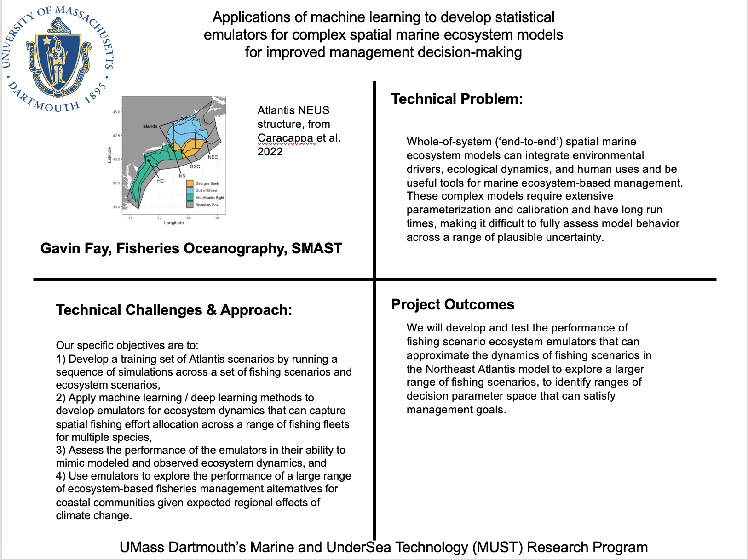

Federal, state, and private funding opportunities that would sustain the research

NSF Dynamics of Integrated Socio-Environmental Systems (DISES)
NSF Coastlines and People (CoPE)
NOAA Climate Program Office
NOAA Fisheries Integrated Ecosystem Assessment Program
USDA food security related grants (applications to seafood sustainability)
Woods Hole Sea Grant biennial research grants

Literature cited
Caracappa, J.C., Beet, A., Gaichas, S., Gamble, R.J., Hyde, K.J., Large, S.I., Morse, R.E., Stock, C.A. and Saba, V.S., 2022. A northeast United States Atlantis marine ecosystem model with ocean reanalysis and ocean color forcing. Ecological Modelling, 471, p.110038.
Fay, G., Link, J.S. and Hare, J.A., 2017. Assessing the effects of ocean acidification in the Northeast US using an end-to-end marine ecosystem model. Ecological Modelling, 347, pp.1-10.
Fay, G., DePiper, G., Steinback, S., Gamble, R.J. and Link, J.S., 2019. Economic and ecosystem effects of fishing on the Northeast US shelf. Frontiers in Marine Science, 6, p.133.
Hassim Sak, et al., Long Short-Term Memory Recurrent Neural Network Architectures for Large Scale Acoustic Modeling, 2014
Fogarty, M.J., 2014. The art of ecosystem-based fishery management. Canadian Journal of Fisheries and Aquatic Sciences, 71(3), pp.479-490.
Guillaume, M., Guillaume, S., 2014. Extending the use of ecological models without
sacrificing details: a generic and parsimonious meta-modelling approach.
Methods Ecol. Evol. 5, 934–943.
Hart, A.R. and Fay, G., 2020. Applying tree analysis to assess combinations of Ecosystem-Based Fisheries Management actions in Management Strategy Evaluation. Fisheries Research, 225, p.105466.
Link, J.S., Fulton, E.A. and Gamble, R.J., 2010. The northeast US application of ATLANTIS: A full system model exploring marine ecosystem dynamics in a living marine resource management context. Progress in Oceanography, 87(1-4), pp.214-234.
Ma, X., Tao, Z., Wang, Y., Yu, H. & Wang, Y. Long short-term memory neural network for traffic speed prediction using remote microwave sensor data. Transp. Res. Part C Emerg. Technol. 54, 187–197 (2015)
Morzaria-Luna, H.N., Ainsworth, C.H., Tarnecki, J.H. and Grüss, A., 2018. Diet composition uncertainty determines impacts on fisheries following an oil spill. Ecosystem services, 33, pp.187-198.
Patrick, W.S. and Link, J.S., 2015. Myths that continue to impede progress in ecosystem-based fisheries management. Fisheries, 40(4), pp.155-160.
Olsen, E., Kaplan, I.C., Ainsworth, C., Fay, G., Gaichas, S., Gamble, R., Girardin, R., Eide, C.H., Ihde, T.F., Morzaria-Luna, H.N. and Johnson, K.F., 2018. Ocean futures under ocean acidification, marine protection, and changing fishing pressures explored using a worldwide suite of ecosystem models. Frontiers in Marine Science, 5, p.64.
Rackauckas, C. et al. Universal differential equations for scientific machine learning. (2020).
Rogers, L.A., Griffin, R., Young, T., Fuller, E., St Martin, K. and Pinsky, M.L., 2019. Shifting habitats expose fishing communities to risk under climate change. Nature Climate Change, 9(7), pp.512-516.

Tallis, H., Levin, P.S., Ruckelshaus, M., Lester, S.E., McLeod, K.L., Fluharty, D.L. and Halpern, B.S., 2010. The many faces of ecosystem-based management: making the process work today in real places. Marine Policy, 34(2), pp.340-348.
Young, T., Fuller, E.C., Provost, M.M., Coleman, K.E., St. Martin, K., McCay, B.J. and Pinsky, M.L., 2019. Adaptation strategies of coastal fishing communities as species shift poleward. ICES Journal of Marine Science, 76(1), pp.93-103.

