Summer Flounder Advisory Panel Meeting I
Wednesday, July 1st, 2026
Agenda:
- 1:00 - 1:30. Introductions, discussion about overall grant direction
- 1:30 - 2:00. Aim I discussion and Q&A
- 2:00 - 2:30. Aim II discussion and Q&A
- 2:30 - 2:45. Break
- 2:45 - 3:15. Aim III discussion and Q&A
- 3:15 - 3:45. Aim IV discussion and Q&A
- 3:45 - 4:00. Conclusion, wrap up, final thoughts

Zoom Link: https://umassd.zoom.us/j/97542220674?pwd=pPsOsTbcuGL1FYXtp5b80GyVB9FAbr.1
Overall Project Motivation
Summer flounder populations have been driven northward in the mid-Atlantic U.S., creating a mismatch between current distributions and catch quota allocations among states (which remain unchanged since the 1990s). The result is a north-south gradient in resource access that affects commercial fishers, recreational anglers, seafood processors, and coastal communities. Our project uses an interdisciplinary socio-environmental systems (SES) framework to understand how climate, ecology, economics, human behavior, and policy interact to drive the resilience of the fishery. Our outreach will provide a comprehensive perspective on the ecosystem services provided to human populations who have been historically underserved in decisions regarding management of the resource.
Goals for Advisory Panel and broader impacts:
As a transdisciplinary project, this research involves scientists from a wide range of disciplines. The purpose of this panel is to ensure that our science is relevant to this fishery and decision makers. This panel consists of representatives from state and federal entities involved in coastal fisheries management. Our goal is to meet remotely in the first three years for these experts to make contributions and feedback to the development and execution of each aim. In years 4 and 5, we will hold larger in-person workshops and invite the advisory team as well as more members from under-represented groups identified through activities in Years 1-3, along with additional agency and industry stakeholders to share research results. In year 4, the workshop will be used to refine our interpretation of the economic and social dynamics of the flounder fishery and invite contributions from participants with knowledge external to the project (e.g., collaborative conceptual modeling as in dePiper et al. 2021).
Based on engagement with stakeholders, we will share our final results in Year 5 and produce a plan for distributing outreach materials. We plan to publish the results of our research, but also a paper summarizing the process of engaging different stakeholders to produce an integrated, transdisciplinary understanding of the factors undermining or promoting resilience in coastal ecosystems. As with your participation in this panel, participation in the in-person workshops is completely voluntary and optional. Further, the goals and methods used in this research project may evolve over time as the grant progresses, including the timeline of virtual and in-person workshops.
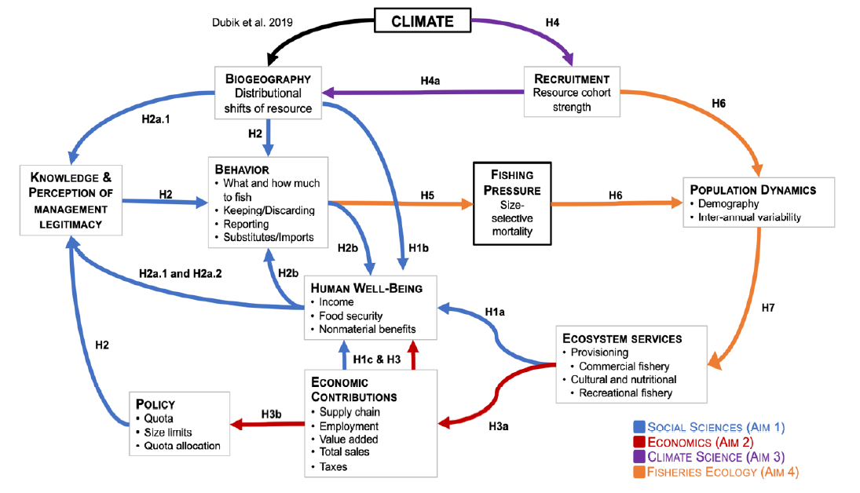

Conceptual framework integrating population dynamics of summer flounder to key outcomes, policy responses, and fisher behavior.
Interview insights continued:
- In both VA and MA, summer flounder are difficult to catch from the shore, and many say you need a boat. In NJ, flounder seemed easy to catch both by boat and from shore.
- Summer flounder seem to be highly valued for their taste. Even if not directly targeting summer flounder, if people catch one that meets the minimum requirement, they will likely keep it because they are good table fare.
- In the past, it seemed that fishing (both in general and specifically for summer flounder) could be used as a method to supplement a household’s food supply substantially; however, due to changes in regulations and fish populations, it seems much less likely to be able to do so currently.

Research Updates:
Survey research:
- More than 20% of anglers report harvesting over the bag and size limits.
- Based on socio-economic characteristics, some anglers were more likely to keep flounder.
Interview insights:
- Importance seemed to vary across regions. In VA and MA, it’s a fish you either target or you don’t. In VA, if you catch a keeper accidentally, it’s seen as a nice bonus. In NJ, it seems to be THE fish to catch during the summer, second to striped bass.
This work will show:
- Who will be most affected by the shift.
- Who is more likely to follow regulations and who is more likely to resist them.
Information Sources:
- In-person and online surveys of recreational anglers from MA to NC.

Motivation: Summer flounder populations are shifting north, creating unequal impacts on different anglers across the states. Preliminary surveys found that >20% of anglers continue harvesting beyond legal limits (bag and size limits), many are unaware of regulations, and underrepresented anglers keep significantly more flounder than white anglers — a disparity the managing bodies have not previously considered. The social components of resource use (identity, well-being, cultural ties) have been largely overlooked.
Objective: We will examine how differences in flounder availability and management rules shape food access, well-being, and cooperation with fishing regulations. We will focus on how these outcomes vary across regions.
Aim I: How do changes in flounder availability and regulations affect outcomes for recreational anglers?
Aim I Discussion Prompts for Advisory Panel:
- If you were designing a survey, what questions would you ask? (One rule: no economic questions)
- How dependent are recreational anglers on flounder? In other words, how important is catching flounder, compared to other fish? How dedicated are they?
- Do you feel summer flounder is a fish people generally tend to catch and keep or catch and release?
- How likely are anglers to answer openly and honestly to questions asking them to report their own rule-breaking behaviors?
- How might you go about finding anglers whose primary goal is to supplement their household food supply?

Aim II: "Determine how the economic contributions of the fishery to the supply chain, livelihoods, and other products are affected by variability in summer flounder abundance and spatial mismatches between abundance and allocation of quota"
Motivation: Existing economic models for summer flounder are based on pre-COVID conditions and do not capture the complexity of the quota-abundance mismatch across states. Preliminary work showed high volatility in landings and dockside value, yet the economic ripple effects through the full supply chain (fishers → processors → distributors) are poorly understood.
Objective: Build updated, post-COVID (Post-COVID vs. specific years (i.e., 2025)) economic contribution estimates for the flounder fishery across the north-south gradient and model how policy and abundance fluctuations ripple through coastal economies in terms of jobs, labor income, and value added.
Methods:
- Supply chain mapping across 8 states: NC, VA, MD, NJ, NY, CT, RI, MA
- In-person surveys of fishers, processors, and distributors to collect post-COVID firm-level revenue and expenditure data.
- IMPLAN input-output modeling using an "Analysis-by-Parts" methodology
- Economic scenario modeling in coordination with Aim 4.
Hypotheses:
- A: Economic contributions of the commercial flounder fishery to coastal economies fluctuate depending on landings, which vary with quota decisions.
- B: Policy decisions (quota allocation between commercial and recreational sectors, minimum size limits) interact with abundance variation to determine the economic dynamics of the supply chain.
Preliminary Research:
- Developing a contact list of fishing organizations as well as identifying secondary data sets as can be seen in the image on the following page.
- Reviewing similar research papers, blogs, opinion pieces, etc. to develop a clearer picture of the current knowledge of flounder abundance related to quotas.
- Developed a draft survey (attached) that includes questions related to costs and revenue as well as questions related to fishing flounder itself, including effects of quota or regulation changes on fishing effort, costs, risks, etc.
  - Separate surveys were written for commercial fishermen, fish processors, merchants/brokers, markets, etc. Some questions are similar while others are specific to the part of the supply chain.

Aim II Discussion Prompts for Advisory Panel:
- Are there parts of the survey (in attached documents titled AimII_SurveyDoc1 and AimII_SurveyDoc2) that should be prioritized or reworded to improve response rate while reducing the possibility of offending respondents?
- Would the survey be best done in smaller question sets over a few days or weeks or all at once? Which survey method do you think would be most suitable for commercial fishermen (e.g., electronic, video call, phone call, or in-person surveys)?
- Do you know of any other data sources (apart from those in the image below) or contacts related to flounder fishing permits, those who fish for flounder, etc.?
- Do you have any recommendations as to how to encourage commercial fishermen, processors, merchants, etc. to take the survey?

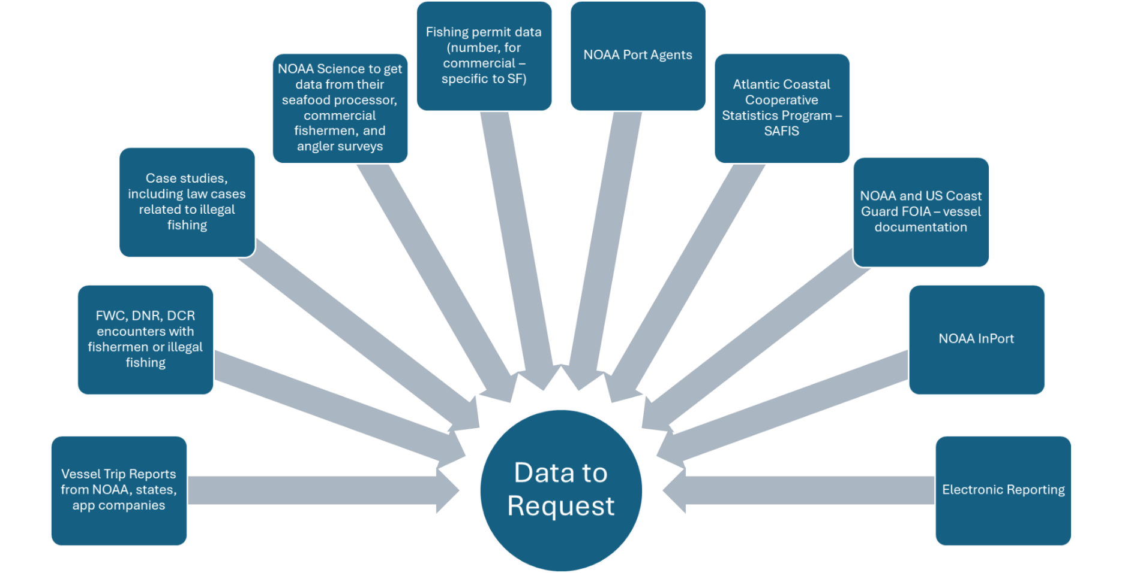
Datasets to be used in Aim II economic modeling plans

Motivation: Recruitment is poorly understood for summer flounder despite being fundamental to sustainable management. The northward population shift may reflect improved juvenile survival conditions at northern latitudes rather than simply adult migration — but this has not been tested. Better understanding of climate-recruitment links is essential for realistic population projections.
Objective: Identify the specific oceanographic conditions that predict strong or weak flounder year classes and determine whether favorable recruitment conditions are shifting northward — enabling more realistic, climate-informed population projections for Aim IV.
Aim III: "Determine the mechanisms linking climate and oceanographic variables to population dynamics of summer flounder"

Research Update:
- Self-organizing maps are demonstrating relationships between sea surface temperature anomalies during early life and recruitment. Now, we are working on identifying the specific time windows and relevant spatial scales of sensitivity.
- We are also working on characterizing spatial heterogeneity in abundance throughout their range.
Hypotheses:
- A: Variable oceanic conditions — especially during the first two years of life — can explain annual fluctuations in juvenile flounder recruitment.
- B: Conditions favoring recruitment are becoming more common at the northern end of the flounder's range, potentially explaining the observed northward biomass shift.
Methods:
- Random Forests, an explainable machine learning method, will be employed using various climate indices and environmental variables to predict and understand sources of variability behind summer flounder biomass.
  - Indices include the NAO index (NOAA CPC), AMO index (NOAA PSL), Gulf Stream index (ecodata R package), and Mid Atlantic Bight Cold Pool index (ecodata R package).
  - The Global Ocean Physics Reanalysis and Simulation product (GLORYS 12V1) variables that will be used are SST, Eastward and Northward sea water velocity, sea water salinity, and sea water potential temperature at sea floor.
- The random forest model will have a temporal lag of two years, using environmental data from two years prior from predictions.

Aim III Discussion Prompts for Advisory Panel:
- On the map provided, please:
- Circle one or more hotspots of summer flounder abundance today
- Draw lines through the outlined range in map to delineate into two or more spatially distinct subpopulations, as would be appropriate today

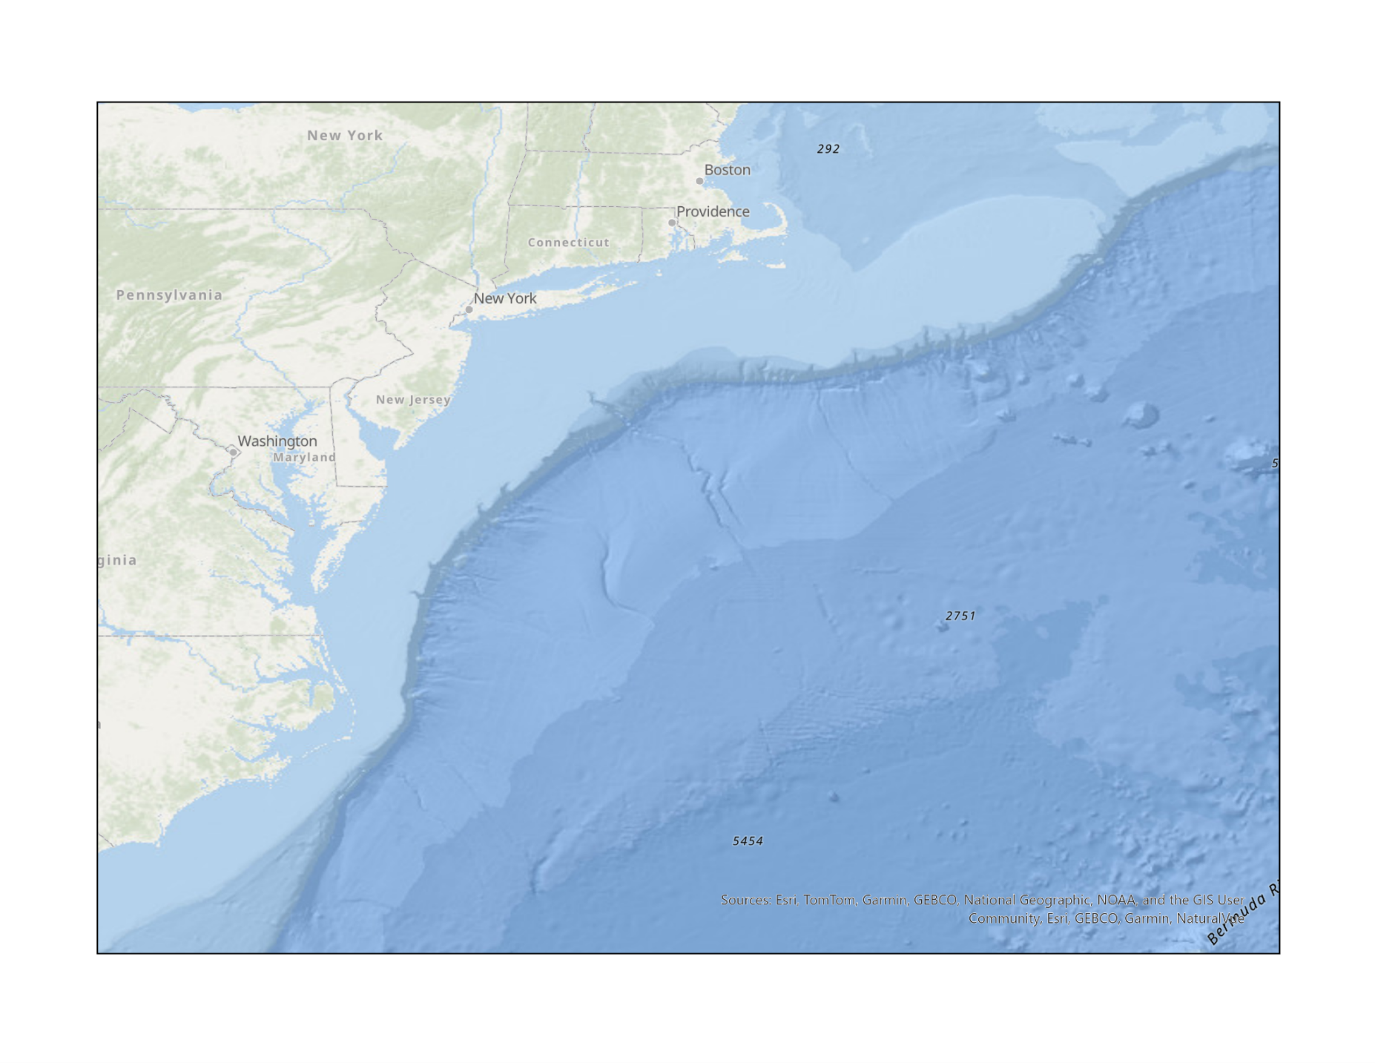

Aim IV: "Integrate the social, economic, and climate drivers of fishing pressure into a model projecting fishery sustainability and ecosystem services under different climate scenarios"
Motivation: Management Strategy Evaluation (MSE) is a modeling framework that compares fishery dynamics with different management measures and assesses the tradeoffs between these measures. Existing MSE models for summer flounder assume full angler compliance with regulations and that commercial fishers always catch their full quota regardless of stock size or spatial distribution — both of which are unrealistic. Incorporating the behavioral, economic, and climate findings from Aims 1–3 into an integrated simulation model will allow realistic projection of fishery outcomes under alternative management scenarios.
Objective: Produce an integrated, validated simulation model of the summer flounder socio-environmental system that can project fishery sustainability and ecosystem service delivery under different management and climate scenarios, identifying policies that minimize distributional inequities and maximize resilience for all stakeholder groups.

Methods: Extension of an existing MAFMC MSE model framework (developed by co-PI Fay in 2022) to incorporate:
- An angler behavior sub-model using Aim 1 data on compliance, demographics, and legitimacy perceptions.
- A commercial fishing pressure sub-model incorporating quota allocation, landings data, and economic drivers from Aim 2.
- A climate-driven, spatially explicit recruitment function from Aim 3.
- Scenario analyses varying quota allocation rules (static vs. dynamic), management approaches, and climate projections.
Advisory group engagement (you!) will inform scenario design and performance metrics.

2022 MSE Information:
https://www.mafmc.org/actions/summer-flounder-mse

Hypotheses:
- A: Ecosystem services of flounder — economic value, cultural value, and food security — increase when disparities between the quota allocation and actual spatial abundance are minimized.

Aim IV Discussion Prompts for Advisory Panel:
- As this stage of the project will incorporate the results from other aims, the methods listed above are our goals but are subject to change with developments in the research. Please rank the methods listed above in order of importance to the fishery.
  - If we only were to improve one or two of the models listed above, which would you choose and why?
- What factors do you think influences an individual angler’s decision to comply or not comply with summer flounder management measures?

