**Default parameters with and without social model. This shows that collective decisions can still be bad? Note: If I had more than 50% fishers in the just fish model, dynamics decreased.**

First, we compared the dynamics of the uncoupled fish model with that of the socio-ecological model by setting the (1-X) variable to a set parameter. We found that fish populations remained stable as long as the proportion of the populations remained 50% or lower (Fig 1a). NOTE: DO WE WANT TO HAVE ANOTHER FIGURE THAT SHOWS WHAT HAPPENS OVER 50%? This shows that given our default parameters, only half of individuals from each patch can fish at one time. However, if the distribution of fishers between patches was uneven, with one patch being fished sustainably and the other experiencing overfishing, both patches were able to recuperate stable population dynamics as the immigration parameter allowed for the overfished patch to benefit from fish coming from the other patch. (Fig 2). Figure 1b shows our coupled socio-ecological model where replicator dynamics influence how many individuals are fishing. Here, the human population maintains fishing levels over 50% for each patch, thereby overfishing both patches.

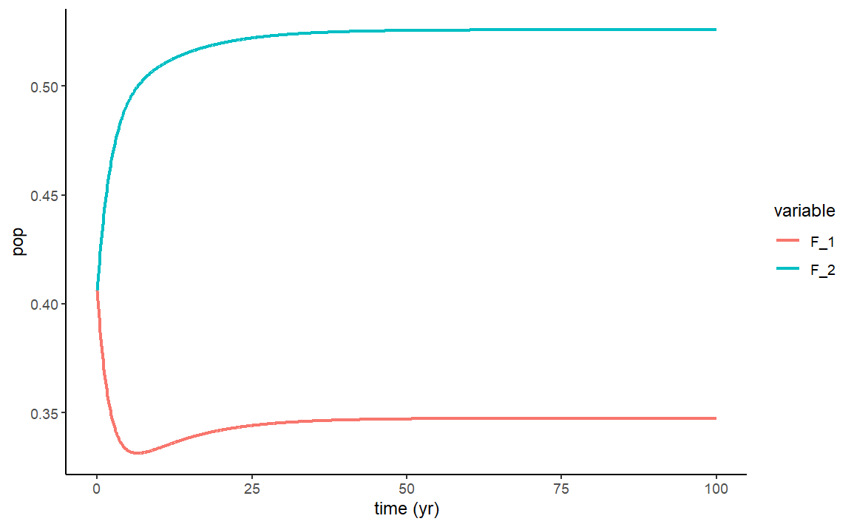

Fig 2 ^

**Having just one patch with unsustainable practices can tank the whole system (fig b, fig a is just showing the sustainable practices). However, you don’t necessarily need to adjust fishing directly. Fig c is just showing how changing the rarity valuation param can change dynamics (like public education or something)**

Next, we altered the parameters to reflect sustainable fishing practices where GIVE PARAMETERS in order to create a healthy system (Fig 3a). Next, we simulated scenarios where one patch’s practices were so unsustainable that both patches began to move toward stock collapse. This is different than the uncoupled model, where unsustainable practices could be mitigated by immigration from the other patch of fish stock. Instead, because of the parameters used in this analysis, humans keep fishing despite lower yields due to their influence over one another. Therefore, in order to improve fishing conditions for both patches, we explored how changing human parameters can influence the dynamics of the whole system. We found, for example, that INCREASING(I think and BY HOW MUCH) just the rarity valuation parameter is sufficient to SAVE THE SYSTEM.

GET BAUCH MODEL 11 TO RUN AND THEN PUT THESE PARAMS THOUGH TO SEE WHICH ARE INFLUENCING

**Shows how social hierarchy doesn’t have a huge impact on overall dynamics. X1 exhibits a little more conservation but eventually tapers off**

Next, we tested our hypotheses that social hierarchy can change the system’s dynamics by running several scenarios and comparing the effect that changes in rho 1 can have on the model. We found, contrary to our predictions, that social hierarchy tended to not have huge overall influences on the model. Figure 4 shows THE FOLLOWING PARAMETERS WHICH MODELS THIS KIND OF SYSTEM. We found that due to the WHATEVER YOU CHANGED, fishers in patch 1 exhibited more conservation practices for a longer amount of time (Fig 4a vs 4b) yet still eventually overfished their patch. This is consistent with many other scenarios we ran, and shows that differences in rho1 vs rho2 has a lower influence on this model than other parameters. Further, as none of the scenarios we ran showed oscillations in the proportion of conservationists in each patch, this shows that the non-linear dynamics of the system become less significant as YOU ADD PATCHES OF SOCIAL DYNAMICS OR WHATEVER.

**Small amounts of dispersion can even out dynamics but rho and d cant**

After finding that social influence is a less substantial parameter in this model, we tested how significant fish dispersion was in the system. We found that it has a huge overall effect on the system’s dynamics as exemplified in figure 5. Here, we modeled sustainable fishing in patch 1 and unsustainable fishing in patch 2 (GIVE PARAMS) with no dispersion (5a) and very little dispersion GIVE I HERE (5b). We found that even small amounts of dispersion are enough to recuperate crashed fish stocks in patch 2. On the other hand, no changes to d or rho could have the same effect. This shows that our immigration parameters have a significantly stronger influence than any social dynamics

DOULBE CHECKGOING OUT 200 YEARS

Ok so it’s graphs like this that are super confusing. Why does patch 1 have 100% conservationists but 100%fish and vice versa?? In this graph rho = 0 so there should not be any outside influence.

**Prop parameter planes showing they have very minimal effect on dynamics – from default params doc**

In order to test how the rho parameter influences the model, we ran a series of parameter planes with each variable paired with changes in rho. We found that at no point, did rho have an effect on the sustainability of the fish population (Fig 6). This shows that the outside social influence in our model actually has little effect on fishing practices.

High movement can save dynamics in lots of scenarios. See difference in the R param planes with high and low movement:

**Low on left, high on right – Actually probs not going to use that**

Finally, to test how influential the immigration parameter is, we observed various parameter planes with models with low immigration rates and compared them with models exhibiting high immigration rates. We found that increasing immigration in turn increased the ability of the fish populations to survive. For example, the