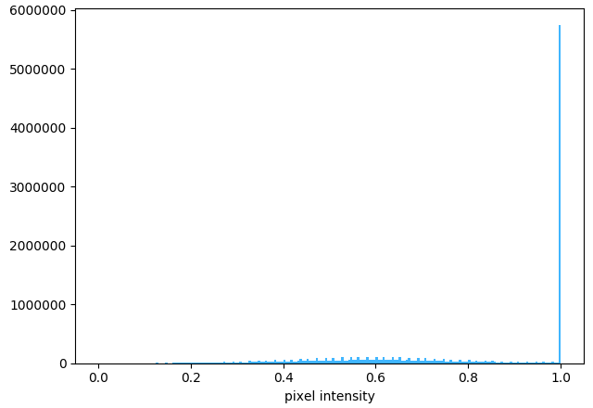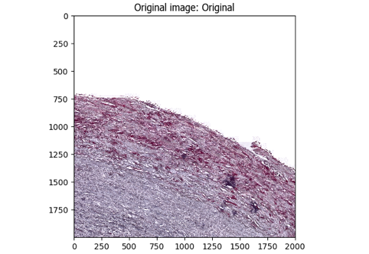**A.**

**The CD34 LRP CellProfiler pipeline workflow.**

***[A].*** The original image (left) is masked using PathProfiler Tissue Segmentation Unet and used as input by CellProfiler 4.2.6; the graph (right) shows the tonal distribution in the digital whole-slide image on a RGB scale.

***[B].*** The input image is converted to a gray scaled image (left); the graph (right) shows the tonal distribution in the gray scaled image.

***[C].*** The gray scaled image is inverted, *i.e.* non-tissue will become black (left); the graph (right) shows the tonal distribution after inverting.

***[D].*** The colors, *i.e.* stains, are unmixed using the original image (left): LRP (middle-top), and DAB (middle-bottom). The graphs (right) show the tonal distributions of LRP and DAB.

***[E].*** The tissue area is identified, as demarcated by the green line in the left image; the total tissue area size is calculated in pixels (right image) and tabulated (table).

***[F].*** The LRP area is identified, as demarcated by the green line in the left image, areas that are excluded due to size (minimal size 8 pixels) are demarcated in magenta; the total LRP area size is calculated in pixels (right image) and tabulated (table).

***[G].*** Finally, the data for each tile are saved in a comma-separated table, including meta-data such as tile positions, image location, object counts (there could be multiple patches of stained areas or tissue). The original image (top-left) is used to outline the LRP-positive objects. The tissue area (dark-green) and LRP area (red) are all demarcated in the top-right image. The table (bottom-right) shows the areas occupied by each object class.

Sample used: AE4.T02-5712.CD34.TIF [Tile= X0, Y14000]

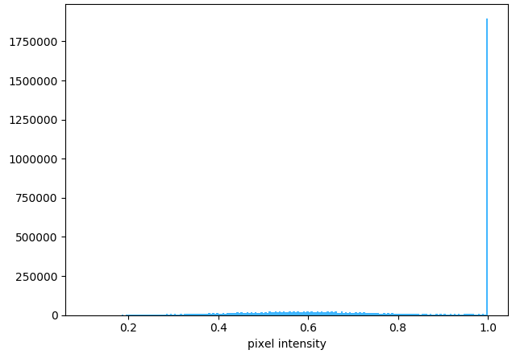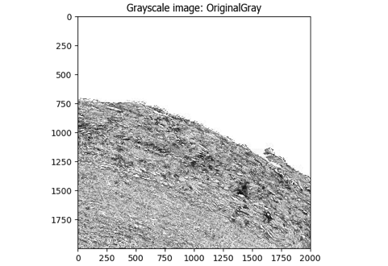**B.**

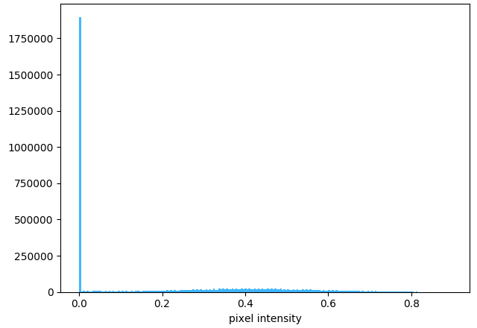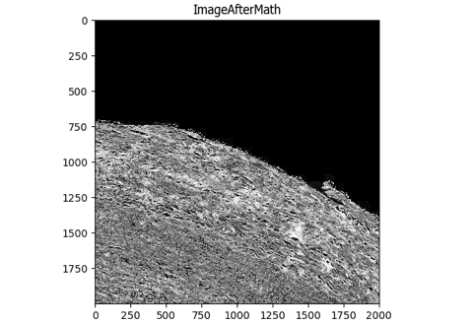**C.**

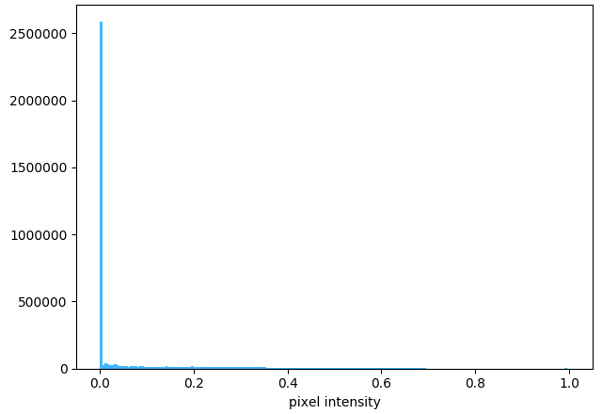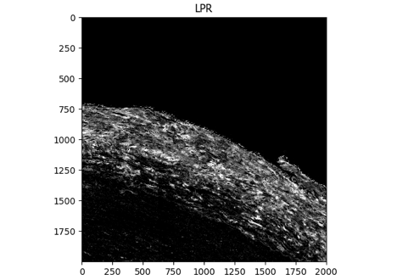

**D.**

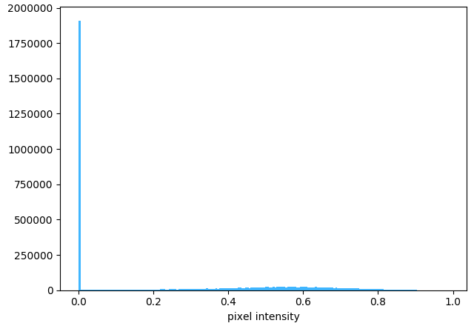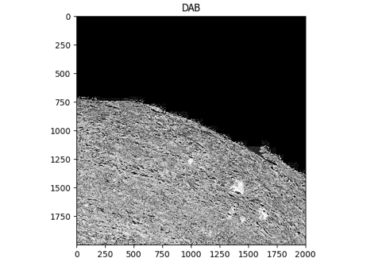

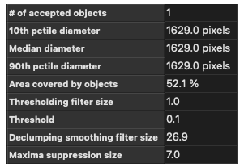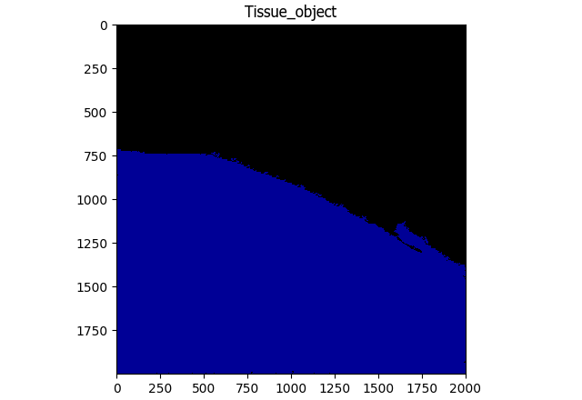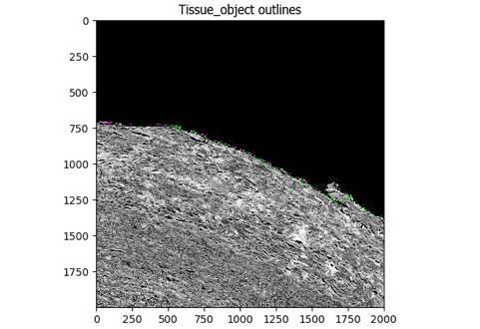**E.**

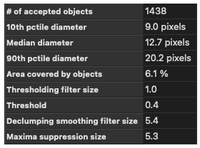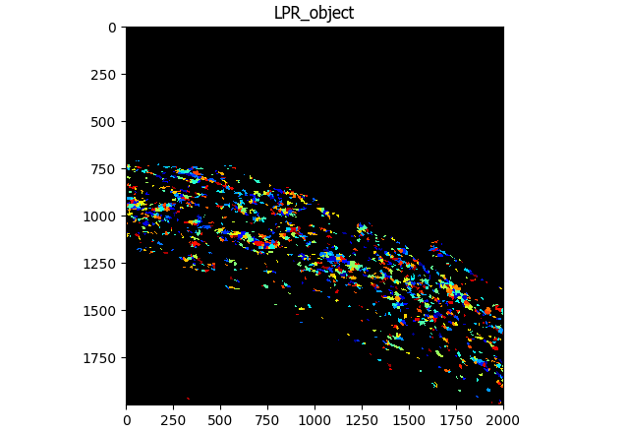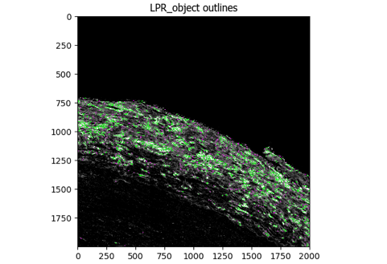**F.**

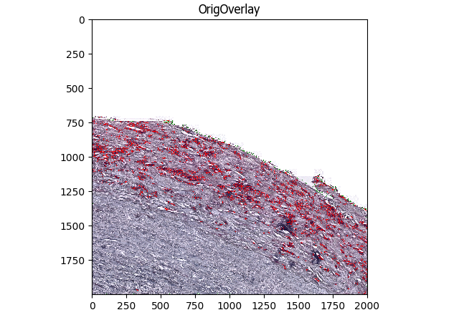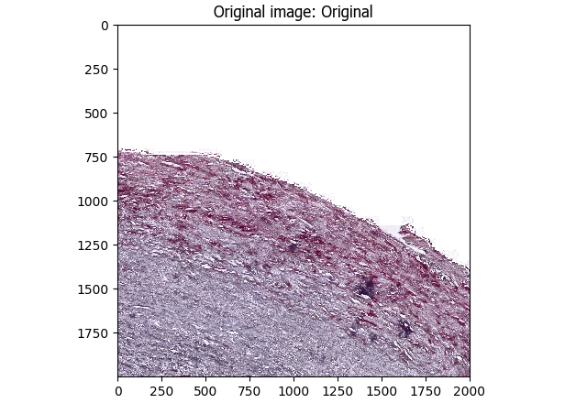**G.**

