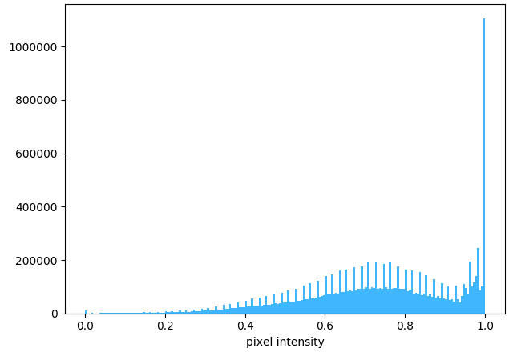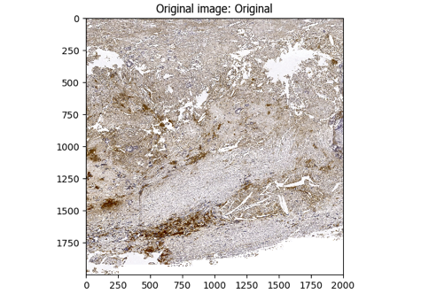**A.**

**The CD68 CellProfiler pipeline workflow.**

***[A].*** The original image (left) is masked using PathProfiler Tissue Segmentation Unet and used as input by CellProfiler 4.2.6; the graph (right) shows the tonal distribution in the digital whole-slide image on a RGB scale.

***[B].*** The input image is converted to a gray scaled image (left); the graph (right) shows the tonal distribution in the gray scaled image.

***[C].*** The gray scaled image is inverted, *i.e.* non-tissue will become black (left); the graph (right) shows the tonal distribution after inverting.

***[D].*** A Gaussian filter is applied to smoothen the image and reduce image artefacts (artifact size 20 pixels) and noise (left); the graph (right) shows the tonal distribution after smoothening.

***[E].*** The colors, *i.e.* stains, are unmixed using the original image (left): DAB (middle-top), and Hematoxylin (HE, middle-bottom). The graphs (right) show the tonal distributions of DAB and Hematoxylin.

***[F].*** The tissue area is identified, as demarcated by the green line in the left image; the total tissue area size is calculated in pixels (right image) and tabulated (table).

***[G].*** The DAB area is identified, as demarcated by the green line in the left image, areas that are excluded due to size (minimal size 8 pixels) are demarcated in magenta; the total DAB area size is calculated in pixels (right image) and tabulated (table).

***[H].*** The Hematoxylin area is identified, as demarcated by the green line in the left image, areas that are excluded due to size (minimal size 6 pixels) are demarcated in magenta; the total Hematoxylin area size is calculated in pixels (right image) and tabulated (table).

***[I].*** The HE-positive identified objects are filtered using the identified DAB objects. If a HE-positive object does not lay within the DAB area, it is discarded.

***[J].*** Finally, the data for each tile are saved in a comma-separated table, including meta-data such as tile positions, image location, object counts (there could be multiple patches of stained areas or tissue). The original image (top-left) is used to outline the DAB- & Hematoxylin-positive objects. The tissue area (dark-green), DAB area (blue), Hematoxylin objects (red), and Filtered objects (yellow) are all demarcated in the top-right image. The table (bottom-right) shows the areas occupied by each object class.

Sample used: AE9.T02-7170.CD68.20141128.TIF [Tile= X22000, Y24000]

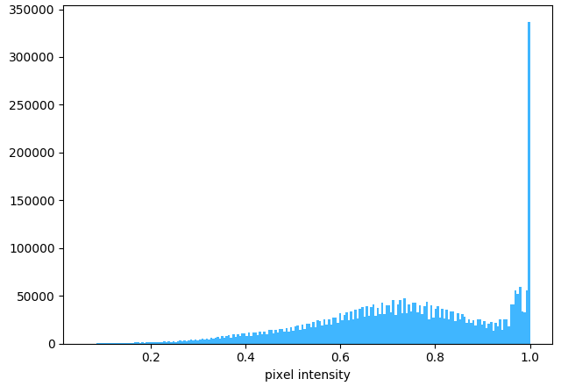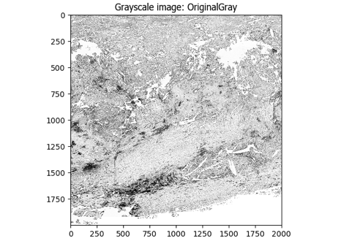**B.**

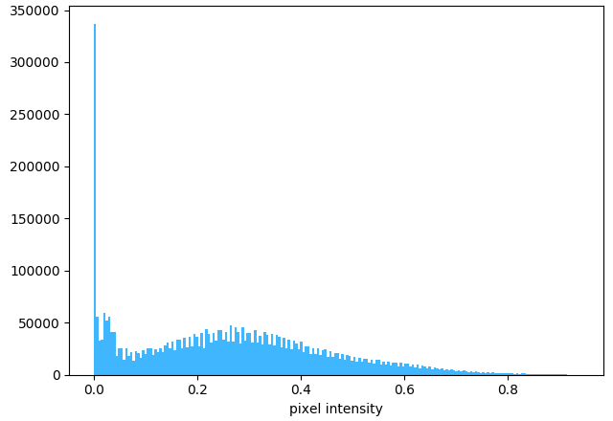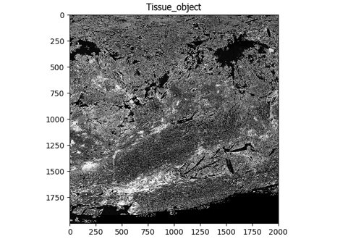**C.**

**D.**

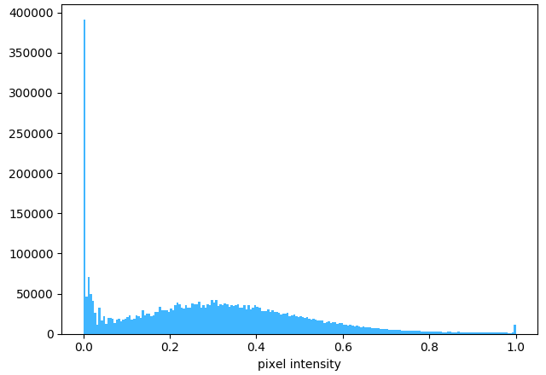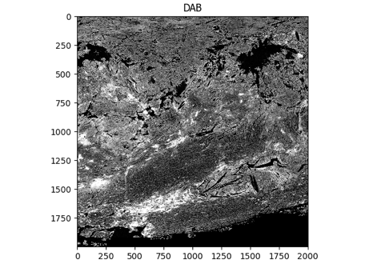

**E.**

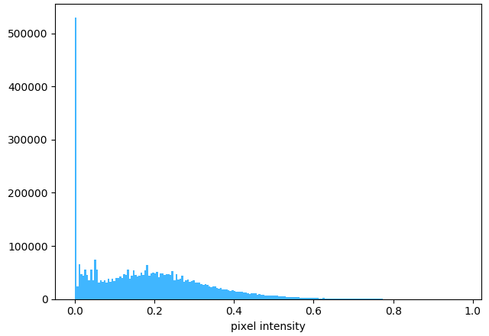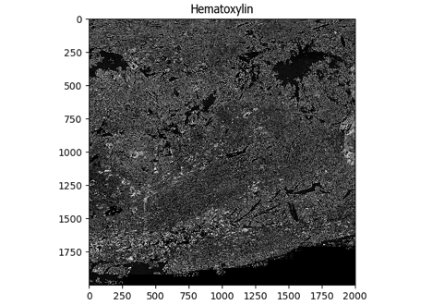

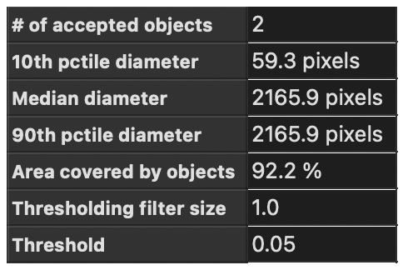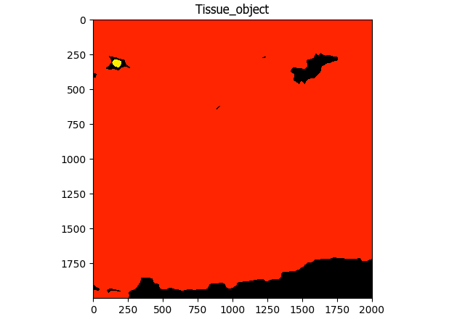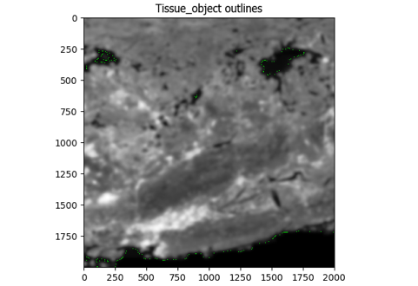**F.**

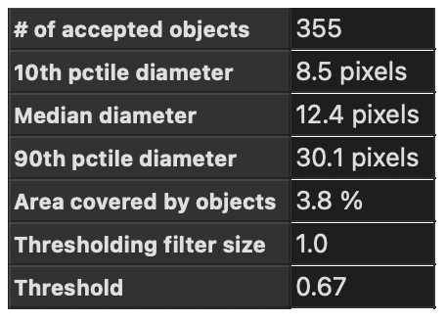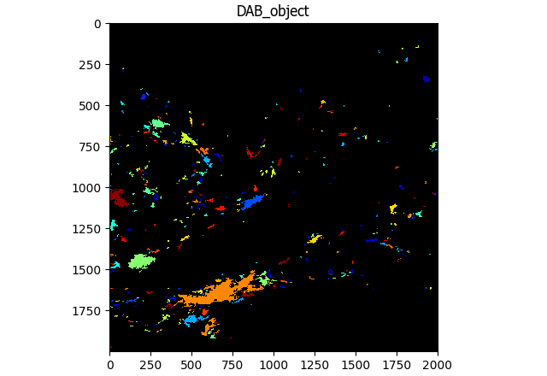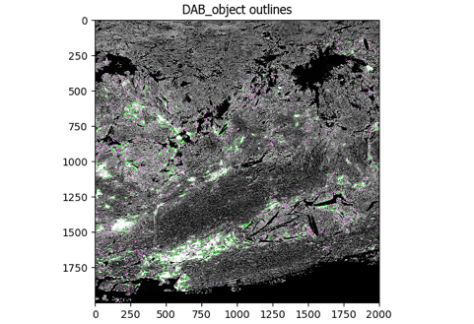**G.**

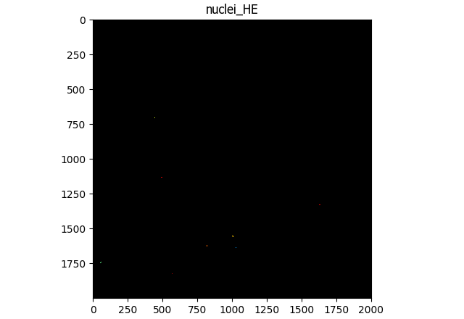

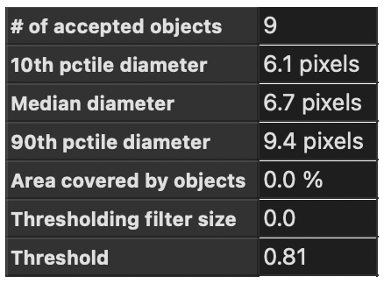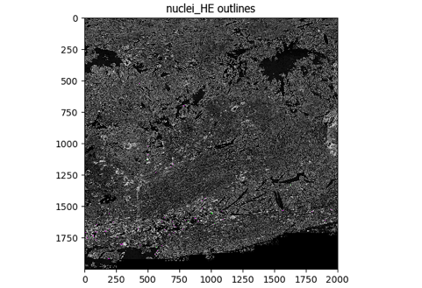**H.**

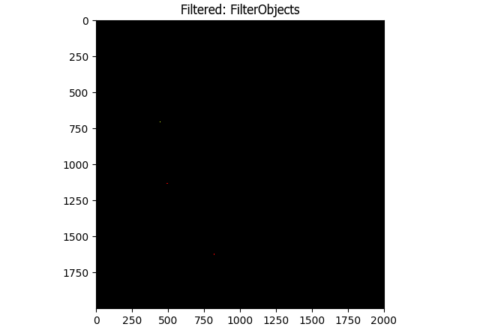

**I.**

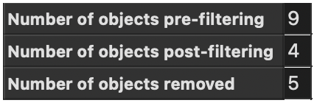

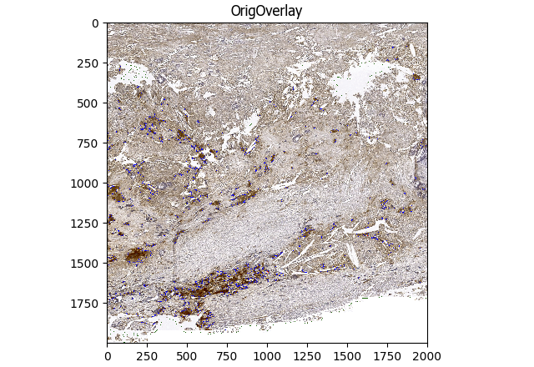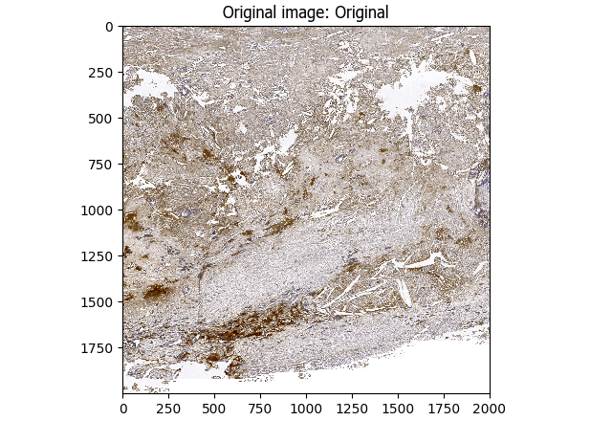**J.**

