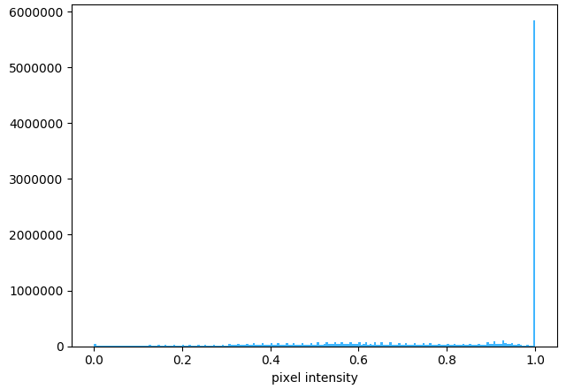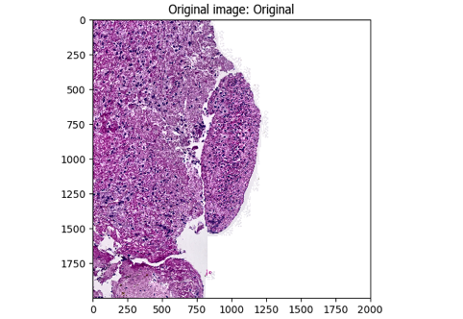**A.**

**The HE CellProfiler pipeline workflow.**

***[A].*** The original image (left) is masked using PathProfiler Tissue Segmentation Unet and used as input by CellProfiler 4.2.6; the graph (right) shows the tonal distribution in the digital whole-slide image on a RGB scale.

***[B].*** The input image is converted to a gray scaled image (left); the graph (right) shows the tonal distribution in the gray scaled image.

***[C].*** A Gaussian filter is applied to smoothen the image and reduce image artefacts and noise (left); the graph (right) shows the tonal distribution after smoothening.

***[D].*** The gray scaled image is inverted, *i.e.* non-tissue will become black (left); the graph (right) shows the tonal distribution after inverting.

***[E].*** The tissue area is identified, as demarcated by the green line in the left image; the total tissue area size is calculated in pixels (right image) and tabulated (table).

***[F].*** The colors, *i.e.* stains, are unmixed using the original image (left): HE (middle-top), and Eosin (HE, middle-bottom). The graphs (right) show the tonal distributions of HE and Eosin.

***[G].*** The HE area is identified, as demarcated by the green line in the left image, areas that are excluded due to size (minimal size 7 pixels) are demarcated in magenta; the total HE area size is calculated in pixels (right image) and tabulated (table).

***[H].***Finally, the data for each tile are saved in a comma-separated table, including meta-data such as tile positions, image location, object counts (there could be multiple patches of stained areas or tissue). The original image (top-left) is used to outline the HE-positive objects. The tissue area (dark-green) and HE area (blue), are all demarcated in the top-right image. The table (bottom-right) shows the areas occupied by each object class.

Sample used: AE2229.UMC.HE.ndpi [Tile= X22000, Y18000]

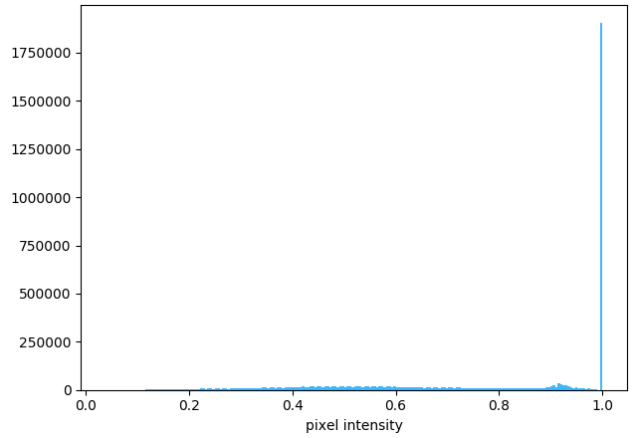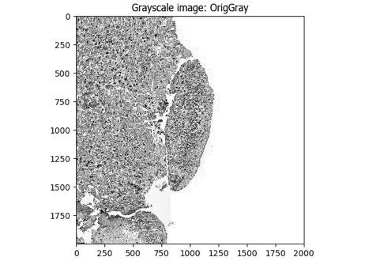**B.**

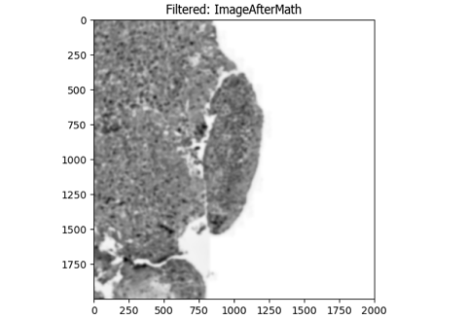

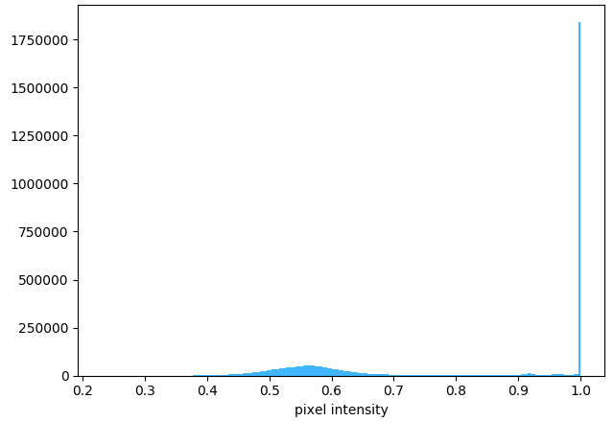**C.**

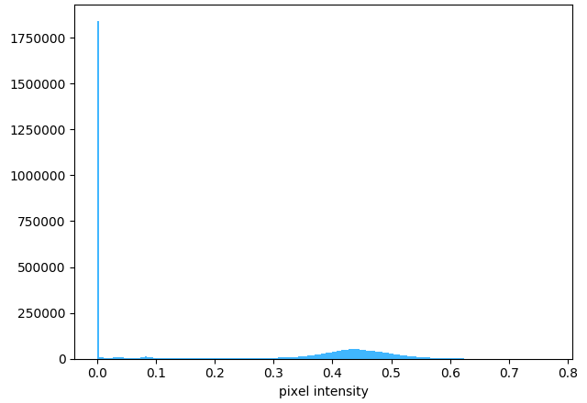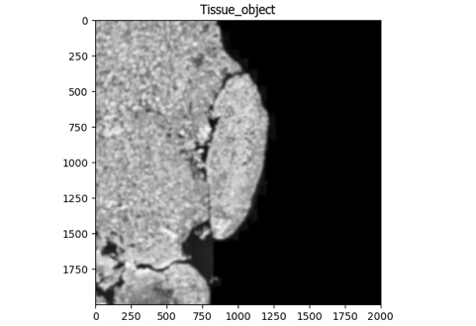**D.**

**E.**

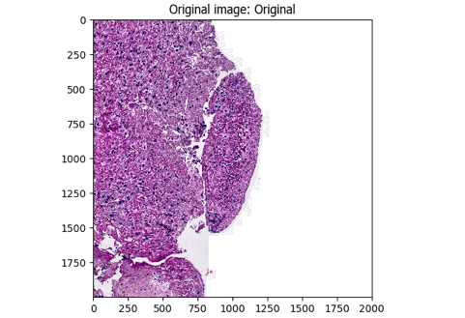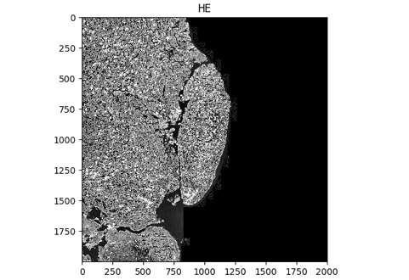

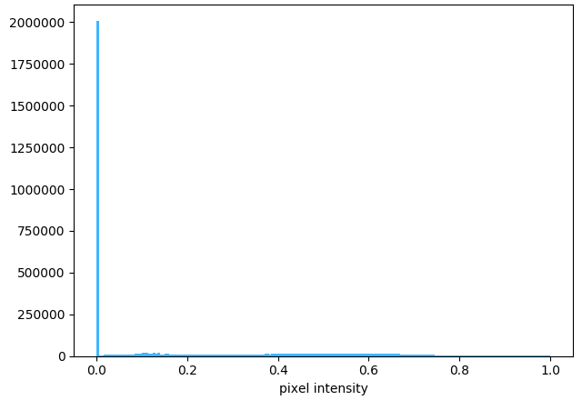**F.**

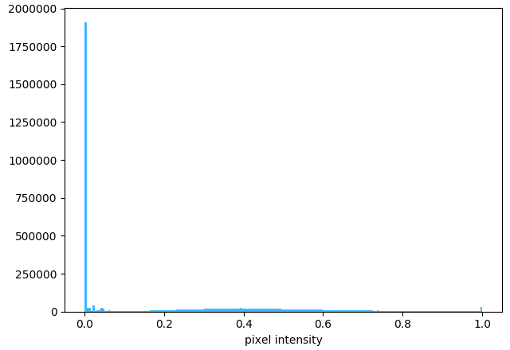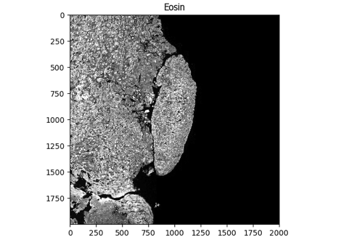

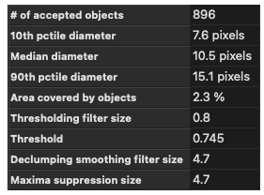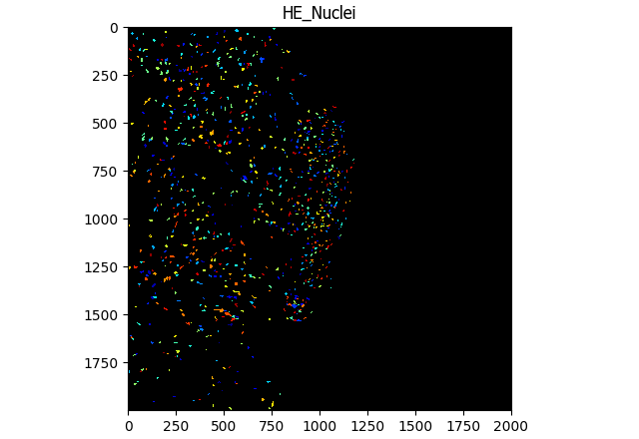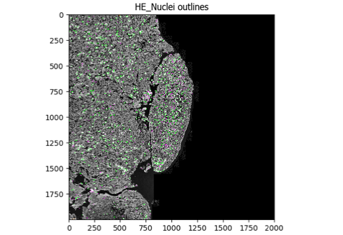**G.**

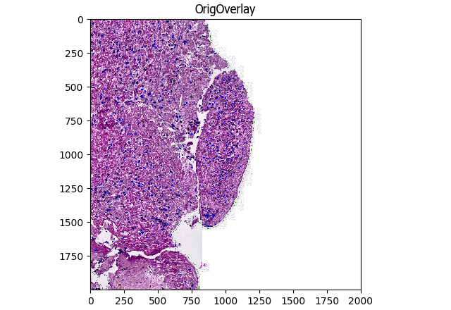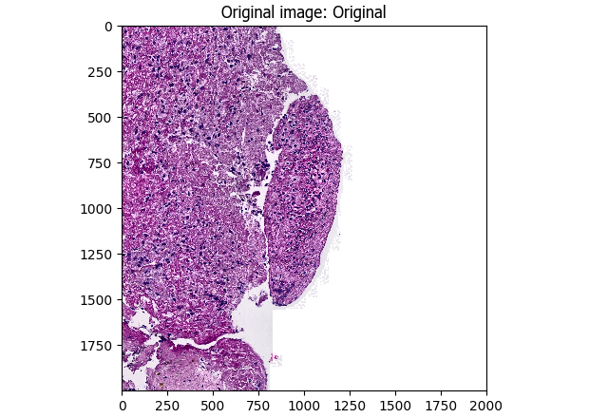**H.**

