Jmeter record postman

Jmeter record IOS Traffic

<http://blogs.quovantis.com/mobile-performance-testing-using-jmeter/>

Add ApacheJMeterTemporaryRootCA.crt to ios to set proxy for capturing requests.

File Upload Configuring in Jmeter

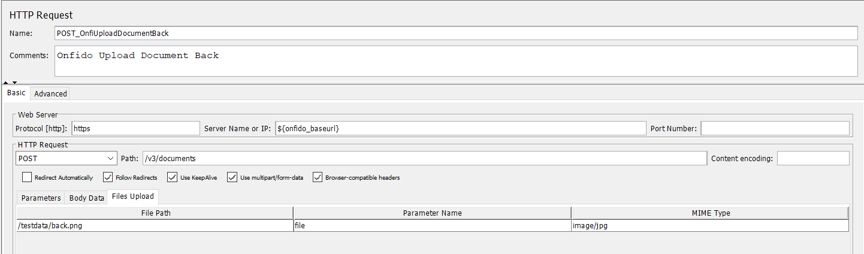

Jmeter configure DB for capturing values.

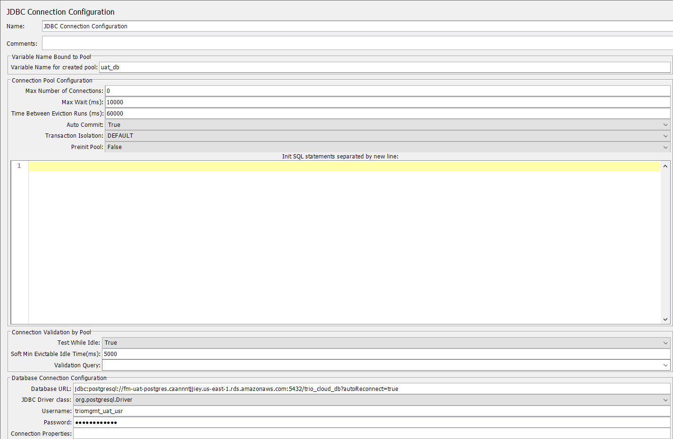

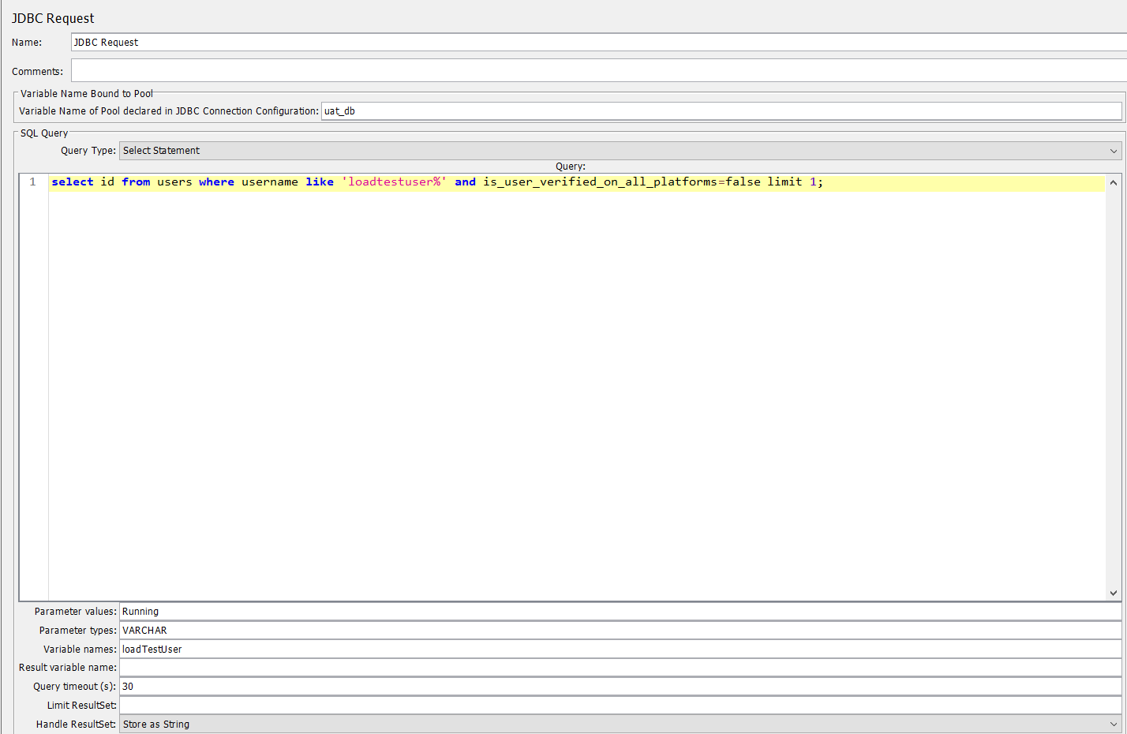

Script to REgistration

import java.net.URLEncoder;

String random = ${__Random(10000000,99999999)};

log.info("random :"+random);

String email_address = "loadtestuser${random}@gmail.com"

log.info("Email before encoded :"+email_address);

String encodedEmail;

String phone = "+9177${random}";

log.info("Phone Number :"+phone);

encodedEmail=URLEncoder.encode(email_address, "UTF-8"); // encodes string into enc scheme

log.info("Encoded Email Address :"+encodedEmail);

vars.put("email_address",email_address);

vars.put("phone",phone);

vars.put("device_uuid", UUID.randomUUID().toString());

//${__setProperty(encodedEmail, ${encodedEmail})};

Priperty Transfers

