**Project-Name : Zomato**

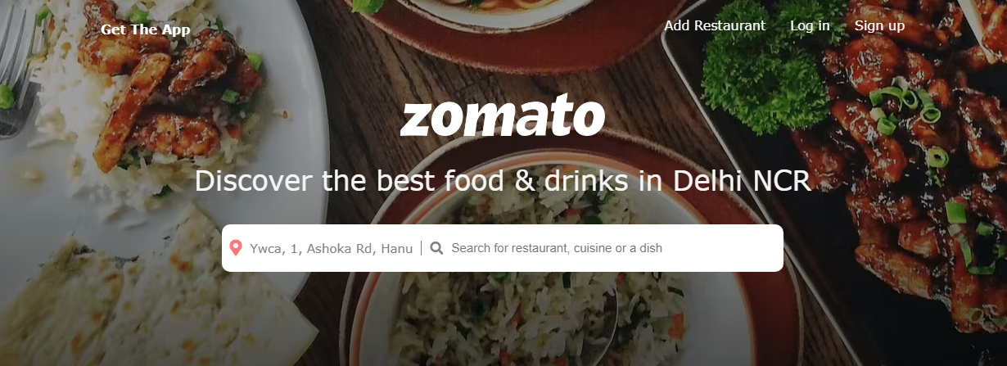

Swapnil Sunil Thorat

Predents

# Overview

Zomato is a fastest growing restaurant discovery website, established in 2008 by Deepinder Goyal and Pankaj Chaddah. Initially, it was named as Foodiebay but in 2010, it was renamed as Zomato. Zomato are works on To begin with, through its food delivery business, Zomato charges a commission to the restaurants on the basis of orders. While users pay a delivery fee, Zomato earns through restaurants who pay a commission for each delivery, which is then split among the delivery partner and the company.

# Goals

1. Login page
2. Home page
3. Payment page
4. Zomato gold Subscription page
5. Login and logout page

Search Restaurant On Zomato

tap on a result of a search query, or navigate to a cuisine page, you land on a list of restaurants. For broad intents or dense neighbourhoods, there can be hundreds of restaurants in the result set.

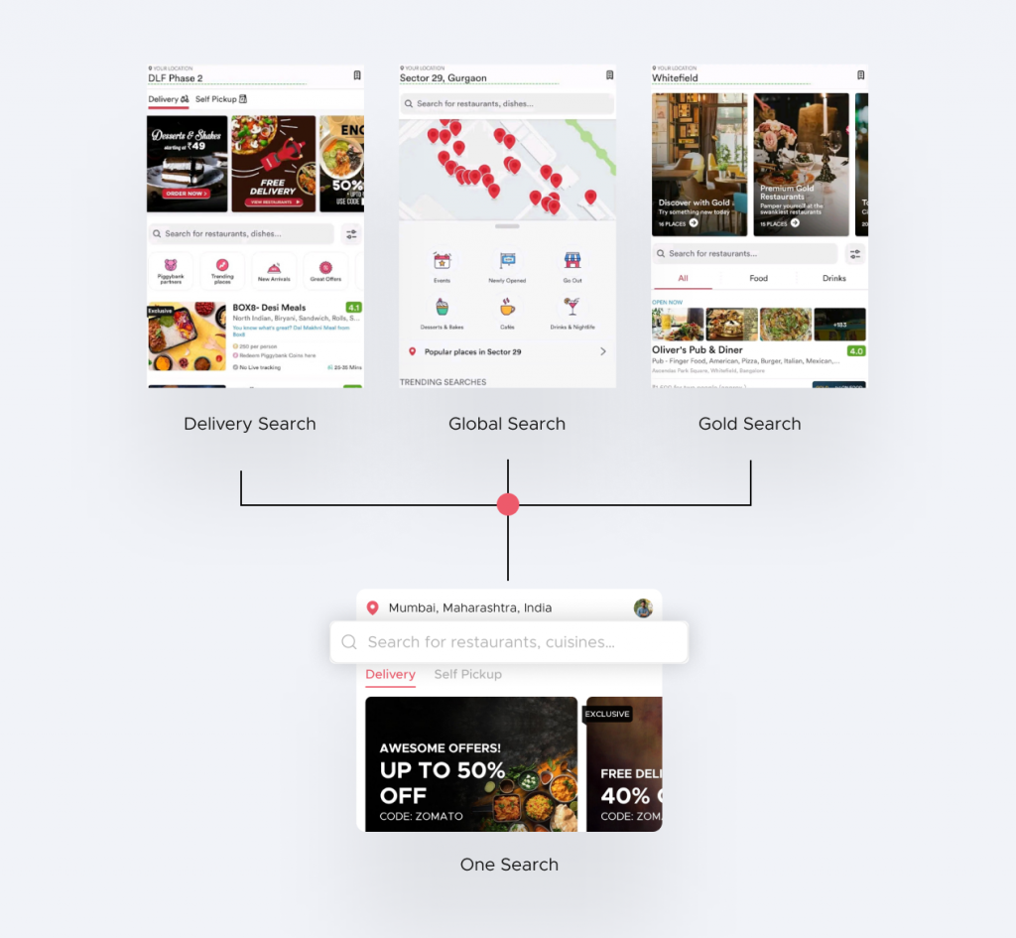

Zomato Payment Page

India Today Web Desk: Zomato has incorporated a wholly-owned subsidiary to handle digital payments and payment gateway services after going public last month. The new subsidiary is called Zomato Payments Private Limited (ZPPL).

These types of Payments are included in Zomato debit cards, credit cards, or any UPI mode for secure payment.



Get The Zomato App

Enhance your experience with the Zomato desktop app for Mac and PC on WebCatalog. Run apps in distraction-free windows with many enhancements. Manage and switch between multiple accounts quickly.

Get the zomato app will send you a link, open it on your phone to download the app

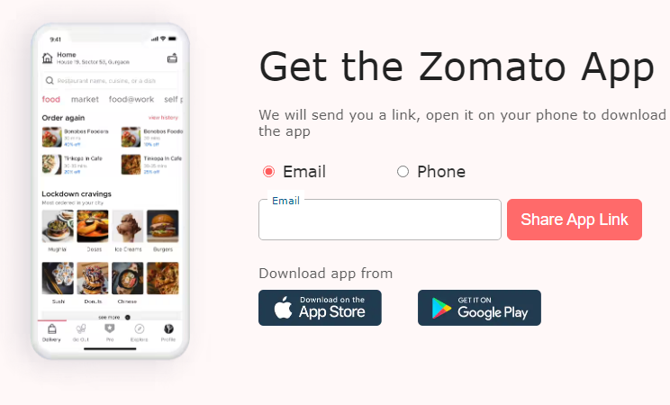

# History

The Company was incorporated as DC Foodiebay Online Services Private Limited a Private Limited Company under the Companies Act 1956 at New Delhi pursuant to a Certificate of Incorporation dated January 18 2010 issued by the Assistant Registrar of Companies NCT of Delhi and Haryana. Pursuant to a Special Resolution passed by the Shareholders on May 16 2012 the name of Company was changed to Zomato Media Private Limited and a fresh Certificate of Incorporation dated May 25 2012 was issued by the RoC. Subsequently pursuant to a Special Resolution passed by Shareholders on April 3 2020 the name of Company was changed to Zomato Private Limited and a fresh Certificate of Incorporation dated April 22 2020 was issued by the RoC. Consequent upon conversion into a Public Limited Company under the Companies Act 2013 pursuant to a Special Resolution passed by the Shareholders on April 5 2021 and fresh Certificate of Incorporation dated April 9 2021 issued by the RoC the name of the Company was changed to Zomato Limited.

The Company ranked as The Top 10 Overall Publishers Downloads by AppAnnie and was ranked amongst India's most desired brands by TRA Research. During the year 2021 the Company was accredited as High-Growth Companies Asia Pacific 2021 by NIKKEI Asia and Financial Times. . The Company was ranked amongst India's Most Attractive Brands by TRA Research and bagged Young Turk of the Year at India Business Leader Awards 2018.During the year 2019 the Company launched Hyperpure a B2B supplies business for restaurant partners. It ranked amongst India's Most Consumer Focused Brands by TRA Research; it was accredited amongst Top Companies: Where India Wants to Work by LinkedIn and ranked amongst Top 10 Overall Publishers by Downloads by AppAnnie.During the year 2020 the company expanded food delivery business across 500 cities in India and acquired `Uber Eats India Assets' of `Uber Eats India Business' from Uber India. The Company received the Award for 'The Best Brand Voice by Twitter'.

Technologies used in Zomato:-

Front-End:

1. Html
2. Css
3. Bootstrap
4. React

Dynamic:

1. Javascript

1. Ci/cd with AWS
2. Login and Logout (oauth and jwt)

Database:

1. Mongodb
2. Json Data

Code compilers:

1. Visual studio code

2. Git bash

3. Git hub

4. Node js