JUST START CODING

Create a console application in visual studio see video: <https://www.screencast.com/t/W2lkCk78KyK>

1. First Challenge: Challenge 1: Write "Hello" and your name to the console window. Use the play button to execute the program.

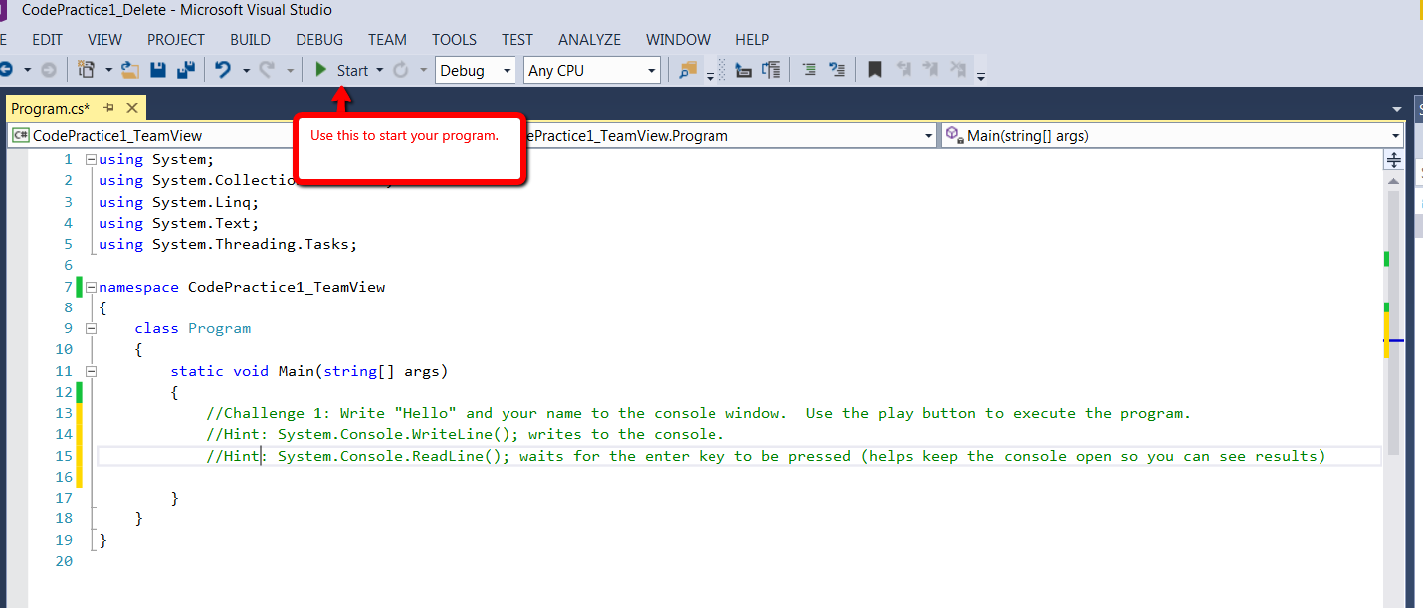

1. Second Challenge: Have the user enter two numbers. Output the sum of the two numbers. Advanced Challenge: Swap the two numbers and output the change to the user.
2. Third Challenge: See how math works with Console.WriteLine(). See if you can figure out what the output will be before running the program.
   1. Hint: Order of operation is multiplication (\*), Division (/), Remainder (%), Addition (+), Subtraction (-).
   2. (-1 + 4 \* 6)
   3. ((35 + 5) % 7)
   4. (14 + -4 \* 6 / 11);
   5. (2 + 15 / 6 \* 1 - 7 % 2);
3. Simple: After the last one, this shouldn’t be too hard. Ask the user for two numbers, then output those numbers as the following scenarios:

* Added together
* Subtracted
* Multiplied
* Divided

More Advanced: Use try catch statements to catch an error when the user enters something that is not an integer, and ask the user again for the correct type until they comply.