Zerg-Rush-Luxan-Database- Documentation

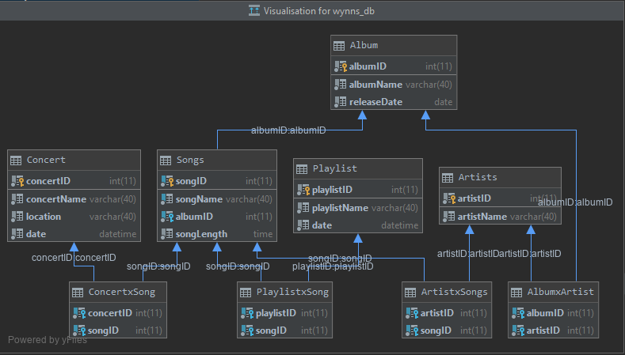**ERD:**

**Table Explanations and Descriptions:**

Main entities:

|  |  |  |  |
| --- | --- | --- | --- |
| Album | | Data Type | Regular Expressions |
| albumID | PK | Int(11) | \d{1,11} |
| albumName | | varchar(40) | \w{1,40} |
| releaseDate | | date | \d{4}-\d{2}-\d{2}\s\d{2}:\d{2}:\d{2} |

|  |  |  |  |
| --- | --- | --- | --- |
| Artists | | Data Type | Regular Expressions |
| artistID | PK | Int(11) | \d{1,11} |
| artistName | | varchar(40) | \w{1,40} |

|  |  |  |  |  |
| --- | --- | --- | --- | --- |
| Songs | | | Data Type | Regular Expressions |
| songID | | PK | Int(11) | \d{1,11} |
| songName | | | varchar(40) | \w{1,40} |
| albumID | FK | | Int(11) | \d{1,11} |
| songLength | | | time | \d{2}:\d{2}:\d{2} |

|  |  |  |  |
| --- | --- | --- | --- |
| Playlist | | Data Type | Regular Expressions |
| playlistID | PK | Int(11) | \d{1,11} |
| playlistName | | varchar(40) | \w{1,40} |
| date | | Datetime | \d{4}-\d{2}-\d{2}\s\d{2}:\d{2}:\d{2} |

|  |  |  |  |
| --- | --- | --- | --- |
| Concert | | Data Type | Regular Expressions |
| concertID | PK | Int(11) | \d{1,11} |
| concertName | | varchar(40) | \w{1,40} |
| location | | varchar(40) | \w{1,40} |
| date | | date | \d{4}-\d{2}-\d{2}\s\d{2}:\d{2}:\d{2} |

Relational Tables:

Relates songs to concerts to create a many-to-many relationship

Relates playlists and songs to create a many-to-many relationship

Relates artists to songs to create a many-to-many relationship

Relates albums to artists to create a many-to-many relationship

|  |  |  |  |  |
| --- | --- | --- | --- | --- |
| ConcertxSong | | | Data Type | Regular Expressions |
| concertID | PK | FK | Int(11) | \d{1,11} |
| songID | PK | FK | Int(11) | \d{1,11} |

|  |  |  |  |  |
| --- | --- | --- | --- | --- |
| PlaylistxSong | | | Data Type | Regular Expressions |
| playlistID | PK | FK | Int(11) | \d{1,11} |
| songID | PK | FK | Int(11) | \d{1,11} |

|  |  |  |  |  |
| --- | --- | --- | --- | --- |
| ArtistxSongs | | | Data Type | Regular Expressions |
| artistID | PK | FK | Int(11) | \d{1,11} |
| songID | PK | FK | Int(11) | \d{1,11} |

|  |  |  |  |  |
| --- | --- | --- | --- | --- |
| AlbumxArtist | | | Data Type | Regular Expressions |
| albumID | PK | FK | Int(11) | \d{1,11} |
| artistID | PK | FK | Int(11) | \d{1,11} |