MODULE-1
# 1. Network Concepts
A computer network is a collection of interconnected devices that communicate and share resources using communication protocols. Networks allow users to exchange data, share hardware resources, and access internet services efficiently.

## Components of a Network

A network mainly consists of sender, receiver, communication medium, protocols, and networking devices. The sender transmits data while the receiver accepts it. Communication media may be wired or wireless. Protocols define the rules of communication, and devices like routers and switches help manage data transfer.

## Types of Networks

LAN covers a small geographical area such as an office or college campus. MAN connects users across a city, while WAN covers very large geographical regions and connects networks globally through the internet.ff

## Advantages

Networks provide fast communication, resource sharing, centralized data management, remote access, and cost reduction. They improve organizational productivity and support online services.

# 2. Threats in Networks
Network threats are harmful activities that attempt to damage systems, steal information, or interrupt communication services. These threats affect confidentiality, integrity, and availability of data.

## Types of Network Threats

### Malware

Malware is malicious software designed to harm computer systems. Viruses attach themselves to files, worms spread automatically across networks, and Trojan horses appear genuine but perform harmful activities secretly.

### Phishing

Phishing attacks use fake emails or websites to trick users into revealing passwords, banking information, or personal details.

### Denial of Service (DoS)

In a DoS attack, attackers overload a server or network with excessive requests, making services unavailable to legitimate users.

### Eavesdropping
Eavesdropping occurs when attackers secretly listen to communication and steal sensitive information during transmission.

### Password Attacks

Attackers attempt to crack passwords using methods such as brute force attacks and dictionary attacks.

## Effects of Network Threats

Network threats can lead to data theft, financial losses, privacy violations, service interruption, and reputation damage.

# 3. Network Security Controls
Network security controls are protective measures implemented to secure systems and networks against unauthorized access and attacks.

## Types of Security Controls

### Physical Controls

Physical controls protect hardware and infrastructure from physical damage or unauthorized access. Examples include CCTV cameras, biometric systems, and locked server rooms.

### Technical Controls

Technical controls use software and hardware technologies to provide protection. Firewalls filter network traffic, antivirus software detects malware, and encryption secures data.

### Administrative Controls

Administrative controls include organizational policies and procedures such as employee training, password policies, and access management rules.

## Importance

Security controls protect confidential data, maintain system stability, reduce cyber risks, and ensure reliable communication.

# 4. Importance of Security
Network security protects systems, devices, and data from attacks, unauthorized access, and misuse.

## Importance of Network Security

Security protects sensitive organizational and personal information from theft or damage. It prevents unauthorized access and cyber attacks that may affect business operations. Security also ensures privacy, supports safe communication, and maintains customer trust.

Organizations with strong security systems experience fewer disruptions and lower financial losses. Security is especially important in banking, healthcare, education, and government sectors where confidential information is handled.

## Consequences of Poor Security

Weak security may result in data loss, system failure, financial damage, and legal problems. It can also damage the reputation of organizations.

# 5. Threat Models
A threat model is a structured process used to identify possible threats, vulnerabilities, and attacks in a system.

## Components of Threat Model

### Assets

Assets are valuable resources such as data, software, hardware, and network services that require protection.

### Threats

Threats are possible harmful actions that may exploit system weaknesses.

### Vulnerabilities

Vulnerabilities are weaknesses in hardware, software, or network configurations.

### Attackers

Attackers are individuals or groups attempting to damage systems or steal information.

### Countermeasures

Countermeasures are security mechanisms used to reduce risks and protect systems.

## Benefits

Threat modeling helps organizations identify risks early, improve security planning, and reduce attack possibilities.

# 6. Security Concepts
Security concepts are fundamental principles used to protect information systems and communication networks.

## Confidentiality

Confidentiality ensures that information is accessible only to authorized users. Techniques such as encryption and password protection help maintain confidentiality.

## Integrity

Integrity ensures that data remains accurate and unchanged during storage or transmission. Hashing and digital signatures are commonly used to maintain integrity.

## Availability

Availability ensures that systems and services remain accessible whenever users need them. Backup systems and disaster recovery methods improve availability.

## Authentication

Authentication verifies the identity of users before granting access to systems.

## Authorization

Authorization determines the level of access and permissions provided to authenticated users.

## Non-Repudiation

Non-repudiation prevents users from denying their actions or transactions. Digital signatures help achieve non-repudiation.

# 7. Common Mitigation Methods
Mitigation methods are techniques used to reduce security threats and vulnerabilities in networks and systems.

## Common Methods

### Strong Passwords

Strong passwords containing letters, numbers, and symbols reduce the risk of password attacks.

### Firewalls

Firewalls monitor and filter incoming and outgoing network traffic to block unauthorized access.

### Antivirus Software

Antivirus programs detect, prevent, and remove malicious software from systems.

### Encryption

Encryption converts data into unreadable form so that unauthorized users cannot understand it.

### Software Updates

Regular updates and patches fix security vulnerabilities in software and operating systems.

### Backup and Recovery

Backup systems help restore data after accidental loss or cyber attacks.

### Multi-Factor Authentication

Multiple verification methods provide stronger user authentication and improve security.

# 8. Why is Wireless Different?
Wireless communication uses radio waves instead of physical cables for transmitting data between devices.

## Why Wireless Networks are Different

Wireless networks transmit signals through open air, making them easier to intercept compared to wired networks. Users can move freely while remaining connected, which increases convenience but also introduces security challenges.

Because wireless signals travel beyond physical boundaries, unauthorized users may access the network if security measures are weak. Physical control over wireless communication is also difficult.

## Wireless Security Challenges

Wireless networks face problems such as signal interception, rogue access points, unauthorized access, and device theft.

## Advantages

Wireless communication provides mobility, easy installation, flexibility, and cost-effective networking.

# 9. Protecting the Means of Communication
Protecting communication means securing data during transmission from unauthorized access or interception.

## Methods of Protection

### Encryption

Encryption converts data into coded form so that only authorized users can understand it.

### Secure Protocols

Protocols such as HTTPS and SSL provide secure communication channels.

### VPN

Virtual Private Networks create secure tunnels for transmitting data over public networks.

### Authentication

Authentication verifies the identity of communicating users and devices.

# 10. Protecting Privacy
Privacy protection ensures that personal and confidential information is not accessed or misused by unauthorized individuals.

## Methods of Privacy Protection

Encryption secures data from attackers, while access control restricts information access to authorized users only. Secure storage systems and privacy policies also help protect user information.

## Importance

Privacy protection prevents identity theft, financial fraud, and misuse of personal information. It also builds user trust in communication systems and online services.

# 11. Promoting Safety
Promoting safety means protecting users, devices, and communication systems from cyber threats, misuse, and harmful activities.

Wireless networks are used in banking, healthcare, transportation, and emergency services. Any attack on these systems can cause major damage, so proper safety measures are necessary.

## Safety Measures

* Authentication – verifies the identity of users before access is given.
* Firewall – filters unwanted and harmful network traffic.
* Antivirus Software – detects and removes malware from systems.
* Encryption – converts data into unreadable form for unauthorized users.
* Network Monitoring – continuously checks networks for suspicious activity.

## Importance

* Prevents cybercrime
* Protects user information
* Maintains reliable communication
* Improves user trust

# 12. The Personal and the Public
Wireless communication affects both individual privacy and public security.

## Personal Concerns

* Privacy Protection – secures personal information from unauthorized access.
* Secure Transactions – protects online banking and payments.
* Identity Protection – prevents identity theft and misuse of personal data.

## Public Concerns

* National Security – protects government and defense communication systems.
* Public Communication – supports transportation and emergency systems.
* Emergency Services – enables quick response during disasters and accidents.

## Importance

A balance between personal privacy and public safety is necessary in communication systems.

# 13. Shaking Up the Status Quo
Wireless technologies have changed traditional communication methods and transformed modern society.

Earlier communication depended mainly on wired systems. Wireless technology introduced mobility, remote access, and mobile communication.

## Effects

* Mobility – users can communicate while moving.
* Digital Transformation – businesses shifted toward online and mobile services.
* Faster Communication – information can be shared instantly.
* New Security Risks – wireless systems introduced additional cyber threats.

## Advantages

* Better accessibility
* Increased productivity
* Easy communication

# 14. Understanding Wireless Forecasts
Wireless forecasts predict future developments and trends in wireless communication technologies.

## Future Trends

* Faster Internet Speeds – improved communication performance.
* Internet of Things (IoT) – smart devices connected through networks.
* Smart Devices – increased use of smartphones and wearable devices.
* Better Security Systems – advanced technologies for protection against cyber threats.

## Importance

Wireless forecasting helps organizations prepare for future technological developments.

# 15. Reasonable Degrees of Security
Reasonable security means implementing practical and acceptable levels of protection rather than expecting complete security.

No system can provide 100% security because attackers continuously develop new attack methods.

## Factors Affecting Security

* Cost – security implementation should be affordable.
* Performance – security should not reduce system efficiency excessively.
* Risk Level – higher risks require stronger security.
* Usability – systems should remain easy to use.

# 16. Regulatory Environments and Issues
Regulatory environments include laws and policies controlling wireless communication and information security.

## Major Issues

* Data Privacy – protection of personal and confidential information.
* Cybercrime – illegal activities performed using networks and computers.
* Spectrum Management – proper allocation of wireless frequencies.
* User Protection – safeguarding users from misuse and cyber attacks.

# 17. Security-Related Regulations
Security-related regulations are laws and standards developed to improve information and communication security.

## Examples

* Data Protection Laws – protect user information and privacy.
* Privacy Regulations – control collection and use of personal data.
* IT Security Standards – provide guidelines for secure systems.
* Telecom Policies – regulate communication services and technologies.

## Importance

* Reduces cybercrime
* Improves security compliance
* Protects users and organizations

# 18. Security Related Market Factors
Security-related market factors are business and economic conditions that influence cybersecurity technologies and services.

## Factors

* Customer Trust – users prefer secure communication systems.
* Security Cost – organizations consider implementation expenses.
* Competition – companies improve security to remain competitive.
* Technology Growth – increasing technology creates demand for better security.

## Impact

Growing cyber threats have increased demand for cybersecurity products and services.

# 19. Guidelines for Security Measures
Security guidelines are recommended practices used to improve network and wireless security.

## Guidelines

* Strong Passwords – difficult passwords reduce unauthorized access.
* Encryption – protects sensitive information during transmission.
* Regular Updates – fix software vulnerabilities and bugs.
* Access Control – restricts system access to authorized users.
* Network Monitoring – detects suspicious activities in networks.
* Security Training – educates users about cyber threats and safe practices.

# 20. Cellular Networks and Bearer Technologies
A cellular network is a wireless communication system divided into small geographical regions called cells.

## Important Terms

* Cell – small coverage area in a cellular network.
* Base Station – controls communication within a cell.
* Frequency Reuse – same frequencies reused in different cells to improve efficiency.
* Bearer Technology – technology used to carry voice and data communication.

## Features

* Wide coverage
* Mobility support
* Continuous communication
* Efficient spectrum usage

## Applications

* Mobile communication
* Internet access
* Emergency communication systems

# 21. First-Generation Wireless (1G)
1G was the first wireless communication technology based on analog signals.

## Features

* Analog Communication – voice transmitted using analog signals.
* Voice-Only Service – supported only voice calls.
* Large Devices – mobile phones were bulky and expensive.

## Limitations

* Weak Security – no encryption methods were used.
* Poor Voice Quality – communication quality was low.
* High Interference – signals were easily disturbed.

# 22. Second-Generation Wireless (2G)
2G is the second generation of wireless technology based on digital communication.

## Features

* Digital Communication – signals transmitted digitally for better quality.
* SMS Support – introduced text messaging services.
* Improved Security – encryption methods provided better protection.

## Advantages

* Better voice quality
* Efficient bandwidth usage
* Lower power consumption

## Applications

* Voice calls
* Text messaging
* Basic internet services

# 23. Spread Spectrum
Spread spectrum is a communication technique where signals are spread across a wide frequency range.

## Types

### FHSS (Frequency Hopping Spread Spectrum)

Signal changes frequencies rapidly during transmission to reduce interference.

### DSSS (Direct Sequence Spread Spectrum)

Signal spreads using a special code sequence for secure communication.

## Advantages

* Resistance to interference
* Better communication security
* Reduced noise effects

## Applications

Used in Wi-Fi systems and military communication.

# 24. Code Division Multiple Access (CDMA)
CDMA is a communication technique where multiple users share the same frequency using unique codes.

## Important Terms

* Unique Code – identifies each user separately.
* Spectrum Efficiency – efficient use of frequency bandwidth.

## Advantages

* High network capacity
* Better voice quality
* Reduced interference
* Improved security

## Applications

Used in mobile communication systems.

# 25. Time Division Multiple Access (TDMA)
TDMA is a communication method where multiple users share the same frequency using different time slots.

## Important Terms

* Time Slot – fixed time assigned to each user for communication.
* Channel Efficiency – better use of available bandwidth.

## Advantages

* Reduced interference
* Organized communication
* Better bandwidth management

## Applications

Used in digital cellular and satellite communication systems.

# 26. Global System for Mobile Communications (GSM)
GSM is a globally accepted standard for digital mobile communication.

## Features

* SIM Card – stores subscriber information securely.
* International Roaming – allows mobile use in different countries.
* SMS Service – supports text messaging.
* Better Security – digital encryption improves protection.

## Advantages

* Worldwide compatibility
* Good voice quality
* Reliable communication

## Applications

* Mobile communication
* Messaging services
* Internet access

# 27. Third-Generation Wireless (3G)
3G is a wireless communication technology providing high-speed mobile communication and internet access.

## Features

* Video Calling – supports real-time video communication.
* Mobile Internet – enables internet access on mobile devices.
* Multimedia Support – supports audio and video applications.

## Advantages

* Faster data transfer
* Better network performance
* Support for advanced mobile applications

## Applications

* Video conferencing
* Online browsing
* Multimedia communication

# 28. Short Message Service (SMS)
SMS is a service used for sending short text messages between mobile devices.

## Features

* Fast Communication – messages are delivered quickly.
* Low Cost – economical communication method.
* Reliable Service – works even on low-bandwidth networks.

## Applications

* OTP verification
* Banking alerts
* Notifications
* Personal communication

## Advantages

SMS does not require internet connectivity and works on almost all mobile phones.

# 29. Fourth-Generation Wireless (4G)
4G is a high-speed wireless communication technology based on IP networks.

## Features

* High-Speed Internet – supports fast data transmission.
* HD Video Streaming – enables high-quality multimedia streaming.
* Low Latency – reduces communication delay.
* Online Gaming – supports real-time gaming applications.

## Advantages

* Better multimedia experience
* Faster internet connectivity
* Improved communication quality

## Applications

* Mobile broadband
* Video conferencing
* Cloud services
* Smart applications

MODULE-2

Wireless Transmission Media
Wireless transmission media refers to communication channels that transmit data through air using electromagnetic waves instead of physical cables. It is widely used in mobile communication, Wi-Fi, satellite communication, and wireless networking.

Wireless communication provides mobility, flexibility, and easy installation. However, it also introduces security risks because signals travel openly through space.

## Types of Wireless Transmission Media

* Radio Waves – used in mobile and Wi-Fi communication.
* Microwaves – used in satellite and long-distance communication.
* Infrared Waves – used for short-range communication.
* Spread Spectrum Signals – used for secure wireless transmission.

## Advantages

* Mobility and portability
* Easy installation
* Flexible communication
* Reduced wiring cost

## Disadvantages

* Signal interference
* Security risks
* Limited range in some technologies

---

Infrared Systems
Infrared (IR) systems use infrared light waves for wireless communication between devices over short distances.
Infrared communication requires direct line-of-sight between devices because infrared signals cannot pass through walls or obstacles.

## Features
* Short-range communication
* Low power consumption
* High security due to limited range
* Line-of-sight communication

## Applications
* TV remote controls
* Wireless keyboards and mice
* Short-range device communication

## Advantages
* Low interference
* Simple implementation
* Secure local communication

## Limitations
* Cannot penetrate walls
* Limited communication range
* Requires proper alignment

Narrowband Radio System
A narrowband radio system uses a small range of radio frequencies for communication.
These systems transmit signals over a narrow frequency band, reducing bandwidth usage and improving communication efficiency for certain applications.

## Features
* Uses limited frequency range
* Lower bandwidth requirement
* Simple communication system

## Advantages
* Efficient spectrum usage
* Lower power consumption
* Reduced communication complexity

## Disadvantages
* Limited data transmission speed
* More vulnerable to interference

## Applications
* Radio communication
* Paging systems
* Simple wireless communication devices

Wideband Radio Systems: Spread Spectrum
Wideband radio systems use a large frequency range to transmit signals. Spread spectrum technology spreads signals across a wide bandwidth for secure and reliable communication.
Spread spectrum techniques improve resistance to interference, jamming, and unauthorized interception.

## Advantages
* Better communication security
* Resistance to interference
* Reduced signal noise
* Reliable wireless communication

## Types
* Frequency-Hopping Spread Spectrum (FHSS)
* Direct-Sequence Spread Spectrum (DSSS)

Frequency-Hopping Spread Spectrum (FHSS)
FHSS is a spread spectrum technique in which the signal rapidly changes frequencies during transmission according to a predefined sequence.
Both sender and receiver follow the same hopping pattern, making communication secure and difficult to intercept.

## Features
* Rapid frequency changes
* Better resistance to interference
* Improved communication security

## Advantages
* Difficult to intercept signals
* Reduced jamming effects
* Better reliability

## Applications
* Bluetooth communication
* Military communication systems
* Secure wireless communication

Direct-Sequence Spread Spectrum (DSSS)
DSSS is a spread spectrum technique where the signal is spread using a special code sequence before transmission.
The receiver uses the same code to recover the original data. DSSS provides better noise resistance and communication reliability.

## Features
* Uses spreading code sequence
* High resistance to interference
* Improved signal reliability

## Advantages
* Better security
* Reduced noise effects
* Reliable data transmission

## Applications
* Wi-Fi networks
* Wireless LAN systems
* Secure communication systems

WLAN Products and Standards — Today’s Leaders?
Wireless Local Area Network (WLAN) products allow devices to communicate wirelessly within a local area using Wi-Fi technology.

IEEE developed the 802.11 family of standards for WLAN communication. These standards define speed, frequency, and communication methods.

## Common WLAN Standards
* IEEE 802.11a – higher speed using 5 GHz frequency.
* IEEE 802.11b – widely used standard using 2.4 GHz frequency.
* IEEE 802.11g – improved speed with backward compatibility.
* IEEE 802.11n – supports higher speed and wider coverage.

## Advantages of WLAN
* Mobility
* Easy installation
* Flexible networking
* Cost-effective communication

## Limitations
* Security vulnerabilities
* Signal interference
* Limited range

802.11 Security
IEEE 802.11 security refers to security mechanisms used to protect wireless LAN communication from unauthorized access and attacks.
Wireless communication is vulnerable because signals travel openly through air.

## Security Objectives
* Confidentiality – protects transmitted information.
* Integrity – prevents unauthorized data modification.
* Authentication – verifies user identity.
* Access Control – restricts unauthorized users.

## Common Security Techniques
* WEP (Wired Equivalent Privacy)
* WPA/WPA2
* Encryption methods
* Authentication protocols

IEEE 802.11b
IEEE 802.11b is a WLAN standard operating in the 2.4 GHz frequency band with data transfer speeds up to 11 Mbps.
It became popular because of its low cost and easy implementation.

## Features
* Operates at 2.4 GHz
* Supports wireless LAN communication
* Low-cost implementation
* Compatible with many devices

## Advantages
* Easy deployment
* Good coverage area
* Affordable technology

## Limitations
* Lower speed compared to newer standards
* More interference due to crowded frequency band

Securing WLANs
Securing WLANs means protecting wireless local area networks from attacks, unauthorized access, and data theft.
Wireless networks are vulnerable because signals can be intercepted easily.

## WLAN Security Measures
* Strong passwords
* Encryption techniques
* Firewall protection
* MAC address filtering
* User authentication
* Secure access points

## Importance
* Prevents unauthorized access
* Protects confidential information
* Maintains network reliability

---

Eavesdropping
Eavesdropping is the unauthorized interception and monitoring of wireless communication.
Attackers capture transmitted signals to steal confidential information such as passwords and messages.

## Causes
* Open wireless communication
* Weak encryption
* Insecure networks

## Effects
* Data theft
* Privacy violation
* Unauthorized access

## Prevention Methods
* Encryption
* Secure authentication
* VPN usage
* Strong wireless security protocols

Unauthorized Access
Unauthorized access occurs when attackers gain entry to a network or system without permission.
Wireless networks are especially vulnerable because attackers may connect from outside physical boundaries.

## Causes
* Weak passwords
* Open Wi-Fi networks
* Poor authentication methods

## Effects
* Data theft
* Network misuse
* Malware attacks

## Prevention Methods
* Strong passwords
* Access control systems
* Multi-factor authentication
* Network monitoring

Interference and Jamming
Interference occurs when unwanted signals disrupt wireless communication. Jamming is a deliberate attack where attackers block communication using powerful signals.

## Causes
* Nearby wireless devices
* Radio signal overlap
* Intentional signal jamming

## Effects
* Reduced communication quality
* Signal loss
* Network disruption

## Prevention Methods
* Spread spectrum techniques
* Frequency management
* Signal filtering

Physical Threats
Physical threats are dangers that affect wireless devices and network infrastructure physically.

## Examples
* Device theft
* Hardware damage
* Unauthorized physical access
* Environmental damage

## Effects
* System failure
* Data loss
* Network interruption

## Prevention Methods
* Physical locks
* CCTV monitoring
* Secure server rooms
* Restricted access areas

Countermeasures
Countermeasures are security methods used to reduce or prevent wireless security threats.

## Common Countermeasures
* Encryption – protects transmitted data.
* Authentication – verifies authorized users.
* Firewalls – filter harmful traffic.
* Intrusion Detection Systems – monitor suspicious activities.
* Security Policies – guide secure system usage.

## Importance
Countermeasures improve network security and reduce cyber risks.

Infrared (IR)
Infrared communication uses infrared light waves for short-distance wireless communication.

## Features
* Short-range communication
* Requires line-of-sight
* Low interference

## Applications
* Remote controls
* Wireless peripherals
* Device communication

## Advantages
* Secure local communication
* Low power consumption

---

Narrowband
Narrowband communication uses a small portion of the frequency spectrum for transmission.

## Features
* Limited bandwidth
* Simple communication system
* Lower transmission speed

## Advantages
* Efficient frequency use
* Reduced power consumption

## Limitations
* Limited data rates
* More susceptible to interference

The Infamous WEP
WEP (Wired Equivalent Privacy) was the first security mechanism developed for wireless LANs.
It was designed to provide security equivalent to wired networks, but later became vulnerable to attacks.

## Features
* Uses encryption keys
* Provides basic wireless security
* Supports authentication

## Problems with WEP
* Weak encryption algorithms
* Easy password cracking
* Vulnerable to attacks

## Importance
WEP demonstrated the need for stronger wireless security mechanisms.

---

Encryption
Encryption is the process of converting readable data into unreadable form to prevent unauthorized access.
Only authorized users with the correct key can decrypt the information.

## Types
* Symmetric Encryption – same key for encryption and decryption.
* Asymmetric Encryption – different keys for encryption and decryption.

## Importance
* Protects confidentiality
* Secures communication
* Prevents data theft

Authentication
Authentication is the process of verifying the identity of users or devices before granting access.

## Methods
* Password authentication
* Biometric authentication
* OTP verification
* Smart cards

## Importance
Authentication prevents unauthorized users from accessing systems and networks.

Wired Equivalency Protocol Flaws Too Public
WEP flaws became widely known because attackers could easily break WEP encryption using freely available tools.

## Major Flaws
* Weak encryption algorithm
* Short encryption keys
* Repeated initialization vectors
* Poor authentication methods

## Effects
* Unauthorized access
* Data interception

## Result

WEP was replaced by stronger security standards such as WPA and WPA2.

Other Authentication Techniques
Modern wireless systems use advanced authentication methods for better security.

## Techniques
* Multi-Factor Authentication (MFA) – uses multiple verification methods.
* Digital Certificates – verify device and user identity.
* Smart Cards – secure authentication using embedded chips.
* Biometric Authentication – uses fingerprints or facial recognition.

## Advantages
* Stronger security
* Better user verification
* Reduced unauthorized access

Physical Security
Physical security protects wireless devices, servers, and network infrastructure from physical damage or unauthorized access.

## Physical Security Measures
* CCTV surveillance
* Security guards
* Biometric access systems
* Locked server rooms
* Device tracking systems

## Importance
Physical security prevents theft, hardware damage, and unauthorized system access.

MODULE 3

WAP :- wireless application protocol
-> technology used to access internet services on mobile phones and wireless devices.
Earlier mobile phones were weak:
- small screens
- low memory
- slow internet
So WAP was created to make internet work properly on mobile devices.
Features of WAP:-
- Works on wireless networks
- Supports mobile internet browsing
- Lightweight and fast
- Works on low bandwidth
- Secure communication possible
- Supports text and simple graphics
WAP ARCHITECTURE
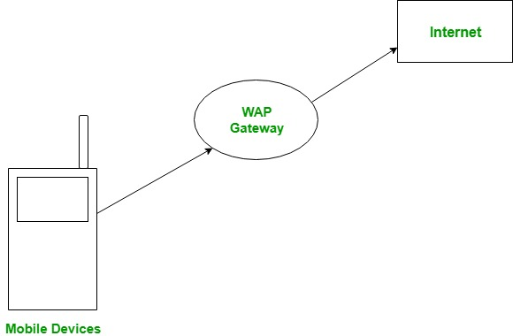

(1) Mobile Device
Phone or PDA used by user.

(2) WAP Gateway
Acts like a translator between mobile network and internet.

(3) Web Server
Stores websites and services.
WORKING OF WAP
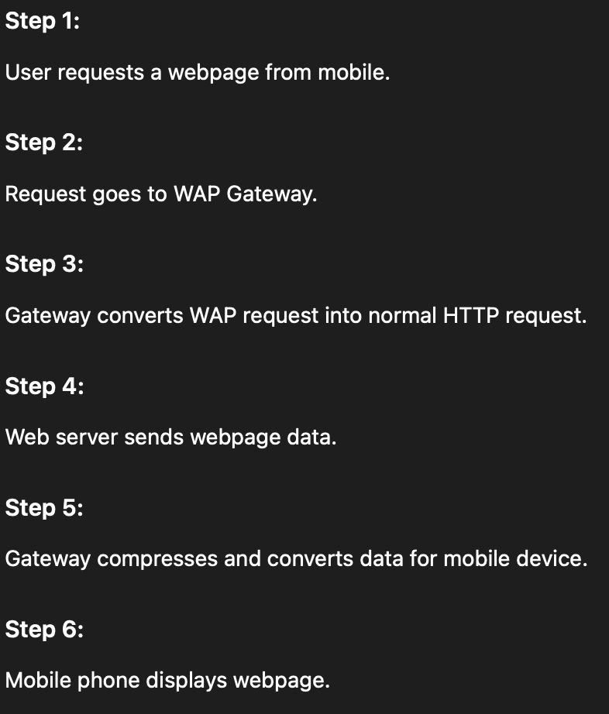

Comparison of TCP/IP, OSI and WAP Models

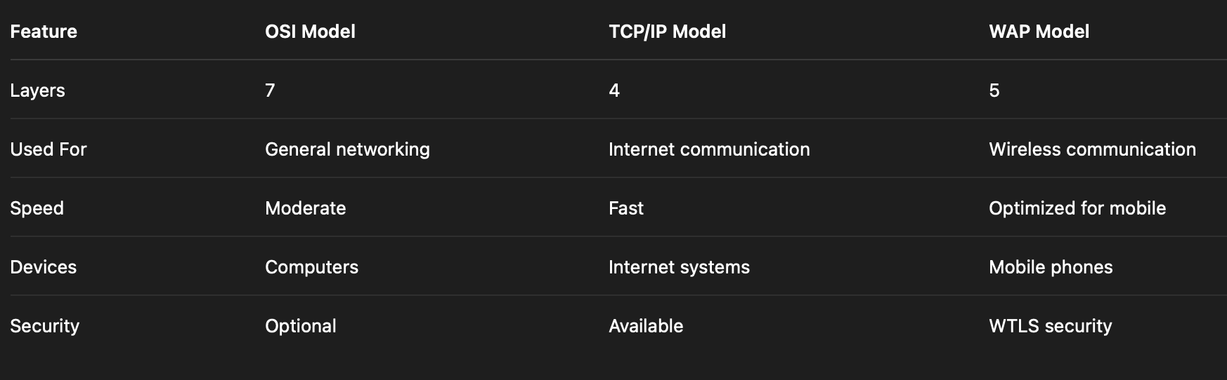

Security status for WAP:-
WAP provides security for wireless communication.

Goals:
- Protect data
- Prevent hacking
- Maintain privacy

Security Problems:
- Weak wireless signals
- Easy interception
- Low device power
Virus:-
A virus is a harmful computer program that enters a system and damages files, data, or software.
It can spread from one computer to another through:
- internet
- USB drives
- email attachments
- infected files

Common Threats:
- Malware
- Trojan horse
- Worms

Effects:
- Data theft
- Slow performance
- Device damage

Prevention:
- Antivirus
- Secure downloads
- Updated software
#AUTHORIZATION
Authorization means:
Giving permission to access resources.
Example:
- Admin can edit files
- Normal user can only view files

Types:
Read access -> User can only view or read the data.
Write access -> User can add, modify, or delete data.
Execute access -> User can run or execute a program or file.
#AUTHENTICATION
Verifying the identity of a user.
Example:
- Username + Password
- OTP
- Fingerprint

Purpose:
- Ensure real user is accessing system
#NON-REPUDIATION:-
A sender cannot deny sending a message.
Example:
Digital signature in online banking.

Importance:
- Proof of communication
- Legal security
#SECURE SESSION:-
Safe communication between client and server.

Features:
- Encrypted data
- Safe login
- Protected transactions

Example:
HTTPS connection.
SECURITY PRODUCTS:-
Security products protect systems and networks.

Examples:
- Firewall
- Antivirus
- VPN
- IDS (Intrusion Detection System)

Functions:
- Detect attacks
- Block unauthorized access
- Protect data
SECURITY TECHNOLOGY:-
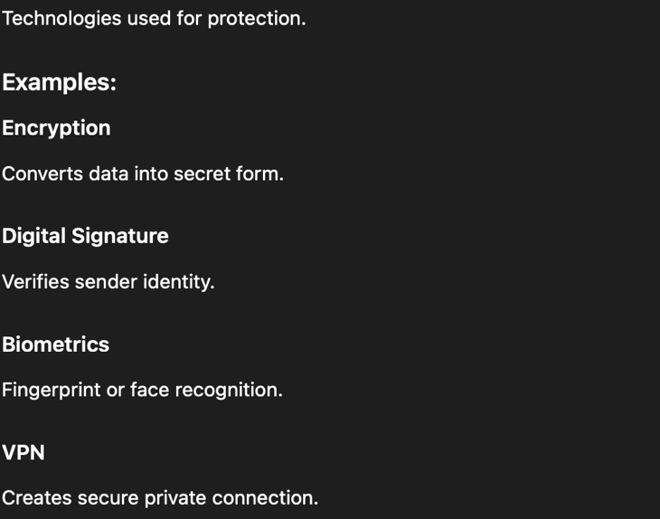
#CLEAN TRUST CONTROL:-
#WAP SECURITY ARCHITECTURE: -

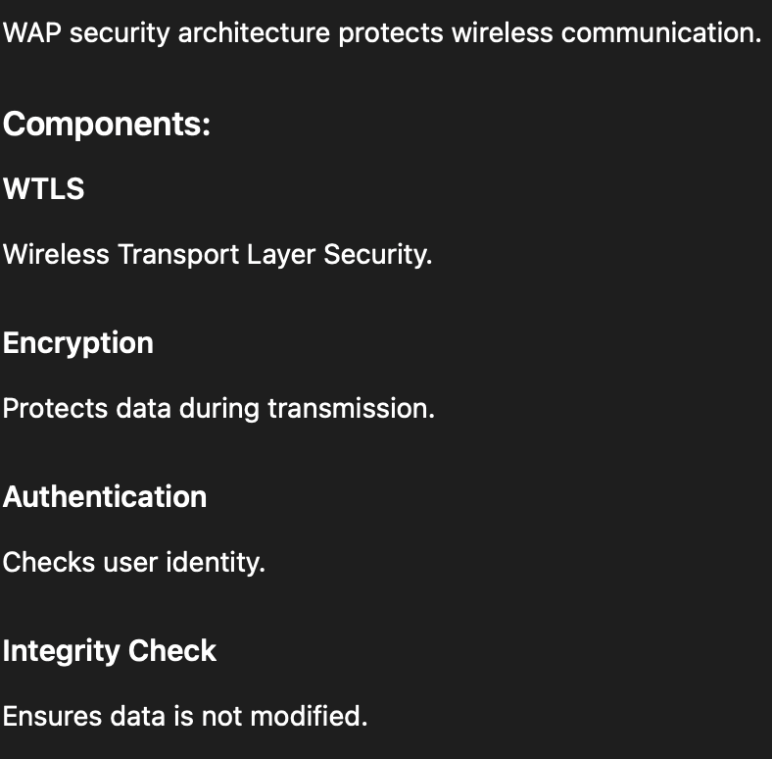

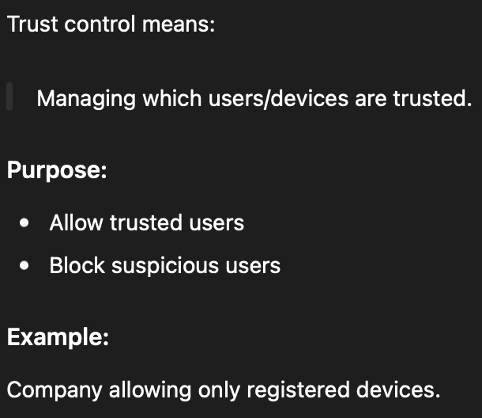
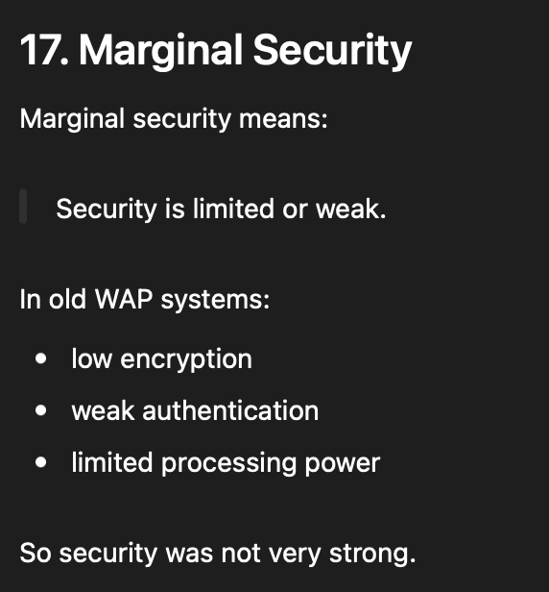
#WIRELESS ACCESS TO THE INTERNET:-

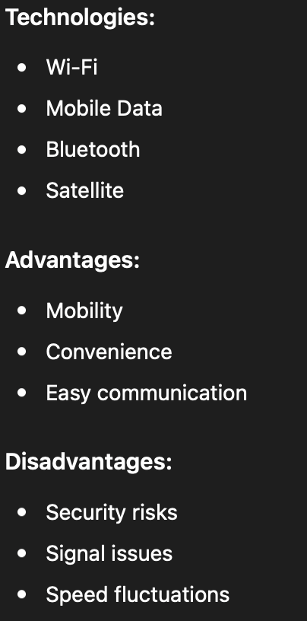

#WIRELESS MIDDLEWARE: -
