VinoSim Final Presentation Script (Semester 2)
About 11 to 12 minutes of speaking, then questions. Follows the 14-slide deck; slide 14 (references) is an appendix and is not presented. Citations in parentheses are not read aloud; full references are at the end. All sources and figures have been checked against the originals.

Slide 1 · Title (25 sec)
Hi everyone, I'm Ashley. This is VinoSim, and today I'll show you what I got done this semester.
VinoSim is a learning app for people who are new to wine. Lots of people can tell if a wine is bitter or sweet, but at the table they don't know what to say. I want a user to spend a few minutes and fill in a short tasting sheet on their own.

Slide 2 · A familiar moment (35 sec)
Picture this. Someone in their first job, or a grad student, gets brought along to a work dinner. The wine is already poured.
They can taste things. This red feels kind of thick. That white makes their mouth water. There's a leafy smell. Then they get stuck. Is "thick" body? Is "mouth-watering" acidity? What do you even call that smell?
The dinner won't pause for them, and nobody is going to say, take a wine course and come back next week.

Slide 3 · This happened to me (35 sec)

That person was me.
A friend invited me to the party on this poster. There was a dress code, there was wine tasting, and there was an open bar. Honestly, I got nervous and didn't go.
Later my friend told me a lot of really successful people were there. My first thought was, great, I just lost a million dollars because I can't talk about wine.
(Pause and let people laugh.)
Joking aside, that's when I decided to actually learn about wine, and that's how VinoSim started.

Slide 4 · Survey (45 sec)
It turns out I'm not the only one.
In 2015, Gallo surveyed 1,000 American adults who drink wine often (E. & J. Gallo Winery, 2015). Among millennials, 34% felt awkward when a server asked them to taste the wine, 34% worried their choice would be judged, and 31% felt uncomfortable talking about wine. Four in ten of all respondents were scared of mispronouncing a wine's name.
In the UK, a 2018 survey of more than 2,000 people found that 73% are intimidated by restaurant wine lists (Shaw, 2018).
To be fair, both surveys come from Gallo, which sells wine. They show the awkwardness is common. They don't show that my app works.

Slide 5 · The class they can't find (1 min)
So why not just take a class? Tim Jackson, a Master of Wine, looked at this in his 2017 research paper, and WSET published the main results a year later (Jackson, 2017, 2018). WSET is the UK wine school whose tasting method I use later.
About 28 million people in the UK drink wine every month. He estimated that 6 to 7 million are interested in a beginner course, and 4 to 5 million would pay for at least two hours. But in his sample, only 12 to 14% had ever taken one. Interest was higher among younger people, especially 25 to 34.
The finding that matters most to me is this. The biggest group of people who want a course, 42%, are what he calls "Unconfident Tentatives". They feel they don't know much, and for them a course is mainly about confidence.
So lots of people want to learn, there aren't many classes, and the dinner usually comes first.

Slide 6 · Who it's for (45 sec)
So my user is someone early in their career, or a student who sometimes goes to these dinners. They're at the table, but quiet. They can feel the dryness. They just can't name it.
I also surveyed 10 people I know. More on that later, but here's one number now: 7 of the 10 mostly stay quiet at these dinners. Three don't have the words, and three are afraid of getting laughed at.
I'm not designing for people who already talk about tannins, people who don't care about wine, or people who just want the app to pick their glass.

Slide 7 · Learning goal (2 min 10 sec)
This is the part I spent the most time on: the learning goal. What can a user actually do after using the app?
First, what I'm not aiming for. Research on wine experts shows they don't have better noses. Their smell thresholds are about the same as beginners'. What they do better is recognize wines and describe them (Parr et al., 2002; Hughson & Boakes, 2002). Beginners often notice something but can't find the word (Solomon, 1990; Croijmans & Majid, 2016). Becoming an expert takes years, and that's not what my users want right now.
So I picked the end point first and worked backward, which is called backward design (Wiggins & McTighe, 2005). The end point is this: in about five minutes, with no hints, the user writes a four-line tasting sheet on their own.
The four lines are a simplified version of WSET's Level 2 tasting method (WSET, 2026): appearance, nose, palate, and a conclusion where you rate the quality.
How do we know it's right? It's like a math problem where you have to show your work. Each word has to point to something they actually felt. Writing "high tannin" without being able to say where you feel the dryness doesn't count. My standard is all four lines filled in, with at least two of acidity, tannin and body tied to a real sensation.
Some people in my survey asked for a line to memorize instead. I said no. A line gets you through tonight, but not the next bottle. So I kept the five minutes and dropped the script.
To get there, I use scaffolding. The tutor asks one step at a time, and later the help is taken away (Wood, Bruner & Ross, 1976; Collins, Brown & Newman, 1989). The real test is the next bottle: can they write the sheet before opening the tutor?

Slide 8 · Interface (40 sec)
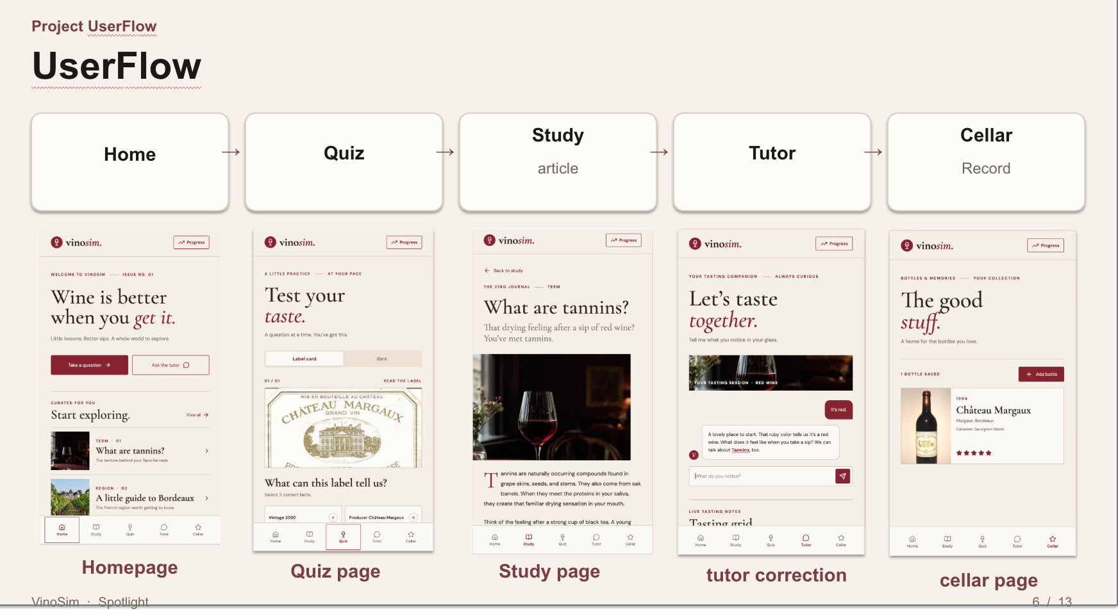
Here's the interface. I rebuilt the pages this semester.
This is the flow: Home, Quiz, Study, Tutor, Cellar. Home shows one question and one note, Quiz is for practice, Study has short articles, Tutor is the tasting assistant, and Cellar records the wines you've had.
The biggest change is the Tutor, which is now a chat. In correction mode it searches the knowledge base first and shows which note it used. Roleplay mode is just for practicing speaking up. It doesn't look anything up or grade you.
One piece is still missing: an editable four-line sheet next to the chat.

Slide 9 · Quiz (1 min)
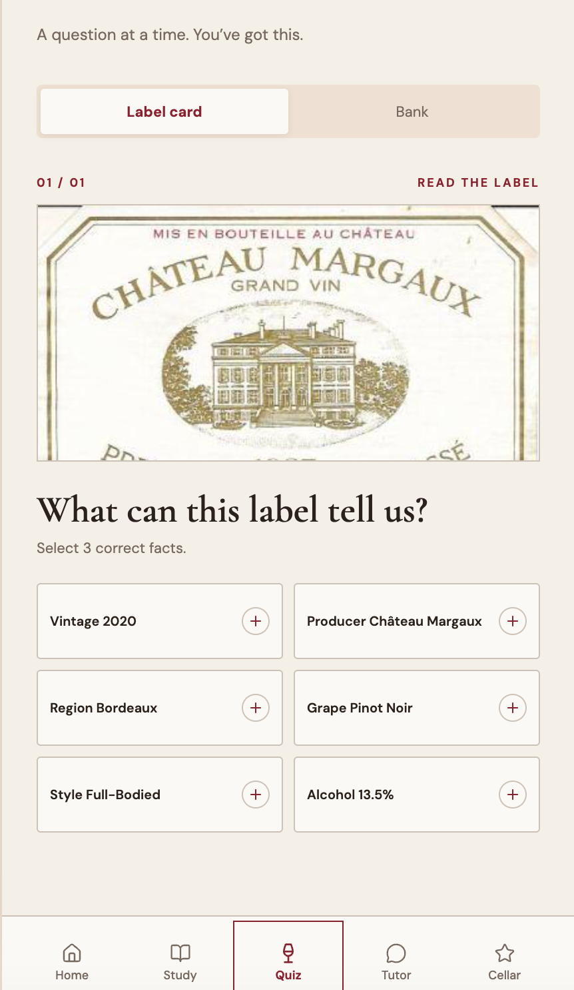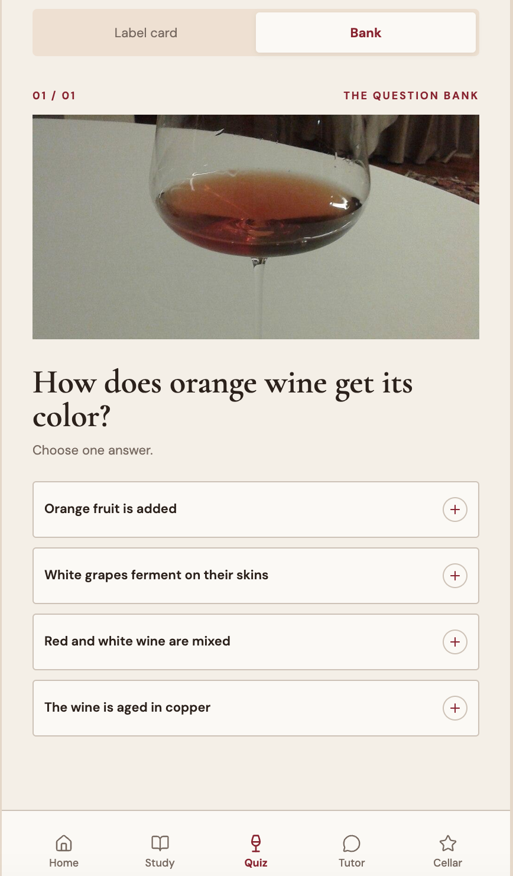
The Quiz has two kinds of questions.
On the left, the user looks at a Château Margaux label and picks three correct facts out of six: the producer is Château Margaux, the region is Bordeaux, and the style is full-bodied.
On the right is a question bank item: how does orange wine get its color? The answer is that white grapes ferment with their skins.
I wrote the questions from WSET beginner material. The backend bank has five multiple-choice questions and a few label questions. The two you see here are still sample data in the frontend, so the two sides aren't connected yet.
Building this showed me that getting a question right and writing a sheet are different things. "What do tannins feel like?" is useful, because it links a feeling to a word. "What grape is red Burgundy?" is just background, and a high score on that doesn't mean the goal is reached.

Slide 10 · Dialogue (1 min 15 sec)
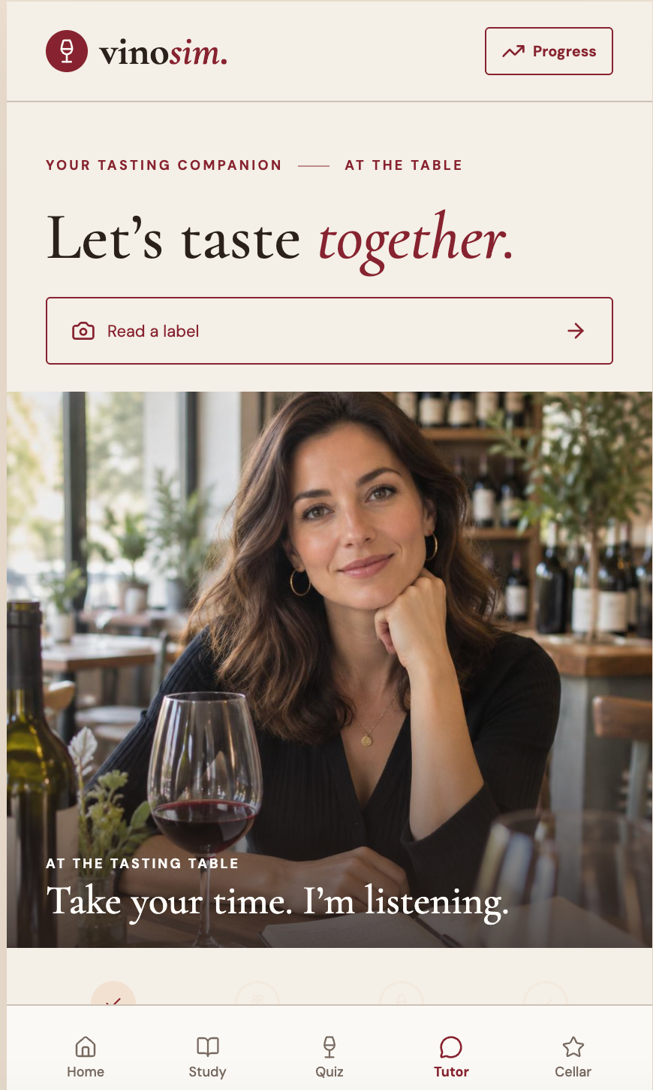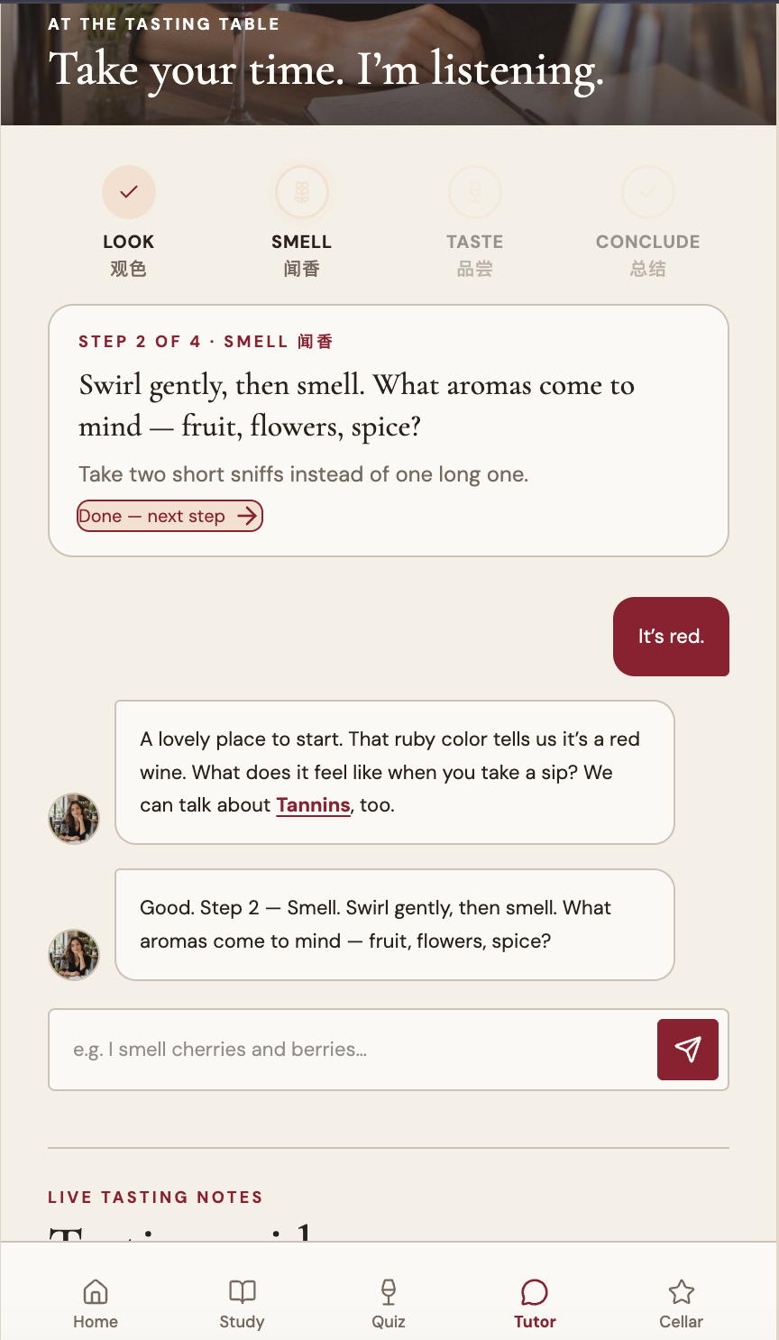
This is the Tutor in action.
On the left is the opening screen: "Take your time, I'm listening." On the right, the user just says "It's red." The tutor builds on that, says the ruby color means it's a red wine, and asks what it feels like on a sip, with a link to tannins.
The four steps at the top, look, smell, taste and conclude, match the four lines of the sheet. When the user finishes one step, the tutor moves to the next. That's the scaffolding.
I also tested retrieval. For "Why does this red wine feel so drying?", the closest notes were Tannin at 0.747, Palate order at 0.718, Acidity at 0.688 and Body at 0.686. That's cosine similarity, and tannin came out first, which is right. This search-then-answer setup is called retrieval-augmented generation, or RAG (Lewis et al., 2020).
A good answer links "dry" to tannin and says where you feel it, on the gums and inside the cheeks. A weak answer just says "high tannin" and leaves the user with nothing to check against.

Slide 11 · Ten people, one form (1 min)
Now my survey. These are 10 people I know, not a random sample, so please don't read them as percentages.
Seven of the ten mostly stay quiet, split evenly between having no words and being afraid of getting laughed at. None had ever been offered a wine class. One took a class years ago and has forgotten most of it.
The open question was the most useful. When asked to describe a red wine, five people could only say "dry" or "astringent" and didn't connect it to tannin. Three said "I don't know" or guessed. Only two used the word tannin. That's exactly the gap the learning goal targets: they can feel it, but they don't have the word.
And seven said they'd be willing to fill in a simple sheet. A few wanted lines to memorize, and you've heard why I didn't build that.

Slide 12 · Plan for the rest of the term (45 sec)
Last, my plan for the rest of the term. The course ends this semester, so I'm keeping it small and focusing on one thing: the tasting sheet.
First, I'll add an editable four-line sheet to the Tutor page. It should take about five minutes, in the user's own words.
Second, if there's time, I'll have a few friends taste one bottle and write a sheet before and after using the tutor, using the same standard as before. It's a small check, not a conclusion.
Fading out the scaffolding won't fit this semester, so it goes in my final report as future work. And I'm deliberately not adding recommendations, prices or memorized scripts.

Slide 13 · Closing (10 sec)
That's all from me. They can taste it, they just can't say it yet, and that's the step VinoSim tries to help with. Thank you, and I'm happy to take questions.

References
Collins, A., Brown, J. S., & Newman, S. E. (1989). Cognitive apprenticeship: Teaching the crafts of reading, writing, and mathematics. In L. B. Resnick (Ed.), Knowing, learning, and instruction: Essays in honor of Robert Glaser (pp. 453–494). Lawrence Erlbaum Associates.
Croijmans, I., & Majid, A. (2016). Not all flavor expertise is equal: The language of wine and coffee experts. PLoS ONE, 11(6), e0155845. https://doi.org/10.1371/journal.pone.0155845
E. & J. Gallo Winery. (2015, December 8). Gallo survey finds that today's wine drinkers are diverse with an appreciation of new offerings for more occasions [Press release]. https://www.gallo.com/press/2015-12-08-wine-drinker-diversity
Hughson, A. L., & Boakes, R. A. (2002). The knowing nose: The role of knowledge in wine expertise. Food Quality and Preference, 13(7–8), 463–472. https://doi.org/10.1016/S0950-3293(02)00051-4
Jackson, T. (2017). Elementary consumer wine education: UK market size, characteristics and significance to the trade [Master of Wine research paper]. Institute of Masters of Wine.
Jackson, T. (2018). Consumer wine education: Should the wine trade care? [WSET Alumni report]. Wine & Spirit Education Trust. https://www.wsetglobal.com/media/5507/wsetalumreport_consumerwineeducation-2018-03.pdf
Lewis, P., Perez, E., Piktus, A., Petroni, F., Karpukhin, V., Goyal, N., Küttler, H., Lewis, M., Yih, W., Rocktäschel, T., Riedel, S., & Kiela, D. (2020). Retrieval-augmented generation for knowledge-intensive NLP tasks. Advances in Neural Information Processing Systems, 33, 9459–9474. https://proceedings.neurips.cc/paper/2020/hash/6b493230205f780e1bc26945df7481e5-Abstract.html
Parr, W. V., Heatherbell, D., & White, K. G. (2002). Demystifying wine expertise: Olfactory threshold, perceptual skill and semantic memory in expert and novice wine judges. Chemical Senses, 27(8), 747–755. https://doi.org/10.1093/chemse/27.8.747
Shaw, L. (2018, July 5). 73% of Brits are intimidated by wine lists. The Drinks Business. https://www.thedrinksbusiness.com/2018/07/73-of-brits-are-intimidated-by-wine-lists/
Solomon, G. E. A. (1990). Psychology of novice and expert wine talk. The American Journal of Psychology, 103(4), 495–517. https://doi.org/10.2307/1423321
Wiggins, G., & McTighe, J. (2005). Understanding by design (2nd ed.). Association for Supervision and Curriculum Development.
Wine & Spirit Education Trust. (2026). WSET Level 2 systematic approach to tasting wine (Issue 2.1). https://www.wsetglobal.com/student-resources/systematic-approach-to-tasting-sat/
Wood, D., Bruner, J. S., & Ross, G. (1976). The role of tutoring in problem solving. Journal of Child Psychology and Psychiatry, 17(2), 89–100. https://doi.org/10.1111/j.1469-7610.1976.tb00381.x

