Database Security
Assignment 1
- Follow the instructions provided by your instructor regarding the server address, and your credentials needed to logon to the server.

- Using the Administrative Tools option from the Start button, access “Computer Management” application and obtain a list of all users allowed access the server.
Action: Screenshot the list of local users from the computer management window.
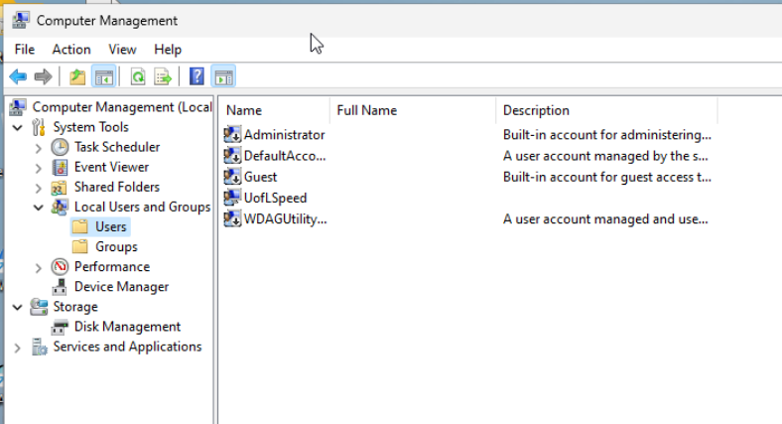

- Use the Groups menu item to determine which of those have administration access.
Action You can screenshot and circle the administration accounts or just provide a list in a Word document.
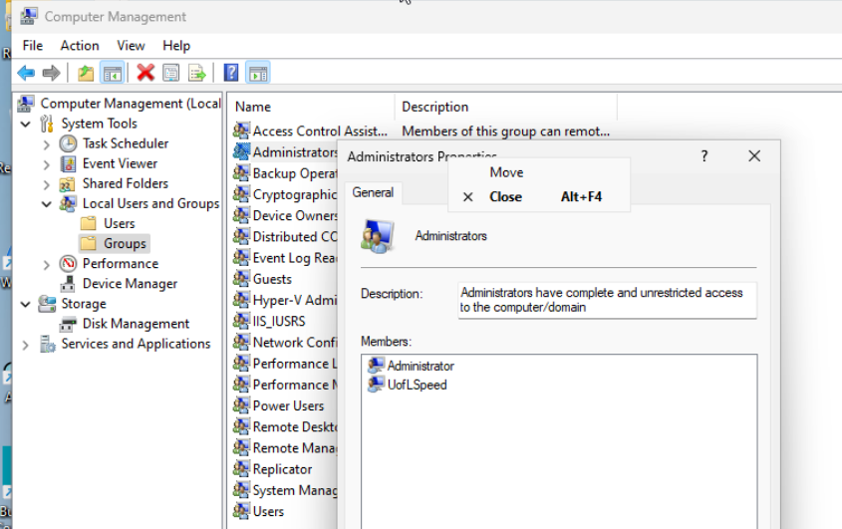

- Create a simple new user using the first 3 letters of your first name followed by the last three letters of your last name and two digits representing your birth year, e.g., John Smith born in 1978 will create a user with an id Johith87)
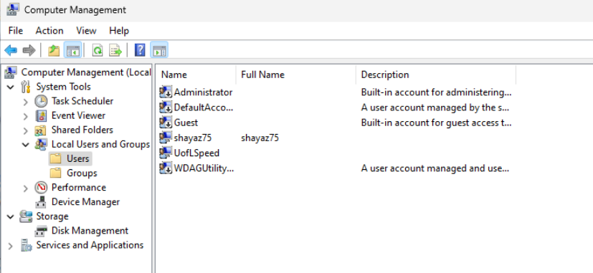

- Assign the user that you just created the password Secretpass2022 – Note this is a case-sensitive password. Also, make sure you do not add this user the administrators group.
Action: You can screenshot this screen before you click on the CREATE button.

- Logout (signout) of the Administrator account then login using the user id you created in steps 5 and 6 above.
Note: You may need to send a CTRL-ALT-DEL key sequence like you did when first logging into the system. (Left side arrow, choose the letter “A” icon, then the three dots. You should see a list of accounts including the one you just created!)

- Repeat steps 2, 3, and 4 above and report your findings (including warnings and/or failure screens, if applicable) using additional screenshots and lists as needed.
Step 2. I could open the Computer Management console and navigate through the settings.
Step 3. I would view the ‘users’ and ‘groups’ ..and was able to view the groups/administrators list of users. Which was the same as my screenshot.
Administrators
UofLSpeed
Step 4. Creating a new user in step4 resulted in an error Describing ACCESS IS DENIED. Screenshot provided.
