Assignment 3 - Data Encryption

- SQL Server Encryption Tutorial
The following article provides a good overview of SQL Server encryption.
- https://www.sqlshack.com/an-overview-of-the-column-level-sql-server-encryption/

Service Master Key
- Each SQL Server instance has its service master key.
- Created automatically during installation and protected by the Data Protection API (DPAPI).
Database Master Key
- The database master key within each database is used in creating certificates or asymmetric keys.
- Must be manually created before using encryption inside a database.
Encrypting columns Using a passphrase
- Not very secure. Can be easily compromised.
- The passphrase must be shared with users and applications
Encrypting columns Using a certificate
- A database-level securable. follows the X.509 standard.
- Can load a certificate externally (from a file or assembly).
- Can generate a self-signed certificate that has a key pair.
- The private key of the certificate is encrypted by the database master key.
- Steps: a) Create a certificate, b) Create a symmetric key that will be encrypted by the certificate

- Preparation

- Get SQL Server Management Studio located once you RDP into the same machine that you accessed in the previous Assignment #1.
- For this assignment, you need to create the BigData database by running the following script: BigData-Database-Create.sql.

- Next, perform the lab using this script: BigData-Encryption-Lab.sql.

- Deliverables

-- Display the original table
select * from dbo.cust
go
/* Task #1: Show the original table in a screen shot. */
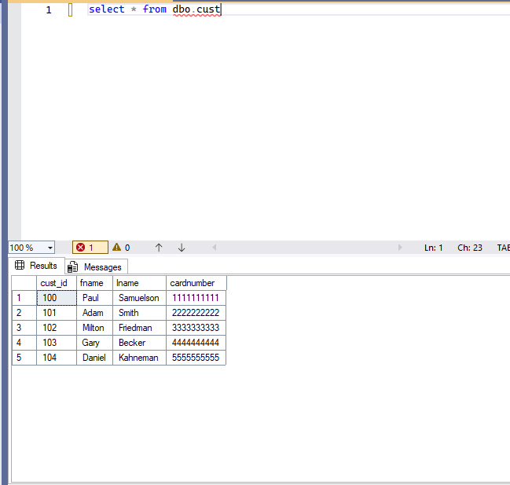

--
Display the encrypted table
select * from dbo.cust_encrypt
go
/* Task #2: Show the encrypted table in a screen shot. Also, explain why we need to change the data type for encryption. */
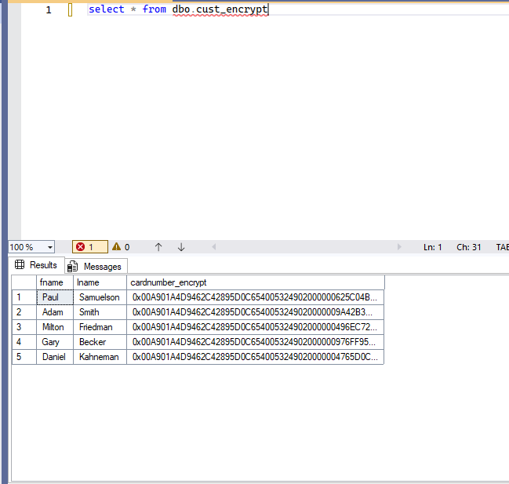

--

We need to change the data type to protect the customer information. This ensures the data can not be exported and used maliciously.

Display the encrypted table
select * from dbo.cust_encrypt
go
/* Task #3: Show the encrypted table in a screen shot. Also, explain the encryption process after Task #2. */

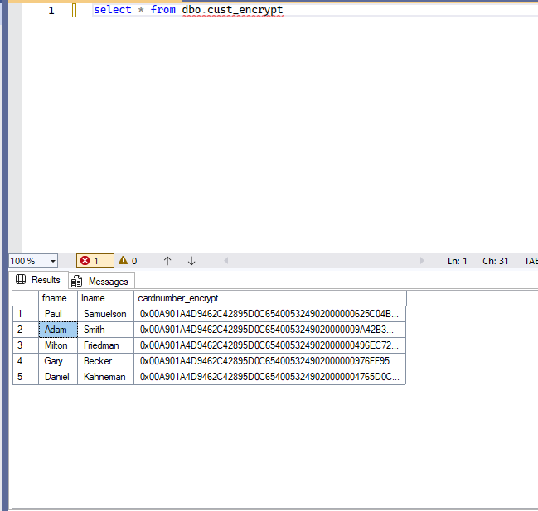

The encryption process utilized a symmetrical key, composed of by a MASTER key, from it we created a certificate using the algorithm AES_256. After which we then dropped the database dbo.cust_encrypt to apply the new cryptographic encoding.

-- Display the decrypted table
select fname,
lname,
cardnumber = convert(nvarchar(25), DecryptByKey(cardnumber_encrypt))
from dbo.cust_encrypt
go
/* Task #4: Show the encrypted table in a screen shot. Also, explain the decryption process after Task #3. */
/* Did you get the original data back? If not, what's wrong? */
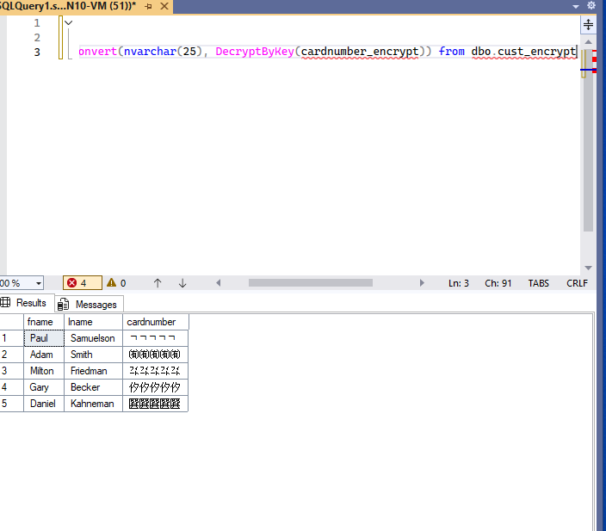
/* Hint: Check out the current data type of cardnumber with the original one */

The conversion has left the cardnumbers reverted to plain text, of another language, or character set. A reversion to the original data can be had by provide permissions to the Symmetric key and Certificate:
Symmetric key permission: GRANT VIEW DEFINITION
Certificate permission: GRANT VIEW DEFINITION and GRANT CONTROL permissions
Execute these scripts with from a user account with admin privileges, the data will show up correctly restored.

