Assignment
- Create an account on IBM Quantum (https://quantum-computing.ibm.com/ ).
- In the IBM Quantum Composer create the following circuits and interpret their results:

  - 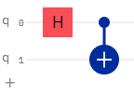
  - Modify your circuit adding measurements to the qubits [0] and [1] and run your circuit using a real quantum device, interpret your results. Explain the difference from the results obtained in a. if any.
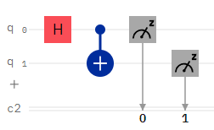
- Implement the following circuit and interpret the results:
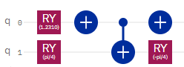
- (Optional) Watch Peter Shor’s video explaining his famous algorithm (we will talked about this algorithm later) (https://www.youtube.com/watch?v=6qD9XElTpCE&t=471s&ab_channel=Qiskit)
Additional Sources:
Great video about Quantum computing https://www.youtube.com/watch?v=OWJCfOvochA&t=86s&ab_channel=WIRED
An explanation of entanglement
https://www.youtube.com/watch?v=z1GCnycbMeA&ab_channel=TED-Ed

