#700743770

Sravanti Cherukuri Assignment #2

**Git hub link :** https://github.com/sxc37701/ML_Assignments/tree/main/Assignment%232

**Video Link:** https://drive.google.com/drive/folders/1CtEjxD967psXs6P3PzpRjSIn1j51gX8p

**#Question 1**

1. Use a python code to display the following star pattern using the for loop

**Code**

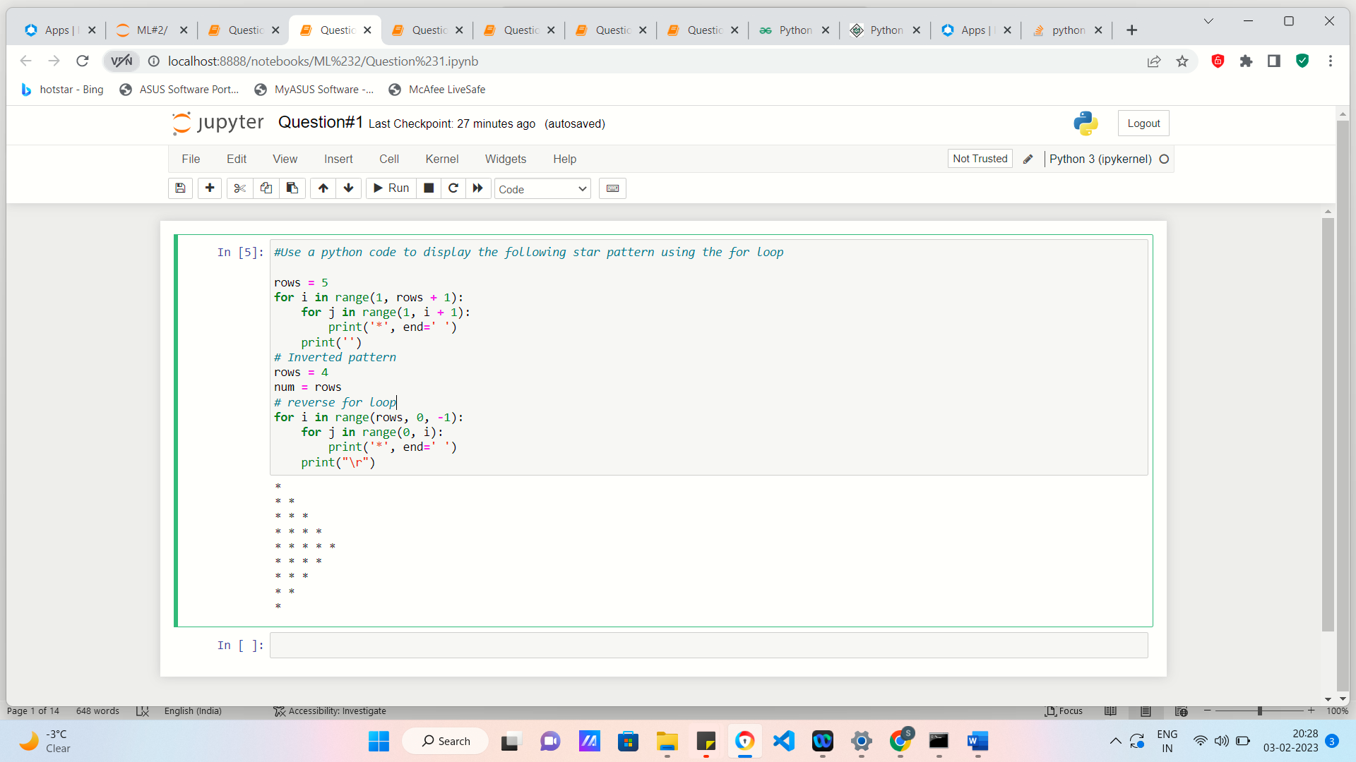

# **Question 2**

Use looping to output the elements from a provided list present at odd indexes. my_list = [10, 20, 30, 40, 50, 60, 70, 80, 90, 100]

**Code**

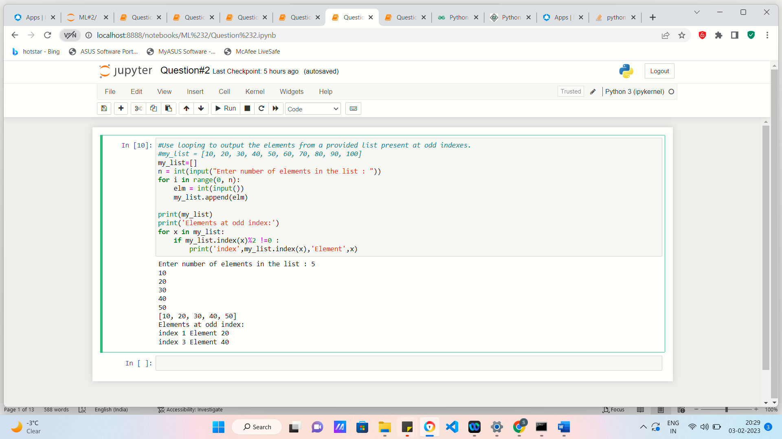

#**Question 3**

Write a code that appends the type of elements from a given list. Input x = [23, ‘Python’, 23.98] Expected output [23, 'Python', 23.98]

[<class 'int'>, <class 'str'>, <class 'float'>]

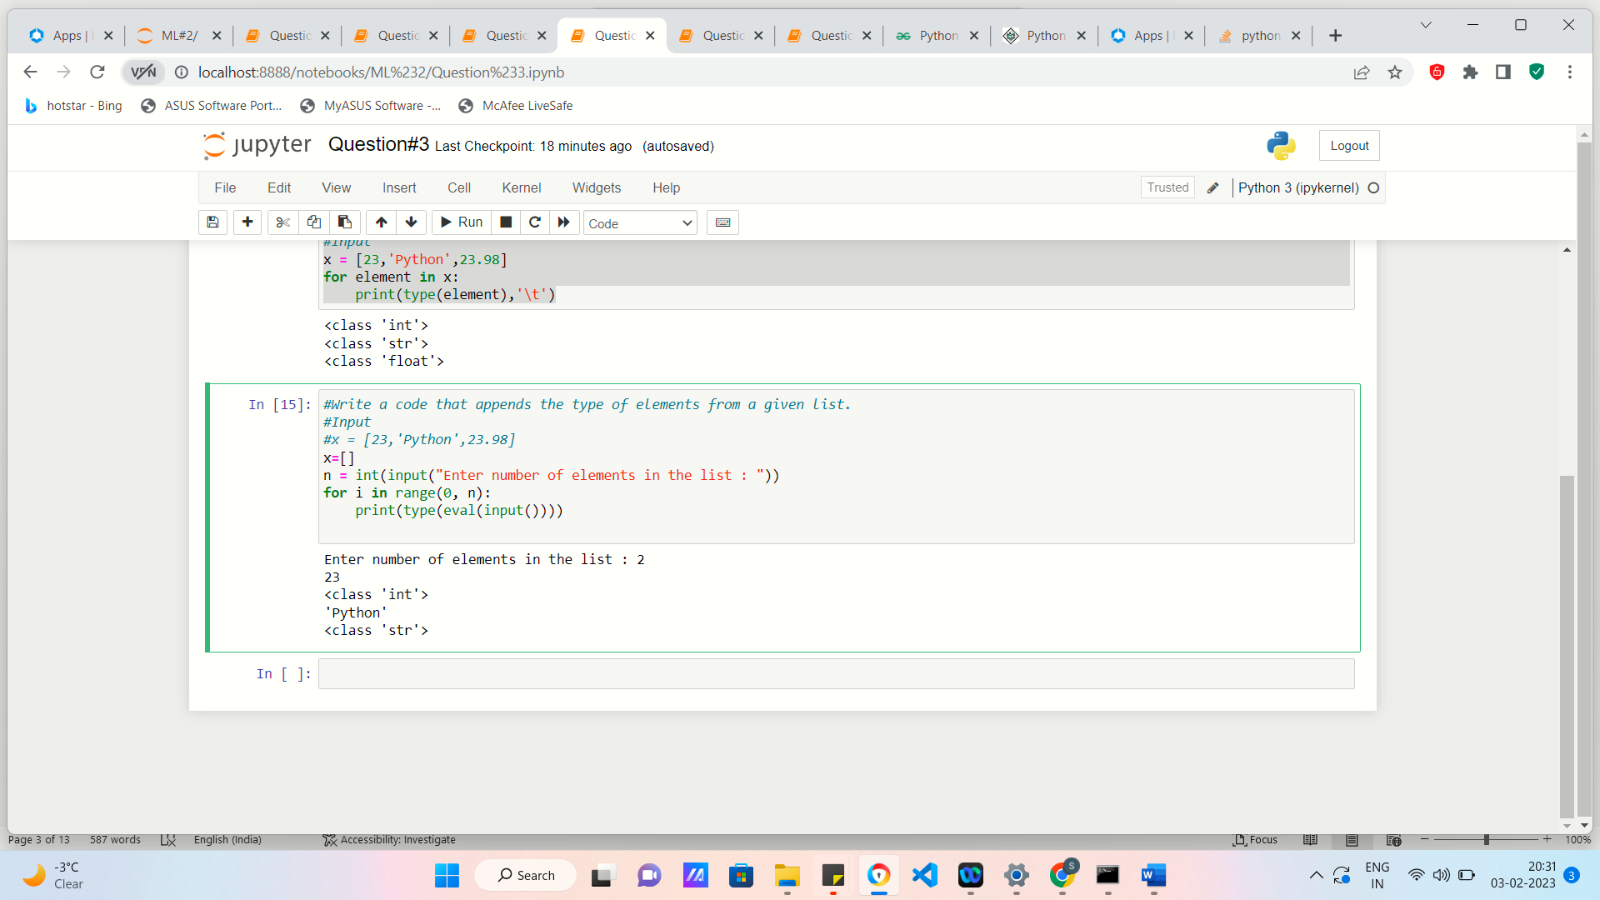

**#Question 4**

Write a function that takes a list and returns a new list with unique items of the first list. Sample List: [1,2,3,3,3,3,4,5] Unique List: [1, 2, 3, 4, 5

**Code**

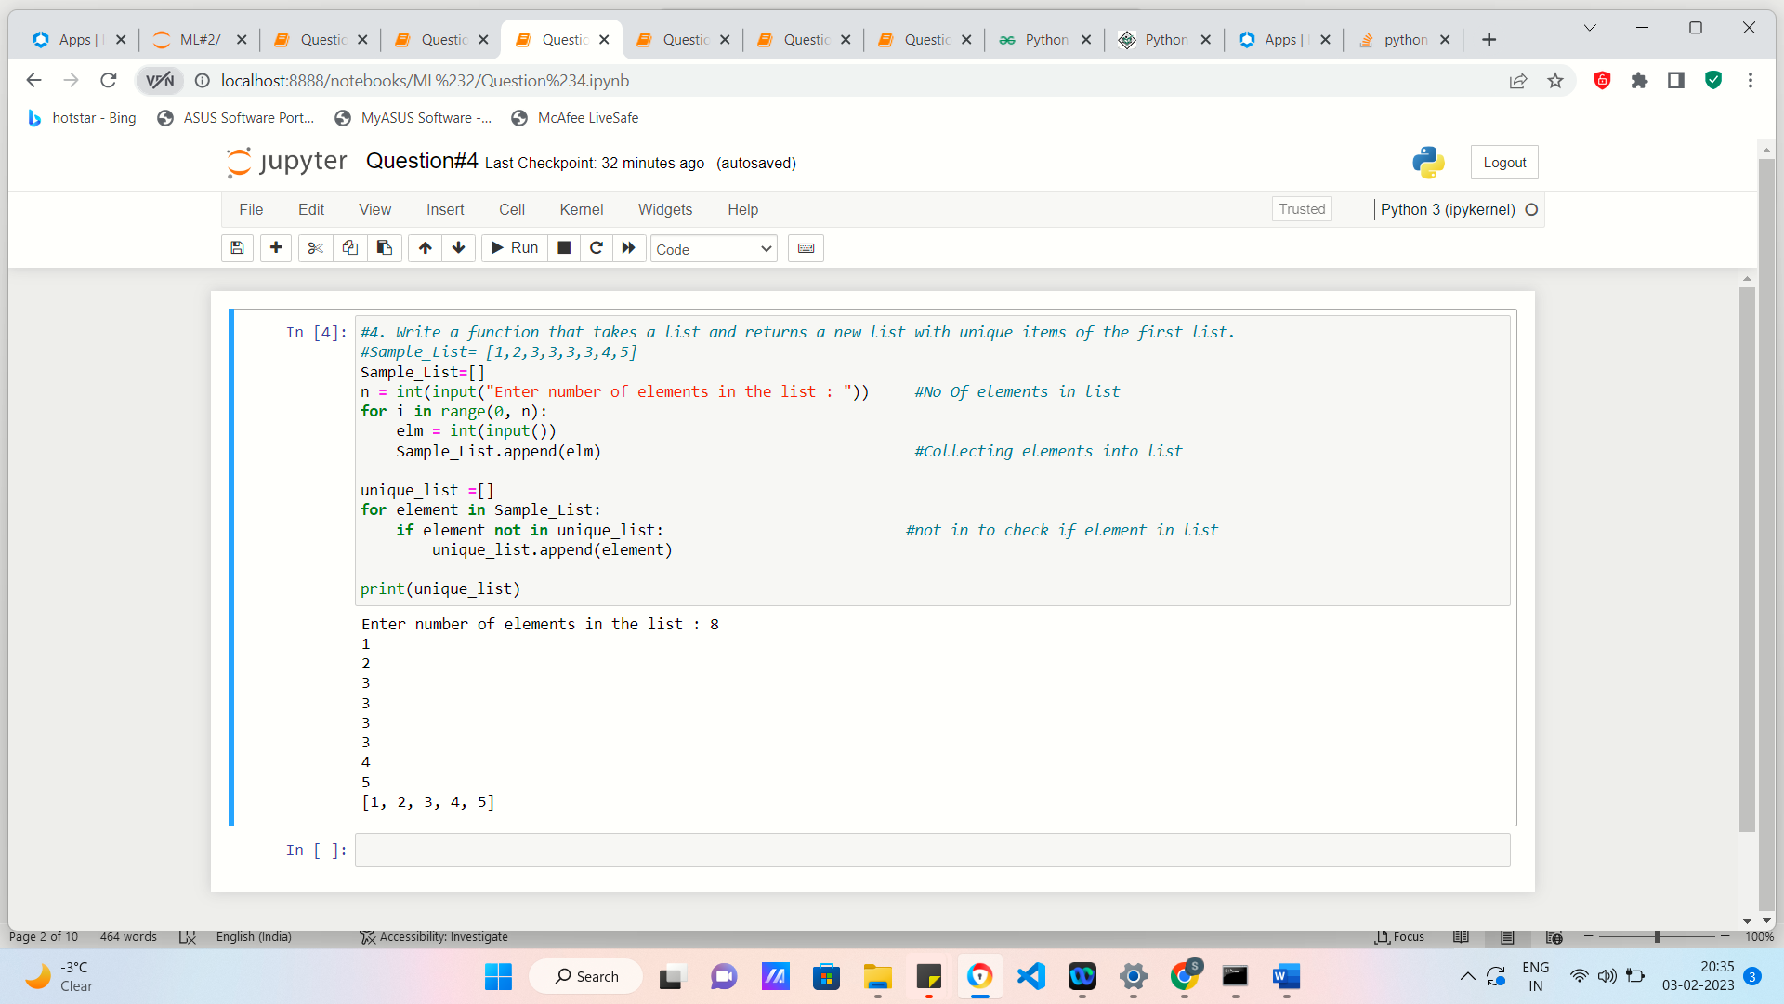

**#Question 5**

Write a function that accepts a string and calculate the number of upper-case letters and lower-case letters. Input String: 'The quick Brow Fox' Expected Output: No. of Upper-case characters: 3 No. of Lower-case Characters: 12

**Code & Output**

