**IDENTIFYING BRAIN TUMOR WITH DEEP LEARNING ALGORITHMS BASED ON CT-SCANNED IMAGES**

**700747116**

**SOWMYA GANIPINENI**

**RESULTS**

**1. USER INTERFACE:**

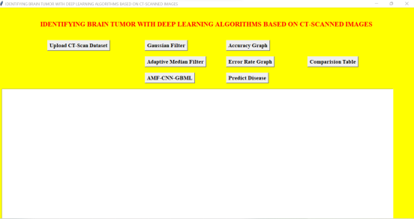

**2. UPLOAD DATASET:**

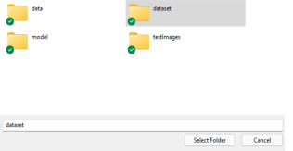

After uploading the dataset, immediately we get the output of adaptive median filter-

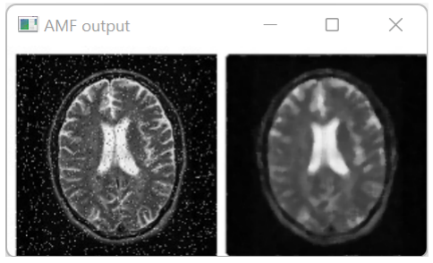

**3. OUTPUT OF ADAPTIVE MEDIAN FILTER:**

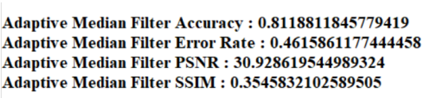

**4. OUTPUT OF GAUSSIAN FILTER:**

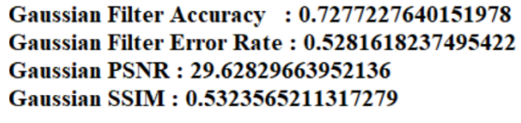

**5. OUTPUT OF AMF-CNN-GB:**

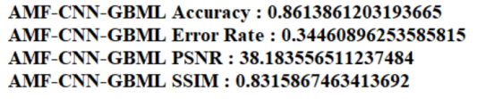

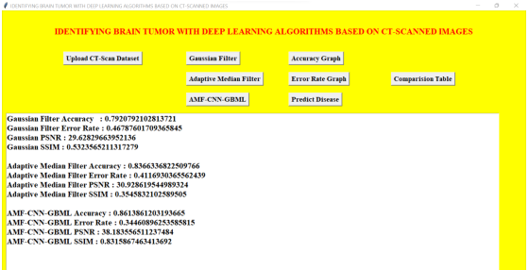

**6. PREDICT DISEASE:**

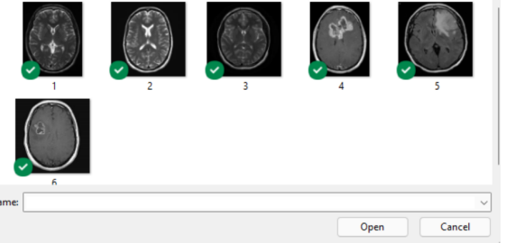

**Input image of user**

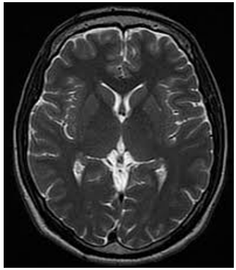

**Output image without tumor**

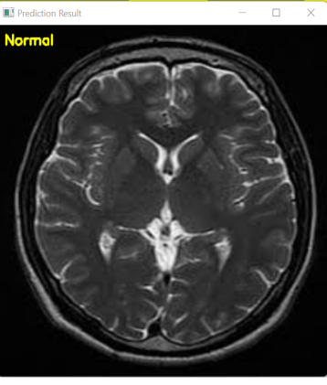

**Input image of user 2**



**Output image with tumor**

