ATS / PTT TMS
User Guide
Internal beta · November 2026
This is an internal test version. It is already connected to real projects, but it is still changing every week.
Please use it for your normal work alongside your usual process, and tell us what works and what does not.
Write down anything that does not work as expected and anything you would like added, in the TMS Beta Feedback Form that comes with this guide, and send the form back in one document (see section 13).

Contents
1. What the TMS is
2. Signing in and switching language
3. Roles: who sees what
4. My workspace, to-dos and notifications
5. Projects and Loads
6. RFQ / Quotes
7. OOG first screen, trailers and permits
8. Carriers and rate agreements
9. AI reading
10. What is manual and what the AI helps with
11. Units, dates and other conventions
12. Known limits of this beta
13. How to give feedback

1. What the TMS is
The TMS is the one place where ATS and PTT run their freight: inquiries and quotes, projects, every Load and its legs, carriers, documents and to-dos. It is built for drayage, OTR, heavy haul and oversize cargo, BESS containers, project cargo and transloading.
An AI assistant reads e-mails and attachments for you and proposes updates, but a person always checks and confirms before anything is saved, and the TMS never sends an e-mail on its own: it prepares drafts that you send yourself.
Area | What you do there
My workspace | Your to-do list, number tiles (click a number to see those Loads), your projects.
Projects | One project per customer job. Holds its Loads, milestones, terms, rate agreements and timeline.
Load | One container / truck. Holds legs (moves), cargo, appointments, documents, POD and charges.
Customers · Carriers · Locations | Master data. Carriers also keep a compliance record.
RFQ / Quotes | Inquiries from customers, carrier quotes, customer quotes, then conversion to a project.
AI reading | Paste an e-mail (or connect your mailbox) and review what the AI found.
Team | Management only: who has which role.

2. Signing in and switching language
- Open https://tms-668605433770.us-central1.run.app/ in Chrome or Edge (it also works on a phone).
- Click Sign in with your company Google account and use your ATS / PTT Google account.
- The first time, your account waits for a manager to give you a role. You will see a waiting page; it refreshes by itself. The managers get a notification that you signed in.
- When your role is set you will see a notification (bell, top right) and the full menu.
Language. Click EN (or 中文) at the top right to switch the whole interface between English and Chinese. Your choice is remembered in this browser. Names, notes and e-mails that people typed stay in the language they were written in.
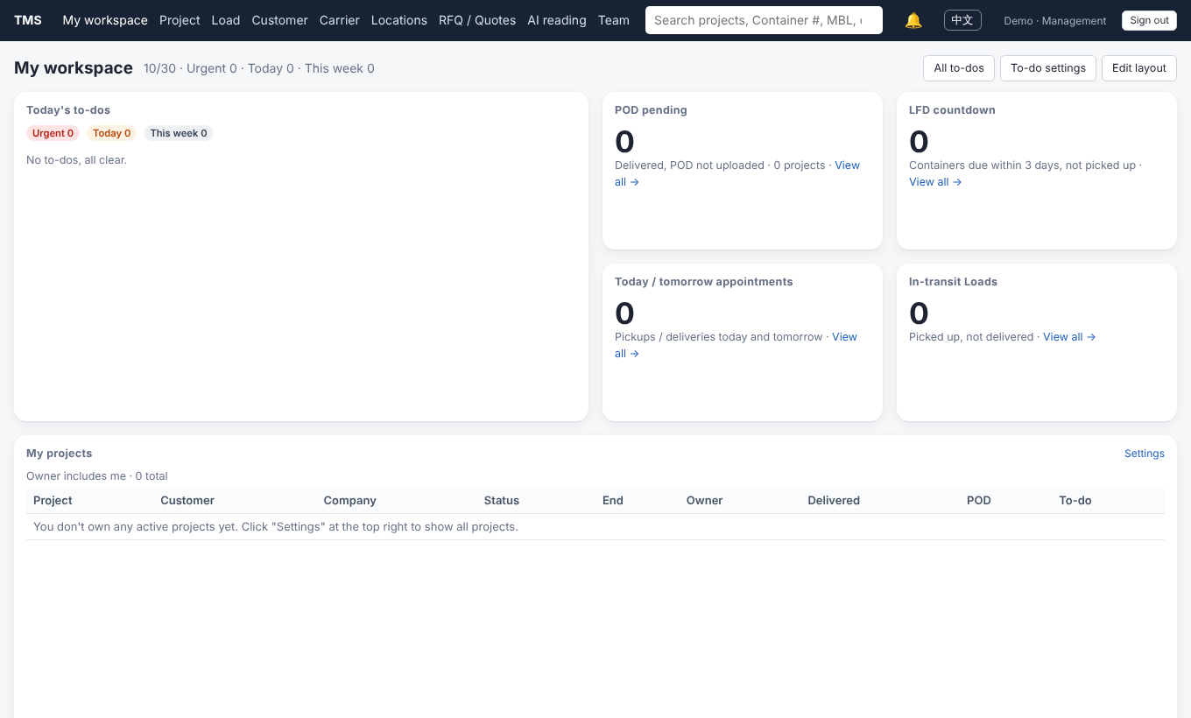
My workspace in English. Click any number tile to open the Loads it counts.

3. Roles: who sees what
One person can hold several roles. A manager assigns them on the Team page. Management, AP and AR see every project. Operations and RFQ / Sales see only the projects they own (and those projects' Loads); whoever creates a project owns it by default, and to cover for a colleague a manager adds you as an owner of that project.
Role | Can do | Does not see
Management | Everything, including margins, team and AI usage, closing Loads, waiving PODs. | —
Operations (OP) | Their own projects and those projects' Loads: legs, BOL, POD, permits, AI reading, mailbox scan, RFQ, carrier rate agreements. | Projects they do not own; AR and AP amounts (except the carrier rate on a rate agreement), margins.
RFQ / Sales | Inquiries, carrier and customer quotes, converting a won inquiry into a project. | AP / AR of running projects, margins.
AP (payable) | Carrier charges and invoices, carrier rate agreements. | AR, margins, operations editing.
AR (receivable) | Customer charges and invoicing. | AP, margins, operations editing.

4. My workspace, to-dos and notifications
- Today's to-dos are created by rules, for the projects you own: LFD coming up, ETA passed without arrival, appointments not confirmed, permits not confirmed, POD not received or not uploaded, carrier insurance expiring, rate agreement missing, AI updates waiting for you, and more. Click one to go straight to the record.
- Number tiles: click the number to open the Load list filtered to exactly those Loads. Edit layout lets you add, remove and resize tiles; To-do settings lets you switch rules on or off and change their thresholds.
- Search (press / anywhere): container #, MBL, Load #, carrier load #, project, customer, carrier, invoice #.
- Notifications (bell): role changes, projects handed to you, and similar events pop up on screen and stay in the bell list.

5. Projects and Loads
A project is one customer job (for example “PTT#4475 Hithium Carson CA → Nokesville VA”). It holds any number of Loads; each Load is one container or truck, and has one or more legs (e.g. drayage port → yard, then OTR yard → job site).

Creating
- New project: customer, ATS or PTT, owners, defaults (shipper, consignee, cargo, hazmat, BOL notes, detention free time, terms).
- New Load or Batch new Loads (paste a list of containers). Or let the AI create the project and its Loads from a “project start” e-mail (section 9).

Working a Load
- Legs: carrier, carrier load #, equipment, driver, planned / actual pickup and delivery, appointment times and confirmation, check-in / check-out times (used for detention), tracking link.
- Cargo: enter dimensions and weights in any unit (“40'”, “12.19 m”, “13'6"”, “20 t”); the TMS stores feet and pounds. Every “ton” is a metric ton (2,204.6 lbs).
- Status is automatic from the legs: planning → awaiting arrival → arrived → in transit → in yard → delivered. Only Hold / Cancelled are set by hand.
- BOL: “Generate BOL” on the Load, or tick several Loads on the project page and “Generate BOL for selected”. English only, with the ATS or PTT header from the project.
- Timeline: every change is recorded (who, when, old → new) and can be reverted by management. Add your own notes there.

POD: a person must confirm it
The AI may see a POD in an e-mail and mark it received. That is not enough: someone in operations must check it (signature, date, pieces, exceptions), file it where the customer wants it (OneDrive, portal…), and then click POD checked and uploaded on the Load (or tick several Loads on the project page and click POD uploaded for selected). You may paste the link where it was filed.
A Load cannot be closed, and a project cannot be set to Complete, until every Load’s POD is uploaded (or a manager marks it “no POD needed” with a reason). Finance only picks up completed projects.
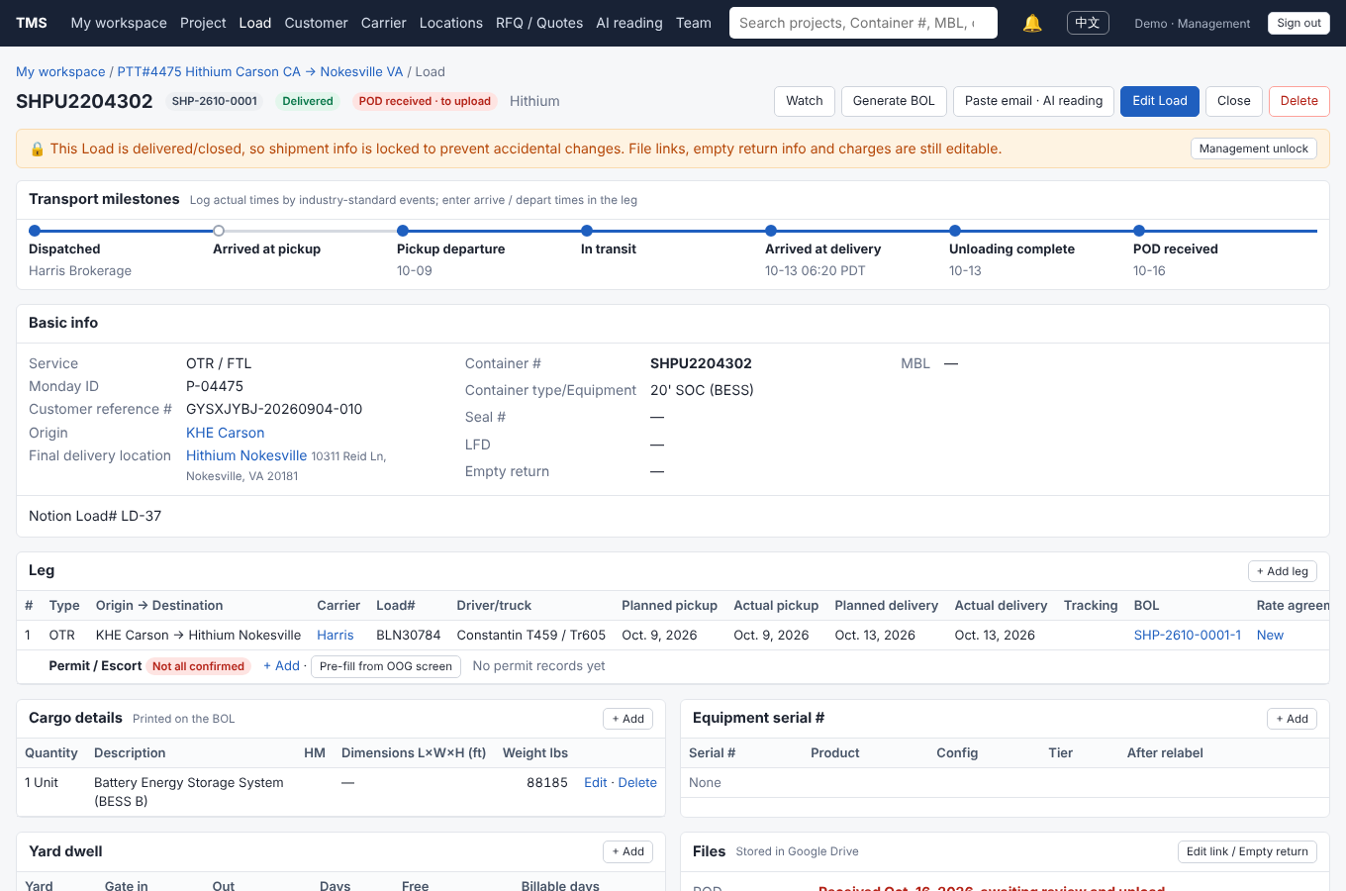
A Load: legs with BOL and rate agreement links, permits per state, and the POD status.

6. RFQ / Quotes
- New inquiry: paste the customer’s e-mail (and attach PDFs, pictures or Excel), or type the e-mail subject so the TMS reads the whole thread from your connected mailbox. The AI organizes it into lanes and cargo (in ft / lbs), lists the questions still open, and recognizes the customer (one click adds a new customer).
- Check the scope and the OOG first screen (section 7).
- Draft the RFQ e-mail to carriers (the customer name is never included). You send it yourself from Gmail.
- Paste carrier replies: the AI turns each reply into a carrier quote (rate lines, conditions, validity). You check and save.
- Customer quote: built from the chosen carrier cost plus your markup; edit freely; download a simple or formal PDF; send it yourself.
- Won: “Convert to project” creates the project, one Load per truck, the legs with the chosen carrier, and the AP / AR charges.

7. OOG first screen, trailers and permits
- For every lane, the TMS checks each state on the route against the company’s 48-state oversize / overweight notes: legal size and weight, overweight permit limits, escort and police thresholds, superload and route survey, night / weekend limits. Enter the origin, destination and via states on the lane for the best result.
- Gross weight = cargo + tractor + trailer. Permits are for non-divisible cargo only; tick “divisible” on cargo that can be split.
- The trailer library (deck height, deck length, tare weight) drives the suggestion; managers can edit it. Company rule: a 20' BESS of 90,000 lbs or more goes on a 9-axle when the route passes California, otherwise on a 4+4 8-axle if the axle weights allow.
- Permits per leg: on the Load page, “Pre-fill from OOG screen” adds a row for each state that needs a permit; record status, permit #, validity and escorts booked. The to-do list warns when permits are missing or will expire before delivery.
The OOG screen is a first check, not a permit decision. It does not calculate axle-group weights or route clearances. The state DOT permit is always the final word.

8. Carriers and rate agreements
- Carrier compliance record: the documents (COI, W-9, authority) stay in Google Drive with the compliance specialist. In the TMS you only record the Drive link, insurance expiry dates, W-9 on file and the date MC / DOT was checked. The to-do list warns 30 days before insurance expires.
- Rate agreement (rate confirmation): one per project and carrier, not one per Load. Open the project page → Carrier rate agreements → New. The rate is pre-filled from the RFQ quote or from what the project already pays that carrier; fill in this project’s accessorial rates and payment days (Net 30 by default).
- The agreement is a plain-text contract between Party A (ATS or PTT) and Party B (the carrier). It does not commit to any volume: loads are tendered one at a time. It spells out the proof needed for detention (real-time notice, in / out times on the BOL / POD signed by driver and shipper / consignee, GPS or ELD record, written approval) and how to invoice our AP team.
- Generate the PDF, then click Open Gmail draft, attach the PDF and send it yourself.

9. AI reading

Paste an e-mail
- Open AI reading → Paste e-mail (or “Paste e-mail · AI reading” on a project or Load).
- Paste the whole e-mail, replies included. You may attach PDFs, photos or Excel / CSV files.
- The AI matches the content to your open projects and Loads and proposes changes: ETA / arrival, LFD, appointments, pickups and deliveries, driver and truck, carrier load #, POD received, cargo lines, notes; or a new project with its Loads.
- Review: tick what is right, untick what is wrong, then Apply. Nothing is saved before you apply.

Connect your mailbox
- Open AI reading → Mailbox scan → Connect my mailbox and allow Google’s read-only access (“view your e-mail”). The TMS cannot send or delete mail. You can disconnect at any time.
- At the times you choose (default 5:00 pm Los Angeles time, once a day) the TMS searches your new e-mails for the container #, MBL # and carrier load # of the running projects in your scan scope. E-mails that mention none of them are never opened.
- My scan settings (same page): one or two scans a day (6 am to 9 pm, at least 3 hours apart), weekends on or off, and the scope: projects I own (default), plus projects pinned to my workspace, or all running projects (management only). The page shows your AI calls and estimated cost for the last 30 days.
- What it finds lands in your to-do list as “AI found X updates to confirm”. Review and apply as above.
- Scan now runs it immediately. Find by subject reads one thread (any date, up to 15 e-mails), useful for project start e-mails.

What the AI reads
- E-mail text (up to about 60,000 characters per reading).
- PDF and image attachments: up to 10 files, 8 MB each, 12 MB in total. PDFs are read first; small signature logos are skipped.
- Excel / CSV attachments up to 5 MB (each row is read with its column names, so packing lists work well).
- Not read: .zip, .docx and other formats. The review page lists anything it could not read.
Rules the AI always follows
It never sends e-mail. It never saves without your confirmation. It only reads amounts in the RFQ module; it never writes money in operations or finance. It can make mistakes, so always check before you apply.

10. What is manual and what the AI helps with
Task | Done by a person | AI can help
Create a project and its Loads | Yes, or confirm the AI’s proposal | Reads a project start e-mail / packing list and proposes the project and Loads
Update ETA, LFD, appointments, pickup / delivery, driver | Confirm | Reads e-mails (pasted or from the daily mailbox scan) and proposes the changes
Inquiry scope (lanes, cargo, units) | Check and edit | Organizes the customer’s e-mail and attachments, converts units
RFQ e-mail to carriers | Send it yourself | Drafts it
Carrier quotes | Check and save | Reads carrier replies into rate lines
Customer quote | Set markup, edit, send | Builds it from the chosen carrier cost
OOG first screen | Enter route states, decide | Checks the 48-state rules and suggests a trailer (rules, not AI)
BOL, rate agreement PDF | Generate and send | —
POD | Check, file, click “POD uploaded” | Notices a POD in e-mail and marks it received
Permits, escorts | Apply, record, book | Pre-fills the states that need a permit (rules)
Carrier compliance record | Keep it up to date | —
Charges, invoices, closing | Yes (finance module comes later) | —
Sending any e-mail | Always a person | Never

11. Units, dates and other conventions
- Dimensions in feet (13'6" is shown for heights and widths), weights in pounds. Any unit can be typed; “ton” always means metric ton.
- Dates are YYYY-MM-DD in forms; times are local to the location.
- Customer names never appear on carrier paperwork (RFQ e-mails, rate agreements).
- Every change is kept in the timeline; deleted records are recoverable by management.

12. Known limits of this beta
- The finance module (invoicing, payments, QuickBooks) is not built yet; charges are recorded only.
- The English interface is a translation of the Chinese one; a few rare texts and anything people typed in Chinese stay in Chinese. Please note any untranslated or unclear text in the feedback form.
- The OOG screen does not calculate axle-group weights or route clearances.
- Mailbox scan runs once a day; Gmail limits how many e-mails can be read per minute, so a very large first scan may finish over two runs.
- The AI can misread an e-mail. Always review before you apply.

13. How to give feedback
Please keep the TMS Beta Feedback Form (Word document) open while you test and add a line whenever something happens. Send the whole form back in one document.
- Problems: what you were doing, the page (copy the address bar), what you expected, what happened, and a screenshot if you can.
- Requests: what you would like the TMS to do and why it would help your work.
- Questions and anything confusing in the screens or in this guide are welcome too.
Urgent problems that stop your work: message Shaun directly as well.
Thank you for testing!

