Name:- Shaktiraj Daudra

Id:- 2018kucp1092

Answer 1

/\*

Write a C program that contains a string (char pointer) with a value Hello World. The program should XOR(bitwise)

each character in this string with 0 and displays the result.

\*/

#include <stdio.h>

int main() {

//initializing the string...

char msg[11] = {'H','e','l','l','o',' ','W','o','r','l','d'};

//iterating each character, bitwise xoring, and printing output....

//printing output in integer format

for(int i=0; i<11; i++){

printf("%d ",msg[i] ^ 0);

}

printf("\n");

//printing output in character format

for(int i=0; i<11; i++){

printf("%c ",msg[i] ^ 0);

}

return 0;

}

Output:-

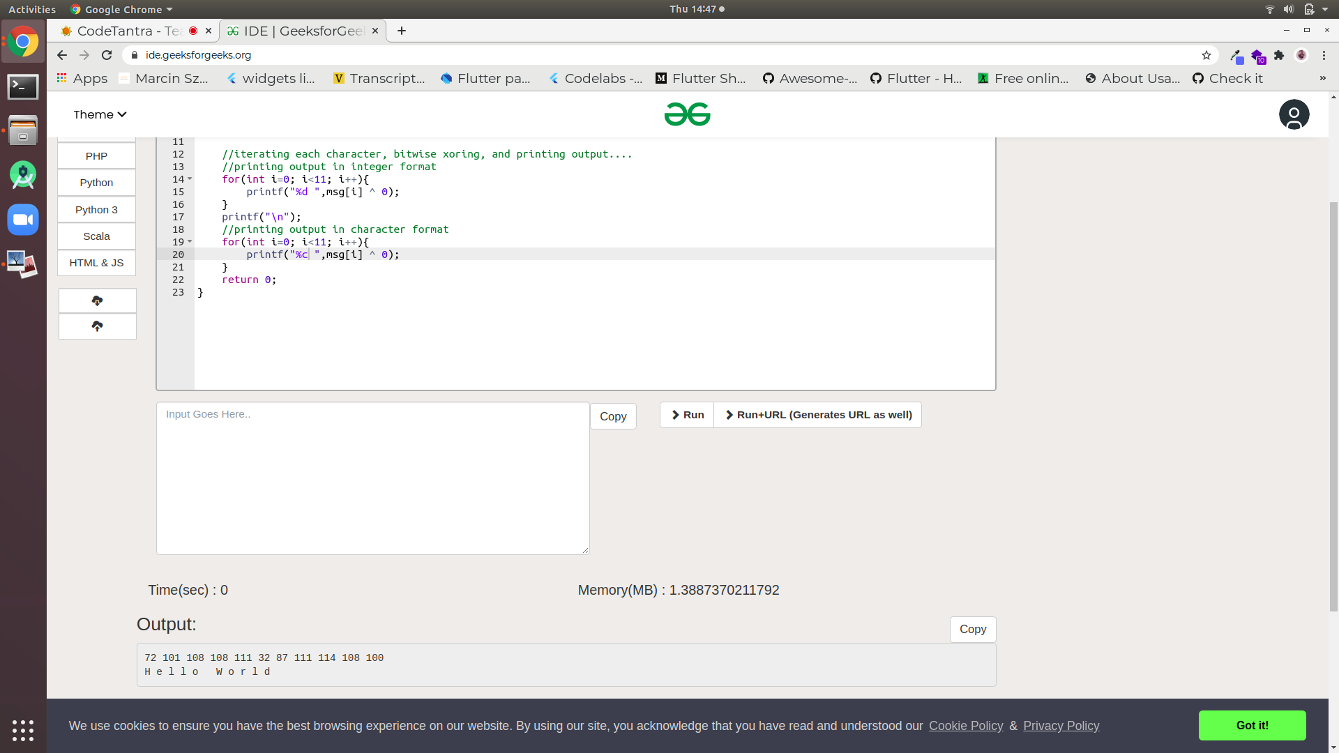

Answer 2:

#include <iostream>

using namespace std;

int main() {

//taking plain-text from user

//PLAIN TEXT SHOULD ONLY HAVE alphabets from a-z

string plainText;

string cipherText = "";

cin>>plainText;

//shift

int shift;

cin>>shift;

bool isPositive = true;

//handling sign and magnitude seperately for simplicity

if(shift<0){

shift = shift \* -1;

isPositive = false;

}

int l = plainText.length();

//encryption

for(int i=0; i<l; i++){

int s = shift % 26;// as pattern will repeat from 26th character from current position

if(isPositive){

if(plainText[i] + s > 'z'){

int difference = s - (int)('z' - plainText[i]);

char x = 'a' + (difference - 1);

cipherText[i] += x;

}else{

char c = (char)((plainText[i]^0) + s);

cipherText += c;

}

}else{

//for negative shift not completed

}

}

cout<<cipherText<<endl;

return 0;

}

