TECHNICAL REFERENCE
TAZ Centroid Connector Rules
Generation, ending-node selection, QA/QC, and HERE_MISS workflow
Project: TAZ Centroid Connector Generator
Updated: July 24, 2026
Purpose: Current operational rules and reviewer guidance
Core principle: Generate straight, well-separated connectors from an interior TAZ point to valid GSTDM nodes, preserve exclusive ending-node ownership across TAZs, and record missing roadway connections separately as HERE_MISS.
This document separates automatic generation rules from manual QA/QC responsibilities. The hard-rule fields should be reviewed again whenever a connector is manually edited.

1. Automatic Generation and Selection Rules
- Input coordinate system
All source layers must use the same projected coordinate system, with distance units in feet. The workflow does not silently reproject mismatched layers.
- Interior TAZ start point
Create one guaranteed interior point for each TAZ using representative_point(). This point is the fixed start of every centroid connector for that TAZ.
- Angular candidate sectors
Divide the full 360 degrees around each TAZ into 10 equal angular sectors. Each clipped sector represents a possible connector direction.
- HERE road-density priority
Use HERE Master LINKS to rank candidate sectors by clipped roadway length divided by clipped sector area. Higher-density directions receive higher selection priority.
- GSTDM node classification
Derive MAJOR_LEVEL from the connected GSTDM LINKS and their FUNC_CLASS values. The lowest numeric connected functional class becomes the node's MAJOR_LEVEL; lower numbers represent more major roads.
- Snap eligibility
Keep MAJOR_INT and snap eligibility conceptually separate. MAJOR_LEVEL 1 or 2 produces MAJOR_INT = Y and is normally blocked as a CC target. MAJOR_LEVEL 3, 4, or 5 is eligible. A missing MAJOR_LEVEL is not eligible.
MAJOR_INT is a functional-class-based flag; it is not a node-degree, geometric-intersection, or topology calculation.
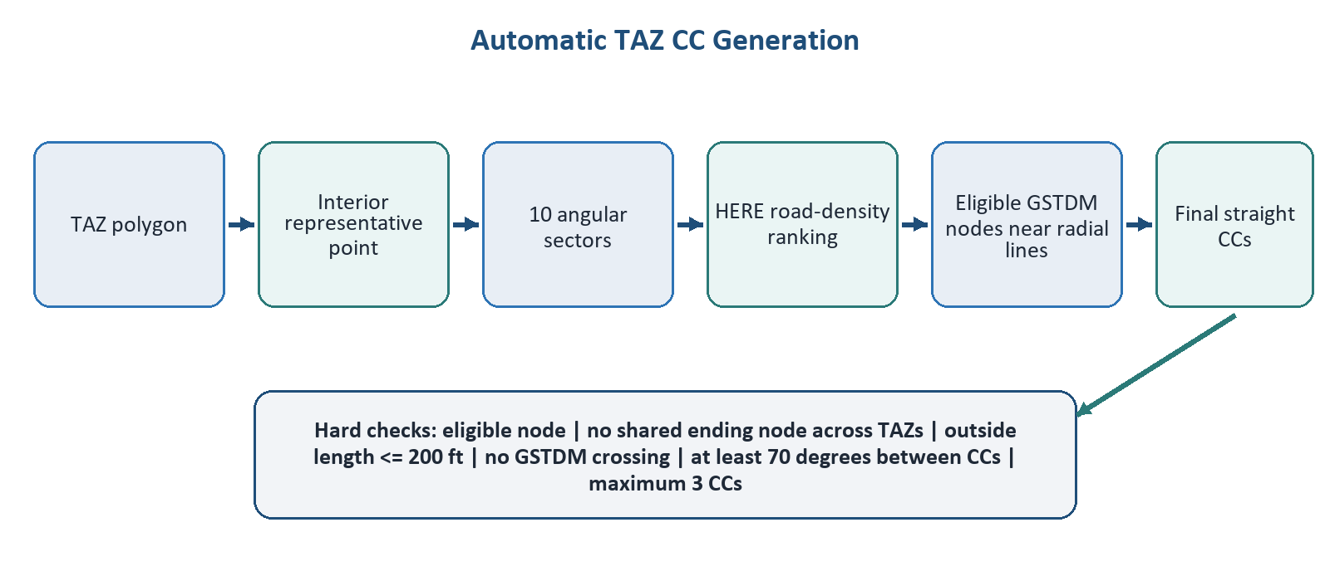
Figure 1. Automatic generation and hard-rule screening.
- Boundary-first ending-node search
For each candidate direction, search eligible GSTDM nodes near the centroid-to-boundary radial line. Prefer valid nodes in progressively wider boundary-distance bands: 0-25, 25-50, 50-100, and 100-200 feet.
- Internal fallback
Use an internal node only when no boundary-near node satisfies every hard rule. Record that exception with INTERIOR_FALLBACK = True.
- Straight connector geometry
Create each final connector as a straight line from the fixed interior TAZ point to the selected GSTDM ending node.
- Hard geometry limits
An automatically generated connector must pass every hard geometry check.
- OUTSIDE_LEN must not exceed 200 feet.
- The connector must not cross a GSTDM LINK away from its own target-node endpoint.
- The ending node must be snap-eligible.
- Connector count and angular separation
Target three connectors per TAZ, retain at least one when valid, and never retain more than three. Final connector bearings within a TAZ must remain at least 70 degrees apart. Discard a lower-priority candidate rather than relaxing the angle.
- Cross-TAZ ending-node exclusivity
Centroid connectors from different TAZs must not share the same ending GSTDM node. If another TAZ already owns the preferred node, select a different nearby eligible node.
- One-way ending-node connectivity and HERE_MISS
When a proposed CC ending node is connected to a one-way roadway link, inspect the surrounding network links first. Use the basemap to confirm whether a physical connecting roadway exists.
If the roadway is visible on the basemap but is missing from the network data, digitize the missing connection between the appropriate GSTDM nodes and store it in the separate HERE_MISS layer. Do not represent the missing roadway as another TAZ CC.
Review A/B direction and attributes before export. The current HERE_MISS default creates two directional records, so reviewers must not assume two-way operation when the observed roadway condition is one-way.
- Shortage and review flags
A TAZ with one or two valid connectors keeps those connectors but remains below the target count. A TAZ with no valid connector is flagged for manual review.
- Output identity and directed records
Export the source TAZ identifier as N. Each accepted CC produces two directed Cube records: TAZ-to-node and node-to-TAZ, with FCLASS = 32.

2. Ending-Node and HERE_MISS Workflow
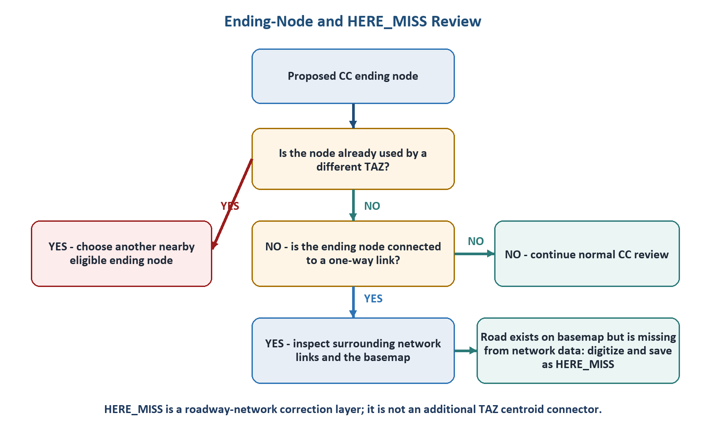
Figure 2. Ending-node exclusivity and one-way connectivity review.
Important distinction: A TAZ CC connects a TAZ centroid to a GSTDM node. A HERE_MISS feature corrects a missing roadway-network link between network nodes.
- Confirm the proposed ending node is not used by a different TAZ.
- If the node is attached to a one-way link, inspect adjacent links for a usable network connection.
- Compare the network with the basemap; do not add a link based only on visual proximity.
- When a physical roadway is visible but absent from the network, digitize it between the appropriate GSTDM nodes.
- Save the new roadway in HERE_MISS and document the basemap observation in QC notes.
- Verify link direction, A/B values, LANES, HERE_MISS, and FCLASS before export.

3. Default Parameters
Parameter | Current default
Angular sectors per TAZ | 10
Target / minimum / maximum CCs | 3 / 1 / 3
Minimum final bearing separation | 70 degrees
Blocked major-level ceiling | 2
Eligible MAJOR_LEVEL values | 3, 4, and 5
Maximum outside-TAZ connector length | 200 feet
Maximum snap distance | Unlimited when blank; hard geometry rules still apply

4. Manual QA/QC Rules
- Keep the centroid/start point fixed; change only the connector ending node.
- After every manual edit, recheck OUTSIDE_LEN, CROSSES_GSTDM, final bearing separation, connector count, and ending-node ownership.
- Use Load CC File to replace the browser's current CC baseline, not to append another baseline.
- Keep HERE_MISS independent from TAZ CCs and export it separately.
- Export Final CC and TAZ QC Status before using browser reset, default-replacement, or destructive import actions.
- Record the reason for unusual endpoint selections, internal fallbacks, or basemap-derived HERE_MISS additions in QC notes.
Global browser-review exception: Nodes identified as outside Georgia through NONGA = 1 are treated as eligible in the current Global review dataset regardless of functional class. This is a browser-review exception, not the standard core-generation rule.

5. Review Statuses
Status | Meaning
WAITING FOR QC | The TAZ has connectors but has not been approved.
FLAG | The TAZ has no connector or requires attention. A zero-CC TAZ remains FLAG.
EDITED | Uploaded data or browser-saved work changed the TAZ, connector, notes, or review data.
REVIEWED | The reviewer approved the current connector configuration.

6. Export Rules

TAZ centroid connectors
A | B | FCLASS
TAZ ID | GSTDM ending node | 32
GSTDM ending node | TAZ ID | 32

HERE_MISS roadway links
A | B | LANES | HERE_MISS | FCLASS
Node 1 | Node 2 | 1 | 1 | 32
Node 2 | Node 1 | 1 | 1 | 32
Default HERE_MISS values are editable. Review actual directionality before export, especially when the network condition involves a one-way roadway.

7. Final Review Checklist
- Each TAZ has no more than three CCs.
- Different TAZs do not share an ending node.
- Every standard ending node has MAJOR_LEVEL 3, 4, or 5.
- Final CC bearings within a TAZ are at least 70 degrees apart.
- OUTSIDE_LEN is no more than 200 feet.
- CROSSES_GSTDM is false.
- Every INTERIOR_FALLBACK case is documented.
- One-way ending nodes have been checked for surrounding network connectivity.
- Basemap-visible but network-missing roadways are stored as HERE_MISS, not as TAZ CCs.
- Final CC, HERE_MISS, TAZ QC Status, and QC notes are exported and archived together.
Project references: README.md; PROJECT_SUMMARY.md; QAQC_WEB_APP.md; config.py; defaults.py; geometry.py; selection.py; processing.py; docs/index.html; and docs/app.js.

8. Illustrated QA/QC Examples
The following screenshots are practical examples from the project QA/QC web page. They are included to show how the rules appear during map review; they are illustrative examples, not approval records.

Example 1 - Three CCs with distinct ending nodes
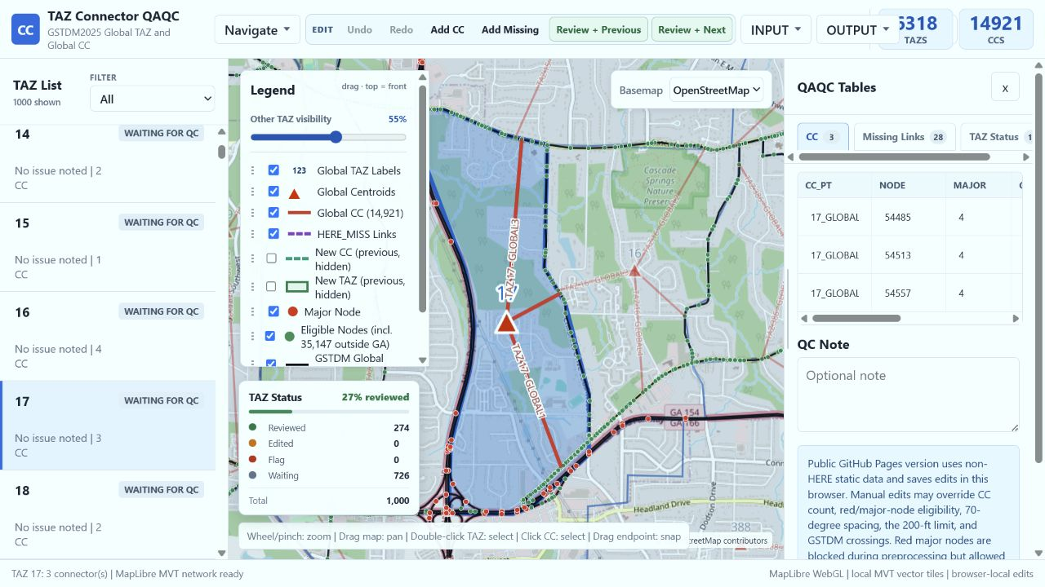
Figure 3. TAZ 17 with three centroid connectors terminating at three distinct network nodes.
What to verify: Each CC ends at a different network node. Review the three records together and confirm endpoint uniqueness, reasonable spatial separation, and the assigned node level before accepting the TAZ.

Example 2 - HERE_MISS verification on the street basemap
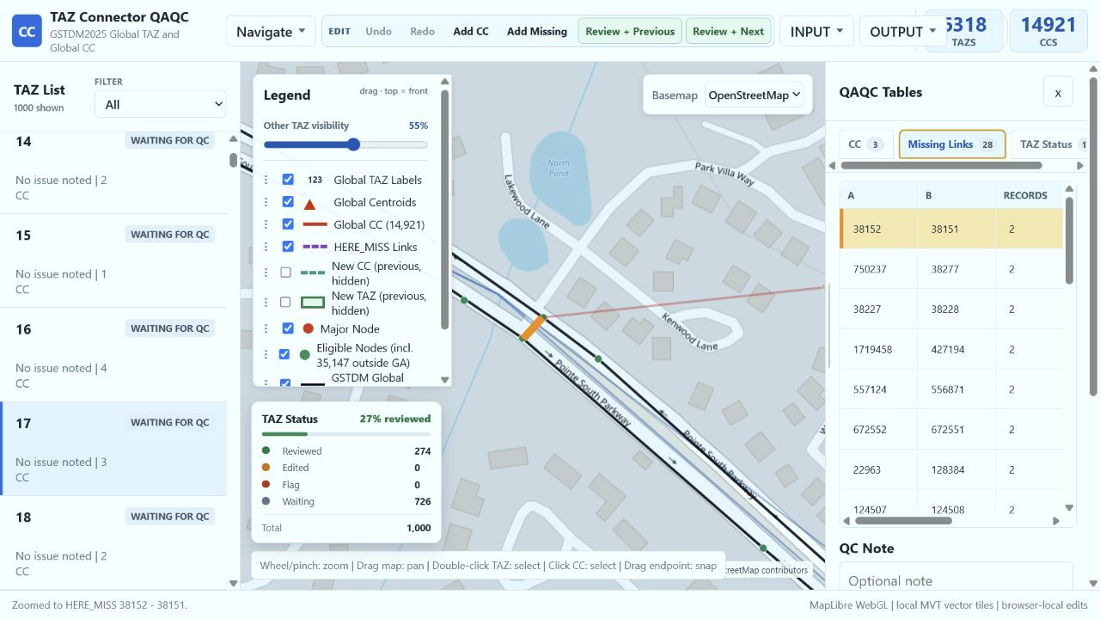
Figure 4. Selected HERE_MISS candidate 38152-38151 displayed as an orange segment on the street basemap.
What to verify: When a CC ending node is on a one-way link, first check whether an existing connectlink already provides the required connection. If none exists, use the basemap to determine whether a physical roadway supports adding a connector. The proposed network record is classified as HERE_MISS.

Example 3 - Confirm the same HERE_MISS candidate on satellite imagery
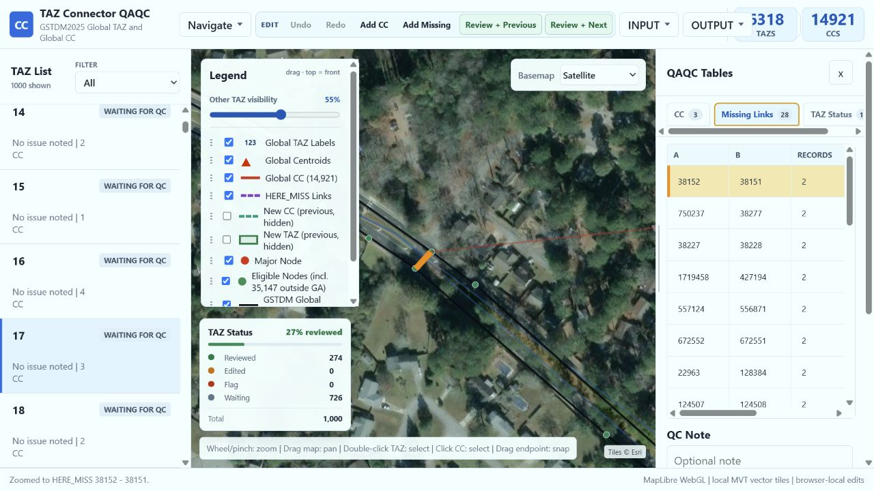
Figure 5. The same HERE_MISS candidate 38152-38151 checked against satellite imagery.
Decision note: Use imagery as a second visual check of the roadway and its alignment. Do not add a HERE_MISS record solely because two nodes are close together. Confirm the physical connection, review A/B direction, and complete the required HERE_MISS attributes before export.

