**ShinyCoin: Top 30 Crypto Currency Analysis using R-Shiny**

**Group 6**

**Application User Guide**

Contents

1. Introduction Page 2

2. Exploratory Data Analysis: 2

a) Horizon Graph 2

b) Anomaly Diagnostics 3

c) Simple Time Series 3

3. Statistical Analysis: 3

a) Seasonal Diagnostics 4

b) Time Series Decomposition 4

c) Auto correlation 5

4. Time Series Forecasting: 6

1) Cross validation plan: 6

2) Prediction 6

# Introduction Page

A short description and uses cases of the application are presented on this page.

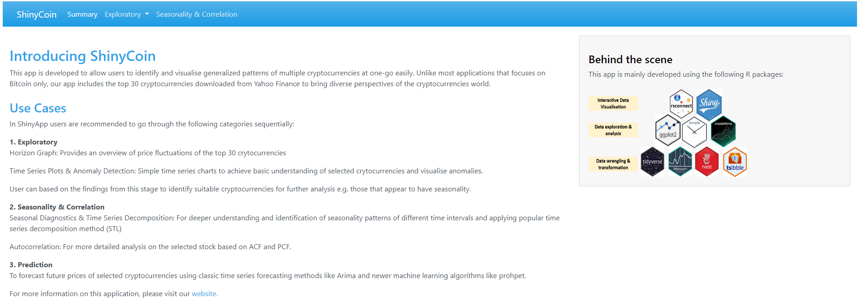

# Exploratory Data Analysis

Three types of Exploratory Data Analysis would be performed. Horizon Graph, Simple Time Series plot and Anomaly Diagnostics.

## Horizon Graph

Horizon Graph depict the fluctuation of historical cryto currencies’ prices in percentile. Blue color represents the positive value, red for negative. The darker the shade of color, the greater the fluctuation. The Horizon graph generated can display all top 30 Crypto Currencies’ price of time-series values on a single page that supports comparisons among them.

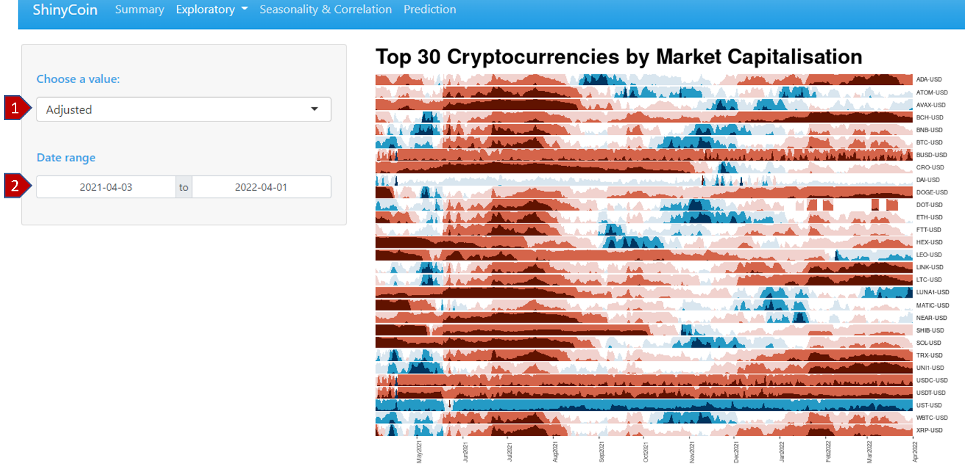

1. Choose the desired value of observation (adjusted, low, high, open, close, volume)
2. Select the desired period of observation. Default value is one year from now.

## Anomaly Diagnostics

Allow users to view anomalies of price changes upon selection of desired date range. The anomalies would be marked with red color.

Note: Simple Time Series plot and Anomaly Diagnostics share the same set of UI interface.

1. Select the desired cryptocurrency, allow choosing up to four different coins for comparison.
2. Choose the desired value of observation (adjusted, low, high, open, close, volume)
3. Choose the desired date range.

## Simple Time Series

Simple Time Series Plot is a line plot showing the evolution of the time series over time. This app allows users to choose up to four coins for comparison and generate the results across the panel on each individual facets.

# Statistical Analysis

The statistical Analysis contains three types of analysis, Seasonal diagnostics, Time Series Decomposition and Auto Correlation.

## Seasonal Diagnostics

Seasonal Diagnostics help users identify the repeating short-term cycle in the series. Provide users seasonal diagnostics results upon chosen of time interval (from weekday, Month, Quarter and Year) and compare those results of up to four-time intervals in one screen.

1. Select the desired cryptocurrency.
2. Choose the desired value of observation (adjusted, low, high, open, close, volume)
3. Select desired time interval for the observation (allow up to four selections for comparison).
4. Select desired time period of observation.
5. Click/Tap on “View” to generate the Seasonal Diagnostics for the selected coin.

## Time Series Decomposition

Allow users analyze the Time Series Decomposition of individual Crypto Currency upon chosen of decomposition components from Season, Trend, Observed, Remainder and Seasonal adjusted. For the app we choose multiplicative type of decomposition model, because of the high volatility of Crypto currencies, the changes over time are non-linear and not constant, so they can increase/decrease with time.

Repeat step [1] & [2]

1. Choose desired decomposition components (Season, Trend, Observed, Remainder). Allow up to four selections of components for comparison.
2. Select desired time period of observation.
3. Click/Tap on “View” to generate the Time Series Decomposition analysis for the selected coin.

## Auto correlation

The**autocorrelation function** (ACF) shows the value of the correlation coefficient between the chosen Crypto Currency and lagged versions of itself upon choice of lag specification (from 1 to 90) and time period. The ACF considers all of the components of the time series (mentioned in the decomposition part) while finding the correlations.

Repeat step [1],[2] &[4]

1. Select desired lag specification.
2. Select desired time period of observation.
3. Click/Tap on “View” to generate the Auto Correlation analysis for the selected coin.

# Time Series Forecasting

This is to apply suitable time series models to predict the prices of crypto currencies, and to compare the results of the various forecast models quickly. From this, investors could predict their potential rate of returns.

Note: Due to the complexity of the algorithm, it takes a while for the App to perform the forecasting analysis, then demonstrates the results.

# Cross validation plan

Cross validation plan is used to predict the future price based on a resampled dataset and provide users the opportunity to estimate the accuracy of this app.

1. Select the desired cryptocurrency.
2. Choose the desired Date Range.
3. Select desired Training/ Validation split (from 0.6 to 0.9).
4. Click/Tap on “Predict Future Prices” to generate Cross Validation Plan for the selected coin.

# Prediction

This app allows users to generate three forecasting Plots: Forecast Validation Plot, Forecast Plot, Residual Plot using eight models: Arima, Prophet, Elastic Net, Random Forest, XGBoost, SVM, ARIMA Boosted, Prophet Boosted for the selected coin.

Repeat the step from [1] to [3]

1. Click/Tap on “Predict Future Prices” to generate the forecasting results of three Prediction Plots for the selected coin.