# Neural Networks and Deep Learning

## Assignment 5

**SAI TEJA GOUD KASALA**

**700741728**

1. Save the model and use the saved model to predict on new text data (ex, “A lot of good things are happening. We are respected again throughout the world, and that's a great thing.@realDonaldTrump”)

2. Apply GridSearchCV on the source code provided in the class

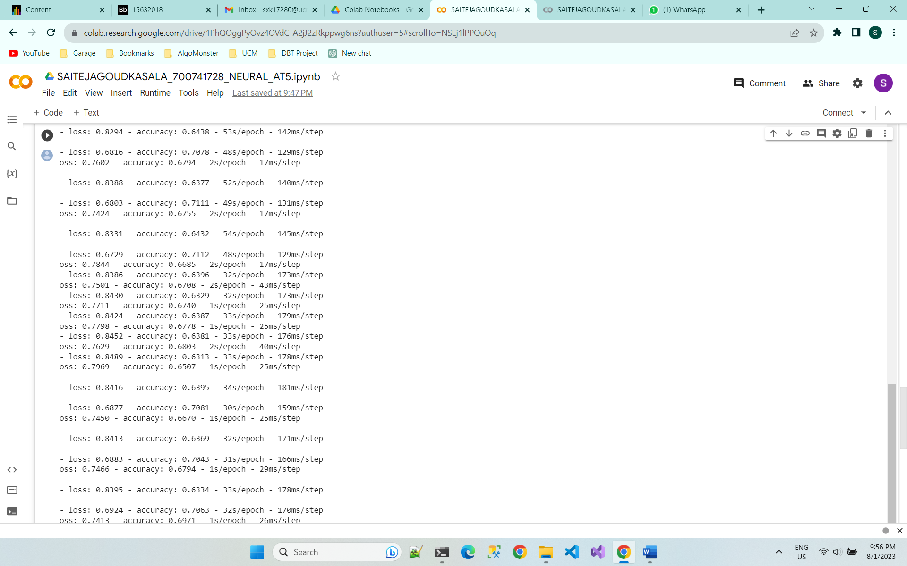

**Git Hub link :**

<https://github.com/sxk17280/NeuralAssignment5>

**Video Link:**

[**https://github.com/sxk17280/NeuralAssignment5/blob/main/SAITEJAGOUDKASALA_700741728_NEURAL_AT5.mp4**](https://github.com/sxk17280/NeuralAssignment5/blob/main/SAITEJAGOUDKASALA_700741728_NEURAL_AT5.mp4)