Test cases:

1. When entered 1, prints 1

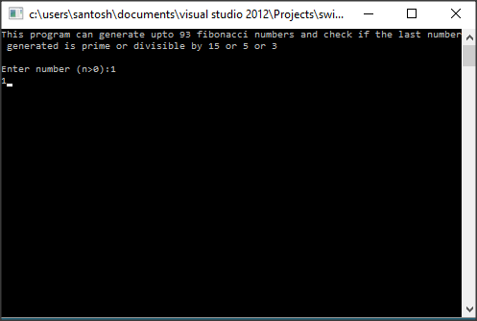

1. When entered 2 prints 1, as 1 is not prime

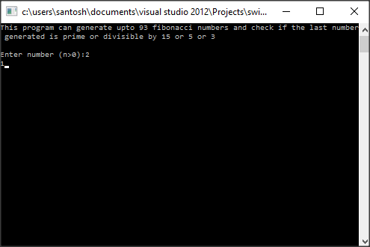

1. When entered n=3 prints BuzzFiz, as 2 is prime

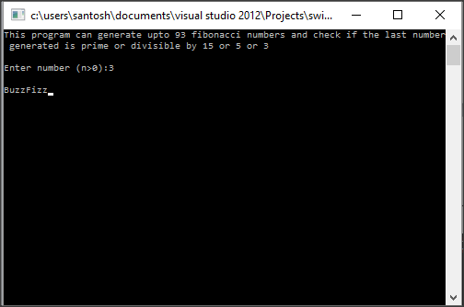

1. When entered n=4 prints BuzzFizz, as 3 is prime

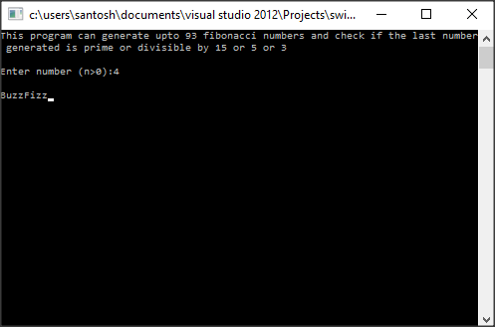

1. When entered n=10 prints Fizz, as 55 (10th Fibonacci number) is divisible by 5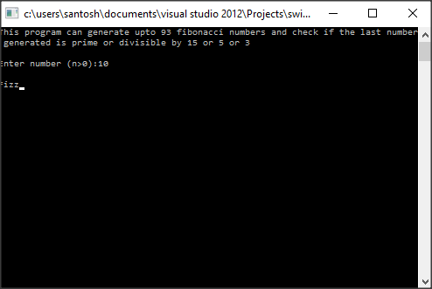
2. When entered n=25 prints Fizz, as 75025 (25th Fibonacci number) is divisible by 5

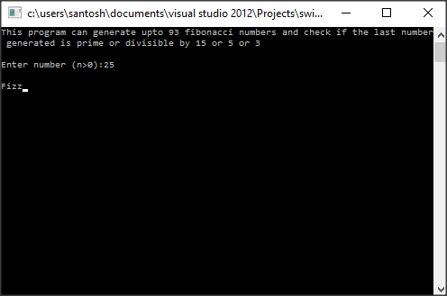

1. When entered n=44 prints Buzz as 701408733 is divisible by 3

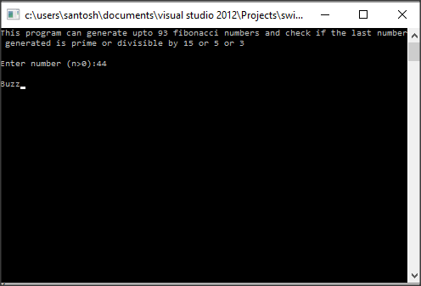

1. When entered n=60 prints FizzBuzz as 1548008755920 is divisible by 15

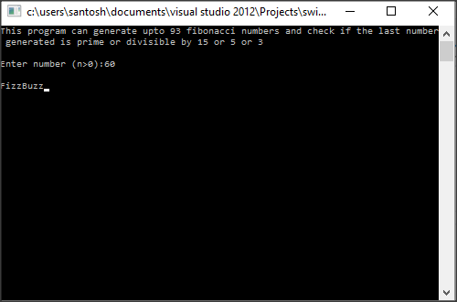

1. When entered n=75, prints Fizz as 2111485077978050 is divisible by 5

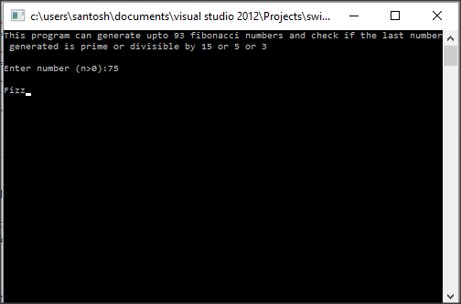

1. When entered n=93, prints 12200160415121876738 which is neither prime nor divisible by 15 or 5 or 3

