MarketAutomationWebApp

*Note: Sub-titles are not captured in Xplore and should not be used

İlhan Mustafa Akgül  
 Bilişim Sistemleri Mühendisliği  
 *Kocaeli Üniversitesi*  
Kocaeli, Türkiye  
 line 5: [ilhanmustafaakgul@gmail.com](mailto:ilhanmustafaakgul@gmail.com)

*Abstract*—*A market automation website facilitating the organization and management of market data, prepared using framework, MySQL, JavaScript, and CSS.* (*Abstract*)

Keywords—framework, MySQL, JavaScript, and CSS. (key words)

# INTRODUCTİON(problem definition)

**Inventory Management Issues:**

* Need to monitor and update the quantity of products in stock.
* Requirement to generate automatic alerts when stock levels are low.
* Risk of resource waste and customer dissatisfaction due to product stockouts.

**Sales Analysis and Reporting Problems:**

* Inability to determine the best-selling products and lack of access to effective data for inventory management.
* Inability to track sales trends and adjust sales strategies accordingly.
* Difficulty in financial analysis due to incomplete or inaccurate income reports.

**Customer Relationship Management (CRM) Challenges:**

* Lack of sufficient information about customer preferences, leading to the inability to provide personalized service.
* Low customer satisfaction and ineffective loyalty programs.

**Order Management Issues:**

* Inability to track customer orders and lack of control over the delivery process.
* Increase in customer complaints due to late or incorrect deliveries.

**Pricing and Discount Management Challenges:**

Murat Öztürk  
 Bilişim Sistemleri Mühendisliği  
 *Kocaeli Üniversitesi*  
Kocaeli, Türkiye  
 line 5: murat5506furkan@gmail.com

* Non-competitive product pricing leading to low sales.
* Revenue loss due to ineffective management of discounts and promotions.

# Ease of Use

## İntuvitive İnterface

Firstly, the website generally features an intuitive interface that allows users to quickly adapt. There are headers on the homepage that guide users to their desired destinations, facilitating easy discovery of desired content. Users can navigate forward or backward using the progress bar. In summary, this website offers a user-friendly experience with its easy interface, fast accessibility, and personalized recommendations. These features enable users to quickly access the videos they want and enjoy a pleasant viewing experience..

## Quick Access and Seamless Experience

Test results indicate that the website offers fast loading times, quick transitions between data sets, and a seamless user experience. This means that users can access content more quickly and smoothly. These results demonstrate that users have a positive experience with the application and that it meets their needs.

# Flowchart

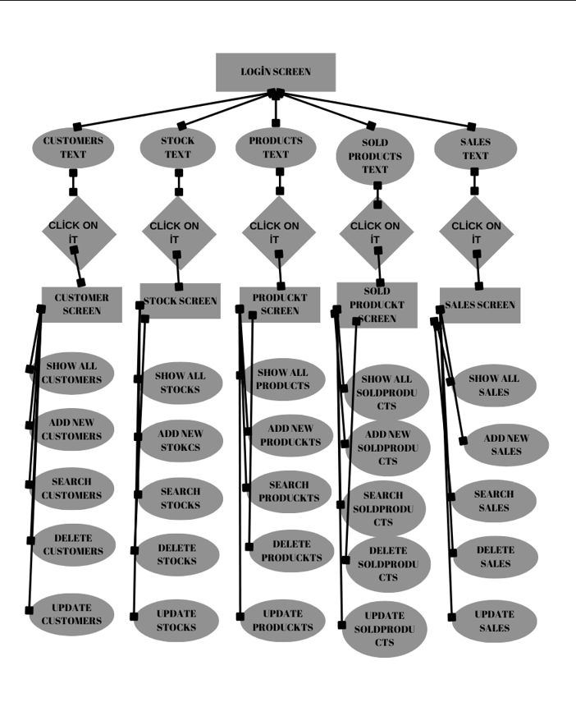

The flowchart is designed to guide the user's experience step by step. Activities and fragments are meticulously arranged to present the information, functions, or content that the user needs in a user-friendly manner. This arrangement is carried out to enhance the user's experience and provide them with the most suitable options according to their desires. Presenting different scenarios based on the user's requests and needs aims to offer a more personalized experience.

## SOFTWARE ARCHITECTURE

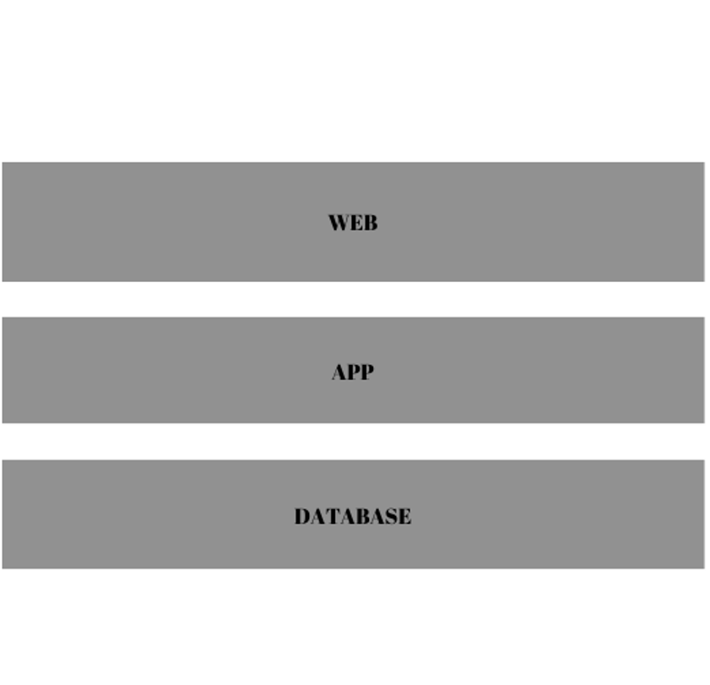

**A Website Designed with Three-Tier Software Architecture**

This report presents a detailed analysis of a website designed using three-tier software architecture. The three-tier architecture consists of the presentation layer, the application layer, and the data layer. The functions and interactions of each layer are described below:

* **Presentation Layer:**

The presentation layer is where the user interface is designed and the user experience is created. This layer typically involves technologies such as HTML, CSS, and JavaScript to create web pages. It is the section where information is presented to the user and user interactions are managed. For example, when viewing a web page in a web browser, the presentation layer controls the appearance of the page and user interactions.

* **Application Layer:**

The application layer is where the business logic resides. This layer processes requests from the presentation layer, accesses the database when necessary, and performs the required data manipulations. It usually operates on the server-side (backend) and acts as an intermediary between the presentation layer and the data layer. The application layer can be built using web servers, frameworks, or customized application code.

* **Data Layer:**

The data layer is where data is stored and managed. This layer typically interacts with relational or document-based databases using a database management system (DBMS). Database operations (queries, insertions, updates, deletions, etc.) are performed in this layer. It handles data requests from the application layer and returns the results.

This three-tier architecture facilitates the development, maintenance, and scalability processes of the website by logically separating its components. Each layer has a specific responsibility, and changes can be made to one layer with minimal impact on the others. This enables development teams to work more efficiently and create a more sustainable code base by reducing complexity.

## Why the three-tier architecture

* **Modularity and Easy Maintenance**: The three-tier architecture enables the separation of code into different layers, allowing each layer to be independently developed and maintained. This facilitates a more modular and manageable codebase, easing the development process.

**Functional Separation:** Each layer performs a specific function. The presentation layer handles user interface creation, the application layer processes business logic, and the data layer manages data storage and retrieval. This separation clarifies the software's functions and responsibilities, reducing complexity.

**Scalability:** The three-tier architecture facilitates the scalability of the website. Each layer can be independently scaled, enhancing performance as the website grows or experiences increased traffic.

**Flexibility and Adaptability:** This architecture allows for the use of different technologies and solutions. Different JavaScript libraries or frameworks can be utilized for the presentation layer, while different programming languages or frameworks may be preferred for the application layer. This accommodates the expertise of team members and aligns with project requirements.

**Security:** Differentiating between the data layer and the application layer enhances data security. It prevents direct access to the database by users and enables control through the application layer, thereby enhancing security measures.

## ER (Entity-Relationship) diagram

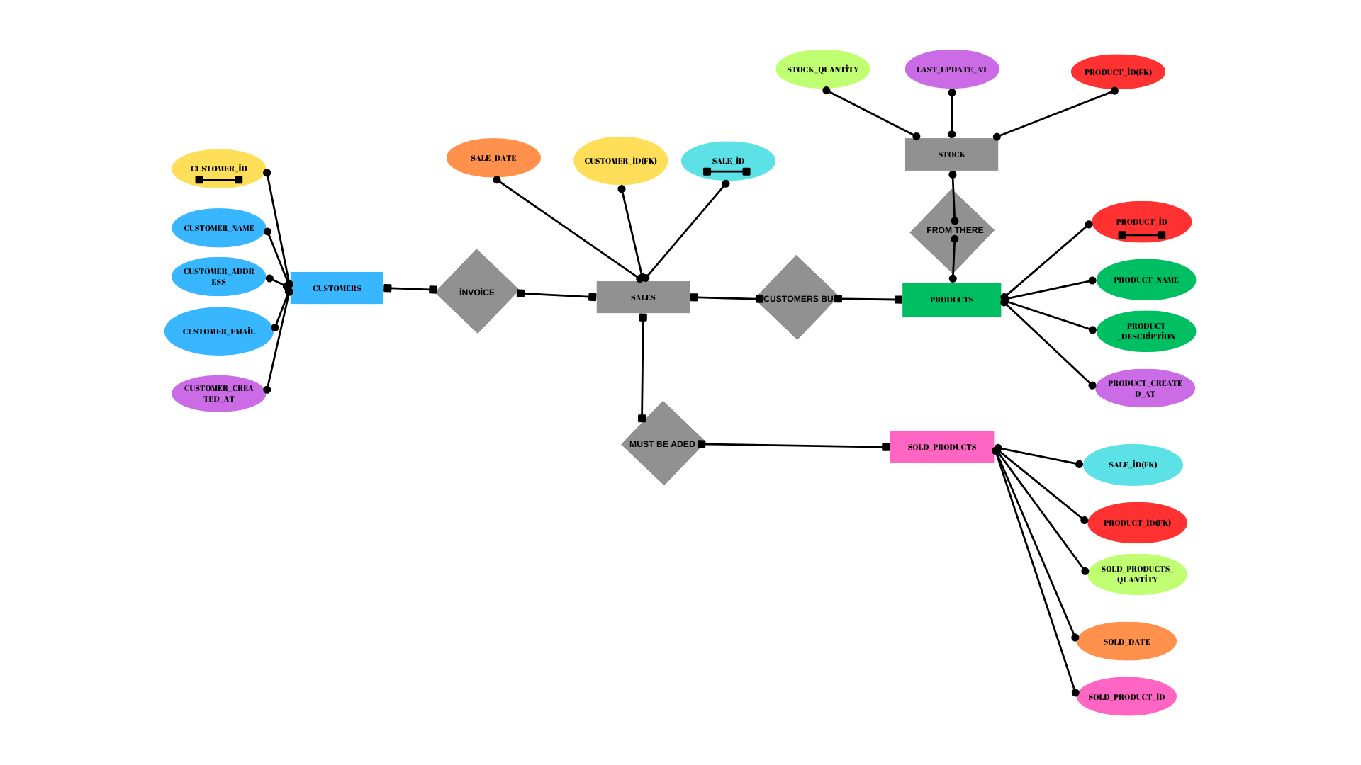

**1. Customers Table:**

* This table stores customer information.
* It includes fields such as customer name, last name, address, and email address.
* Each customer is assigned a unique customer ID.

**2. Inventory Table:**

* The inventory table stores stock information for current products.
* It includes fields like product ID, update date, and stock quantity.
* The stock quantity represents the current stock of the product.

**3. Sales Table:**

* This table records completed sales transactions.
* It includes fields such as sale ID, customer ID, sale date, and total price.
* Each sale transaction is assigned a unique sale ID, and it is associated with the customer's ID.

**4. Sold Products Table:**

* This table contains details of sold products, storing product information for each sale transaction.
* It includes fields such as sale ID and product ID.
* It facilitates the association of each sold product with its respective sale transaction.

**5. Products Table:**

* The products table stores basic information about all available products.
* It includes fields like product ID, product name, description, and unit price.

- Each product is assigned a unique product ID.

1. These tables are used to support the fundamental functions of a retail business, enabling the recording and tracking of operations such as customer information, inventory management, sales transactions, and product management. This structure optimizes business processes by ensuring data is stored systematically and easily accessible.

# DEVELOPMENT PROCESS

**Spring Framework :**

The Spring Boot documentation greatly assisted me in overcoming the challenges encountered while using the Spring Boot framework in my project. These documents provided a comprehensive guide on project configuration, management of configuration files, and fundamental Spring Boot features. Additionally, the examples and explanations provided by the documentation aided in understanding complex topics within the project. Lastly, the up-to-date nature and wide range of topics covered by the documentation provided a solid foundation for meeting the project's requirements.

**MySQL**

* The MySQL Workbench documentation played a significant role in database management and SQL query creation in my project. These documents offered a detailed guide covering the usage of Workbench's interface, designing database schemas, and data manipulation. Moreover, the examples and practical tips provided by the documentation helped in executing database operations more efficiently. Lastly, the official nature and provision of current information by the documentation facilitated the accurate integration of project database components.
* **W3Schools:**
* W3Schools' HTML tutorials served as a valuable resource for creating the basic structure of web pages in my project. These tutorials provide a detailed guide on HTML tag usage, form elements, and image placement. Furthermore, through sample code and interactive applications, the tutorials facilitated rapid improvement of my HTML skills. Lastly, the accessibility and user-friendly interface of the tutorials enabled effective integration of relevant HTML components into the project.

W3Schools' CSS tutorials were instrumental in designing the style and layout of web pages in my project. These tutorials offer comprehensive information on CSS properties, selectors, and layout techniques. Additionally, through sample applications and practical tips, the tutorials helped in swiftly enhancing my CSS skills. Lastly, the current and extensive nature of the tutorials provided flexibility in customizing the project's user interface as desired. W3Schools' SQL tutorials served as a vital resource for creating database operations and queries in my project. These tutorials provide a comprehensive guide covering the fundamentals of the SQL language, table creation, and data querying. Moreover, through interactive exercises and sample queries, the tutorials assisted in effectively improving my SQL skills. Lastly, the explanatory and understandable nature of the tutorials facilitated the proper management of project database components.

W3Schools' JavaScript tutorials were a significant resource for creating dynamic web content in my project. These tutorials offer a comprehensive guide covering the fundamental building blocks of the JavaScript language, event handlers, and DOM manipulation. Additionally, through sample projects and interactive applications, the tutorials effectively aided in enhancing my JavaScript skills. Lastly, the current and extensive nature of the tutorials enabled the creation of dynamic and impactful elements in the project's user interface.

I utilized the Postman platform to conduct API tests during the development process of my project. Postman facilitated the creation and testing of API calls used to ensure the compatibility of various project components. Additionally, the user-friendly interface of Postman and its diverse debugging tools enabled me to conduct API tests quickly. Lastly, the reporting features of Postman aided in monitoring and improving the performance of the project.

##### References

<https://dev.mysql.com/doc/workbench/en/>

<https://www.w3schools.com/html>

<https://www.w3schools.com/css>

<https://www.w3schools.com/sql>

<https://www.w3schools.com/js>

https://chatgpt.com/

1. PROJE BANTISI:

**IEEE conference templates contain guidance text for composing and formatting conference papers. Please ensure that all template text is removed from your conference paper prior to submission to the conference. Failure to remove template text from your paper may result in your paper not being published.**