1. Freemarker

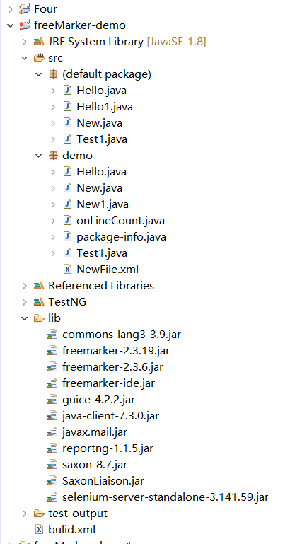

testng-xslt

