

Name – Sonu

Roll Number – 24136

Subject – Java Practicals

Class – MCA

Semester –1st

Department – DCSA

Submitted to –

**1. Program in Java to implement Print Prime Number Upto 100 .**

class Primenumbers{

static boolean isprime(int n){

if(n==1 || n==0){

return false;

}

for(int i=2;i<n;i++){

if(n%i==0){

return false;

}

}

return true;

}

public static void main(String[] args){

int N=100;

for(int i=1;i<=N;i++){

if(isprime(i)){

System.out.print(i + " ");

}

}

}

}

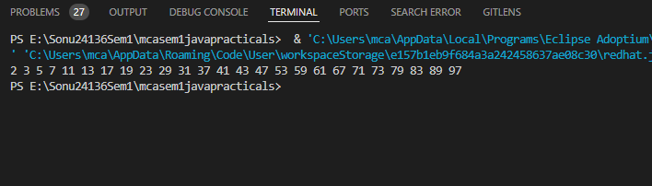

**2. Program in Java to implement finding whether a number is Armstrong or not.**

public class Armstrong {

int power(int x, long y)

{

if (y == 0)

return 1;

if (y % 2 == 0)

return power(x, y / 2) * power(x, y / 2);

return x * power(x, y / 2) * power(x, y / 2);

}

// Function to calculate order of the number

int order(int x)

{

int n = 0;

while (x != 0) {

n++;

x = x / 10;

}

return n;

}

boolean isArmstrong(int x)

{

// Calling order function

int n = order(x);

int temp = x, sum = 0;

while (temp != 0) {

int r = temp % 10;

sum = sum + power(r, n);

temp = temp / 10;

}

return (sum == x);

}

public static void main(String[] args)

{

Armstrong ob = new Armstrong();

int x = 153;

// int x;

System.out.println(ob.isArmstrong(x));

x = 1253;

System.out.println(ob.isArmstrong(x));

}

}

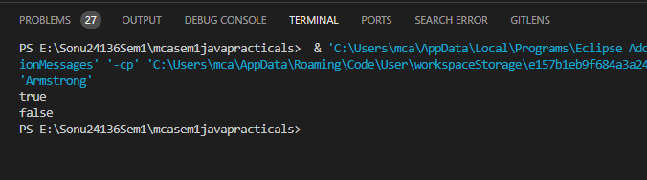

**3. Program in Java to implement array reading and writing on/from console.**

import java.util.Scanner;

public class Array {

public static void main(String[] args){

int size,i;

Scanner sc=new Scanner(System.in);

System.out.println("Enter the size of Array: ");

size=sc.nextInt();

int[] arr=new int[size];

System.out.println("Enter the elements of Array: \n");

for(i=0;i<size;i++){

arr[i]=sc.nextInt();

}

System.out.println("The Elements of Array are: \n");

for(i=0;i<size;i++){

System.out.print(arr[i]+" ");

}

sc.close();

}

}

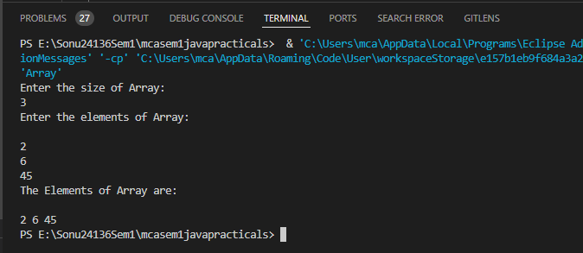

**4. Program in Java to implement selection sort using functions.**

import java.util.Scanner;

public class Selectionsort {

public static void main(String[] args){

int size,i,j,temp;

Scanner sc=new Scanner(System.in);

System.out.println("Enter the size of Array: ");

size=sc.nextInt();

int[] arr=new int[size];

System.out.println("Enter the elements of Array: \n");

for(i=0;i<size;i++){

arr[i]=sc.nextInt();

}

System.out.println("The Elements of Array are: \n");

for(i=0;i<size;i++){

System.out.print(arr[i]+" ");

}

for (i = 0; i < size-1; i++) {

for(j=i+1;j<size;j++){

if(arr[i]>arr[j]){

temp=arr[j];

arr[j]=arr[i];

arr[i]=temp;

}

}

}

System.out.println("\nArray after applying Selection sort: \n");

for(i=0;i<size;i++){

System.out.print(arr[i]+" ");

}

sc.close();

}

}

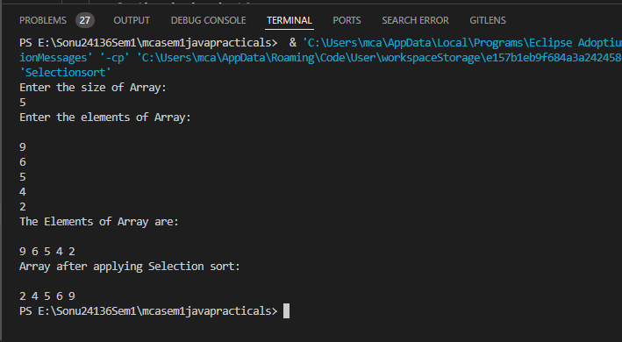

**5. Program in Java to implement Bubble Sort using Functions.**

import java.util.Scanner;

public class Bubblesort{

public static void main(String[] args){

int size,i,j,temp;

Scanner sc=new Scanner(System.in);

System.out.println("Enter the size of Array: ");

size=sc.nextInt();

int[] arr=new int[size];

System.out.println("Enter the elements of Array: \n");

for(i=0;i<size;i++){

arr[i]=sc.nextInt();

}

System.out.println("The Elements of Array are: \n");

for(i=0;i<size;i++){

System.out.print(arr[i]+" ");

}

boolean swapped;

for (i = 0; i < size - 1; i++) {

swapped = false;

for (j = 0; j < size - i - 1; j++) {

if (arr[j] > arr[j + 1]) {

temp = arr[j];

arr[j] = arr[j + 1];

arr[j + 1] = temp;

swapped = true;

}

}

// If no two elements were

// swapped by inner loop, then break

if (swapped == false)

break;

}

System.out.println("\nArray after applying Bubble sort: \n");

for(i=0;i<size;i++){

System.out.print(arr[i]+" ");

}

sc.close();

}

}

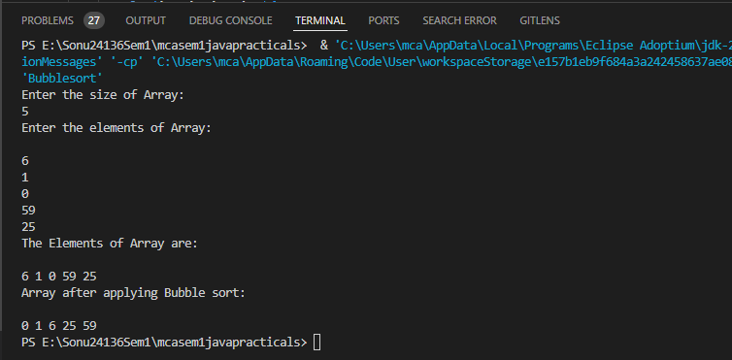

**6. Program in Java to implement Insertion sort using functions.**

import java.util.Scanner;

public class Insertionsort {

public static void main(String[] args){

int size,i,j,temp;

Scanner sc=new Scanner(System.in);

System.out.println("Enter the size of Array: ");

size=sc.nextInt();

int[] arr=new int[size];

System.out.println("Enter the elements of Array: \n");

for(i=0;i<size;i++){

arr[i]=sc.nextInt();

}

System.out.println("The Elements of Array are: \n");

for(i=0;i<size;i++){

System.out.print(arr[i]+" ");

}

for (i = 1; i < size; i++) {

int key = arr[i];

j = i - 1;

while (j >= 0 && arr[j] > key) {

arr[j + 1] = arr[j];

j = j - 1;

}

arr[j + 1] = key;

}

System.out.println("\nArray after applying Insertion sort: \n");

for(i=0;i<size;i++){

System.out.print(arr[i]+" ");

}

sc.close();

}

}

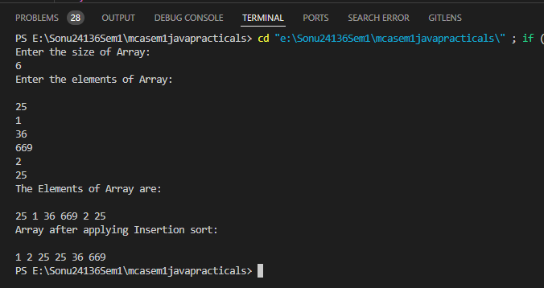

**7. Program in Java to implement Matching a Particular Substring in a String without using inbuilt matching function(s).**

class Substring {

public static void main(String[] args) {

// create a string

String txt = "Ich bin Spark.";

String str1 = "Spark";

String str2 = "Ich bin Spark. Hello, ";

boolean result = txt.contains(str1);

if(result) {

System.out.println(str1 + " is present in the string.");

}

else {

System.out.println(str1 + " is not present in the string.");

}

result = txt.contains(str2);

if(result) {

System.out.println(str2 + " is present in the string.");

}

else {

System.out.println(str2 + " is not present in the string.");

}

}

}

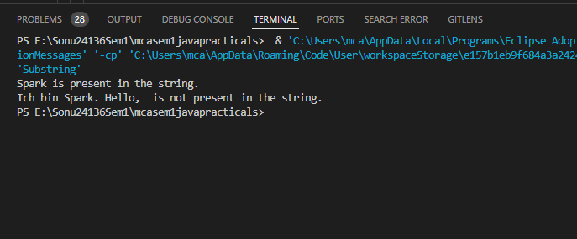

**8. Program in Java to implement Garbage Collection Usage in Java.**

public class GC {

public void finalize(){System.out.println("object is garbage collected");}

public static void main(String[] args) {

// System.out.println("Programme worked successfully.");

GC s1=new GC();

GC s2=new GC();

s1=null;

s2=null;

System.gc();

}

}

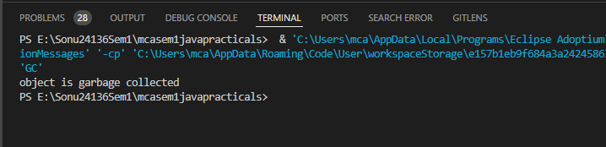

**9. Program in Java to implement array of objects and create a student record with details of name, address, contact number and email ID .**

import java.util.Scanner;

class ArrofObject {

String name;

String address;

String contactnumber;

String email;

public ArrofObject() {

name = "name not give";

address = "address not given";

contactnumber = "contactnumber not given";

email = "email not given";

}

public void setData() {

Scanner scan = new Scanner(System.in);

System.out.print("Name: ");

name = scan.nextLine();

System.out.print("Address: ");

address = scan.nextLine();

System.out.print("Contact Number: ");

contactnumber = scan.nextLine();

System.out.print("Email: ");

email = scan.nextLine();

}

public void display() {

System.out.println("************************************");

System.out.println("* Name: " + name);

System.out.println("* Adress: " + address);

System.out.println("* Contact Number: " + contactnumber);

System.out.println("* Email: " + email);

System.out.println("************************************");

}

}

public class StudentInfo {

public static void main(String[] args) {

int n;

Scanner scan = new Scanner(System.in);

System.out.println("Enter the number of students: ");

n = scan.nextInt();

ArrofObject[] student = new ArrofObject[n];

System.out.println("Enter the details of students:");

for (int i = 0; i < n; i++) {

student[i] = new ArrofObject();

student[i].setData();

// student[i].display();

}

System.out.println("Data of all Students\n");

for (int i = 0; i < n; i++) {

student[i].display();

}

}

}

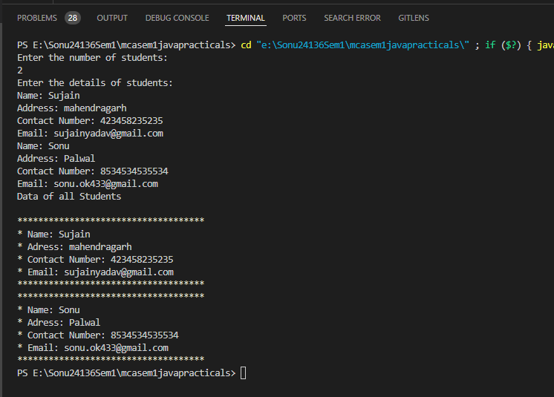

**10. Program in Java to implement Single & Multi-level inheritance.**

class Bicycle {

void displayFeatures() {

System.out.println("Features: Pedals, Manual power");

}

}

class Motorbike extends Bicycle {

void displayFeatures() {

super.displayFeatures();

System.out.println("Added feature by Motorbike: Engine");

}

}

class ElectricBike extends Motorbike {

void displayFeatures() {

super.displayFeatures();

System.out.println("New feature by ElectricBike: Electric motor and battery");

}

}

class TransportationEvolution {

public static void main(String args[]) {

ElectricBike myEbike = new ElectricBike();

myEbike.displayFeatures();

}

}

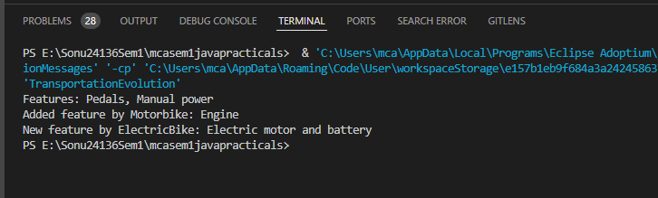

**11. Program in Java to implement Abstract Class Usage.**

abstract class StudentInfo{

abstract void printinfo();

}

class Student extends StudentInfo{

void printinfo(){

int roll=24136;

String name="Sonu";

float fee=33156.3F;

System.out.println(roll);

System.out.println(name);

System.out.println(fee);

}

}

public class Abstract {

public static void main(String[] args) {

StudentInfo st = new Student();

st.printinfo();

// System.out.println("Hola Amigo!! Its test Line.");

}

}

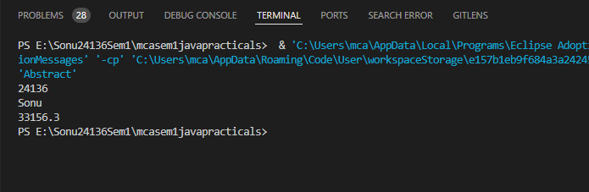

**12. Program in Java to implement Interface Usage to implement multiple inheritance.**

interface Interface1{

void Dance();

}

interface Interface2{

void Run();

}

class Man implements Interface1, Interface2{

public void Dance(){

System.out.println("That man is dancing.");

}

public void Run(){

System.err.println("That man is running.");

}

}

class Interface{

public static void main(String[] args){

Man man = new Man();

man.Dance();

man.Run();

}

}

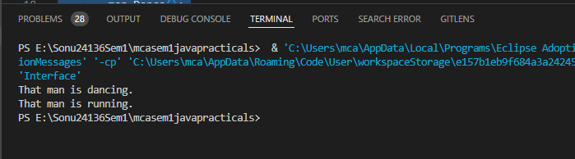

**13. Program in Java to implement Packages usage to use one function of a class in another.**

**Code to create pakage:**

package people;

public class Children{

private String name;

public Children( ) {

name = "Unknown";

}

public void setName(String name) {

this.name = name;

System.out.println(name);

}

public String getName() {

return name;

}

public static void main(String[] args) {

// Children child = new Children();

}

}

**Code to import and use the pakage:**

package test;

import people.Children;

public class Test {

public static void main(String[] args) {

Children children= new Children(); //declare and initialize

children.setName("Sonu");

System.out.println("Yay! Its working.");

}

}

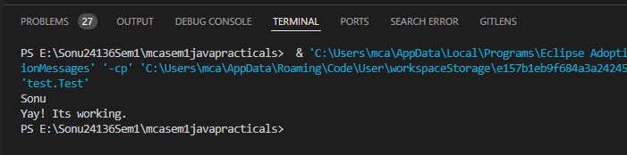

**14. Program in Java to implement I/O and file handling.**

import java.io.File;

import java.io.IOException;

import java.util.Scanner;

import java.io.FileWriter;

import java.io.*;

// import java.io.FileNotFoundException;

class Filehandling{

public static void main(String[] args) throws IOException {

// *****Writing in file */

try{

FileWriter Writer=new FileWriter("myFile.txt");

Writer.write("IchBinSpark.");

Writer.close();

System.out.println("Successfully written in file.");

}

catch(IOException e){

System.out.println("An error has occured");

e.printStackTrace();

}

// finally

// ****Reading from File */

// File obj=new File("myfile.txt");

System.err.println("File successfully created!");

try{

File obj=new File("myFile.txt");

Scanner Reader = new Scanner(obj);

while(Reader.hasNextLine()){

String data = Reader.nextLine();

System.out.println(data);

}

Reader.close();

if(obj.createNewFile()){

System.out.println("File created: " + obj.getName());

}

else{

System.err.println("File already exists!");

}

}

catch(FileNotFoundException e){

System.out.println("An error has occured.");

e.printStackTrace();

}

}//

}

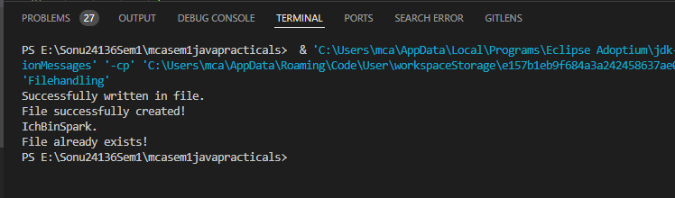

**15. Program in Java to implement Exceptions.**

public class Exception {

static void checkAge(int age) {

if (age < 18) {

throw new ArithmeticException("Access denied - You must be at least 18 years old.");

}

else {

System.out.println("Access granted - You are old enough!");

}

}

public static void main(String[] args) {

// checkAge(15); // Set age to 15 (which is below 18...)

checkAge(20);

}

}

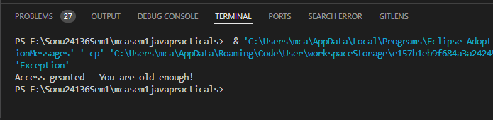

**16. Program in Java to implement Applets.**

**Skipppppppp**

**17. Program in Java to implement Multiple Threads.**

**18. Program in Java to implement Event Handlers.**

import java.awt.*;

import java.awt.event.*;

class EventHandling {

Button btn;

Checkbox cb;

EventHandling() {

Frame frame;

frame = new Frame("Checkbox with Itemlistner.");

cb = new Checkbox();

cb.setBounds(250, 250, 300, 300);

btn = new Button("Click Here");

btn.setBounds(60, 70, 120, 80);

cb.addItemListener(new ItemListener() {

public void itemStateChanged(ItemEvent e) {

if (cb.getState()) {

System.out.println("Feature is Enabled.");

} else {

System.out.println("Feature is Disabled.");

}

}

});

btn.addActionListener(new ActionListener() {

public void actionPerformed(ActionEvent e) {

System.out.println("Button Clicked");

}

});

frame.add(cb);

frame.add(btn);

frame.setSize(500, 500);

frame.setLayout(null);

frame.setVisible(true);

}

public static void main(String[] args) {

new EventHandling();

}

}

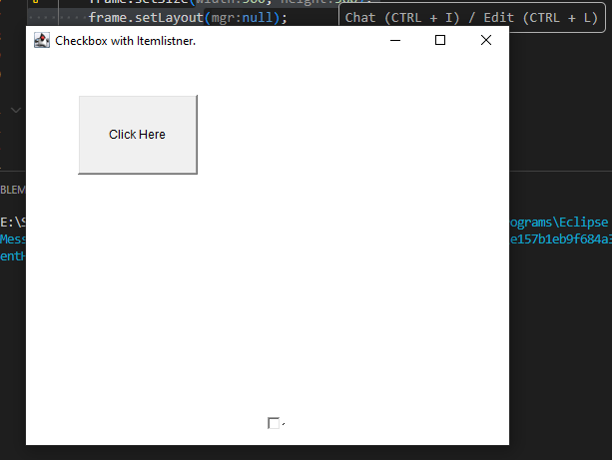

**19. Program in Java to implement Mini Calculator.**

**20. Program in Java to define two complex numbers and do the addition and multiplication and print the results.**

import java.util.*;

class Complex {

int real, imagin;

Complex() {

}

Complex(int tempReal, int tempimagin) {

real = tempReal;

imagin = tempimagin;

}

Complex addComplex(Complex c1, Complex c2) {

Complex c3 = new Complex();

c3.real = c1.real + c2.real;

c3.imagin = c1.imagin + c2.imagin;

return c3;

}

Complex multiComplex(Complex c1, Complex c2) {

Complex c3 = new Complex();

c3.real = (c1.real * c2.real - c1.imagin * c2.imagin);

c3.imagin = (c1.real * c2.imagin + c1.imagin * c2.real);

return c3;

}

}

public class ComplexAddition {

public static void main(String[] args) {

Scanner scanner = new Scanner(System.in);

Complex c1 = new Complex();

System.out.print("Enter your 1st real number: ");

c1.real = scanner.nextInt();

System.out.print("Enter your 1st imaginary number: ");

c1.imagin = scanner.nextInt();

Complex c2 = new Complex();

System.out.print("Enter your 2nd real number: ");

c2.real = scanner.nextInt();

System.out.print("Enter your 2nd imaginary number: ");

c2.imagin = scanner.nextInt();

// Complex c1 = new Complex(3, 2);

System.out.println("Complex number 1 is : " + c1.real + " + " + c1.imagin + "i");

// Complex c2 = new Complex(1, 4);

System.out.println("Complex number 2 is : " + c2.real + " + " + c2.imagin + "i");

Complex c3 = new Complex();

c3 = c3.addComplex(c1, c2);

System.out.println("Sum of the Complex numbers : " + c3.real + " + " + c3.imagin + "i");

c3 = c3.multiComplex(c1, c2);

System.out.println("Multiplication of two Complex numbers : " + c3.real + " + " + c3.imagin + "i");

}

}

