Project Report

Title: Community Geo Tag Reporter
Student Name: Smridhi Narwal
Roll Number: 24BCE11505
Course: Java Fundamentals
Instructor: Dr. Priscilla Dinkar
Submission Date: 27 november, 2025

Table of Contents
- Introduction
- Problem Statement
- Objectives
- System Requirements
- Project Features
- Design and Implementation
6.1 Class Diagram and Architecture
6.2 User Interface Layout
- Key Source Code Highlights
- Screenshots and Visual Demonstration
- Testing and Evaluation
- Object Oriented Programming Concepts Used
- Conclusion
- Future Enhancements

This project Community Geo Tag Reporter is a Java based application developed to help users report local community problems with location details in a simple and structured way. The system focuses on situations where internet access is limited so that users can still record issues offline and share them later. It aims to support better communication between citizens and local authorities through clear and organized problem reports.

- Problem Statement
In many areas citizens face issues such as damaged roads blocked drains broken street lights and waste accumulation. These issues often remain unresolved because there is no simple way to record and track them especially in places with poor internet connectivity. Existing solutions are either completely online or not user friendly for ordinary citizens. There is a need for a simple offline first tool that allows users to log community problems with location details and supporting information.

2.Objectives
The main objectives of this project are as follows.
To design and implement a Java application that allows users to create and store community problem reports.
To include location details such as address and simple geo tags for each report.
To support offline data entry by storing reports locally on the system.
To provide a way to view all reports and prepare them for sharing or printing for submission to local authorities.

3.System Requirements
Hardware Requirements.
A computer or laptop with a basic processor.
At least four gigabytes of memory.
Sufficient storage space for Java project files and data files.
Software Requirements.
Operating system such as Windows Linux or Mac.
Java Development Kit version eight or above.
A Java integrated development environment such as IntelliJ IDEA Eclipse or NetBeans.
Git and GitHub account for version control and project submission if required by the institution.
Github Link:
https://github.com/sxro10/community-geoissue-reporter.git

4.Project Features
The Community Geo Tag Reporter provides the following key features.
Add New Report. Users can enter a description of the problem address details geo tag information and optional image file path.
View Reports. Users can list all stored reports with basic details such as description location and status.
Offline Storage. Reports are stored locally so that the application can be used without continuous internet connection.
Simple Status Tracking. Each report can have a basic status such as pending or resolved.

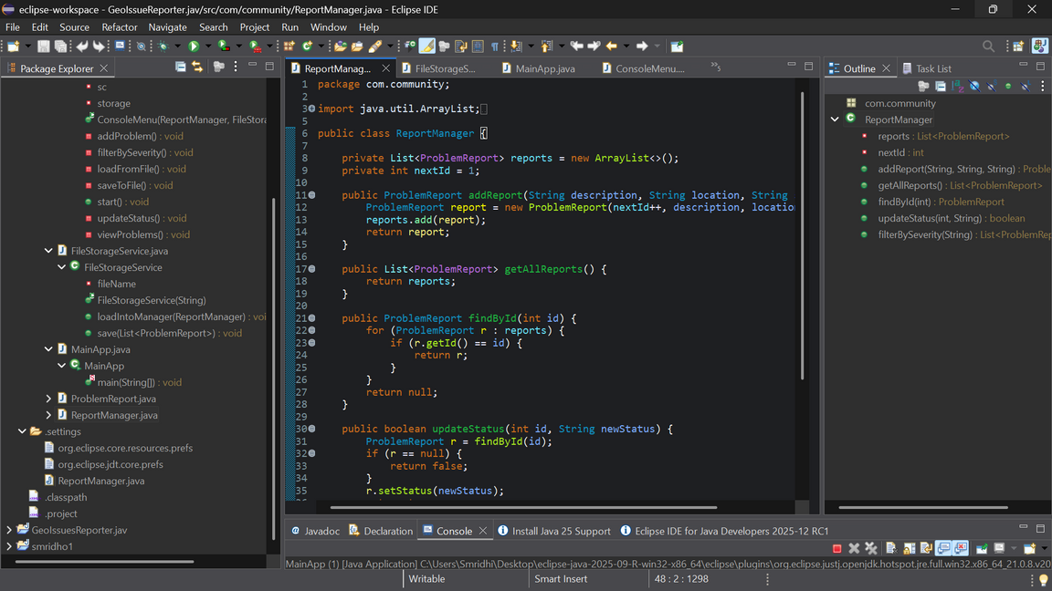

5.Design and Implementation
5.1 Class Diagram and Architecture
The application follows a modular design using basic object oriented principles. The core classes include a Problem Report class and a main controller or manager class that handles user interaction and data storage.
Insert Class Diagram image here.
Problem Report Class.
Represents a single community problem entry.
Contains fields for identifier description address geo coordinates image path date and time and status.
Reporter Manager Class.
Maintains a list of problem reports.
Provides functions for adding new reports listing reports and saving or loading data.
5.2 User Interface Layout
The initial version of the application uses a command line interface.
The user is shown a simple menu with options such as add report view reports and exit.

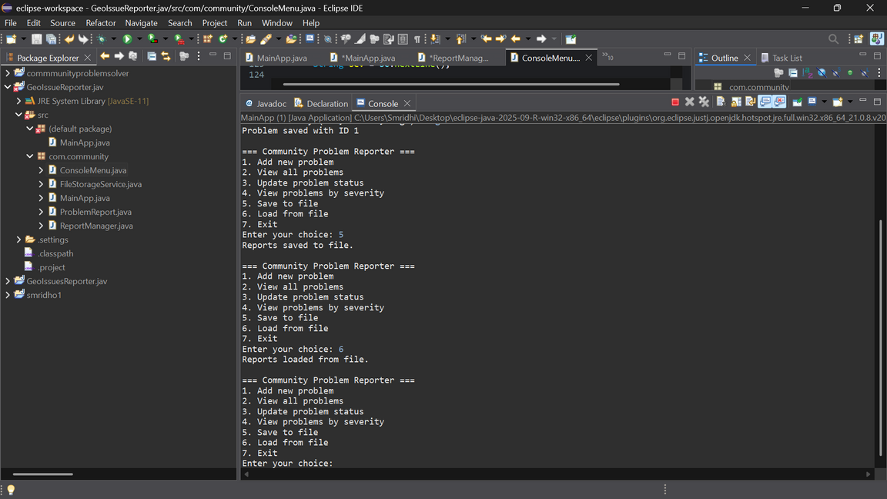

6.Key Source Code Highlights
The code is organized into multiple classes to separate data logic and user interaction.
Important methods include creating new reports generating identifiers and displaying reports in a readable format.

7.Screenshots and Visual Demonstration
This section presents visual proof of the working application.
Insert Screenshot of Report Creation Screen here.
Insert Screenshot of List Reports Screen here.
If a video demonstration is required insert a note such as Insert Link or Reference to Demo Video here.

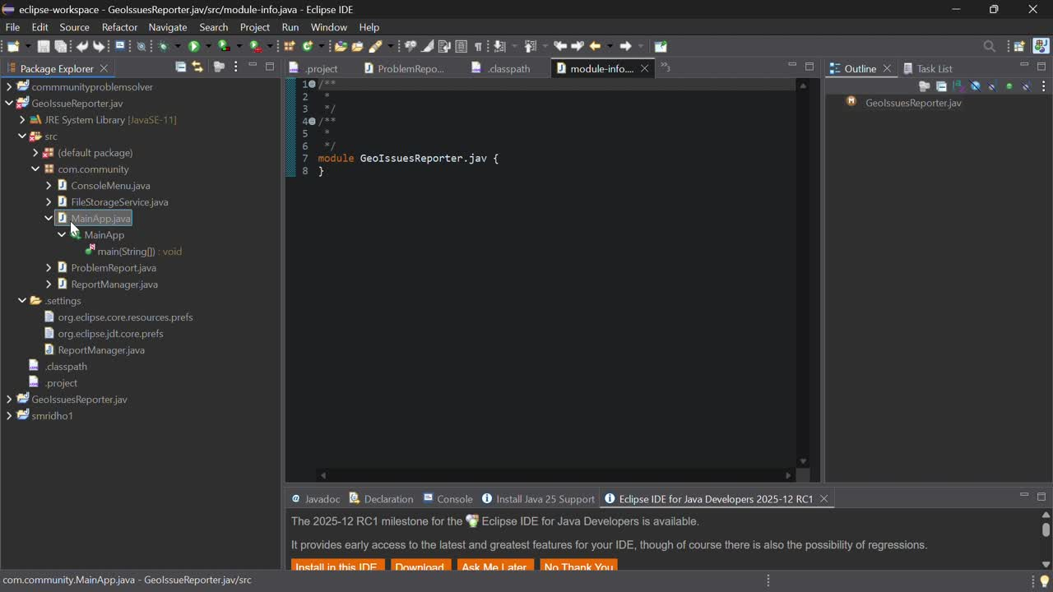

8.Testing and Evaluation
The application was tested using different input scenarios to check correctness and stability.
Test cases included adding reports with valid data adding multiple reports viewing all reports and handling empty lists.
The system behaved as expected in normal cases and simple input validation was performed at the user interface level.
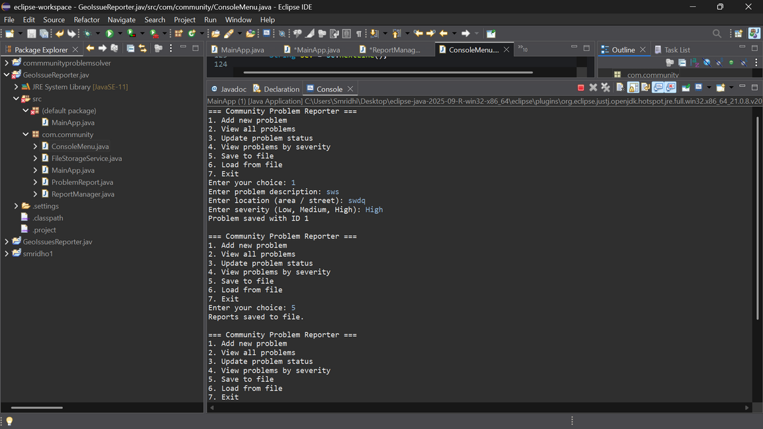

9.Object Oriented Programming Concepts Used
The project applies the following object oriented concepts.
Encapsulation. Data related to each problem report is stored in a single class with private fields and public methods.
Abstraction. The user interacts with simple menu options while internal details of storage and object handling are hidden.
Modularity. Different responsibilities such as data representation user input handling and storage can be placed in separate classes.

10.Conclusion
The Community Geo Tag Reporter project demonstrates how Java can be used to build a simple offline first application for community problem reporting. The system allows users to register issues with clear descriptions and basic location details and stores them locally for later review or submission. It fulfills the main objectives of supporting offline data entry and providing a structured format for community issues.

11.Future Enhancements
Future improvements to the project may include the following.
Adding a graphical user interface using JavaFX or Swing.
Implementing map based geo tagging and more accurate location handling.
Adding export options such as saving reports to a CSV file or formatted report document.
Integrating with an online server or web application for automatic submission when internet is available.

