**Name : Sai Siddipeta**

**ID:700759592**

1. To read the provided csv file we use pd.read_csv

1. To show statistical description we use df. describe()

1. To check the data we use if there are any null values. We use **isnull().sum()** and we found 5null values in **‘Calories’** Column.
2. To find the mean value of it we use **df[‘Calories’].mean()** and we found the mean value as **375.79024390243904.** And to replace the values we use **.fillna(x,inplace = True)**

After filling the mean value in null values we get the output as

We can use any two columns and to find the aggregation of it we use .agg([‘min’,’max’,’count’,’mean’])

And the output is as displayed.

* To find below calorie values between 500 and 1000.
* We use filtered_df = df[(df[‘Calories’]>=500 &(df[‘Calories’]<=1000)]
* Print(filtered_df)

* To find below calorie values between 500 and 1000.
* We use filter_df = df[(df[‘Calories’]>500 &(df[‘Calories’]<100)]
* Print(filter_df)

1. To find the below Question we use

df_modified = df.drop(columns=[‘Maxpulse’]

print(df_modified)

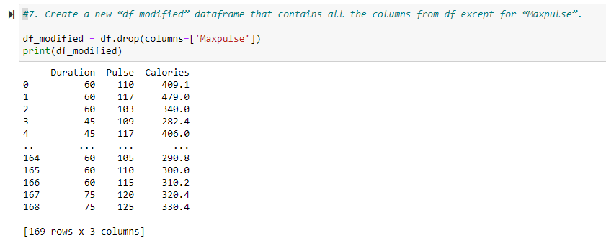

1. To delect ‘Maxpulse’ column completely we use

df.drop(columns=[‘Maxpulse’], inplace = True)

1. To convert a column into int datatype.

We use df[‘Calories’].astype(int)

And to print it we use df.dtypes

