# Literature Review

According to the literature, COVID-19 lockdowns have resulted in environmental benefits compared to the transition to electric vehicles (EVs) [1]. This experiment proposes hypotheses derived from the results of literature investigating the impact of the spread of electric vehicles on air quality and tests them using predictive modelling, correlation calculations and visualisation analysis.

In addition, a canonical correlation analysis has been used to investigate the relationship between air quality and quality of life [2]. Canonical Correlation Analysis (CCA) was used in the literature to investigate the relationship between the Air Quality Index (AQI) and quality of life; CCA is a statistical method used to analyse the relationship between two sets of variables. According to the literature, in this experiment, in order to be able to determine the degree of association between air quality and quality of life and the contribution of the variables of interest, the hypothesis will be further confirmed based on correlation and regression analysis.

The literature suggests that globally, NO2 reduction due to COVID-19 has been estimated to range from 13% to 23% [3], with nitrogen dioxide primarily accumulating in the air as a result of fossil fuel combustion in automobiles, industry, and power generation facilities [US EPA, 2021]. Therefore, based on this literature, the impact of traffic due to COVID-19 lockdowns can be used as a reliable proxy to estimate the potential impact of electric vehicles adoption and a clean air zone. Correlation and visualisation analysis are also used for multifaceted presentation.

Horton et al. (2021) conducted a modelling study to investigate the potential public health and air pollution benefits of the widespread adoption of heavy-duty electric vehicles in China. The study found that such adoption would reduce nitric oxide and fine particulate matter, with an estimated 562 cases of avoided premature mortality (95% CI 410-723). Based on the literature, this project will adopt a predictive model similar to the global integrated assessment model in the literature as well as a time series approach to prediction as well as validation after data splitting of the data.

### In addition, A non-linear model fit with two degrees was implemented to fit the trend between air quality during the epidemic lockdown and the percentage change in transportation that was affected by the policy. Polynomial regression allows for better fitting complex relationships than Tableau's default linear regression. By adding higher-order terms, the non-linear features of the data can be better captured. Therefore when selecting this model in Tableau, visual coding should also observe the model fit to prevent over-fitting. Applying quantification to calculate correlation coefficients and visual analysis combined with polynomial regression allows the user to see the connections in various aspects.

It is also immensely beneficial for comparing the variability of transportation modes with air quality during the lockdown and non-lockdown periods. Correlations can be effectively demonstrated by combining heat maps.

1. *Hypothesis 2 (Whether modifications in transportation mode during an epidemic lockdown can effectively affect air quality and whether similar policies can be implemented)*

In terms of quantification, a high degree of similarity was observed between the variation of NOx during the blockade and the traffic variation curve in terms of curvature and peak segments. The format was harmonised by adjusting the format to different dates. By aligning the format of the different dates and choosing the inner join method to link the air quality and mobility data COVID-19 sheets, the mean values are obtained every ten days for a frequency, and the similarity of the two variables can be observed at the same time. Eventually, Figure 1 shows that the two curves have a significant repeatability, as people change their travel patterns due to the epidemic, and the NOx index decreases when the degree of change (the change is negative, the higher the degree the smaller the value) is high, and rises when the policy is gradually relaxed and people return to their previous travel patterns.

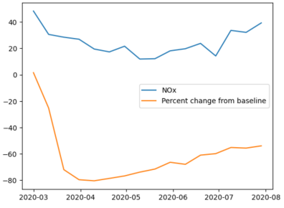

Figure 1: General view of NOx and percent change of transportation station

Extracting the lockdown period from the non-lockdown period and calculating the correlation coefficients by averaging the different quarters and using DataFrame.corr(), it can be determined that during the lockdown period the index of pollutant emissions is highly correlated with the degree of change in traffic patterns affected by the lockdown. However, in the absence of similar measures to the lockdown, the correlation is significantly smaller as shown on the left side of the graph below.

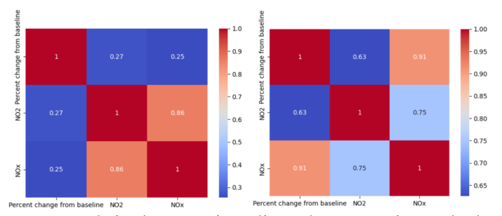

Figure 2: Correlation between air quality and transportation mode change

Further extensions were made to investigate whether there is a definitive solution to reduce pollution if a policy with the same efficiency as an epidemic lockdown, such as the Bristol clean air zone policy, is implemented in the centre of Bristol. Using the heat map in the Tableau visual coding approach and the text size in the map to highlight areas that receive more pollution, it is, therefore, possible to provide policy proponents with different implementation intensities of policies for different regions. The map below shows that the pollution index is highest around Colston Avenue. Therefore the amount of money charged for petrol cars around Colston Avenue could be increased to limit travel. It can also be seen that the greater the change in travel patterns during the most significant blockade period from March to August 2020, the lower the NOx index will be, with the most skewed rate of decline in NOx within the low-cost range occurring at a transportation mobility change percentage around 40. The figure on the bottom right further shows that when the change in traffic patterns peaks during the March to August lockdown period, NOx pollution reaches the low end. However, after the closure, NOx does not decrease even if the number of traffic changes is maintained at a certain amount, thus confirming that choosing the right policy can be effective in changing traffic patterns and improving air quality.

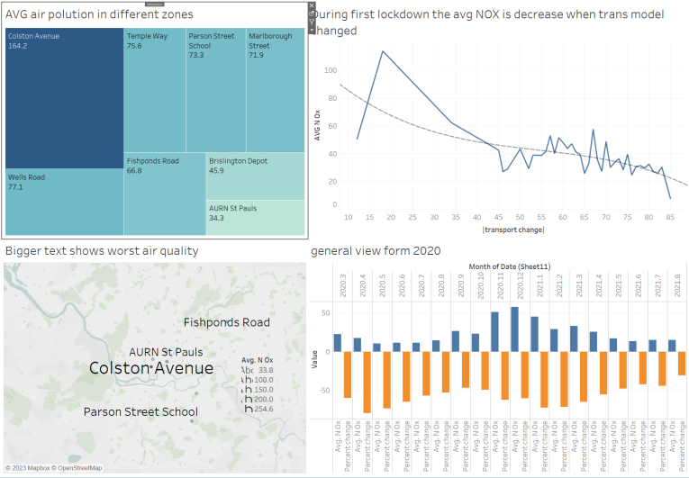

Figure 3: Tableau dashboard shows NOx figures in map and line format

Ultimately, the policy can be refined by looking at the pollution indices for different areas of Bristol and the probability that a change in the number of transport stations will both effectively reduce pollution and reduce costs. For example, the policy implementer could keep the transport mobility change percentage in the low 40s for areas of average pollution and between 60 and 80 for more polluted areas. The policy should not be fixed but monitored regularly according to the level of pollution and adjusted dynamically for the benefit of different areas.

~~The findings suggest that changes in traffic resulting from epidemic-related closures may positively impact air quality. However, long-term restrictions on human activities are not a viable solution for improving air quality. Instead, implementing restrictions or controls on high-polluting activities may be more effective.~~

The results demonstrate a significant correlation between the number of electric vehicles (EVs) and the quantity of NOx, supporting our hypothesis that an increase in EVs can decrease NOx emissions. This highlights the potential benefits of promoting EV adoption to reduce air pollution.

In summary, our study suggests that promoting the adoption of electric vehicles and implementing restrictions or controls on high-polluting activities may be effective strategies for improving air quality. Our proposed analytical pipeline can be a valuable tool for further exploring the relationship between air quality and residents' quality of life with more data.

# Further Work and Improvement

## Consider Other Cities’ Experience

To further evaluate the effect of traffic limits on air quality, future studies should include more metropolitan traffic locations and conduct randomised trials.

## Build a Holistic Data Centre for Multiple Agencies

Currently, parking, traffic, road safety, and air pollution are managed by three separate government agencies, each operating independently without sharing data or ideologies. By utilizing multi-tasking digital video tools and the newest iteration of Air Quality Monitors, councils can now tackle these issues more comprehensively. Such systems enable councils to correlate the effect of better driver compliance with changes in air quality. These hyper-local devices use the same infrastructure as CCTV surveillance cameras to collect real-time data on airborne particulates like nitrogen dioxide and carbon dioxide.

## Analyse the Correlation Between Different Restrictions

Analyzing the correlation between different time periods and restrictions can help identify the best policy to improve air quality.

## Improve Data Accuracy

The current data set has missing values, and outliers may affect the accuracy of analytics. Collecting actual charging points data in Bristol grouped by postal area and the number of EV in postal areas will help analyze the data with more precision, enabling specific improvements to be made in Bristol.

## Analysis of the cost of implementing the policy

The lockdown policy during the COVID-19 outbreak has significantly changed travel patterns and the transformation of transport stations, while the NOx index has been at an all-time low. However, the government has suffered a significant hit in terms of revenue. The drop in consumption and the shortening of working hours have significantly reduced tax and other revenues, and the number of orders received by the country has fallen. In addition to this ban, the implementation of the Bristol clean air zone policy, which mentions a daily charge of between 9 pounds and 100 pounds for high-emission vehicles such as petrol cars, could effectively change the way people travel. However, as the location is around the city centre of Bristol, it is necessary to consider whether the implementation of the policy will have a significant impact on the economy of the city centre, and therefore the revenue from the clean air zone and more economic income to support the monitoring of automatic number plates and the maintenance of the network. Therefore, it is necessary to analyse the indirect costs of the implementation of the policy in order to facilitate its smooth implementation.

# Conclusions

The use of EVs and the COVID-19 closure policy have a positive impact on air quality, and the quality of life in Bristol is positively impacted by good air quality, leading to an overall improvement in The quality of life in Bristol is positively impacted by good air quality, leading to an overall improvement in citizens' quality of life.

Air quality can be effectively controlled during an epidemic lockdown and people's transport patterns change, returning to pre-lockdown effects as the policy is eased. Pollution indices fall fastest in all areas when the transport mobility change percentage is around 40, so a similar policy could be proposed to keep the transport mobility change percentage at around 40. At the same time, the Colston Avenue area is the most polluted, so a policy similar to the clean air zone could be implemented with greater intensity, and the AURN St Pauls area could be loosened while controlling costs.